|  |
| --- |
| Knowledge Translation via Greenscapes |
| Instructions on Access, Operations, and Installation |
| PS2020  300975 Professional Experience – Spring 2020 |



19205696 | Harsh Prajapati

18339619 | Henry Lai

18326635 | Karl Munsayac

18906383 | Tanuj Jain

Table of Contents

Table of Contents2

Accessing Platforms3

GEESE Website3  
REDCap Platform3  
VirtualMin Server Management Interface4  
PhPMyAdmin Database Interface5  
GEESE Gmail Account5  
Modifying files within VirtualMin Server Management Page6

GEESE Administrative Functions8

How to Utilize REDCap Functions12

Creating a new project and setting up surveys for GEESE12  
Installing custom repository modules14  
Enabling custom repositories within projects16

Installing GEESE & REDCap on a server17

Accessing Platforms

GEESE Website

The following link provides access to the overall website via the group server:

<https://ps2020.cdms.westernsydney.edu.au/_ps2020/>

To log-in to the client’s administrative account:

1. Press the ‘Login’ button located on the top right
2. Enter the following username and password combination:

Username: geese  
Password: Geese1234

You will now have access to the administrative dashboard of GEESE.

REDCap Platform

The following link provides access to server’s REDCap application:

<https://ps2020.cdms.westernsydney.edu.au/redcap/>

To log-in to REDCap:

1. Enter the following username and password combination:

Username: geese  
Password: Geese1234

You now have access to the main administrative account for REDCap.

VirtualMin Server Management Interface

To access the ‘VirtualMin’ server management interface, the University’s VPN is required.

1. To install the OpenVPN application, please follow the given instructions in this link:

*Windows*

<https://wsu.service-now.com/kb_view.do?sysparm_article=KB0016241>

*OSX*

<https://wsu.service-now.com/kb_view.do?sysparm_article=KB0016242>

1. Once installed, turn on the VPN and click on the following link:

<https://137.154.179.75:10000/>  
or  
<https://137.154.179.75:20000/>

1. Upon entering the site, type in the following combination:

Username: ps2020  
Password: !2p020-cdms#!  
  
You know have access to the VirtualMin Management Interface. From here you can press the ‘File Manager’ button (on the left hand-side) to view the files installed on the server.

For a more in-depth guide with how to use this interface, read through the following:

<https://www.virtualmin.com/documentation/users/server-owner>

PhPMyAdmin Database Interface

The following link provides access to the group server’s database management system (University VPN is required to be on first):

<https://ic2-virtualmin-03.cdms.westernsydney.edu.au/phpmyadmin/>

1. After pressing on the link, a login message will appear. Use a SCEM ACCOUNT to login and be given access to the website itself.
2. Once verified, the main login page will appear. Use the following login combination:

Username: ps2020  
Password: NtC8Y3uhiktFWGA

1. Once accessed, both of GEESE and REDCap’s database are located on the left hand-side.
2. Press the ‘+’ button to expand the databases to show the tables

GEESE Gmail Account

This Gmail account is used for the sign-up ‘s verification code’ function. The account is hard coded within GEESE to send emails to users who registered within GEESE and provides them their verification code before logging in.

You can access this account by going into Gmail and logging in with the following credentials:

Email: [teamgesse2020@gmail.com](mailto:teamgesse2020@gmail.com)   
(We have a small typo with the word ‘geese’, sorry!)

Password: teamgeese1234

We currently have the security & recovery details set to Tanuj’s mobile number. If you require to change this later, feel free to log-in to the account and do so.

IMPORTANT NOTE:  
DO NOT CHANGE THE PASSWORD of this account. Both the email address and password are hard coded within GEESE. If you wish to change the password later, we suggest getting a programmer to change the code within the file ‘send_email.php’. The directory is the following: /_ps2020/php/request/send_email.php.

Modifying files within VirtualMin Server Management Page  
  
The following set of instructions provide an in-depth process for modifying the existing files within GEESE through the server management panel:

1. Follow the instructions on ‘VirtualMin Management Interface’ to get access to the group’s server.
2. Press the ‘File Manager’ button located on the left-hand side of the panel under the section ‘Webmin Modules’:

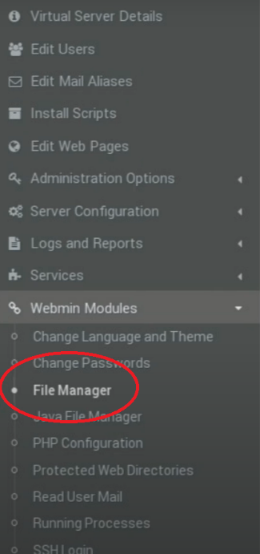  
In here, we can see all the files that operate GEESE

1. Right-click the desired file to be edited and press ‘Edit’:

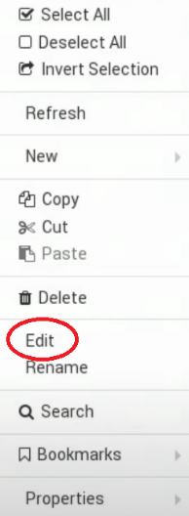

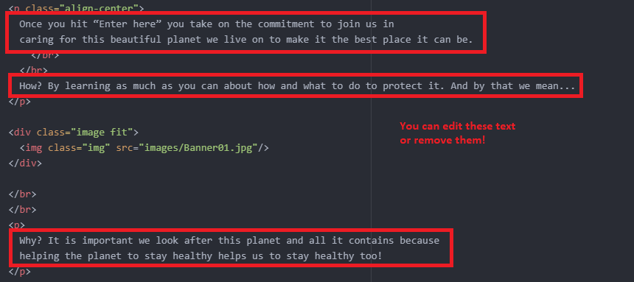

1. Once the text editor appears, navigate to the desired part of the code to modify. For example:
2. Once satisfied, press the save button located on the top right hand-side:

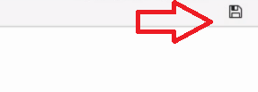

1. Refresh the main server’s page to see the changes.

GEESE Administrative Functions

Manage Users

The manage users page can be used to manage all the users registered within GEESE. You can edit every single field for each user including their username, password, account type, school, class, and even the status (activated or disabled). You can also delete the account by pressing the bin button.

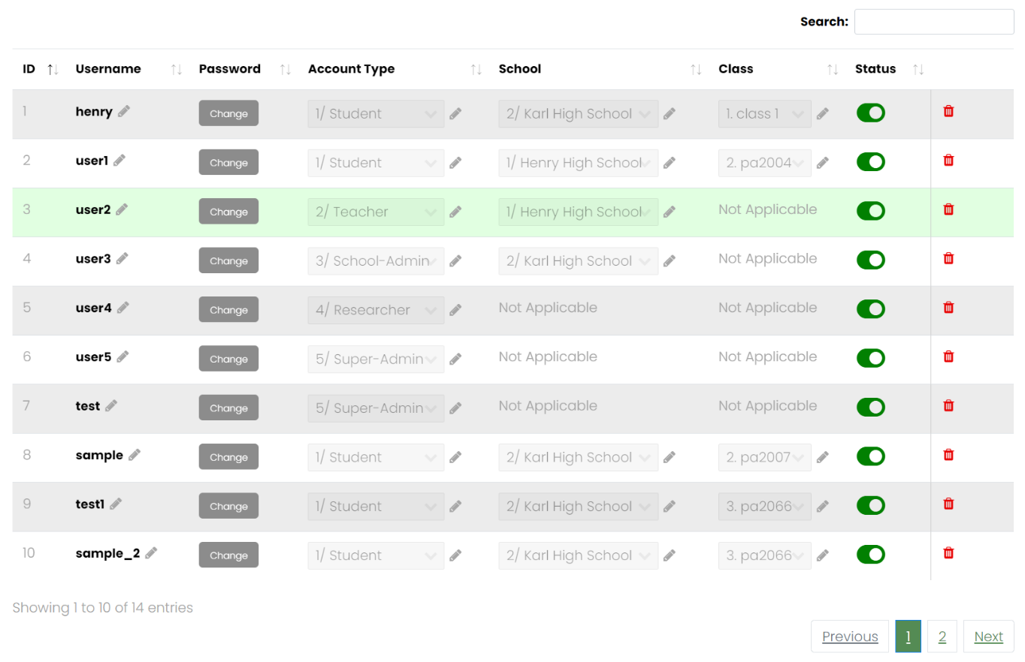

Manage Schools

This page will allow you to create a school within the database by providing the school name. You can also enter a ‘staffCode’ which you can provide to a school IT admin to change account privilege during account registration.

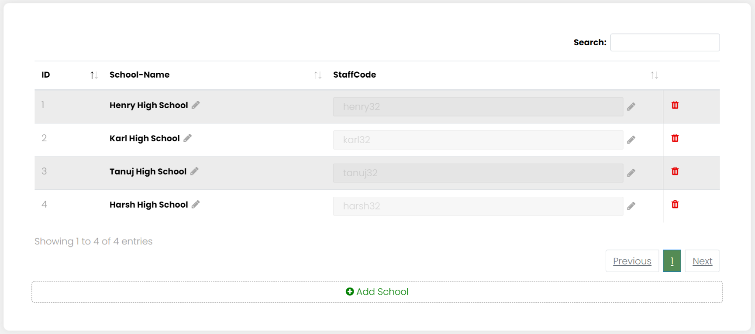

Manage Class

Like ‘Manage Schools’, manage class allows you to create classes within a school. You can also enter an access code that can be distributed to school students to use during account registration. Additionally, you can add a new class if needed.

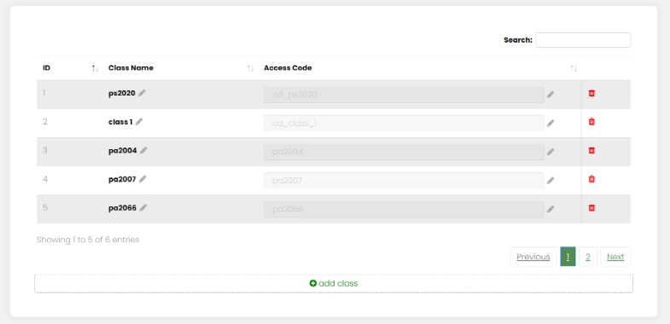

Manage Class

The manage teachers page allows you to organize the teacher accounts registered within GEESE. Like how ‘Manage Users’ work, you can edit all the desired fields for a teacher account, as well as the ‘class’ that they are assigned in.

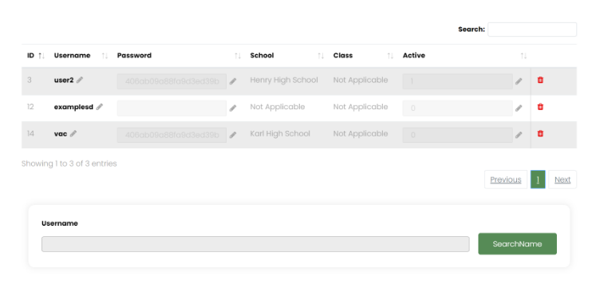

Manage Students

This page allows you to manage the student accounts registered within GEESE. You can modify a student’s registered school as well as their class. Additionally, you can add a new student account by pressing the ‘Add-New-Student’ button and providing the details on the given field. Keep in mind that the participant account has to exist to be added within the role.

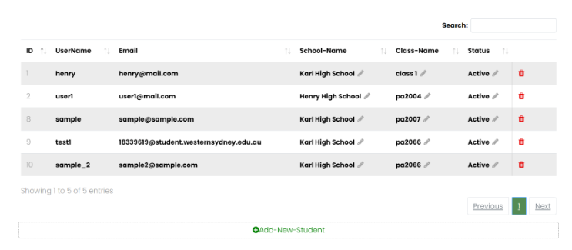

How to Utilize REDCap Functions

First, login to REDCap using the provided combination:

Username: geese  
Password: Geese1234

Creating a new project and setting up surveys for GEESE

1. Press the ‘New Project’ button located on the top left:



1. Fill in the details for the project by providing the title, purpose, and notes.
2. Press the ‘Create Project’ button to create the project.

Once you have created the project, we can now begin by enabling surveys within the project:

1. On the main project setup page, press the ‘Enable’ button found for the project’s settings:

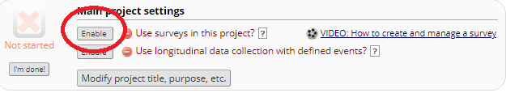

1. Pressing this button will give the project the ability to create surveys as well as distribute them. To create a survey, press the ‘Online Designer’ button within the second box:

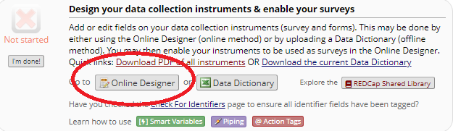

Once you are in the designer page, you are now ready to create a data instrument (‘Surveys’ are basically data instruments). To do so, conduct the following steps:

1. Press the ‘Create’ button located on the right hand-side of the page, under the ‘Add new instrument’ label:

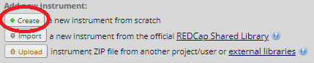

1. Give the survey a name and press ‘Create’.
2. Press the newly made instrument to begin editing.
3. Press the ‘Add Field’ button to create a field based on the question. There are several types of fields that can be used, ranging from buttons, text box responses, descriptive texts, etc. Take your time to craft your new survey.

IMPORTANT STEP:

1. Once you’re finish designing the survey, go back to the designer page, and press the ‘Survey Queue’ button. Press the ‘Activate’ button for the survey to enable survey queues. On the right hand-side select the drop-down button that says, ‘select a survey’ and select the newly created survey. After this, tick the ‘Auto start’ button on the right then press ‘Save’:

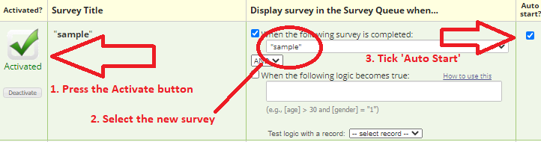

IMPORTANT NOTE:

The reason why we use survey queues for this platform is to enable ‘checks’ within the GEESE system to ensure that the user has completed the ‘Demographics’ survey. If the survey queue is not activated for the new survey, all other surveys will not be enabled! So, make sure you do not skip this step.

Once you are finish creating your survey, we can now implement it within GEESE.

1. On the left-hand side of the panel, press the ‘Survey Distribution Tools’ button:

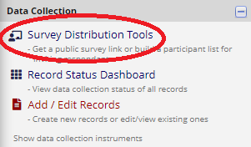

1. Within the ‘Public Survey URL’, copy the whole link. This link provides access to the project’s instruments and surveys when given to a participant.
2. In GEESE, log in to the client account using the given combination.
3. Press the ‘Site Settings’ button. Press the ‘add survey’ button located below the list, and provide a survey name to be displayed within a participant’s dashboard, the instrument’s survey title from REDCap (The name of the survey from the instrument list) and paste the distribution link within the ‘URL’ field:

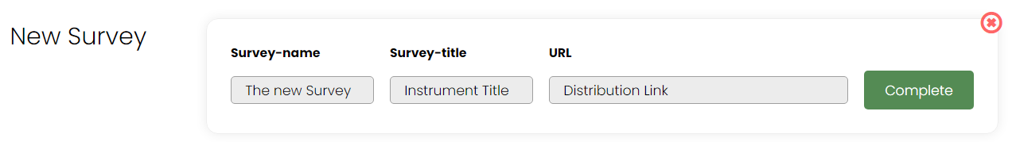

1. Once complete, go back to the dashboard to see the new survey.

Installing Custom repository modules (image mapping)

1. In REDCap, press the ‘Control Center’ button located at the top of the panel:



1. Once you are in the control center, press the ‘External Modules’ button located on the left-hand side of the panel:

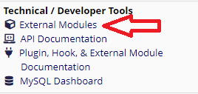

Upon pressing this button, you will be given the module manager page.

1. Press the blue button titled ‘View modules available in the REDCap Repo’
2. On REDCap’s repo page, search for ‘image map’ and install the ‘Custom Imagemap’ and ‘Custom Imagemap with radiobuttons’ module by Lieven Vaneeckhaute:

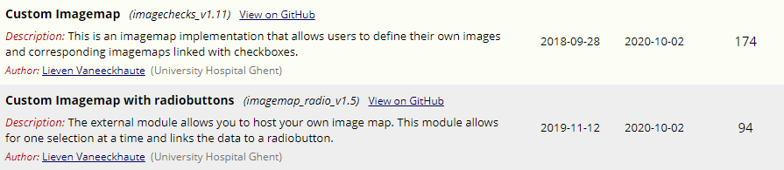

(The download button is on the right-hand side)

1. Once the repos are downloaded, go back to the module manager page within the REDCap’s control center. Press the ‘Enable a module’ button (that’s color green) and select the two newly installed modules.
2. You know have the modules prepared to be used within surveys:

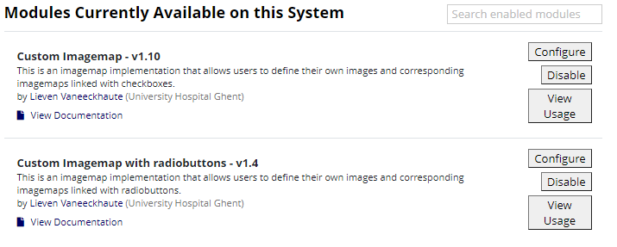

The following documentation provides instructions on how to use these within surveys:

Image Mapping for check boxes (multiple selections):

<https://ps2020.cdms.westernsydney.edu.au/redcap/modules/imagechecks_v1.10/howto.html?1600083904>

Image Mapping for radio buttons (single selection):

<https://ps2020.cdms.westernsydney.edu.au/redcap/modules/imagemap_radio_v1.4/howto.html?1600084078>

Enabling custom repository modules within projects

To enable these modules within a REDCap project:

1. Go to the ‘My Projects’ page (located on the top left) and select an existing project.
2. Press the ‘External Modules’ button found on the left-hand side of the panel:

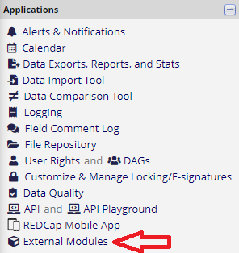

1. Press the ‘Enable a module’ button to see the available and installed modules that can be used:

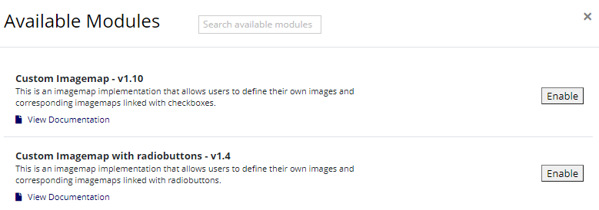

Press ‘Enable’ on the desired modules

1. Once enabled, they will appear on the ‘Currently Enabled Modules’ list.
2. Follow the documentation provided above to utilize image mapping within surveys

Installing GEESE & REDCap on a Server

There are several pre-requisites needed prior to the installation of both GEESE and REDCap. These include:

* A dedicated server: VirtualMin Server Management System (Used to host the platform)
* Access to the server’s database through PhPMyAdmin, which is used to create databases for:
  + GEESE
  + REDCap
* An estimated capacity of at least 500MB – 1GB (this can scale depending how big the population size is going to be for the research)
* An installation package for the administrative version of REDCap (provided by WSU IT along with instructions)

All these components are needed to ensure that GEESE and REDCap can operate as intended.

The folder uploaded within the RDS server titled ‘PS2020 – GEESE (Final)’ contain the whole code base and files for the platform. We recommend that you contact a member of the SSTARS team or WSU IT to implement this within your desired server.

REDCap is installed using an installation package. The installation package is provided by WSU IT simply requires you to upload the file within the server and run it through there. It will then install REDCap through a step-by-step set of instructions.

Prior to running the website or REDCap, please ensure that the file we have provided titled ‘ps2020.sql’ has been implemented within your server. You can simply copy everything within that text file and paste it on the SQL command execution.