Method to Evaluate Alternative Cameras Systems for Fingermark Capture

*Redacted*

Submitted in fulfillment of requirements for the degree of,
Master of Research

Supervisors
*Redacted*

Submitted to the School of Science
Western Sydney University
6th of December 2024

Dedication

Acknowledgements
****

Statement of Authentication

The work presented in this thesis is, to the best of my
knowledge and belief, original except as acknowledged
in the text. I hereby declare that I have not submitted
this material, either in full or in part, for a degree at this
or any other institution.

……………………………………………………..
*****

Declarations

Table of Contents
Chapter 1: Background 1
1.1 Introduction 2
1.2 History of Forensic Imaging 3
1.3 What is fingerprint evidence and its significant? 5
1.3.1 Levels of Fingerprint detail 5
1.3.2 Fingerprints vs Fingermarks 7
1.3.3 Formation of Fingermarks 7
1.3.4 Significant of Fingerprints 9
1.3.5 History of fingerprints evidence 9
1.4 Current methods used to detect and capture fingermarks. 11
1.4.1 Optical Techniques 11
1.4.1.1 Absorption 11
1.4.1.2 Fluorescence and Luminescence 13
1.4.1.3 Diffused Reflection 13
1.4.1.4 Ultraviolet (UV) Imaging 14
1.4.1.5 Infrared (IR) Imaging 15
1.4.2 Fingerprint Powders 16
1.5 Requirements to Photographically Capture Fingermarks. 17
1.5.1 Guidelines for general photographic capture of evidence items 18
1.5.2 Guidelines for photographic fingermark evidence capture 20
1.5.3 Current methods to photographically capture fingermarks that are in hard-to-reach places. 20
1.6 Past research that has been conducted using alternate cameras within forensic science. 21
1.6.1 Fingermark research with alternative cameras 21
1.6.2 Other forensic areas where alternative cameras have been researched 22
1.7 Project Aims and Objectives 23
1.7.1 Aim 23
1.7.2 Objectives 23
Chapter 2: Materials and Methods 24
2.1 Camera devices used throughout experimentation. 24
2.2 Part 1 of Method Development: Image Quality 27
2.2.1 Resolution and Contrast 28
2.2.2 Distortion 32
2.2.3 Colour accuracy. 35
2.2.4 Capability to capture coloured powders. 41
2.2.5 Capability to capture fluorescent powders. 45
2.2.6 Capability to capture latent fingermarks via diffused reflection. 48
2.2.7 Capability to capture black powdered fingermarks 48
2.2.8 Depth of field 49
2.2.9 Pixel per inch 52
2.2.10 CAST Grading for fingermarks in sections 2.2.4 to 2.2.7 52
2.3 Part 2 of Method Development: Fingermark Image Quality 54
2.4 Part 3 of Method Development: Practicability in a controlled environment 55
2.4.1 Creation of fingermark targets 56
2.4.2 Behind door handle 58
2.4.3 On top of fence 58
2.4.4 Outside of windowsill 58
2.4.5 Under a handrail 58
2.4.6 Small safe (Inside evidence items) 58
2.4.7 UC grading 58
2.5 Part 4 of Method Development: Pseudo-operational application 58
Chapter 3: Results 59
3.1 Results for Part 1 of Method Development: Image Quality 61
3.1.1 Resolution and Contrast 61
3.1.2 Pixel Per Inch Results 1
3.1.3 Depth of Field Results 3
3.1.4 Distortion Results 5
3.1.5 Colour Accuracy Results 1
3.2 Fingermark Image Quality Results 1
Chapter 4: Discussion 1
Chapter 5: Conclusion 3
5.1 Conclusion 3
Chapter 6 – Future Research 5
References 5
Bibliography 6
Glossary 7
Appendices 8
Index 9

List of Tables
Table 1: List of Cameras used throughout the project 25
Table 2: Focal Distance for Alterative Cameras 27
Table 3: Visual Examples of level of difference from the Ground Truth 41
Table 4: CAST Grade levels with example fingermark images (Group 2014) 54
Table 5: Results form for Part 3 Practicability 58
Table 6: Locations of fingermarks used in pseudo-operational experiments 1
Table 7: The visual limits and calculated lp/mm for the dental camera in all lighting conditions. 4
Table 8: The visual limits and calculated lp/mm for the DSLR Camera in all lighting conditions. 6
Table 9: The visual limits and calculated lp/mm for the Otoscope in all lighting conditions. 8
Table 10: The visual limits and calculated lp/mm for the Iphone in all lighting conditions. 10
Table 11: The visual limits and calculated lp/mm for the Teslong Straight in all lighting conditions. 12
Table 12: The visual limits and calculated lp/mm for the Teslong Side in all lighting conditions. 14
Table 13: Recorded PPi measurements from FCS for each lighting conditions 3
Table 14: Recorded Depth of Field Results for each lighting condition 3
Table 15: Amount and type of distortion between the alternate cameras 4
Table 16: Colour difference for each alternate camera compared to the ground truth 1
Table 17: Optimal power level of polilight for each type of alternate Camera to best capture each type fluorescent powder 4
Table 18: DSLR/ Standard Methods results for situation 1. 6
Table 19: Iphone results for situation 1. 8
Table 20: Dental Camera results for situation 1. 9
Table 21: Teslong Straight for situation 1. 10
Table 22: Teslong Side results for situation 1. 11
Table 23: Otoscope results for situation 1. 11
Table 24: Lift results for situation 1. 12
Table 25: DSLR/ Standard Methods results for situation 2. 14
Table 26: Iphone results for situation 2. 15
Table 27: Dental Camera results for situation 2. 16
Table 28: Teslong Straight for situation 2. 17
Table 29: Teslong Side results for situation 2. 18
Table 30: Otoscope results for situation 2. 19
Table 31: Lift results for situation 2. 20
Table 32: DSLR/ Standard Methods results for situation 3. 22
Table 33: Iphone results for situation 3. 23
Table 34: Dental Camera results for situation 3. 24
Table 35: Teslong Straight for situation 3. 25
Table 36: Teslong Side results for situation 3. 26
Table 37: Lift results for situation 3. 27
Table 38: DSLR/ Standard Methods results for situation 4. 28
Table 39: Iphone results for situation 4. 30
Table 40: Dental Camera results for situation 4. 31
Table 41: Teslong Straight for situation 4. 32
Table 42: Teslong Side results for situation 4. 33
Table 43: Lift results for situation 4. 34
Table 44: DSLR/ Standard Methods results for situation 5. 35
Table 45: Iphone results for situation 5. 36
Table 46: Dental Camera results for situation 5. 37
Table 47: Teslong Straight for situation 5. 38
Table 48: Teslong Side results for situation 5. 39
Table 49: Lift results for situation 5. 40
Table 50: Charging times for alternate cameras 42
Table 51: Remaining Charge of each alternate camera after the week of battery testing 42

List of Figures
Figure 1: The three main fingerprint pattern types (Houck 2016). 6
Figure 2: Fingerprint ridge features (Houck 2016) 6
Figure 3: Diagram depicting the deposit of a positive fingermark (Bleay, Croxton & De Puit 2018). 8
Figure 4: Diagram depicting the deposit of a negative fingermark (Bleay, Croxton & De Puit 2018). 8
Figure 5: Diagram depicting the deposit of an impression (Bleay, Croxton & De Puit 2018). 9
Figure 6: Example Diagram of how light interacts with a surface (Bleay, Croxton & De Puit 2018) 12
Figure 7: Diagram of reflection and absorption of light (Bleay, Croxton & De Puit 2018) 12
Figure 8: Example of a fingermark dusted with pink fluorescent powder, illuminated by 505nm (blue) light. Taken with a Canon 90D DSLR with a 550nm (orange) barrier filter attached to the lens. 13
Figure 9: Diagram demonstrating diffuse reflection through the use of oblique lighting (right) and specular lighting (left) (Bleay, Croxton & De Puit 2018) 14
Figure 10: DIagram of uv illumination of a fingermark (Bleay, Croxton & De Puit 2018) 15
Figure 11: Diagram of IR illumination on a coloured substrate (Bleay, Croxton & De Puit 2018) 16
Figure 12: Example of a fingermark dusted with black fingerprint powder captured via a Canon 90D. 17
Figure 13: Flowchart of the order enhancement techniques should be applied to fingermarks for recovery. (Laboratory 2022) 17
Figure 14: Flowchart demonstrating the general photographic documentation process (SWGDE 2019) 19
Figure 15: Example of a tape lift performed on an ideal fingermark conducted in laboratory conditions. Image of fingermark (Left) and Image of lifted fingermark (right) 21
Figure 16: Torch used during experimentation 28
Figure 17: Variable Contrast USAF Target labelled 1 to 15 from highest contrast target to lowest contrast target. 29
Figure 18: Setup of the DSLR camera for the photographic capture of the variable contrast USAF target. 30
Figure 19: Setup of the Iphone for the photographic capture of the variable contrast USAF target. 30
Figure 20: Setup of the Teslong Straight (left) and Side (Right) cameras for the photographic capture of the variable contrast USAF target. 30
Figure 21: Setup of the Dental camera for the photographic capture of the variable contrast USAF target. 31
Figure 22: Setup of the Otoscope for the photographic capture of the variable contrast USAF target. 31
Figure 23: Labelled version of the 5th target in the variable contrast USAF target. The middle section has been enlarged to display visual limit. This image was captured via the DSLR in the ambient with torch lighting condition. 32
Figure 24: Dot Grid Distortion test target (Right) 33
Figure 25: Setup of the DSLR camera for the photographic capture of the Distortion Target. 34
Figure 26: Setup of the Dental camera for the photographic capture of the Distortion Target. 34
Figure 27: Setup of the Iphone for the photographic capture of the Distortion Target. 35
Figure 28: Setup of the Otoscope for the photographic capture of the Distortion Target. 35
Figure 29: Setup of the Teslong Straight (Right) and Side (Left) cameras for the photographic capture of the Distortion Target. 36
Figure 30: Calibrite colorchecker classic Colour Test Target 37
Figure 31: GTI minimatch MM4e lightbox 37
Figure 32: Setup of the DSLR camera for the photographic capture of the Colour Accuracy Target. 38
Figure 33: Setup of the Dental camera for the photographic capture of the Colour Accuracy Target. 38
Figure 34: Setup of the Iphone for the photographic capture of the Colour Accuracy Target. 39
Figure 35: Setup of the Otoscope for the photographic capture of the Colour Accuracy Target. 39
Figure 36: Setup of the Teslong Straight (Bottom) and Side (Top) cameras for the photographic capture of the Colour Accuracy Target. 40
Figure 37: the dusted fingermark depletion series to form the coloured/fluorescent powdered fingerprint test targets. 43
Figure 38: Setup of the DSLR camera for the photographic capture of fingermark test targets. 43
Figure 39: Setup of the Dental camera for the photographic capture of fingermark test targets. 44
Figure 40: Setup of the Iphone for the photographic capture of fingermark test targets. 44
Figure 41: Setup of the Otoscope for the photographic capture of fingermark test targets. 45
Figure 42: Setup of the Teslong Straight (Left) and Side (Right) cameras for the photographic capture of fingermark test targets. 45
Figure 43: Polilight PL500 46
Figure 44: DSLR Camera with 550nm barrier filter attachment (Left). Setup of the DSLR camera for photographic capture of the fluorescent powdered fingermark targets (Right). 47
Figure 45: Otoscope setup for capturing fluorescent fingermark test targets, with the barrier filter setup in the required position for use of coloured light. The setup was the same when using the UV light, but the barrier filter was removed. 47
Figure 46: Iphone setup for capturing fluorescent fingermark test targets, with the barrier filter setup in the required position for use of coloured light. The setup was the same when using the UV light, but the barrier filter was removed. 48
Figure 47: Dental setup for capturing fluorescent fingermark test targets, with the barrier filter setup in the required position for use of coloured light. The setup was the same when using the UV light, but the barrier filter was removed. 48
Figure 48: Teslong straight (top) and side (bottom) camera setup for capturing fluorescent fingermark test targets, with the barrier filter setup in the required position for use of coloured light. The setup was the same when using the UV light, but the barrier filter was removed. 49
Figure 49: Dusted White powdered fingermark targets 49
Figure 50: SpderLenscal™ depth of field target 50
Figure 51: Setup of the DSLR CAMERA for the photographic capture of the depth of field target. 51
Figure 52: Setup of the Iphone for the photographic capture of the depth of field target. 51
Figure 53: Setup of the Dental CAMERA for the photographic capture of the depth of field target. 52
Figure 54: Setup of the Otoscope for the photographic capture of the depth of field target. 52
Figure 55: Setup of the Teslong Straight (Left) and Side (Right) CAMERAs for the photographic capture of the depth of field target. 53
Figure 56: Inch ruler used as the test target for PPI experiment. 54
Figure 57: A high contrast pink coloured powdered fingermark captured via the Teslong straight camera. Left captured using ambient light. Right captured using ambient light with torch. 56
Figure 58: Simulation Apparatus used throughout experimentation to replicate the selected situations. (Brilliant Basics Portable Single Garment Rack). 58
Figure 59: Simulation Apparatus setup for behind a door handle scenario. The red arrow indicates where the fingermark target was placed for the experiment. 60
Figure 60: Simulation Apparatus setup for on top of a fence scenario. The red arrow indicates where the fingermark target was placed for the experiment. 61
Figure 61: Simulation Apparatus setup for outside of a windowsill scenario. The red arrow indicates where the fingermark target was placed for the experiment. 61
Figure 62: Simulation Apparatus setup for under a handrail scenario. The red arrow indicates where the fingermark target was placed for the experiment. 61
Figure 63: SuresafeTM Fremont (J.Burrows) (left) and the simulation with the fingermark location indicated via the red arrow (right). 62
Figure 64: Graphical Representation of Table 7 5
Figure 65: Graphical Representation of Table 8 7
Figure 66: Graphical Representation of Table 9 9
Figure 67: Graphical Representation of Table 10 11
Figure 68: Graphical Representation of Table 11 13
Figure 69: Graphical Representation of Table 12 15
Figure 70: The graph demonstrates the resolution limit of each camera within the different number targets on the USAF resolution and contrast target Captured in Ambient Lighting. 1
Figure 71: The graph demonstrates the resolution limit of each camera within the different number targets on the USAF resolution and contrast target captured in ambient with torch lighting. 2
Figure 72: The graph demonstrates the resolution limit of each camera within the different number targets on the USAF resolution and contrast target captured in low lighting. 2
Figure 73: Graph depicting the results from the depth of field targets for the cameras tested. A. ambient lighting. B. ambient with torch lighting. 4
Figure 74: The graphically represent of the median grade for each type of black powdered fingermark target within each lighting condition tested. 1
Figure 75: The graphically represent of the median grade for each type of white powdered fingermark target using diffused reflection as its lighting conditions. 2
Figure 76: The graphically represent of the median grade for each type of latent fingermark target using diffused reflection as its lighting conditions. 2
Figure 77: The graphically represent of the median grade for each type of coloured fingermark targets within each lighting condition tested. a. Orange Powder. B. Pink Powder. C. Red powder. D. Yellow powder. E. Green powder. 3
Figure 78: The graphically represent of the median grade for each type of fluorescent fingermark targets within each lighting condition tested. a. Orange Powder. B. Pink Powder. C. Red powder. D. Yellow powder. E. Green powder. 4

List of Equations
Equation 1: lp/mm Equation based on the USAF Target, including an Example of how to calculate lp/mm after the visual limit is determined (Worldwide 2023). 33
Equation 2: Distortion percentage (Hollows & James 2011) 36

Abbreviations
DSLR: Digital single-lens reflex
SWGIT: Scientific Working Group on Imaging Technologies
UV: Ultraviolet
IR: Infrared
AFIS: Automated Fingerprint Identification System
FBI: Federal Bureau of Investigation
PPI: Pixel Per Inch
USAF: United States Air Force
UVC: Short-wave ultraviolet
ISO: International Standards Organization
ALS: Alternate Light Source
FCS: Forensic Comparison Software
CAST: Centre for Applied Science and Technology
UC: University of Canberra
FCS: Forensic Comparison Software
RGB: Red, Green, Blue
SDR: Standard Dynamic Range
IFRG: International Fingerprint Research Group

Abstract

Chapter 1: Background

Introduction
Forensic photography is an important aspect of forensic science that allows for the photographic documentation of evidence items and crime scenes. The images captured can be considered evidence depending on the situation, for example: fingermarks that are photographically captured at a crime scene. These fingermark images are what is expertly examined, not the physical fingermark within the crime scene. An important type of identification evidence is fingerprints which can aid in the identification of potential persons of interest in an investigation. Fingermarks are not always in easily accessible situations, which can make photographical capture using the standard practices difficult. Examples of these types of situations include behind most door handles, on top of fences, and within restricted sections of evidence items such as safes. To potentially improve crime scene investigations and in particular the photographic capture of fingermarks in difficult to reach locations, alternative solution such as the use of alternative cameras could be explored.
To photographically document crime scenes and the evidence within crime scene, investigators employ the method of forensic photography. Links can be established from evidence items within a crime scene to specific places, or people, though the image evidence capture via forensic photography (Duncan 2023). The photographs taken at scenes allows for photographic documentation of that scene, and when all the components of a crime scene are recorded or processed, it can aid in scene descriptions and can possibly connect gaps within the investigation. Along with image evidence being collected of the overall scene, forensic photography can document evidence that cannot be physically collected (Robinson & Richards 2012). Forensic photography is an important aspect of investigations and is a necessary method to ensure a scene is documented accurately.
Fingerprint evidence is found at most crime scenes. It is a crucial form of identification evidence and should be collected when possible. A fingerprint is located at the fingers of palm side of a hand and is defined as the friction skin ridges in this location (Saferstein 2015). Along with fingerprints, palm prints and footprints can also leave impressions as the soles of the feet and palms also contain friction skin ridges (Saferstein 2015). An impression left by finger ridge patterns is caused by the perspiration from sweat glands within fingers that leaves a deposit on a surface (Saferstein 2015). There are two types of fingerprint impressions, one being a latent fingerprint which is invisible to the human eye, and the other is a patent fingerprint which is visible to the human eye (Saferstein 2015). A print collected under controlled conditions like those collected as reference prints are defined as fingerprints (Hawthorne, Plotkin & Douglas 2021). A print collected under uncontrolled condition like those found at crime scenes and contains friction ridge detail are defined as fingermarks (Hawthorne, Plotkin & Douglas 2021). Fingermarks are used for establishing links between crime scenes, certain places, possession of items to persons of interest, and for disaster victim identification (Hawthorne, Plotkin & Douglas 2021). Fingermarks must be visible in order to capture the mark as evidence, and enhancement techniques are applied in cases where the mark is not visible (Hawthorne, Plotkin & Douglas 2021). Techniques to enhance fingermarks include; chemical enhancement such as ninhydrin, electrostatic dust lifting, and the most common method which is powder dusting (Barbaro & Mishra 2022). Laboratory based enhancement techniques include; vacuum metal deposition, and cyanoacrylate or super glue fuming (Barbaro & Mishra 2022). Enhancement techniques are applied to increase the visibility of the mark by increasing the contrast between the mark and the background. The mark is captured once it is visible, which is achieved through photography and/or a tape lift (Hawthorne, Plotkin & Douglas 2021). Fingerprints are valuable forms of identification evidence and aid in establishing links within an investigation, this type of evidence should be correctly captured when possible.
Most of the time the photographic capture of fingermarks within a scene is a straightforward process, given that the mark is in an accessible area that the standard camera can reach, but there are multiple situations where a standard camera cannot capture the mark easily. A common standard camera used within investigations is a digital single-lens reflex (DSLR) camera (Robinson & Richards 2012). To correctly capture a quality image of a fingermark, the following should occur: the fingermark fills the frame, macro lenses are used, the mark is in focus, the camera is perpendicular to the mark to avaid distortion (Robinson & Richards 2012), and the angle of the flash is correct when using flash photography to ensure the mark is correctly exposed (Gardner 2012). In situations where standard photography procedures cannot be used to accurately capture a quality image of the mark, distortion occurs due to the camera angle or lack of accessibility to the mark (Houck & Siegel 2015). Examples include behind a door handle, on top of a fence or outside on a windowsill of a tall building. In these situations, the fingermark still needs to be collected as it is crucial evidence. The current methods to capture fingermarks in these situations include tape lifting the mark, which involves placing adhesive tape over the print then removing the tape to be placed on a backing card (Miller & Massey 2018). The lift is photographically captured and/or collected for further analysis (Houck & Siegel 2015). The other method consists of using a mirror to reflect the mark and photograph the reflection. The issues associated with the current methods include the damage that can occur during a lift with no guarantee of the lift being successful, and with the use of a mirror distortion occurs due to the reflection along with the time consumed due to set up.
There is a significant gap within the literature with limited research being conducted in this area to address these issues. Possible solutions include using alternative cameras to capture fingermarks in hard-to-reach places. Potential alternative camera devices include iphones, intra-oral, and fibre optic cameras. There has been brief work conducted using iphones within forensic work and fingerprint capture. Mancini (2017) has stated the possibility of using iphones within forensics as a tool for crime scene photography. Haertel, Linhares and Melo (2021) have explored the use of iphones in relation to fingerprint capture even further, concluding that iphones can capture latent fingerprints, but further research is needed before iphones are accepted for this use. The comparison between DSLR cameras and iphones has been conducted by Cardinal (2020) concluding that the performance of both cameras is similar, but the iphone is limited to their inbuilt algorithms of set specifications limiting their controls, whereas the DSLR allows more control over imaging options. A borescope is a fibre optic camera device used for inspecting within walls, floors and roofs through small openings (Gorse, Johnston & Pritchard 2020). A borescope is a potential device for the capturing fingermarks in hard-to-reach places as it is a small, flexible and portable device that can fit within confined spaces. Another potential device is an intra-oral camera which is a toothbrush shaped device with a lens attached on the top commonly used within dentistry to examine oral cavities (Pentapati et al. 2017). This device is small and can be operated with one hand, which could potentially be used in tight spaces. The previous research conducted with alternative cameras demonstrates the potential for the use of these devices within forensics, but further exploration is required to properly address the gap in the literature.

History of Forensic Imaging
The history of forensic imaging and photography is an important aspect in understanding how cameras have evolved, and what purpose they now play within the forensic science discipline. Forensic imaging is still a current process which is ever evolving, and its history is needed to guide the development of future equipment within the field (Robinson 2016). Camera obscura was the first pinhole camera which is where the history of forensic imaging begins (Robinson 2016). These cameras are believed to have been used to observe the sun by scientists and to aid artists in creating sketches (Robinson 2016).
There were three key evolutionary developments to the camera obscura before it had similar basic components and functions to early photographic cameras (Robinson 2016). This first addition was in 1550 by Girolamo Cardano who added a lens to the camera obscura (Robinson 2016). The second addition was achieved in 1558 by Giovanni Battista della Porta, which included further development to the lens and added additional lenses and curved mirrors, with the goal to produce an image that was upright. However this development was not published until 1588 (Robinson 2016). The third development was achieved in 1568 by Daniele Barbaro who invented the diaphragm (Robinson 2016), which is a part of the camera that consists of a set of blades that can be opened and shut to control the amount of light entering the camera (Robinson & Richards 2012).
The camera obscura was an immobile invention, creating limitations for what could be photographed and how the device operated. To further develop the camera obscura, the camera lucida was invented in 1807 by William Hyde Wollaston (Davenport 1999). The camera lucida was a portable version of the camera obscura which worked using similar principles, light would reflect off the object being “photographed”, the prism attached to a metal rod within the device is where the light shone through (Davenport 1999). A person would be able to view the subject through the peephole next to the prism and draw on the paper underneath the rod simultaneously (Davenport 1999), hence capturing the subject.
Both the camera obscura and camera lucida did not capture an image without the use of person physically drawing what was being visually observed. An invention that allowed subjects to be captured in a lasting photographic image on a medium such as metal or paper (Davenport 1999). This technique used the light rays reflected off a subject onto the recording medium and stabilised the image through the use of chemical reactions (Davenport 1999). Louis Jacques Mande Daguerre was the first to invent the metal plate system of photography (Davenport 1999). The original process of creating lasting photographic images was expensive, complex, and time consuming, but it gradually evolved from the metal plate system to a more streamlined system which was used during the 1990s (Davenport 1999). Further development of this system has allowed photographs to be capture automatically without the need of traditional film, through the development of negatives and prints (Davenport 1999). As the process developed further and become more simplified, the development of millisecond flash photography was created which allowed scientists to study the effect the movement of an object (Davenport 1999).
Sir William Herschel was responsible for the discovery of the infrared region of the electromagnetic spectrum in 1800 (Robinson 2016). Infrared photography is an importance aspect in modern forensic imaging (Robinson 2016). Herschel discovered this region during experimentation of splitting white light into their colours, and placed a thermometer near the non-visible red end (Robinson 2016). In 1826 Joseph Niepce was successful in capturing the first photograph, and credited as the inventor of photography (Robinson 2016).
In the year 1822 many important evolutions to cameras and photography occurred. The Fresnel lens within all DSLR viewfinders was invented (Robinson 2016), an important advance in forensic photography as DSLRs are the commonly used standard within the field. The development of the Fourier series which formed the basis of Fast Fourier Transforms (FFTs), Fourier transforms, discrete cosine transform (DCT), modulation transfer functions (MTFs) and describe optics which are all used for MPEG and JPG imagines currently (Robinson 2016). The theoretical basis of currently used fluorescent photography within case work was discovered in 1852 by Sir George G. Stokes upon his discovery of UV fluorescence (Robinson 2016).
Photography was first used as evidence in 1859 in the United States (Robinson 2016). In 1916 the first defined standards of the admissibility of imaging evidence was conducted by the Ohio Appellant Court (Robinson 2016). The court deemed that motion pictures were not an accurate representation as it did not provide clear detail (Robinson 2016). This lead to similar standards being created for current imaging evidence used within cases, requiring the photographs to be relevant and the representation fair and accurate while not being majorly prejudicial (Robinson 2016).
During the 1950s and 1960s, many developments occurred withing imaging technology with Canon introducing a camera with an electronic flash synchronization (Robinson 2016). By 1965 still photography saw the availability of fully automatic electronic flash units (Robinson 2016).
In 1973, studies began to develop the currently used ACE-V system which is used in fingerprint analysis (Robinson 2016). ACE-V is an acronym for the four steps within the system; analysis, comparison, evaluation, and verification (Robinson 2016). Even though this system was created to aid with fingerprint examinations it is also used by forensic photographers for photographic comparisons (Robinson 2016).
In 1976 the development of the Gretag-Macbeth colour checker target was developed (Robinson 2016), to aid in determining a camera’s ability of capture colours accurately. In 2009 Rags Gardner used the Gretag-Macbeth colour checker and developed a method to calibrate digital cameras to this test target within Adobe Photoshop’s Adobe Camera Raw (Robinson 2016).
In 1989 Kodak developed the D-5000 DSLR which contained all the basic design features that current DSLR models are based upon (Robinson 2016). Further development was conducted by Kodak which lead to DSLRs containing IR, monochrome and colour technologies within the Kodak DSC200 DSLR series in 1992 (Robinson 2016).
In 1989 a professional organisation dedicated to developing standards for imaging technologies and systems that could be implemented and used within the justice system (Robinson 2016). This group was called the Scientific Working Group on Imaging Technologies (SWGIT) (Robinson 2016). SWGIT disbanded in 2015 by succussed by the Organization of Scientific Area Committees (OSAC) which was formed by the National Institute of Standards and Technology (NIST) (Robinson 2016). Even though SWGIT was disbanded their guidelines are still considered standards and the relevant guidelines are still followed (Robinson 2016).

What is fingerprint evidence and its significant?
Fingerprints are defined as an impression left on surface created by the palm side of fingers (Houck 2016). This type of skin is called friction ridge skin, and is also located on the palms of the hands, soles of the feet and on the sole side of the toes (Houck 2016). Unique patterns are created within friction ridge skin from the furrows and small ridges that curve, bend, combine, stop, start, and split apart (Houck 2016). The ridges on the fingers contain sweat pores and when the skin comes in contact with a receptive surface that sweat can transferred onto that surface (Houck 2016). The sweat impression is left on every surface touched, but can usually only be collected from surfaces that are smooth and non-porous such as glass or flat plastics (Houck 2016). Fingerprints can also be left in contaminants like blood or oil, and within soft malleable material like putty (Houck 2016).

1.3.1 Levels of Fingerprint detail
There are three levels of fingerprint detail, the first level is ridge flow and type of pattern, the second level is the characteristics of the ridge, and the third level is shape of ridge edges and pores (Houck 2016). There are three main types of fingerprint patterns which include arches, loops, and whorls (Figure 1) (Houck 2016). Patterns are formed during development by taking the path of least resistance, hence flowing over flat areas creating arches, around raised areas creating whorls and in certain directions to the left or right of raised areas creating loops (Houck 2016).
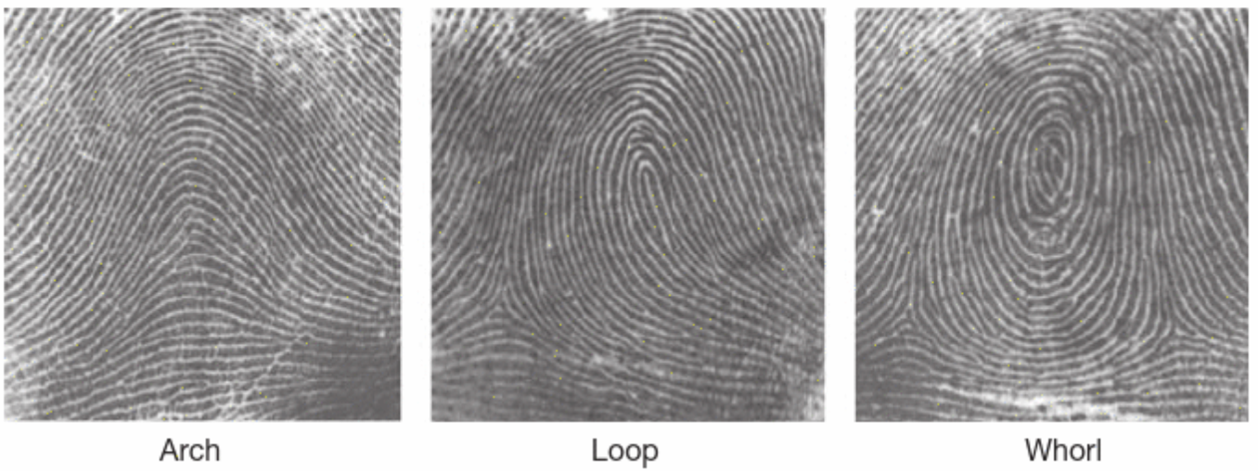
Figure 1: The three main fingerprint pattern types (Houck 2016).
*Draw own diagram*
Ridge features are the lines that stop, start, and split apart. There are many types of ridge characteristics as shown in figure 2 (Houck 2016). Ridge endings are a feature when the ridge comes to a stop, and a bifurcation is when a ridge splits apart (Houck 2016). These two types are the basics for different types of ridge characteristics (Figure 2)(Houck 2016).
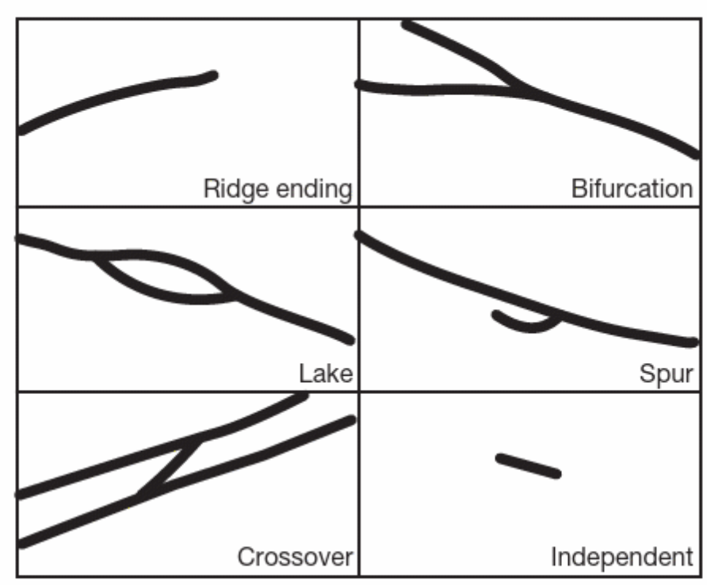

Figure 2: Fingerprint ridge features (Houck 2016)
*Draw own diagram*
Pores are usually invisible to the naked eye but appear on the crest of each ridge when a print is magnified (Houck 2016). Pores can be used as a comparison feature as their distribution along a ridge is random and their size varies (Houck 2016). The shape of the edge of a ridge may also be used for comparison if the print captured is of good quality (Houck 2016). The quality of these feature are determined by the following factors; print quality, pressure used, type of surface the print is deposited on, and a person’s ridge type (Houck 2016).
The features described previously are all biological and developed before birth, but there are other features that can be used within fingerprint comparisons. Creases within the friction ridge skin can either be permanent like the crease where joints are located, and others can appear due to how the skin is used and ages (Houck 2016). Permanent scars can be used as identifying factors as it changes the original fingerprint becoming a unique feature (Houck 2016).

1.3.2 Fingerprints vs Fingermarks
There are two terms used to distinguish between the different types of fingerprints encountered during fingerprint identification. Fingerprints are defined as prints that are collected under controlled conditions and are usually used as a reference print (Houck 2016). These types of prints are normally of good quality when compared to fingermarks. Fingerprints can be collected by inking the finger and rolling the finger on a fingerprint form, or by an electronic fingerprint scanner that scans the finger and produces the fingerprint digitally (Houck 2016). A fingermark is defined as a print found at a crime scene that contains friction ridge detail and can vary in quality (Houck 2016). The variation in quality can range from a high-quality fingermark that shows high levels of friction ridge detail including pattern, characteristics of the ridge, flow of the ridge, pores, and shape of the ridge edge (Houck 2016). Low quality marks lack detail with factors such as surface type, movement during deposition, smudges, pressure, and multiple fingermarks overlapping which affect its quality (Houck 2016). The comparison between an unknown fingermark that is recovered during an investigation part, and a known fingerprint such as a reference fingerprint, are a part of the fingerprint identification process (Houck 2016).

1.3.3 Formation of Fingermarks
There are three types of interaction between a finger and a surface, which are positive marks (Figure 3), negative marks (Figure 4), and impressions (Figure 5) (Bleay, Croxton & De Puit 2018). Positive fingermarks are formed when the residue on the finger is transferred onto the surface via the finger (Bleay, Croxton & De Puit 2018). The visibility of the mark is dependent upon numerous of factors, including the colour of the residue, its composition, the reflectiveness of the surface, and the examination lighting. Positive marks are the most encountered type of fingermark interaction found within crime scenes (Bleay, Croxton & De Puit 2018). Positive fingermarks can either be patent, which is a mark visible to the naked eye, or latent which is a mark that is not visible to the naked eye and requires enhancement techniques (Bleay, Croxton & De Puit 2018). Latent marks are more regularly encountered than patent marks (Bleay, Croxton & De Puit 2018). A negative mark occurs when a finger encounters a surface that is covered in loose particulates, or when a surface is covered in a thin layer of contaminant (Bleay, Croxton & De Puit 2018). When the finger encounters this type of surface the particulates or containment may be picked up by the finger, leaving a negative fingermark impression within particulates or containments on the surface (Bleay, Croxton & De Puit 2018). Negative marks are not common within crime scenes and are considered fragile (Bleay, Croxton & De Puit 2018). Impressions occur on surfaces that are made of soft materials that can deform and melt upon contact (Bleay, Croxton & De Puit 2018). Examples include putty or wet paint, as the ridge detail can leave impressions in these surfaces (Bleay, Croxton & De Puit 2018). These types of fingermarks can also be referred to as plastic fingermarks, as the impression can be permanent in some cases (Bleay, Croxton & De Puit 2018). Impressions are also not common within crime scenes (Bleay, Croxton & De Puit 2018).

Finger
Substance on fingertip
Surface
Surface
Substance on fingertip
Finger
Substance deposited to surface

Figure 3: Diagram depicting the deposit of a positive fingermark (Bleay, Croxton & De Puit 2018).
Surface
Particulates transferred to fingertip
Finger
Particulates left in a negative impression
Finger
Loose particulates on surface
Surface

Figure 4: Diagram depicting the deposit of a negative fingermark (Bleay, Croxton & De Puit 2018).

Finger
Soft Surface
Finger
Soft Surface
Impression left in surface

Figure 5: Diagram depicting the deposit of an impression (Bleay, Croxton & De Puit 2018).

1.3.4 Significant of Fingerprints
There are three fundamental principles of fingerprints that relate to their significant within the forensic discipline. The first indicates that a fingerprint is unique to everyone with no observations indicating identical ridge characteristics (Shrivastava 2023). This principle describes that all fingerprints contain unique features of that individual and even through millions of fingerprint examinations there has not been two fingerprints that have been identified as the same (Shrivastava 2023). The second principle states that a fingerprint does not change during a person’s lifetime (Shrivastava 2023). The fingerprint detail formed during the developmental stages remain the same throughout a person’s life (Shrivastava 2023). Fingerprints do grow but the adult fingerprint would be the enlarged version of the their childhood fingerprint (Shrivastava 2023). Fingerprints are not affected by temporary changes to the skin which include warts, or blisters which can occur due to multiple manual labour occupations (Shrivastava 2023). The third principle states that the ridge patterns of fingerprints can be systematically classified (Shrivastava 2023). Due to the nature of fingerprint patterns, methodology can be developed to classify the different types of patterns and the different features within a fingerprint allowing for records to be kept for identification work (Shrivastava 2023). Investigators use fingerprints for personal identification and well as linking fingermarks found at crime scenes to persons of interest (Shrivastava 2023). Fingerprints can be used in the identification of missing persons, unconscious persons, kidnapped victims, and unknown deceased persons (Shrivastava 2023). The use of fingerprints can extend beyond forensic use as it can also be used to identify infants within hospitals to prevent mix ups, and fingerprints are even used as signatures in India (Shrivastava 2023).

1.3.5 History of fingerprints evidence
It isn’t known for certain when the use of fingerprints for identification first began, but there is evidence linking the use of fingerprints back to the earliest forms of civilisations (Shrivastava 2023). Fingerprints have been discovered in China on ancient bricks and pottery, but it is undetermined if the marks were intentional (Shrivastava 2023). Fingerprints have been found on pottery in the Middle East where a fingerprint was used to sign their work (Shrivastava 2023). Fingerprints have been found to seal important documents across multiple ancient civilisations which include Babylon, China, Egypt and Assyria (Shrivastava 2023).
Research into the details of fingerprints began to develop the current understanding of fingerprint details. In 1684 Dr Nehamiah Grew recorded the patterns on fingers and palms, the sweat pores, and how the epidermal ridges were arranged (Shrivastava 2023). In 1685 Govard Bidloo produced a human anatomy book that detailed the arrangement of the detail within the ridges of fingers (Shrivastava 2023). In 1686 Marcello Malpighi recorded that ridges were elevated on multiple fingers on the palmer side of the hand, and described that the ridges contained loop and spiral like patterns on the end of the fingers (Shrivastava 2023). In the eighteenth century J.C.A. Mayer conducted research to suggest that the arrangements within the skin ridges were not duplicated in two people, but there could be similar arrangements among individuals (Shrivastava 2023). There were also cases where the patterns differed significantly, but all arrangements seemed to have a certain likeness (Shrivastava 2023).
An important development for fingerprint forensics was made by Johannas E. Purkinje in 1823, who systematically classified the patterns of fingerprints for the first time (Shrivastava 2023). W.J. Herschel implemented the official use of fingerprints on a large scale in India for document signing in 1858 (Shrivastava 2023). Documents containing fingerprints were considered more important than those with just signatures, and Herschel was the first British man to be credited for recognising the significance of fingerprints (Shrivastava 2023).
In 1880 Dr. Henry Faulds conducted research that led to the conclusions that fingerprints are unchanging and remain the same throughout a person’s lifetime (Shrivastava 2023). He stated the possibility to use fingermarks within crime scenes to identify persons of interest (Shrivastava 2023). This led to him being the first European to release an article detailing the possibilities of using fingermarks that were visible such as ones deposited in grease, blood, or soot, to aid within investigations (Shrivastava 2023).
In 1892 further research was conducted into fingerprint details by Sir Francis Galton, he also concluded that a person’s fingerprint detail does not change throughout their lifetime (Shrivastava 2023). He recorded the fine characteristic details within a fingerprint now known as minutiae, which are used to compare fingerprints, and created a system to classify fingerprints (Shrivastava 2023).
In 1891 Juan Vucetich implemented fingerprint files as an official method to identify criminals (Shrivastava 2023). Based on the patterns discovered by Galton, Vucetich used these patterns to develop the first fingerprint classification system (Shrivastava 2023). This system is currently being used in Central and South America countries that speak Spanish. He was also the first person to use a fingermark left at a crime scene to identify a person of interest (Shrivastava 2023).
In 1897 Inspector Edward Richard Henry, and officers Azizul Haque and Rai Bahadur Hem Chandra Bose, developed a system for ten-digit classification for fingerprints which was implemented as an identification system for criminals (Shrivastava 2023). In June of the same year the world’s first fingerprint bureau was established in Calcutta, India (Shrivastava 2023). The currently used ten-digit fingerprint identification system was developed based on the systems created by Henry and Vucetich (Shrivastava 2023).
1901 was the year that fingerprint identification was officially used within England and Wales (Shrivastava 2023). New York was the first US state to use fingerprints within criminal records in 1903 (Shrivastava 2023). Throughout the 1900s development regarding fingerprints and their use within crime scene investigations were being refined (Shrivastava 2023). The International Association for Criminal Identification was the first professional fingerprint organisation, established in 1915 in California (Shrivastava 2023). The organisation has been renamed the International Association for Identification, but remains the oldest active forensic international organisation (Shrivastava 2023). In 1924, J. Edgar Hoover established the Federal Bureau of Investigation’s (FBI) first identification division which was soon followed by the establishment of the FBI laboratory in 1932.
The development of an Automated Fingerprint Identification System (AFIS), also known as the fingerprint computer, was established to combat the increased amount of fingerprint analysis being conducted (Shrivastava 2023). This system is currently being used internationally in places such as Europe, Asia, and North America (Shrivastava 2023). AFIS is an automated system that is used to readily identify persons using fingerprints and palm prints (Houck 2016). The AFIS database is composed of multiple AFIS records from both criminal and civil files. An AFIS record consists of a ten-print collection of inked fingerprints, and if possible both hand’s palms print (Houck 2016). The identification data such as the person’s name, date of birth, sex, and relevant identification numbers are linked to the fingerprints collected for the AFIS record (Houck 2016). When a unknown fingermark is collected during an investigation it is run through AFIS and a list of closest matches will return (Houck 2016) which can aid in determining who the collected fingermark belongs to. In cases where there is no results on the AFIS database the unknown print can be placed in the unsolved latent print database (Houck 2016). Here the print is compared to all future records added to AFIS until there is a possible match, or the print is removed due to deletion (Houck 2016).

1.4 Current methods used to detect and capture fingermarks.
During investigations fingermark evidence should be recovered either via photographing the print or physically lifting the mark to be collected for further analysis. A fingermark may not always be visible, in these cases enhancement techniques are required to visualise the mark for capture. This section will discuss the difference optical and powder techniques used to detect and enhance fingermarks for capture.

1.4.1 Optical Techniques
Optical enhancement techniques are a form of fingermark enhancement that is non-destructive, so the fingermark is not damaged during this type of enhancement and allows for other enhancement techniques to be applied further along in the analysis. Optical techniques can range from simply capturing a visible fingermark revealed in white light, to enhancing the contrast through absorption techniques when a mark is visible in a material such as blood, or revealing marks that were once invisible before enhancement.

1.4.1.1 Absorption
Absorption is an optical enhancement technique used to increase the visibility of fingermarks. If a fingermark is deposited in a material that is coloured, the mark itself may have absorption properties which can be used to increase the contrast between the mark and the background (Champod 2016). An example is a fingermark deposited in blood, light can be applied to the mark so the blood absorbs that wavelength of light to reveal the fingermark more clearly (Champod 2016). A key consideration when applying absorption to a mark is the colour of both the mark and the surface (Champod 2016). The goal is illuminating the mark with a colour that will darken the fingermark to favour absorption, and to lighten the surface to favour reflection (Champod 2016). Absorption can also be achieved using white light and a coloured filter, as this will achieve the same results as the coloured light (Champod 2016).

The way absorption works is that when light hits a surface, the light is absorbed, reflected, and/or transmitted (Figure 6) (Champod 2016). When light hits a transparent surface majority is transmitted, some is absorbed, and the remaining light is reflected (Champod 2016). When light hits a non-transparent surface, the light is either absorbed or reflected (Champod 2016). The light reflected is the light that is received by the human eyes, camera, or photosensitive detector which produces the colour of the object that is being observed (Champod 2016). An object will appear white under white light due to there being no selective absorption and all the light being reflected into the eye (Champod 2016). An object will appear coloured under white light, due to selective absorption of wavelengths corresponding to the object’s colour, and the rest of the light will be reflected (Champod 2016). Figure 7 is a representation of how white light is reflected and/or absorbed based on the colour of the surface. This concept is applied in absorption enhancement to allow for the light illuminating the fingermark to be absorbed so it appears darker and the light hitting the surface to be reflected so it appears lighter, hence increasing the contrast (Champod 2016).
Reflection from surface
Radiation transmitted through surface
Absorption into surface

Figure 6: Example Diagram of how light interacts with a surface (Bleay, Croxton & De Puit 2018)
Incident White Light
Incident White Light
Incident White Light
The white surface reflects all colours of light to appear white
The black surface absorbs all colours of light to appear black
The green surface absorbs violet, blue, yellow and red and reflects green to appear green

Figure 7: Diagram of reflection and absorption of light (Bleay, Croxton & De Puit 2018)

1.4.1.2 Fluorescence and Luminescence
Fluorescence occurs when a material with fluorescence properties is excited by an external source. In the case of forensic work, light is the energy source for the excitation (Bleay, Croxton & De Puit 2018). When the fluorescence material is hit by the light, the electrons within the material are excited with energy (Bleay, Croxton & De Puit 2018). As the electrons return to their original or ground state this causes them to emit their excess energy as coloured light (Bleay, Croxton & De Puit 2018). Different chemicals have different excitation levels, which causes the electrons to emit different coloured light (Bleay, Croxton & De Puit 2018). Florescence is applied to fingermark capture when a mark is treated with a fluorescence chemical then excited with the appropriate light levels and captured using the corresponding filter attached to the camera (Bleay, Croxton & De Puit 2018). When a fingermark is treated with a fluorescence chemical the excitation light level and corresponding filter has been measured, and is known to achieve the optimal conditions (Bleay, Croxton & De Puit 2018). Figure 8 is an example of a fingermark dusted with fluorescent powder and illuminated for capture.
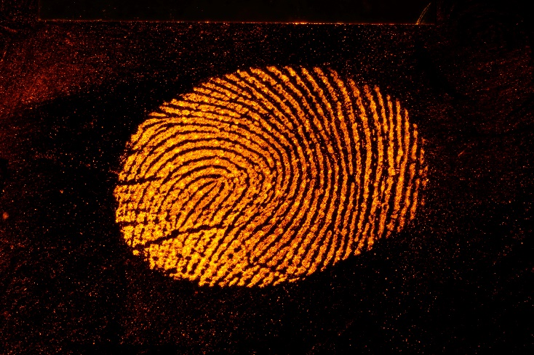
In some cases, natural latent fingermarks may contain luminescence properties and will illuminate under particular light sources and when viewed through the appropriate filter (Champod 2016). Luminescence is a non-destructive process, but has a low success rate within case work and so should be employed before any destructive methods are applied (Champod 2016). This type of examination should occur in darkened conditions as the illuminated fingermarks are faint (Champod 2016). Once the fingermark is detected a range of excitation wavelengths with corresponding filters should be applied to gain the optimal conditions for capturing the fingermark (Champod 2016).

Figure 8: Example of a fingermark dusted with pink fluorescent powder, illuminated by 505nm (blue) light. Taken with a Canon 90D DSLR with a 550nm (orange) barrier filter attached to the lens.

1.4.1.3 Diffused Reflection
Diffused reflection is an optical technique applied to latent fingermarks to increase its visibility. A light source that emits light rays in all directions is angled towards the surface containing the fingermark (Bleay, Croxton & De Puit 2018). The light will be diffusely reflected from the fingermark to the eye or capture device (Bleay, Croxton & De Puit 2018), making the fingermark visible via increasing the contrast between the mark and the background. This technique is particularly used for detecting latent fingermarks on surfaces that are smooth and shiny like plastic, glass, or polished metal (Champod 2016). In some cases where fingermarks are deposited in contaminants the incident light is absorbed causing the ridges to appear dark against a light background (Bleay, Croxton & De Puit 2018).
Oblique lighting and spectral lighting (Figure 9) are both techniques that can be applied to achieve diffused reflection. Oblique lighting involves the light source to be positioned parallel to the photographed surface with the camera positioned perpendicular to the surface (Bleay, Croxton & De Puit 2018). In this set up light should not be reflected to the camera which causes the surface to appear dark (Bleay, Croxton & De Puit 2018). If there is a negative fingermark within contaminants such as dust on the surface (Bleay, Croxton & De Puit 2018), the dust will greatly scatter the light resulting in some light being reflected to the camera, which causes the mark where the dust has been removed to appear dark (Bleay, Croxton & De Puit 2018). The same effect can occur but in reverse if the mark is above the surface, such as fingermarks developed by chemical enhancements (Bleay, Croxton & De Puit 2018). In this situation, the light is reflected from the mark causing it to appear lighter than the surface (Bleay, Croxton & De Puit 2018). Specular lighting is particularly used for latent fingermarks, or marks containing contaminants on surfaces that are smooth and reflective (Bleay, Croxton & De Puit 2018). The light source is positioned at a high angle close to the distance of the camera which is placed perpendicular to the mark (Bleay, Croxton & De Puit 2018). The light that hits the surface will reflect in an angle that misses the camera, but if the surface contains a fingermark the reflected light from the mark will reflect to the camera, causing the mark to appear lighter than the background surface (Bleay, Croxton & De Puit 2018).
Incident light
Scattered light
Camera
Incident Light
Specular reflections
Camera
Diffuse reflection from fingermarks

Figure 9: Diagram demonstrating diffuse reflection through the use of oblique lighting (right) and specular lighting (left) (Bleay, Croxton & De Puit 2018)

1.4.1.4 Ultraviolet (UV) Imaging
The UV reflection process operates in a similar capacity as reflected light used in visual examination, the main difference between them being the wavelength used which is UV radiation (Bleay, Croxton & De Puit 2018). In fingermark detection, short wave ultraviolet (UVC) radiation is used with a wavelength of 254nm (Bleay, Croxton & De Puit 2018). There are two ways in which UV is used to enhance fingermarks, the first being absorption, and the other is reflection (Bleay, Croxton & De Puit 2018). UV absorption is used on glossy paper, here the fingermark residue strongly absorbs the UV radiation due to the fatty acids contained in the marks (Bleay, Croxton & De Puit 2018). This creates contrast between the fingermark and the background as the surface reflects the UV radiation with the fingermark absorbing it (Bleay, Croxton & De Puit 2018). UV reflection is used on smooth, non-porous surfaces, in this case the fingermark ridges reflect the light at a greater capacity than the background or the background absorbs the UV more than the fingermark, as seen in glass substrates (Bleay, Croxton & De Puit 2018). Fingermarks reflect UV radiation more pronouncedly than visible light as UV wavelengths are of similar height to fingermark ridges (Figure 10) (Bleay, Croxton & De Puit 2018).

Scattered UV radiation
Fingermark
UV radiation
Surface

Figure 10: DIagram of uv illumination of a fingermark (Bleay, Croxton & De Puit 2018)
The naked eye cannot see UV radiation, so specialised imaging equipment is required to visualise the enhanced fingermarks (Bleay, Croxton & De Puit 2018). There are two detection systems to view UV reflection, the first being a system that is sensitive directly to UV radiation such as a back-thinned sensor, or a system that converts UV radiation into a visible output such as an image intensifier (Bleay, Croxton & De Puit 2018). Quartz or calcium fluoride optics are required as they can transmit UVC radiation. There are a number of factors that affect the effectiveness of UV imaging (Bleay, Croxton & De Puit 2018). The wavelength of radiation, shorter wavelengths are more successful. The angle of the light source to the surface, oblique to 45 degrees angles provide the best lighting for reflection on non-porous smooth surfaces (Bleay, Croxton & De Puit 2018). Uniform lighting is the preferred method when aiming to achieve UV absorption on a non-porous smooth surface (Bleay, Croxton & De Puit 2018). The surface type influences a mark’s enhancement, surfaces such as glass absorb UV causing it to appear dark thus creating greater contrast between the background and the light reflected from the mark (Bleay, Croxton & De Puit 2018). UV reflection can reduce interfering patterns from multi coloured backgrounds as these colours may appear similar under UV light (Bleay, Croxton & De Puit 2018). Filter types influence the effectiveness of this technique, short-wave UV bandpass filters are required to be used with detection systems to eliminate background fluorescence and additional unwanted reflected radiation (Bleay, Croxton & De Puit 2018).

1.4.1.5 Infrared (IR) Imaging
IR imaging follows a similar process for fingermark enhancement as UV and visible light, particularly absorption/reflection (Bleay, Croxton & De Puit 2018). Fluorescence can occur, but is not commonly used in fingermark enhancement (Bleay, Croxton & De Puit 2018). This technique is applied in situations where a fingermark is visible but is obscured by patterned, coloured backgrounds, or darkened surfaces caused by heating (Laboratory 2022). This method increases the contrast between the mark and the background to be visualised more clearly (Laboratory 2022). It does this by using the differences between the surfaces and the mark’s infrared reflectively (Laboratory 2022). To achieve this, the mark and surface need to be illuminated by an infrared light source and viewed/captured using an infrared sensitive imaging system with an appropriate filter that eliminates visible light and transmits infrared (Laboratory 2022). The effectiveness of this method is affected by the infrared reflectivity of the surface, if a surface strongly and uniformly absorbs infrared radiation this technique is less effective (Laboratory 2022). The mark’s ability to absorb or scatter infrared light also effects the success of the process (Laboratory 2022). IR imaging works best with marks that are enhanced or developed using inorganic or metallic techniques such as metallic powders (Bleay, Croxton & De Puit 2018). Figure 11 is a diagram that demonstrates how a coloured surface reacts when illuminated by IR.

Surface is composed of multiple colours
Incident white light
The different coloured pigments reflect or absorb different visible wavelengths
Incident IR radiation
Colours of surface appear uniform
The IR wavelengths are transmitted through the different coloured pigments

Figure 11: Diagram of IR illumination on a coloured substrate (Bleay, Croxton & De Puit 2018)

1.4.2 Fingerprint Powders
Fingerprint powders are a detection technique that has been used since the 1900s (Champod 2016). This process involves physically applying fingerprint powder to smooth non-porous surfaces via the use of a soft fingerprint brush (Champod 2016). The fingermark is enhanced by the powder particles sticking to the greasy and moist substances contained within a fingermark (Champod 2016). Fingerprint powdering is common technique applied during crime scene investigations, as it is inexpensive and simple (Champod 2016). The powdered marks can be photographically captured (Hawthorne, Plotkin & Douglas 2021) and/or lifted using tape, gel lifers, or silicone casting materials (Champod 2016) for further analysis. Fingerprint powders are most successful with recently deposited marks as the powder sticks to the moist substances within a mark (Hawthorne, Plotkin & Douglas 2021). This technique is preferable used in situations where the mark is located on fixed surfaces or objects that cannot be easily collected for laboratory analysis (Hawthorne, Plotkin & Douglas 2021).
There are many different types of powders and brushes available, the use of each type is dependent upon the situation and personal preference of the user. There are three main types of powders used: conventional fingerprint powder, fluorescent powder, and magnetic powders (Champod 2016). A powder that is commonly used is a metallic aluminium powder which is one of the most effective types of powder for fingermark detection (Champod 2016). Fluorescent powders are usually applied on multicoloured or highly reflective surfaces where conventional powders cannot provide sufficient contrast (Champod 2016). The fluorescence of these powders can occur through fluorescent illumination (section 1.4.1.2 Fluorescence and Luminescence) or UV illumination (section 1.4.1.4 Ultraviolet (UV) Imaging) (Champod 2016). Magnetic powders are composed of a mixture of coarse iron grit with aluminium or copper flake powder, and require a magnetic application wand for use (Champod 2016). The magnetic material within the powder forms the brush on the wand and the fine powder enhances the fingermark (Champod 2016). Magnetic powder is advantageous as it eliminates the motion of physical brushing and may avoid damage to the mark, but is difficult to apply on surfaces that are vertical (Champod 2016). The different type of brushes used for fingerprint powdering can be identified by the various fibres that make up the brushes such as synthetic, natural, and glass (Champod 2016). Figure 12 is an example of a fingermark dusted using conventional black fingerprint powder.
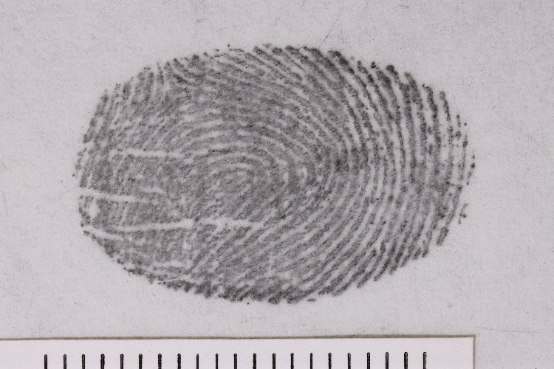

Figure 12: Example of a fingermark dusted with black fingerprint powder captured via a Canon 90D.

1.5 Requirements to Photographically Capture Fingermarks.
To photographically capture a fingermark, it must be visible. In some situations, a camera is capable of capturing a latent print without the need of enhancement, as seen in section 1.4.1.3 Diffused Reflection. To ensure the integrity of the mark remains, the non-destructive methods mentioned in the previous sections should first be applied when the mark requires enhancement. A process from least destructive to most destructive must be followed to optimise the chances of recovering that mark (Laboratory 2022). Figure 13 depicts the order in which these enhancement processes should be applied to fingermarks to ensure the successful recovery of the mark. This section will focus on the photographic capture of fingermarks and what is required to correctly photograph fingermark evidence.

Figure 13: Flowchart of the order enhancement techniques should be applied to fingermarks for recovery. (Laboratory 2022)

1.5.1 Guidelines for general photographic capture of evidence items
To photograph evidence items, a procedure needs to be followed to ensure the images captured are an accurate representation of the evidence being recorded. A range of factors including camera position, linear scales, labels and descriptions, framing, focus, exposure, and number of photos (SWGDE 2019), need to be considered when photographically capturing an item.
When an item is photographed the number of images captured for the item are to be considered. Most of the time an item can be captured using a minimal number of images to correctly capture the evidence (SWGDE 2019). In other cases, numerous photos are required to appropriately capture all the required detail of an item (SWGDE 2019). This can include a combination of different types of ranged photographs, including long-ranged, mid-rage, and close-up photos (SWGDE 2019).
Camera position is a critical factor in accurately capturing an item, as angled shots can cause distortion or inaccurate capture of the evidence. The camera should be positioned perpendicular to the item that is being captured, or perpendicular to the desired part of the item that is being captured (SWGDE 2019). When available, the use of a copy stands or tripods aid in achieving this perpendicular angle (SWGDE 2019).
Linear scales are used to document the size of the photographed item (SWGDE 2019). The scale used must be the appropriate size to the captured evidence, and on the same plane of the evidence. This allows the accurate size of the evidence to be recorded and not appear larger or smaller than its actual physical size (SWGDE 2019). Additional scales may be placed on an item if there are additional features such as fingermarks or blood stains on the item to demonstrate the size of these features (SWGDE 2019). When a scale is used the item must be photographed without the scale first, with the scale later being placed as close to or onto the evidence without hiding any relevant details on the evidence (SWGDE 2019). Caution is needed to ensure that placing the scale does not interfere or alter any other potential evidence within the item such as fingermarks or DNA (SWGDE 2019).
When an item is photographed a descriptor label needs to be placed within the frame to aid in identifying the item within the image (SWGDE 2019). The label should include the item name, case number, item number, date, photographer’s initials, and any other relevant information (SWGDE 2019). A label can be in the form of a place card (SWGDE 2019), or a sticker for the linear scale. The same consideration is needed when placing a label as it would placing a linear scale, as it should not alter potential evidence such as fingermarks or DNA on the item (SWGDE 2019). Another method to identify photographs captured is a photo log, which also records the information that would be contained in a label (SWGDE 2019).
To fully capture the detail of an item, the item photographed should fill the area that is usable within the viewfinder or image. This is termed as ‘filling the frame’ (SWGDE 2019). This technique allows the sensor of the camera to capture the maximum amount of detail possible from the item (SWGDE 2019). Where possible the item should be placed on a background of neutral colours that contrast the item being captured. The item, label, and enough of the scale to dictate the type of units being used, need to be included when filling the frame (SWGDE 2019).
An image in focus is a key factor in accurately capturing the item, this ensures all the required detail of the evidence is recorded (SWGDE 2019). A camera can either focus manually or automatically. Manual focus allows for best results and ensures the whole image is in focus (SWGDE 2019). The item should be in focus before an image is captured, which can be checked via the camera’s viewfinder or live projection on a screen (SWGDE 2019).
Correct exposure is essential to ensure all details of the item is captured. Correct exposure can be achieved in multiple ways which include adjusting the camera’s settings, the use of a flash unit, or using external light sources such as a torch (SWGDE 2019).

Figure 14: Flowchart demonstrating the general photographic documentation process (SWGDE 2019)

1.5.2 Guidelines for photographic fingermark evidence capture
Along with the procedures listed above for the photographic capture of evidence items, additional requirements and considerations should be made when photographing fingermark evidence within a scene, along with pieces of equipment that should be included in a crime scene camera kit that will aid in accurately photographing a fingermark.
The basic recommended equipment for a crime scene digital camera kit includes a professional DSLR camera with changeable lenses capabilities, manual control of exposure and focus, and a minimum of eight-megapixel native resolution (SWGDE 2018). A professional quality macro lens with a fixed focal length and minimal distortion (SWGDE 2018). A detachable flash unit, with appropriate length extension cord or a remote flash unit (SWGDE 2018). Shutter releases that can be operated remotely along with a tripod that can achieve multiple positions and angles (SWGDE 2018). Multiple light sources, such as torches, ALS and required filters (SWGDE guidelines). A media to store images digitally and flat linear scales (SWGDE 2018).
The photographic capture of fingermarks requires particular camera settings, along with the camera being set-up correctly to ensure the mark is captured accurately. The first step is to adjust the camera settings to ensure that the time and date, image size, and image format are correct (SWGDE 2018). RAW or TIFF file types are recommended as they offer no compression or lossless compression (SWGDE 2018). The second step is to record the overall area containing the fingermark with appropriate lighting without linear scales (SWGDE 2018). The third step is to record the same area again but with the inclusion of linear scales (SWGDE 2018). The fourth step is to attach the camera to a tripod, when possible and angle the camera 90 degrees perpendicular to the fingermark (SWGDE 2018). The fifth step is to appropriately place a linear scale next to the mark which may contain the appropriate labelling details and correctly illuminate the mark (SWGDE 2018). Select the most appropriate camera settings based on the mark that needs to be recorded, then capture the impression (SWGDE 2018). Repeat these steps for all impressions within the scene (SWGDE 2018). If a fingermark is enhanced or processed further, it must be re-photographed when appropriate for all impressions that were developed (SWGDE 2018). All images captured need to be downloaded on an approved storage device as soon as possible, and separate storage medias should be used from scene to scene (SWGDE 2018).

1.5.3 Current methods to photographically capture fingermarks that are in hard-to-reach places.
Fingermarks are in a variety of locations throughout a scene or within evidence items. Prints can be found on a range of surfaces which can make capturing the print increasingly difficult. When fingermarks are located, they should be photographically captured straight away to preserve the print for analysis. The procedures described in the previous sections detail how to capture a quality image of a fingermark, but in cases where these procedures cannot be achieved due to fingermark being in awkward situation, such as a door handle or switch (Houck & Siegel 2015), alternative methods need to be employed. The current process is removing the print via a tape lift, which is then collected and/or photographed to be processed later in a laboratory (Houck & Siegel 2015). Tape lifting a fingermark involves placing adhesive tape over the print then removing the tape to be placed on a backing card (Miller & Massey 2018). Lifting presents many issues mainly that this process can cause permanent damage to the fingermark. Figure 15 demonstrates the damage that can occur when a lift is performed. In some cases, a mirror is used to gain a reflection of the difficult to reach fingermark, and a photograph of the reflection is captured. This method introduces the issue of distortion from the mirror and can be difficult and time consuming to set up and gain a successful image.
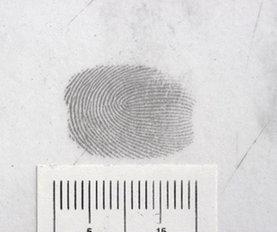
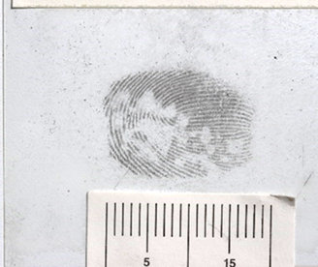

Figure 15: Example of a tape lift performed on an ideal fingermark conducted in laboratory conditions. Image of fingermark (Left) and Image of lifted fingermark (right)

1.6 Past research that has been conducted using alternate cameras within forensic science.
The previous sections have listed how to properly capture these marks within an investigation in both situations where the proper procedure can be performed. But also, when the standard photography procedures cannot be used to accurately capture a quality image of the mark, distortion occurs due to the camera angle or lack of accessibility to the mark (Houck & Siegel 2015). There is a significant gap in the literature to address capturing difficult to reach fingermarks without resulting to techniques that can potentially damage the print, cause inaccurate image capture, or are time consuming. A potential solution is using alternate camera devices such as iphones, fibre optics, or intra-oral cameras to capture these types of fingermarks. These alternative camera devices may have the potential to fit into the awkward spaces or difficult areas that a standard camera cannot, allowing them to gain a more accurate image of the fingermark. Through the use of these cameras, it may be possible to non-destructively gain a photograph opposed to the current practices that involve lifting prints in these situations. This section will showcase previous research that has been conducted that involves using alternative cameras in the forensic field and in particular fingermark capture.

1.6.1 Fingermark research with alternative cameras
There have been a few studies that investigated the use of alternative cameras, particularly iphones, for fingermark use in forensic science. A studied conducted by Pitts et al. (2021) investigated the empirical comparison between DSLR and iphone cameras for the capture of latent fingerprints. This study involved both the iphones and DSLRs used to capture a range of fingerprints. From these images a numerical number was generated to represent the quality of the fingerprints images captured using a Biomentric SDK software (Pitts et al. 2021). The results generated from the quantitative image quality, Pitts et al. (2021) concluded that there was not a statistical difference between the two sets of images produced by the DLRS and the iphone. This research highlights the potential for alternate camera use within fingermark forensics.
A studied conducted by Gupta, Sukhad and Rai (2017) investigated the potential of the use of iphones to remotely authenticate fingerprints, instead of the use of conventional optical sensors. Their method involved using a iphone to capture finger-images, that were pre-processed which allowed the images to be compared and matched to images from optical sensors (Gupta, Sukhad & Rai 2017). The proposed method was validated and demonstrated an efficient approach suggesting it could be used commercially (Gupta, Sukhad & Rai 2017).
Studies conducted by Suresh, Thiyagarajan and Ramamurthy (2018) and Kathiravan et al. (2020) looked at different chemical enhancement techniques for latent fingermarks. These studies used iphones to capture the fluorescence fingermarks. Suresh, Thiyagarajan and Ramamurthy (2018) results showed that the iphone was able to capture level one and two fingerprint detail that could be used for fingerprint analysis. Kathiravan et al. (2020) the iphone was used to detect and capture the enhanced fingermarks in real-time. The images showed the quality needed for fingerprint analysis (Kathiravan et al. 2020). It should be noted that that these studies were investigating chemical enhancement techniques of fingermarks, and the iphones were simply a tool used for capture and image comparison.
The research conducted above are a few examples of where alterative devices have been applied to fingermark capture and identification within forensics. The research demonstrates the potential use of alterative cameras in future forensic work particularly fingerprint work.

1.6.2 Other forensic areas where alternative cameras have been researched
Research has been conducted in other areas of forensic science for the possibility to use alternative cameras in a wide range of areas. A study conducted by Baechler et al. (2017) explored creating a criteria for applications that could be used on smart devices to aid in crime scene investigations. Baechler et al. (2017) surveyed a number of crime scene investigators from both Canada and Switzerland to help in determining a typology for these applications along with creating an evaluation criteria for their relevance, reliability, and operational requirements. Baechler et al. (2017) found that the interest in using iphone applications for crime scene purposes is limited at this current moment. There is a significant gap in this area of using crime scene applications but rather applications that allow access to external databases through the smart devices instead (Baechler et al. 2017).
A study conducted by Thanakiatkrai, Yaodam and Kitpipit (2013) looked into the possibility of using iphones to estimate the age of a bloodstain within a crime scene. Thanakiatkrai, Yaodam and Kitpipit (2013) was the first study to use iphones in combination with a low-cost illumination system to estimate the age of bloodstains. A range of environmental factors that may affect the age estimation such as temperature, light exposure, humidity, and anticoagulant were all explored (Thanakiatkrai, Yaodam & Kitpipit 2013). The technique proposed by Thanakiatkrai, Yaodam and Kitpipit (2013) appeared to easily applicable to crime scene situations as the setup was inexpensive, portable, accurate, and efficient from the initial testing. Thanakiatkrai, Yaodam and Kitpipit (2013) concluded that this technique works under laboratory conditions and simulated situations, but further investigation is needed to determine its suitability in real world crime scenes. The research presented here is a few examples of where alterative devices have been applied to a boarder range of forensic areas, which demonstrates the possibility of alterative cameras being relevant and useful in future forensic work.

1.7 Project Aims and Objectives

1.7.1 Aim
The aim of this project is to develop an overarching methodology that can be applied to evaluate the suitability of alternative camera devices for fingermark capture in difficult-to-reach places.

1.7.2 Objectives
The following objectives will be undertaken to achieve the aim.
- To create criteria to evaluate a camera’s image quality.
- To relate image quality to ability to capture fingermark detail.
- To create criteria to determine a camera’s practicability.
- To evaluate alternative cameras within pseudo-operational environments

Chapter 2: Materials and Methods

2.1 Camera devices used throughout experimentation.
Table 1 describes the standard camera and the representative sample of alternative cameras that will be used throughout this project. As the aim is to determine the best method to evaluate alternative cameras for fingermark capture, a range of alternate cameras were chosen to test how different types perform during experimentation. The Canon 90D is used as the representative sample of a standard DSLR which is used within forensic operational work (Robinson & Richards 2012). The standard camera is used to gain ground truths to allow for images to be produced that the alternative cameras are compared against.

Table 1: List of Cameras used throughout the project
Camera Device | Photo | Referred Name | Description
Canon 90D DSLR with Canon macro lens EF-S 60mm 1:2:8 USM and flash unit with sync cord | 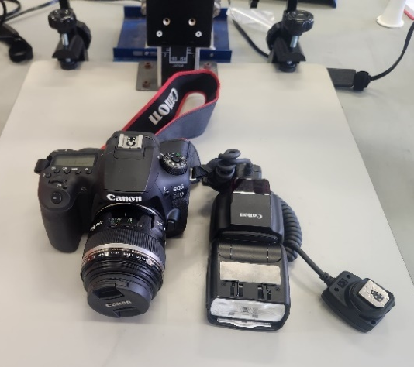 | DSLR | The Canon 90D DSLR represents the standard camera used in forensic work (Robinson & Richards 2012)
ZCFP10 Wifi Dental Camera HD Intraoral Endoscope | 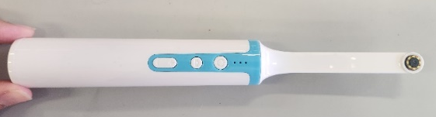 | Dental camera | The dental camera is a toothbrush like device, with buttons on the underside to control flash, zoom, and image capture. The flash button during experimentation did not consistently work to turn off the flash, therefore the default setting of when the camera was turned on was tested to ensure consistent results which was the flash on.  A separate viewing screen is required, this is achieved via a iphone using the DT-Wi-Fi camera app.
iPhone 11 Pro ™ (Apple Inc.) | 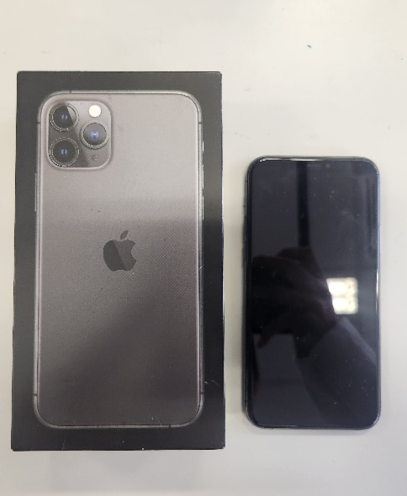 | iphone | The iphone is a mobile device with multiple image capture abilities.
Teslong NTS500™ Pro Inspection Camera | 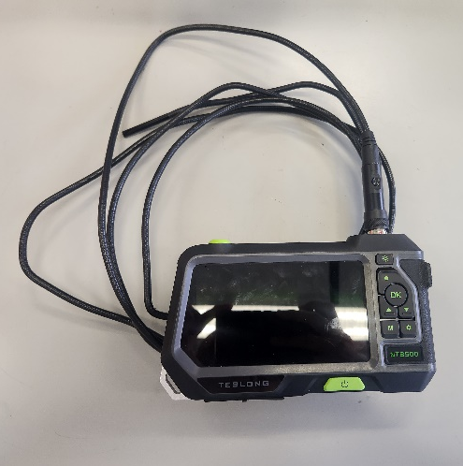 | Teslong  Primary Camera = Teslong Straight  Secondary Camera = Teslong Side | The Teslong is a fibre optic camera attached to a flexible coil that is linked to viewing screen. The camera itself has a primary straight camera and secondary side view camera.
Model SA39A Wireless Otoscope Ear Cleaning Camera | 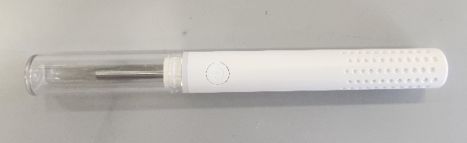 | Otoscope | The otoscope is a small toothbrush size device with a lens on the tip. A separate viewing screen is required, which is achieved via a iphone using the Smart Endoscope app.

Table 2 lists the focal ranges of each alternate camera, throughout the experiments these ranges were used to setup each camera into optical focal distances.
Table 2: Focal Distance for Alterative Cameras
Type of Camera | Focal Distance (mm)
Otoscope | 9 - 22
Dental Camera | 17 - 28
Teslong Side | 20 – 30
Teslong Straight | 27 - 100
Iphone | 80 ≥

During experimentation there was a lighting condition which involved using a torch in ambient lighting. The torch used during experimentation was a Ledlenser P7R (Figure 16)
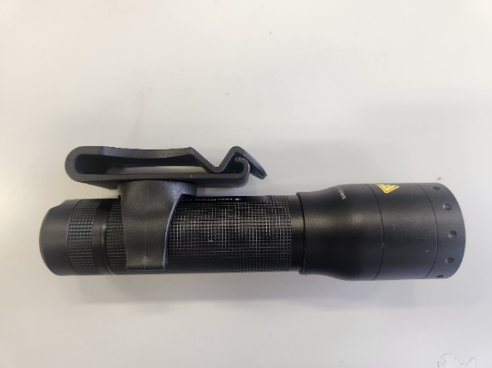

Figure 16: Torch used during experimentation

2.2 Part 1 of Method Development: Image Quality
The image quality of a camera is a key component in evaluating its capabilities and its limitations. This section aimed to determine a series of key experiments to be conducted to determine the image parameters of an alternative camera system. The following aspects were used to determine a camera’s parameters:
- Resolution
- Contrast
- Distortion
- Colour accuracy.
- Capability to capture white fingerprint powder.
- Capability to capture black fingerprint powders.
- Capability to capture coloured fingerprint powders.
- Capability to capture fluorescent fingerprint powders.
- Capability to capture latent fingermarks via diffused reflection.
- Depth of field
- Pixel per inch

2.2.1 Resolution and Contrast
The variable contrast USAF target was used during this experiment (Figure 17). Each camera device captured each section of the target from 1 to 15, from the strongest contrast level to the weakest. This was to determine how a camera’s resolution differed from strong to weak contrast subjects. The lighting environments tested were: ambient with the lights turned on in the laboratory, low with the lights turned off in the laboratory but windows open, and torch where torchlight was used alongside ambient lighting. The different lightings condition was to replicate a range of lighting conditions that are experienced in an operational setting and to aid in determining whether a camera’s resolution differed due to lighting.
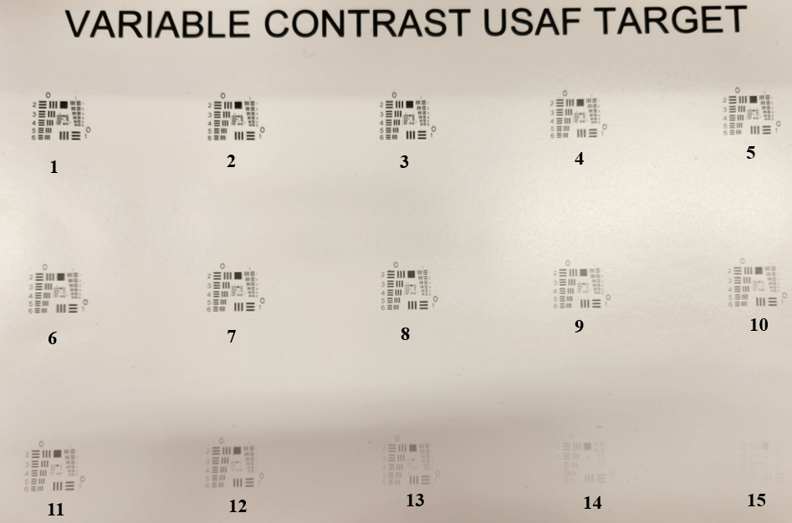
Figure 17: Variable Contrast USAF Target labelled 1 to 15 from highest contrast target to lowest contrast target.

Figure 18 demonstrates the setup of the DSLR to capture the USAF target. The target was moved to ensure each individual target from 1 to 15 was centred in the frame and focused to ensure the target filled the frame. This process was repeated for each lighting condition. In addition, during the ambient lighting with torch, the torch was handheld at a 45-degree angle at varying distances from the target to gain the best illumination for capture. Figures 19 to 22 demonstrate how the alternate cameras were setup to capture the USAF target, but the same capture process used for the DSLR was applied to each alternate camera.

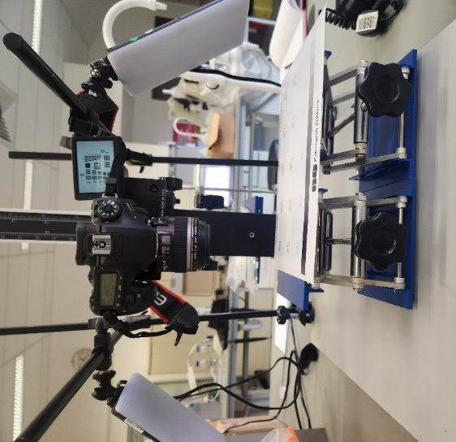

Figure 18: Setup of the DSLR camera for the photographic capture of the variable contrast USAF target.
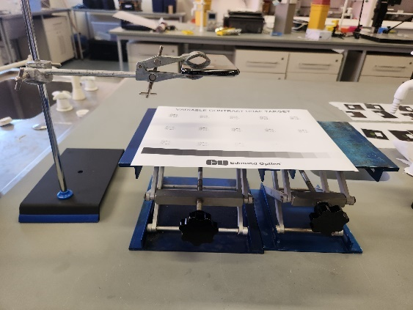

Figure 19: Setup of the Iphone for the photographic capture of the variable contrast USAF target.
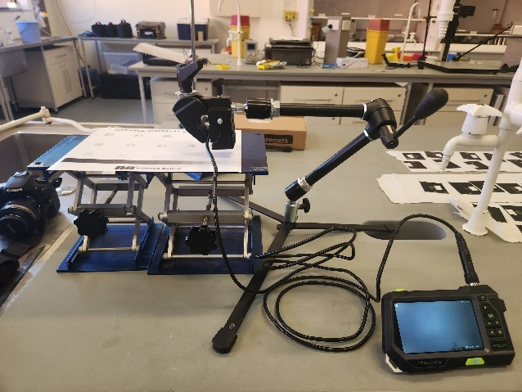
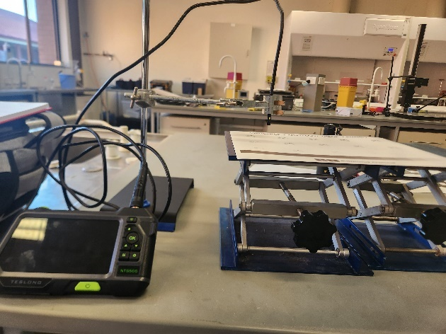

Figure 20: Setup of the Teslong Straight (left) and Side (Right) cameras for the photographic capture of the variable contrast USAF target.
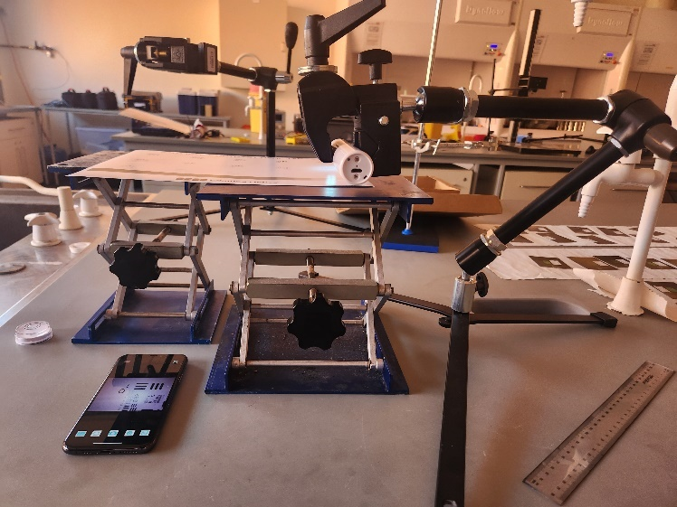

Figure 21: Setup of the Dental camera for the photographic capture of the variable contrast USAF target.
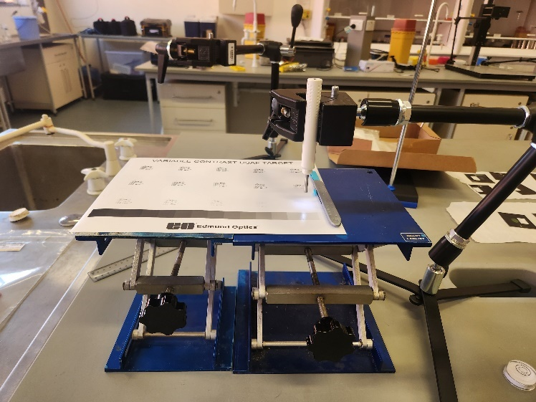

Figure 22: Setup of the Otoscope for the photographic capture of the variable contrast USAF target.
Once all the images were captured, the images were then visually analysed to determine the resolution of each camera. The USAF target consists of 15 individual targets varying in contrast as seen in Figure 17, and from the images captured of each target a visual limit was determined by the examiner. Figure 23 is a labelled USAF target to demonstrate how this test target is read and used. The limit was selected based on the last group and element where the examiner could clearly distinguish separate black and white lines. A visual analysis was conducted on Figure 23. The first step was to determine what group and element is the visual limit of this image, which is indicated in Figure 23. It is group 4 and element 3, these values correspond to the amount of line pairs per millimetre (lp/mm) for that level, which is the resolution of that camera. This analysis was performed for each image captured by the different cameras for all the varying contrast targets. The maximum amount of lp/mm was determined through this analysis and determined using equation 1. The element and group numbers were placed in the correct places within the equation and produced the maximum amount of lp/mm that the camera could capture. The visual limits and calculated line pairs for each camera are displayed in Table 4, Table 5, Table 6,Table 7, Table 8, and Table 9.

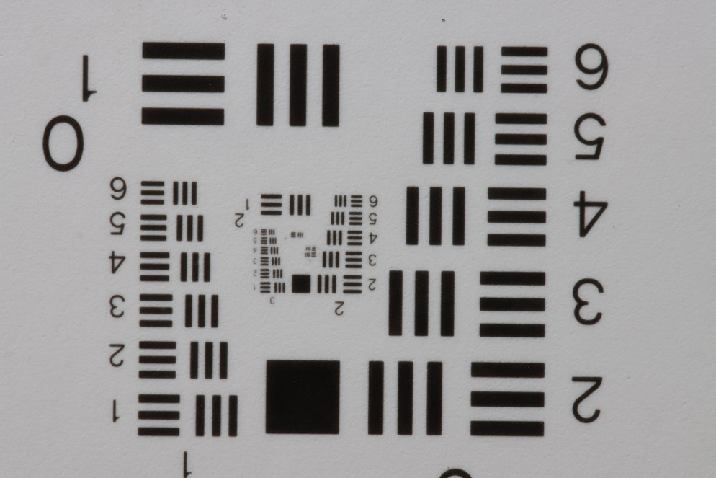
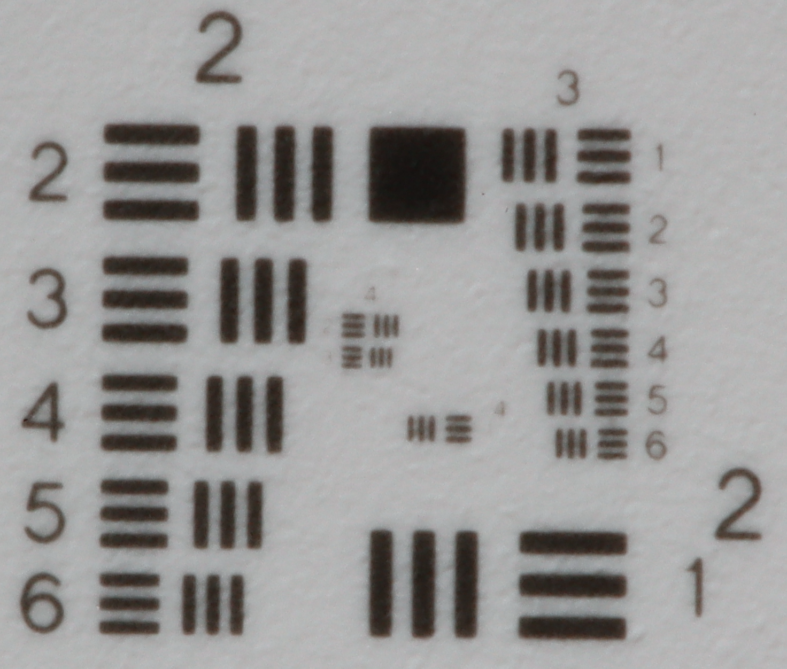
Element Numbers
Group Number
Visual Limit

Figure 23: Labelled version of the 5th target in the variable contrast USAF target. The middle section has been enlarged to display the visual limit. This image was captured via the DSLR in the ambient with torch lighting.

$$2^{(Group Number+ \frac{(Element Number-1)}{6})}$$
Group Number is 4
Element number is 3
$$2^{(4+ \frac{(3-1)}{6})}$$
Which equals 20.16 lp/mm for target used in Figure 23.
Equation 1: Resolution Equation based on the USAF Target, including an Example of how to calculate lp/mm after the visual limit is determined (Worldwide 2023).

2.2.2 Distortion
The dot grid distortion target (Figure 24) was used as the test target for this experiment. Each camera captured the distortion target to determine if there are any significant changes such as barrel or pincushion optical distortion, from the dot target captured. The distortion of the image was measured to assess how much a camera distorts an image, and determine how the distortion will affect fingermark capture. The target was captured by each camera in ambient lighting within a laboratory environment.
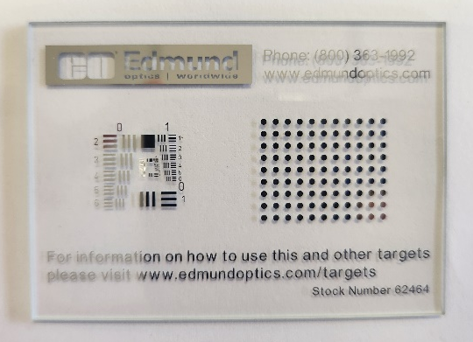

Figure 24: Dot Grid Distortion test target (Right)

Figure 25 demonstrates the setup for the DSLR to capture the distortion test target. The target was centred and filled the frame of the image captured. This process was repeated with all the alternative cameras, figures 26 to 29 all demonstrate the setup of each camera for capturing the distortion target.

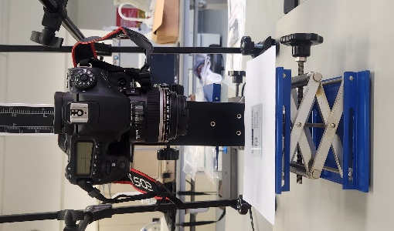

Figure 25: Setup of the DSLR camera for the photographic capture of the Distortion Target.

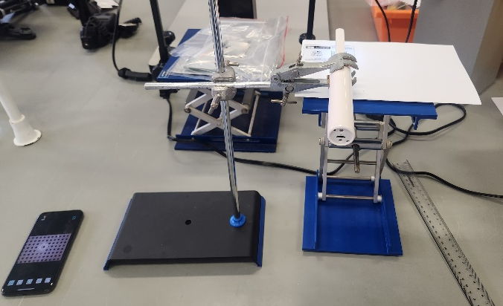

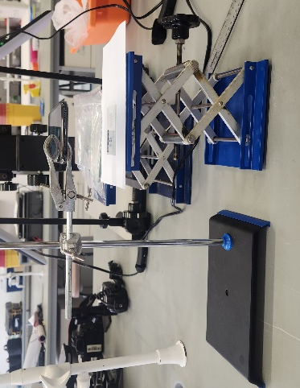
Figure 26: Setup of the Dental camera for the photographic capture of the Distortion Target.

Figure 27: Setup of the Iphone for the photographic capture of the Distortion Target.
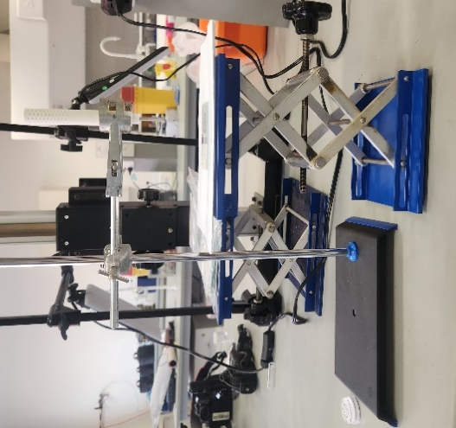

Figure 28: Setup of the Otoscope for the photographic capture of the Distortion Target.

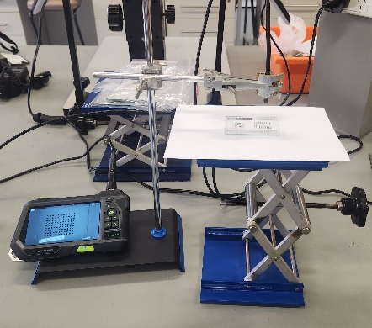
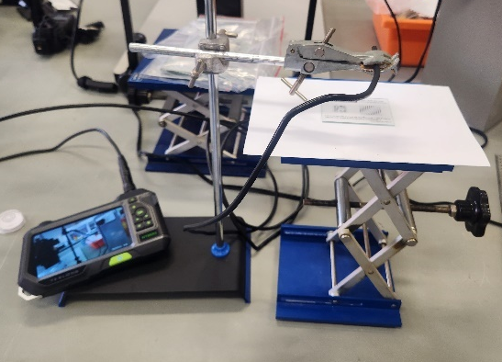
Figure 29: Setup of the Teslong Straight (Right) and Side (Left) cameras for the photographic capture of the Distortion Target.
Distortion was calculated using Equation 2 to determine the amount of distortion between the alternate camera’s images of the distortion target and the ground truth’s (DSLR) image of the distortion target. In the equation D is equal to the percentage of distortion either positive or negative. PD is equal to the predicted distance between the centre of the target to the centre of the dot in the furthest corner of the target, which was measured on the ground truth to produce the true distance value of the target (Hollows & James 2011). AD is equal to the actual distance between the centre of the target to the centre of dot in the furthest corner of the target, that was measured on the alternative camera’s images (Hollows & James 2011). To gain the values for Equation 2, the images were measured using photoshop. The distortion percentage was calculated for each alternate camera and recorded in Table 15 and listed whether it was barrel (negative) or pincushion (positive) distortion (Hollows & James 2011).
Equation 2: Distortion percentage (Hollows & James 2011)
$$D\left(\%\right)= \frac{AD-PD}{PD} ×100\%$$

2.2.3 Colour accuracy.
The Calibrite colorchecker classic (Figure 30) was used as the colour accuracy test target during experimentation. The colour accuracy test was used to determine how accurately each alternative camera records colour and aid in linking their ability to accurately record coloured fingerprint powders. There was a range of lighting conditions applied during this experiment, half were conducted using the laboratory lights as previously used in the distortion and contrast experiments. The laboratory lightings were: ambient, low, and ambient with torch. The other half of lighting conditions were conducted in a GTI minimatch MM4e lightbox (Figure 31), which is a controlled lighting environment that reproduces the lighting of a typical office, typical home, and average outside lighting. All three of these lightbox settings were applied to the target for the cameras to capture. The lighting conditions were tested to determine if lighting affected how the camera captured colour and which lighting conditions were necessary for the final method.
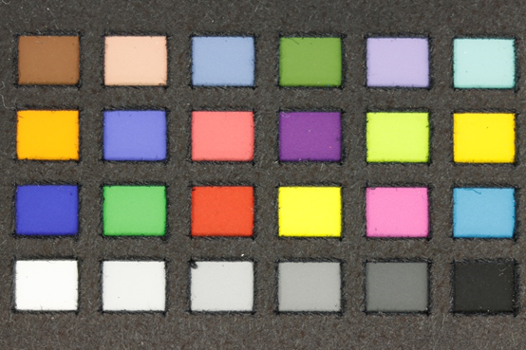

Figure 30: Calibrite colorchecker classic Colour Test Target
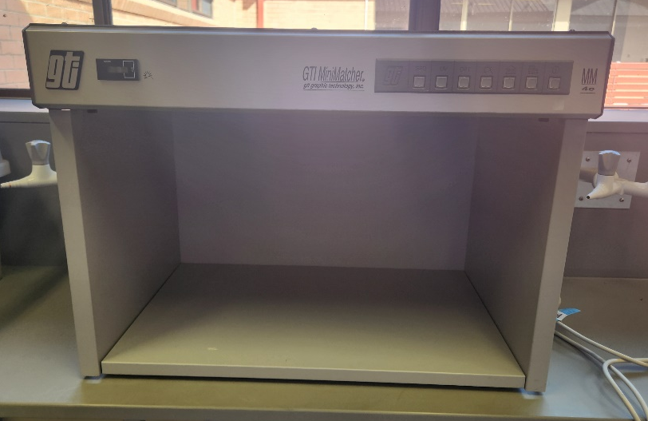

Figure 31: GTI minimatch MM4e lightbox
Figure 32 demonstrates the setup for the DSLR to capture the colour accuracy target, in both the laboratory environment and within the lightbox. The target was centred and filled the frame. In addition, during the ambient lighting with torch, the torch was handheld at a 45-degree angle at varying distances from the target to gain the best illumination for capture. This process was repeated with all the alternative cameras, figures 33 to 36 all demonstrate the setup of each camera for capturing the colour accuracy test target in the laboratory and in the lightbox.

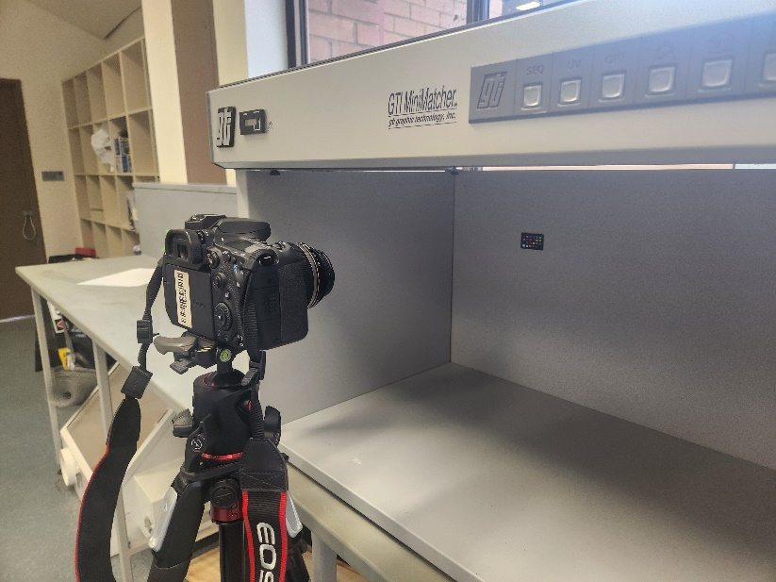
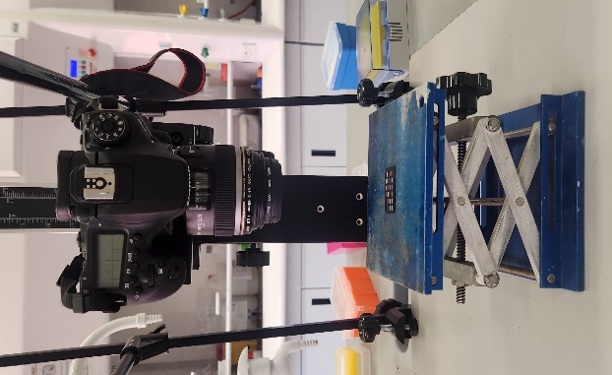
Figure 32: Setup of the DSLR camera for the photographic capture of the Colour Accuracy Target.

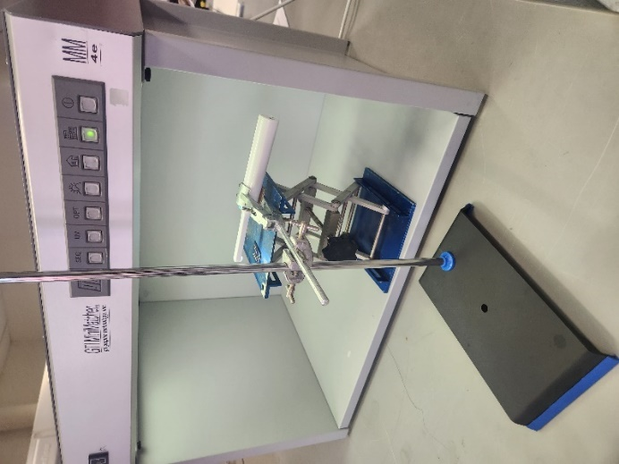
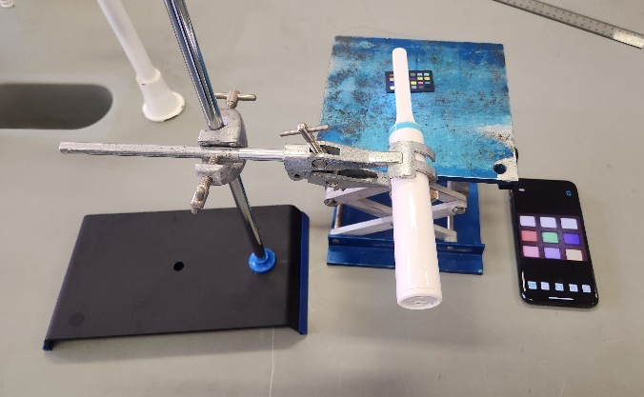

Figure 33: Setup of the Dental camera for the photographic capture of the Colour Accuracy Target.
Due to the dental camera’s short focal distance the target had to be captured in sections, to allow for the full target to be captured in focus.

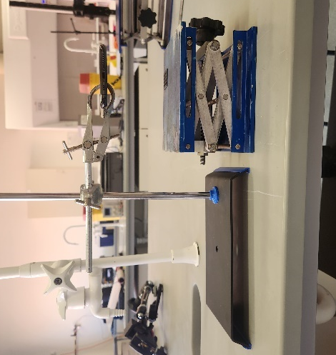
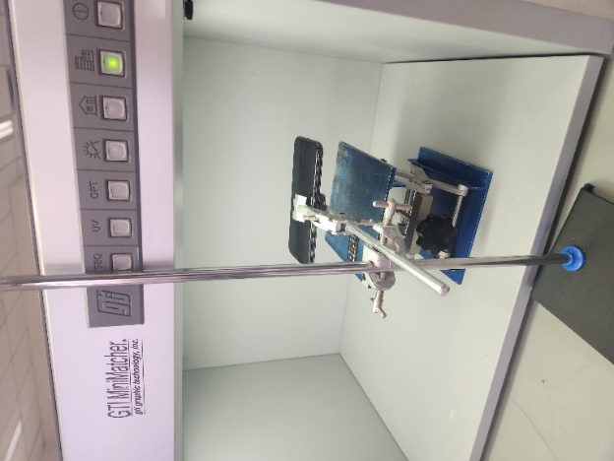

Figure 34: Setup of the Iphone for the photographic capture of the Colour Accuracy Target.
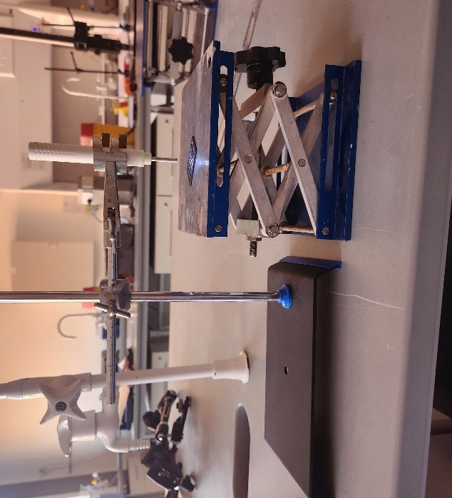
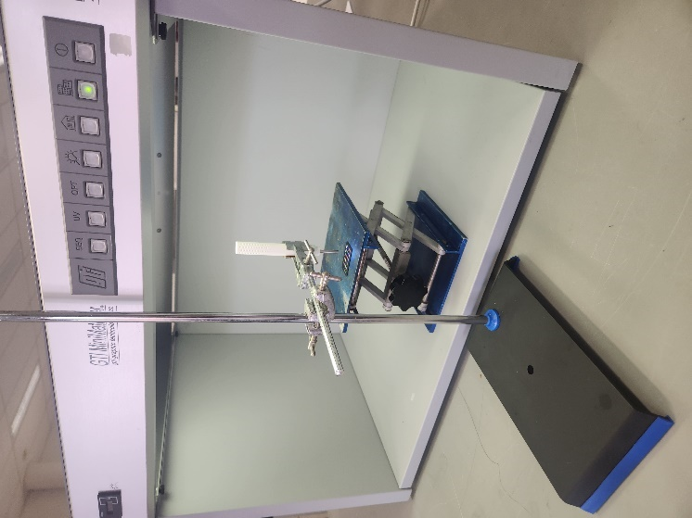

Figure 35: Setup of the Otoscope for the photographic capture of the Colour Accuracy Target.
Due to the otoscope’s short focal distance the target had to be captured in sections, to allow for the full target to be captured in focus.

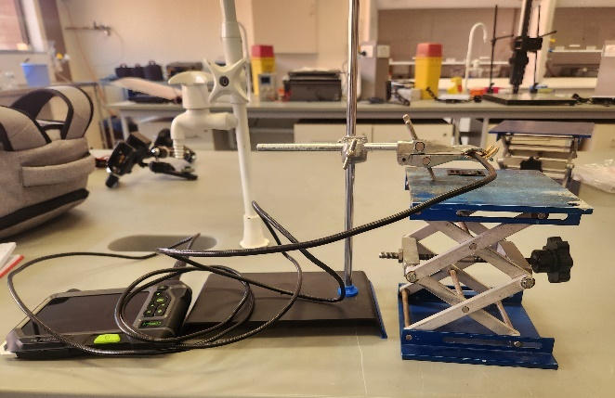
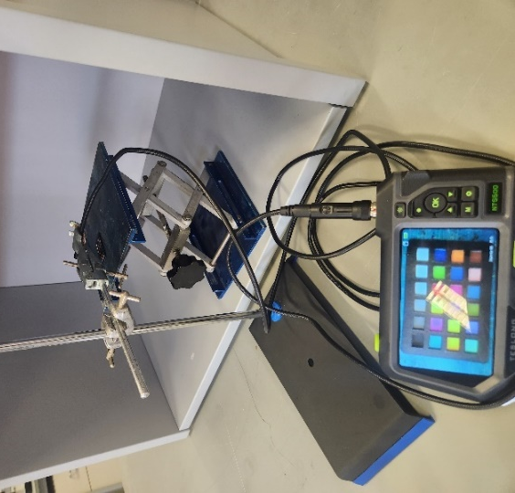

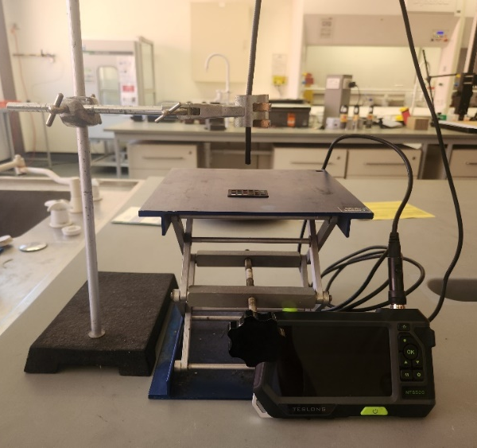
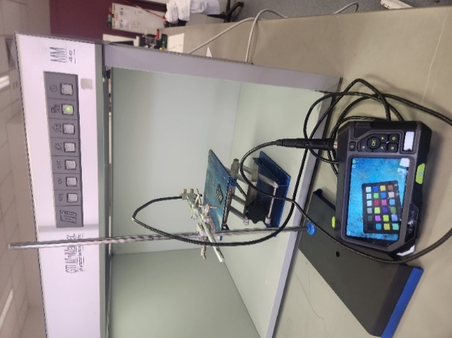

Figure 36: Setup of the Teslong Straight (Bottom) and Side (Top) cameras for the photographic capture of the Colour Accuracy Target.

Each alternative camera’s images were visually analysed to determine how much the colours varied from the ground truth images. A numbered scale was used to describe the amount of variation ranging from no visual colour difference between the alternate’s image and the ground truth. Level 1 is where the colour appeared the same but either in a lighter or darker shade than the ground truth. Level 2 was that colours are notably different, where some colours appeared like the ground truth whereas other colours appeared different. Level 3 was where majority of the colours appeared different to the ground truth. Table 3 visually demonstrates the difference levels of the verbal scale. Table 16 dictates the levels of colour difference for each alternative camera’s images to the ground truth. The computer used to analysis these images were calibrated via the Spyder5EliteTM, the calibrated specifications are as follows:
Desktop resolution = 3840 x 2160
Active signal resolution = 3840 x 2160
Refresh rate (Hz) = 59.997
Bit depth = 8-bit
Colour format = RGB
Colour space = SDR

Table 3: Visual Examples of level of difference from the Ground Truth
 | Example Image
Ground Truth or no difference | 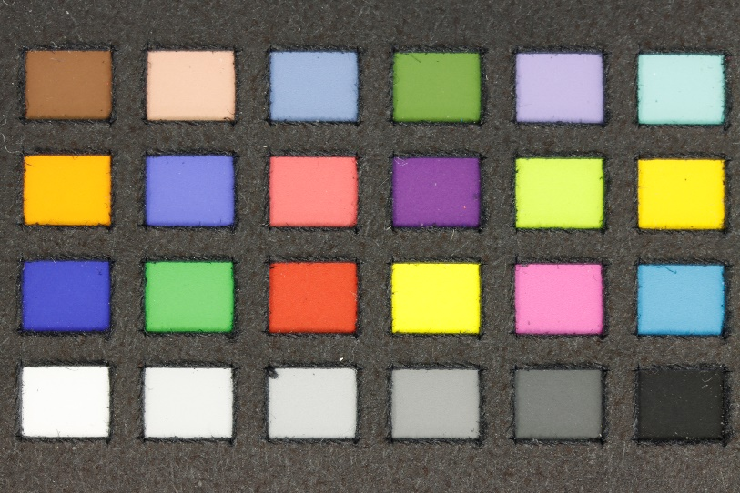
Level 1 | 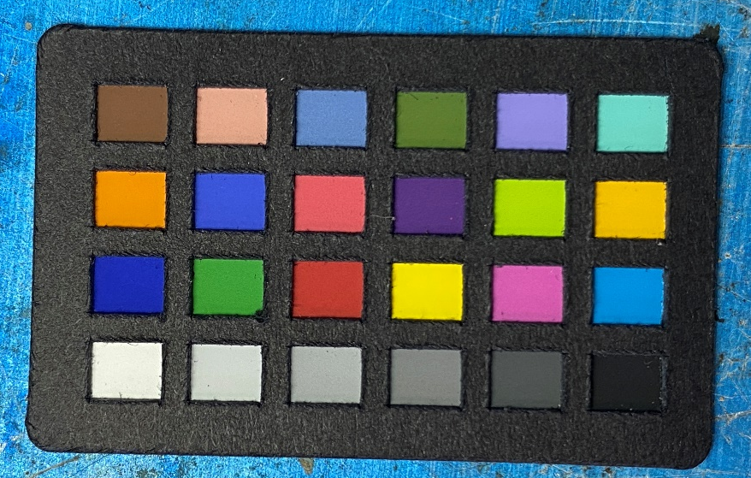
Level 2 | 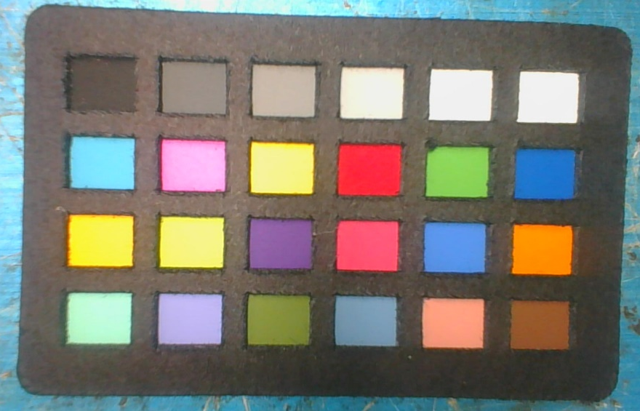
Level 3 | 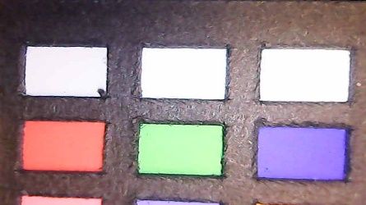  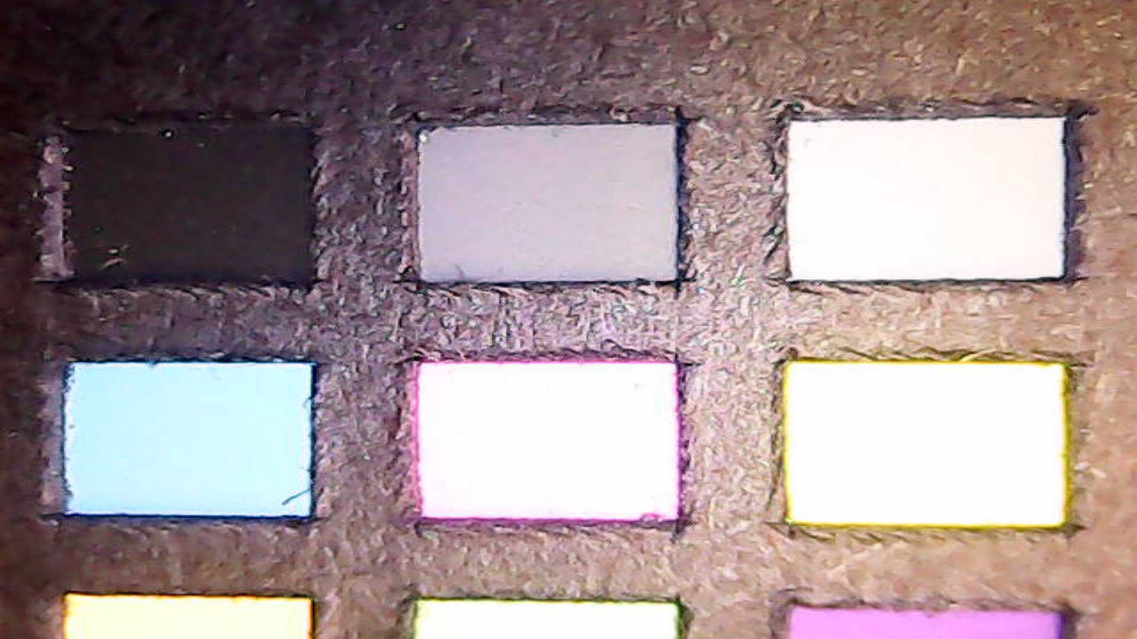  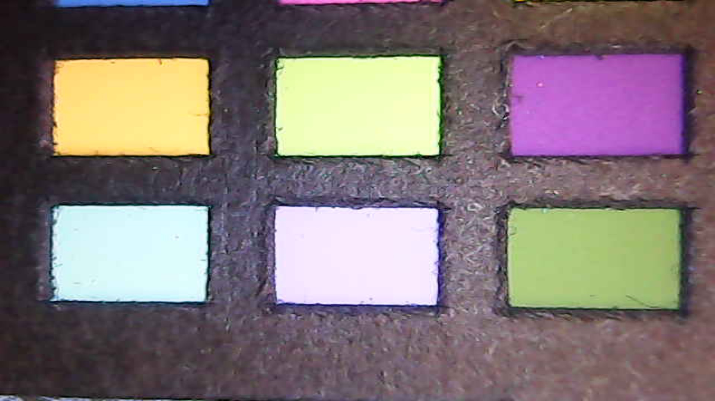  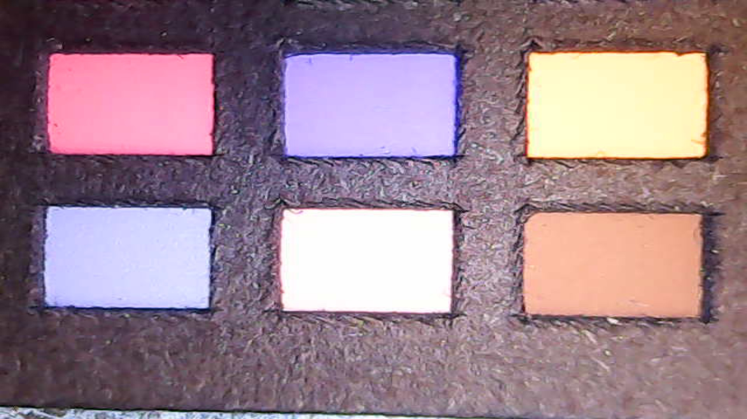

2.2.4 Capability to capture coloured powders.

2.2.4.1 Creation of coloured fingerprint test targets.
A doner deposited a charged depletion series of ten fingermarks from the same finger to create a depletion series on ten black shiny substrates. The chosen finger was charged with a mark deposited on each card labelled 1 – 10 without recharging in-between to form a depletion series of ten marks. This was repeated five times to form a total of five depletion series. The fingermarks were aged for 24hrs then each depletion series was dusted with the following colours to create test targets for each fluorescent powder (Figure 37).
- Red
- Pink
- Green
- Yellow
- Orange

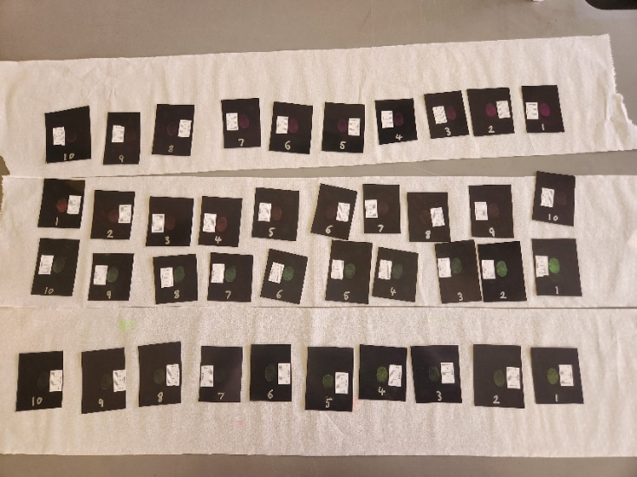

Figure 37: the dusted fingermark depletion series to form the coloured/fluorescent powdered fingerprint test targets.

2.2.4.2 Capture of targets
These test targets were captured using standard white light as the ambient lighting condition and in ambient light with a torch, to determine how well each camera was able to accurately capture coloured fingermarks. Two lighting conditions were tested to determine which lighting conditions were necessary for the final method. Figure 38 demonstrates the DSLR setup to photographically capture the coloured fingermark targets. Figures 39 to 42 demonstrate the setup of each alternative camera to capture the coloured fingermark targets. The targets were captured from the 1st to the 10th one individually each fingermark was centred and filled the frame. The torch was handheld at 45-degree angle at varying distances to gain the best illumination of the target for capture.

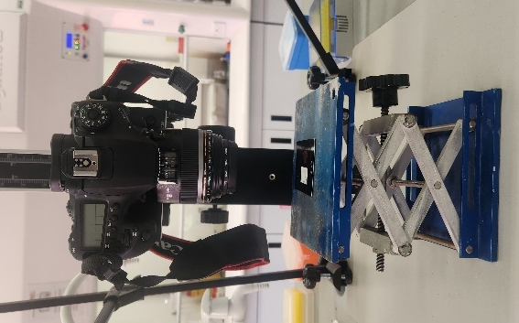

Figure 38: Setup of the DSLR camera for the photographic capture of fingermark test targets.

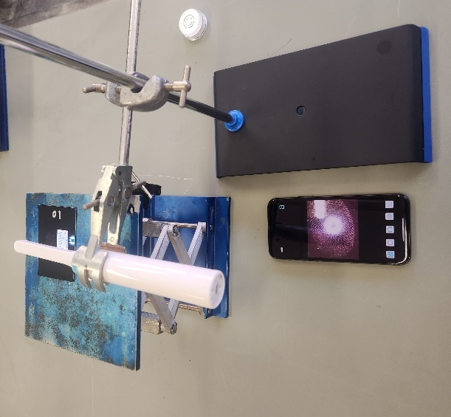

Figure 39: Setup of the Dental camera for the photographic capture of fingermark test targets.
Due to the dental camera’s short focal distance, the target was centred to capture a portion of the fingermark, to allow the mark to be in focus for analysis.

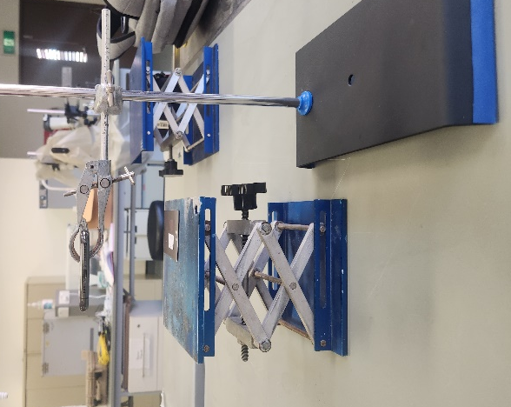

Figure 40: Setup of the Iphone for the photographic capture of fingermark test targets.

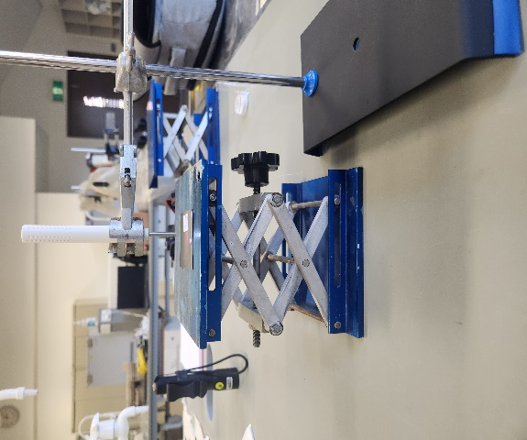

Figure 41: Setup of the Otoscope for the photographic capture of fingermark test targets.
Due to the otoscope’s short focal distance, the target was centred to capture a portion of the fingermark, to allow the mark to be in focus for analysis.

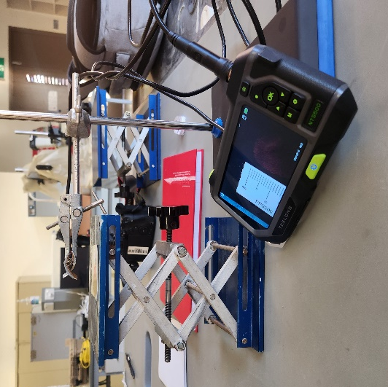
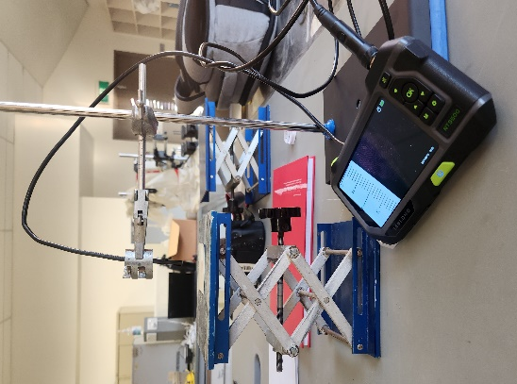

Figure 42: Setup of the Teslong Straight (Left) and Side (Right) cameras for the photographic capture of fingermark test targets.

2.2.5 Capability to capture fluorescent powders.
The targets created in section 2.2.4 were used for the fluorescent tests.
The fingermarks were illuminated using a Polilight PL500TM (Figure 43) at the optimum wavelength that was determined for each powder type used. Green, red, yellow and orange has an optimum wavelength of 450nm (blue light) with pink having an optimal wavelength of 505nm (blue light). A 550nm orange barrier filter was used to photograph the targets to capture the fluorescent fingermarks alongside the polilight. Along with the optimal wavelength used to capture each target, UV light was also used to capture the targets as this did not require a barrier filter. This was to determine if the fluorescent fingermarks could be captured via UV in cases where an alternate camera could not use a barrier filter to capture the fingermark.

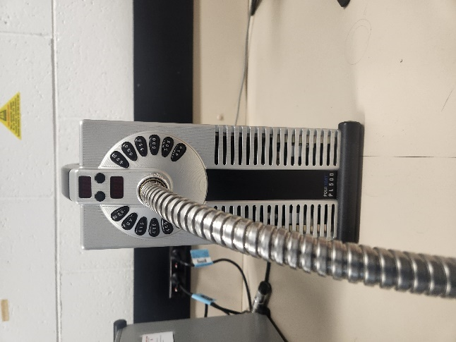

Figure 43: Polilight PL500TM
The DSLR was first used to capture all the test targets using UV with no filter and the optimal wavelength with the 550nm barrier filter. This was to ensure that the powders were fluorescing correctly and were able to be capture via the standard camera before alternate cameras were used. Figure 44 shows the setup of the DSLR camera and the barrier attachment to the lens.
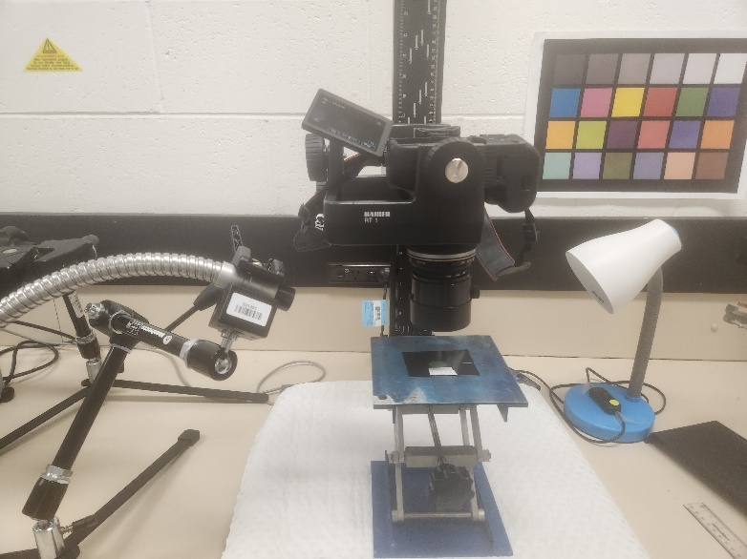
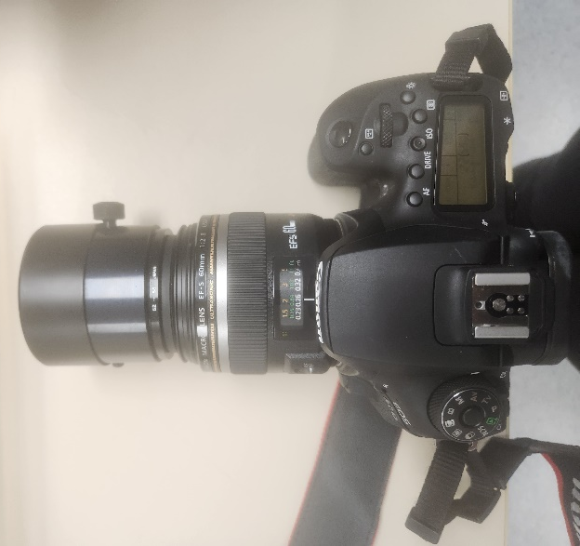
Figure 44: DSLR Camera with 550nm barrier filter attachment (Left). Setup of the DSLR camera for photographic capture of the fluorescent powdered fingermark targets (Right). The setup was the same when using the UV light, but the barrier filter was removed.
To determine if an alternative camera could capture fluorescent fingermarks, from each coloured series the highest contrast and lowest contrast fingermark was chosen. Each alternate camera captured the selected fingermarks with the optimal wavelength for that powder type in conjunction with the 550nm barrier filter placed into front of their lens. Figures 45 to 48 demonstrate the setup of the alternative cameras for photographic capture of the fluorescent powdered fingermarks. Power levels 1 – 7 of the polilight were used to capture each selected fingermark with the power level being decreased by one level at a time after each image was captured. This was performed to determine the optimal light intensity that should be used to gain the best illuminated fingermark that the tested camera can successfully capture. This same process was repeated using the UV setting on the polilight and the barrier filter removed.
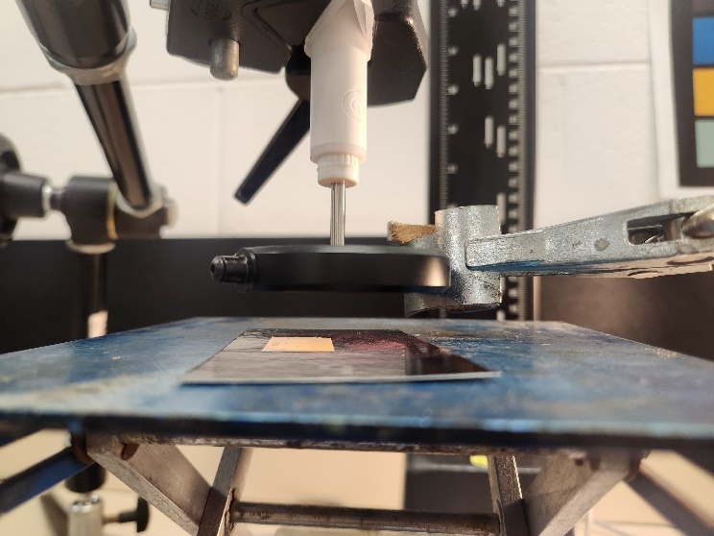
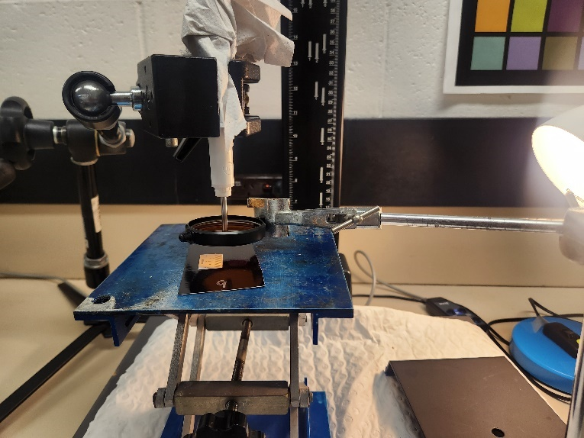
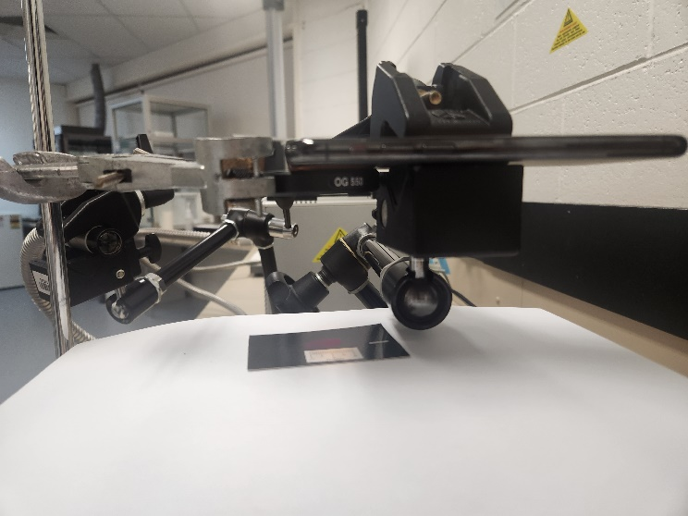
Figure 45: Otoscope setup for capturing fluorescent fingermark test targets, with the barrier filter setup in the required position for use of coloured light. The setup was the same when using the UV light, but the barrier filter was removed.
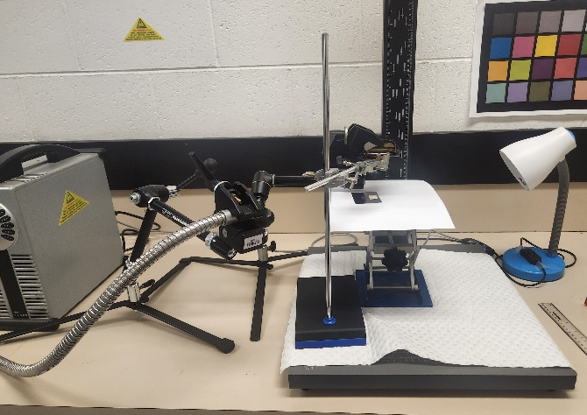

Figure 46: Iphone setup for capturing fluorescent fingermark test targets, with the barrier filter setup in the required position for use of coloured light. The setup was the same when using the UV light, but the barrier filter was removed.
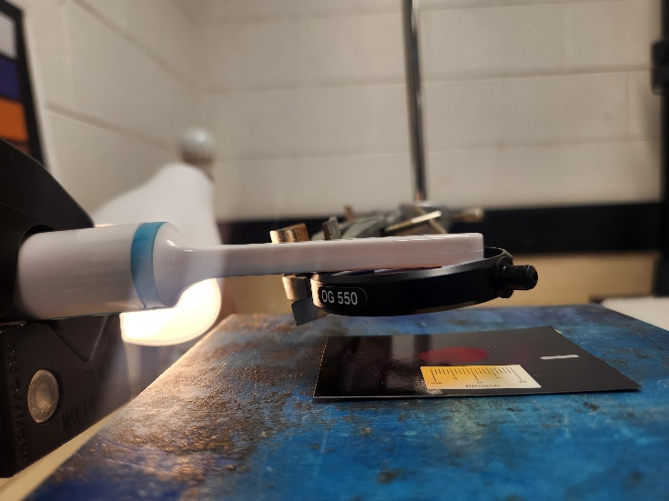
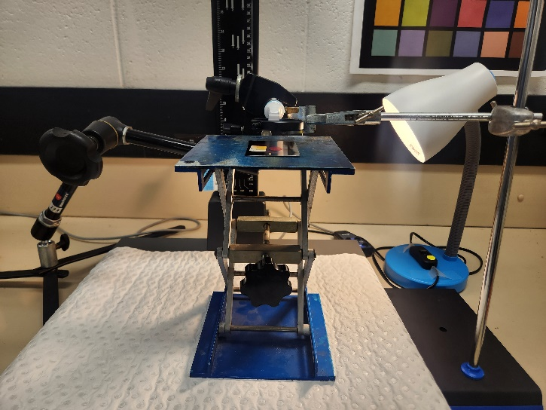
Figure 47: Dental setup for capturing fluorescent fingermark test targets, with the barrier filter setup in the required position for use of coloured light. The setup was the same when using the UV light, but the barrier filter was removed.
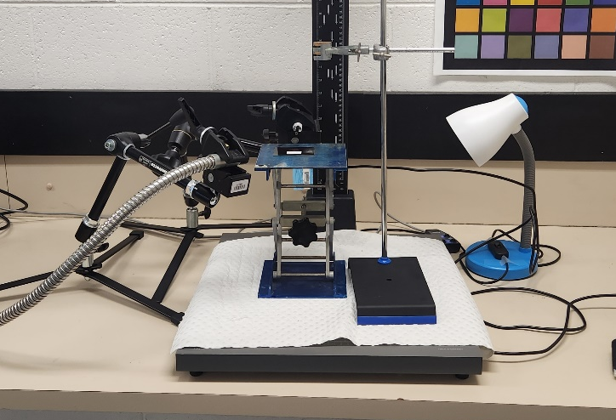
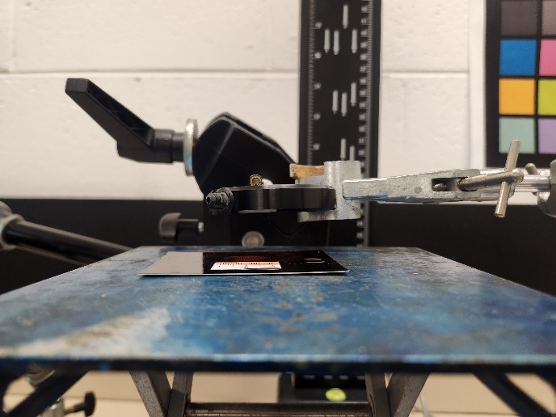
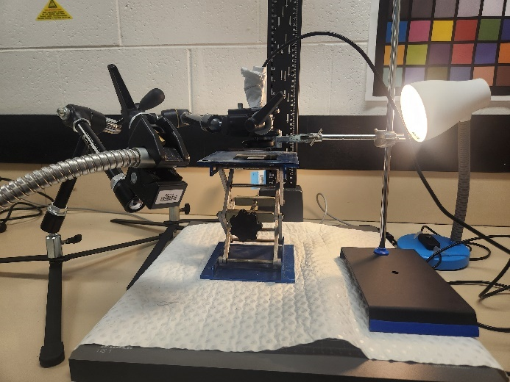
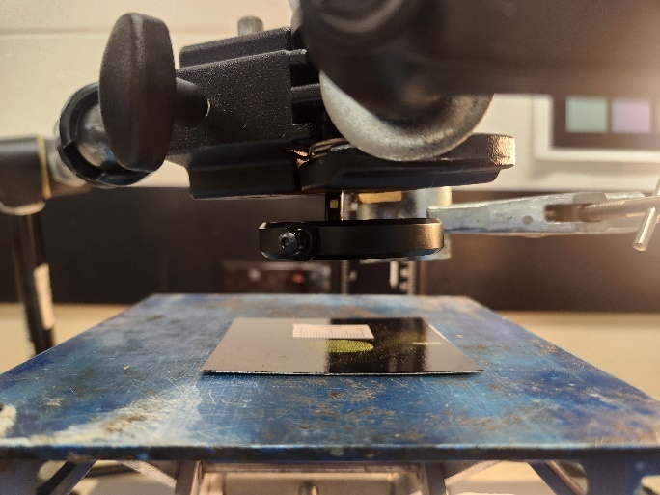
Figure 48: Teslong straight (top) and side (bottom) camera setup for capturing fluorescent fingermark test targets, with the barrier filter setup in the required position for use of coloured light. The setup was the same when using the UV light, but the barrier filter was removed.

2.2.6 Capability to capture latent fingermarks via diffused reflection.

2.2.6.1 Diffused reflection fingerprint test targets creation
A doner deposited a charged depletion series of ten fingermarks from the same finger to create a depletion series on ten black shiny substrates. The chosen finger was charged with a mark deposited on each card labelled 1 – 10 without recharging in-between to form a depletion series of ten marks. This was repeated twice to form a total of two depletion series. One series was left undusted as this formed the latent depletion series, the series was aged 24hrs before photographically captured. The second series were aged for 24hrs then dusted with white fingerprint powder to form the white powder series. Figure 49 is the result of the dusted depletion series to form the white powdered fingerprint test targets.
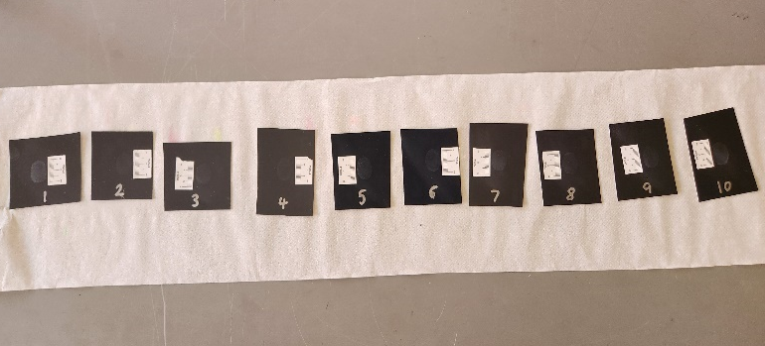

Figure 49: Dusted White powdered fingermark targets

2.2.6.2 Capture of targets via diffused reflection
The cameras were setup the same as shown in figures 38 to 42 as both experiments were capturing fingermark test targets. One lighting condition was used to capture the targets within this experiment, which was ambient with external lighting (torch or flash). These types of fingermarks required diffused reflection in order to capture these types of fingermarks which was achieved using external lighting. The external lighting was handheld and angled across the target to skim the light across the target at different positions to gain the best illumination for capture. This process was repeated with all cameras.

2.2.7 Capability to capture black powdered fingermarks

2.2.7.1 Black powdered fingerprint test targets creation
A doner deposited a charged depletion series of ten fingermarks from the same finger to create a depletion series on ten black shiny substrates. The chosen finger was charged with a mark deposited on each card labelled 1 – 10 without recharging in-between to form a depletion series of ten marks. This was repeated twice to form a total of two depletion series. This was repeated twice to form a total of two depletion series. The fingermarks were aged for 24hrs, then dusted with black fingerprint powder to form two sets of black powdered depletion series.

2.2.7.2 Capture of targets
The cameras were setup the same as seen in figures 38 to 42 as both experiments were capturing fingermark test targets. Three lighting conditions were used to capture the targets within this experiment, they were ambient, ambient with torch, and low lighting. The torch was handheld and angled at 45 degrees at the target the torch was moved around, and at varying of distances from the target to gain the best illumination for capture. This process was repeated with all cameras

2.2.8 Depth of field
Figure 50 is a SpderLenscal™ target originally used for calibrating a camera’s auto focus. In this project it has been used as a depth of field target. Each camera was aimed to focus on the centre of the small square as this was a similar size to a fingermark and would determine the camera’s depth of field when using it for fingermark capture. The images produced allowed the determination of the device’s depth of field range, with a minimum of 60mm in front and 60mm behind. Two lighting conditions were tested to determine if lighting affected the depth of field of the camera and which lighting conditions were necessary for the final method. Ambient and ambient with torch were the lighting conditions used in this experiment. Table 14 contains the depth of field recorded for each camera tested. The depth of field was determined via visual analysis of each camera’s images and the limit recorded was where the lines were no longer visible or out of focus.
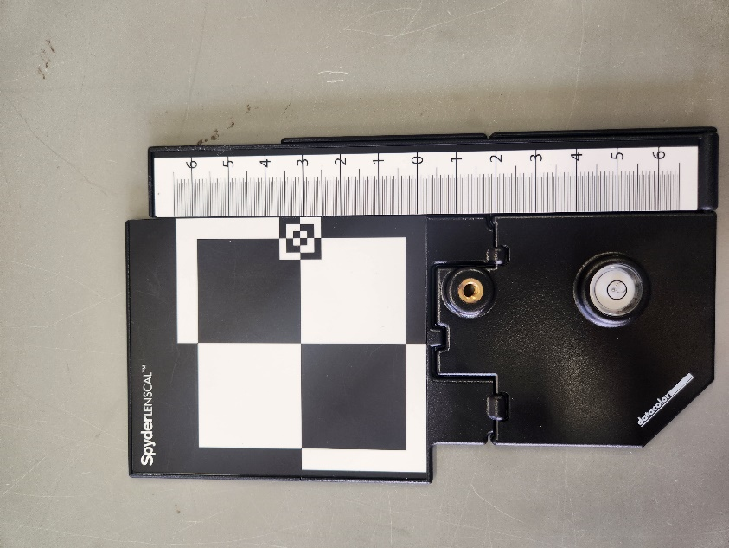

Figure 50: SpderLenscal™ depth of field target

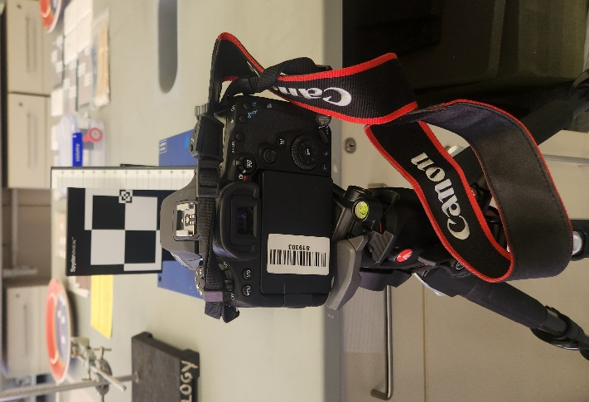
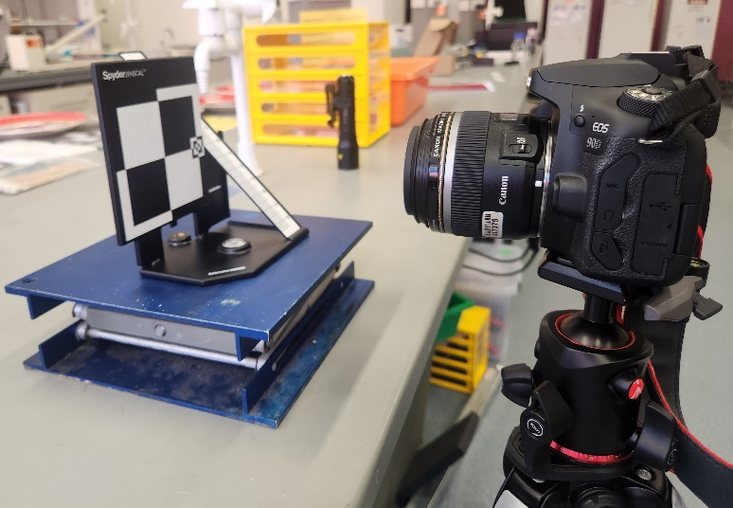

Figure 51: Setup of the DSLR CAMERA for the photographic capture of the depth of field target.
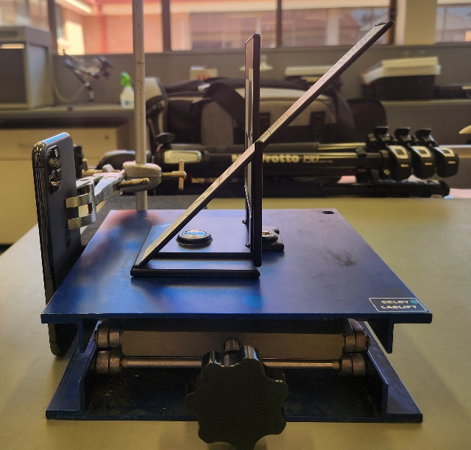
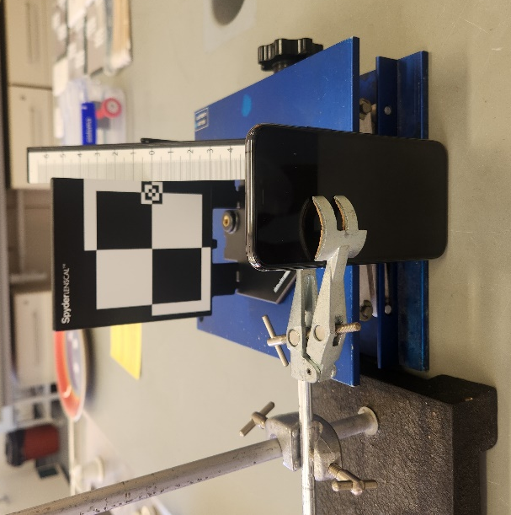
Figure 52: Setup of the Iphone for the photographic capture of the depth of field target.

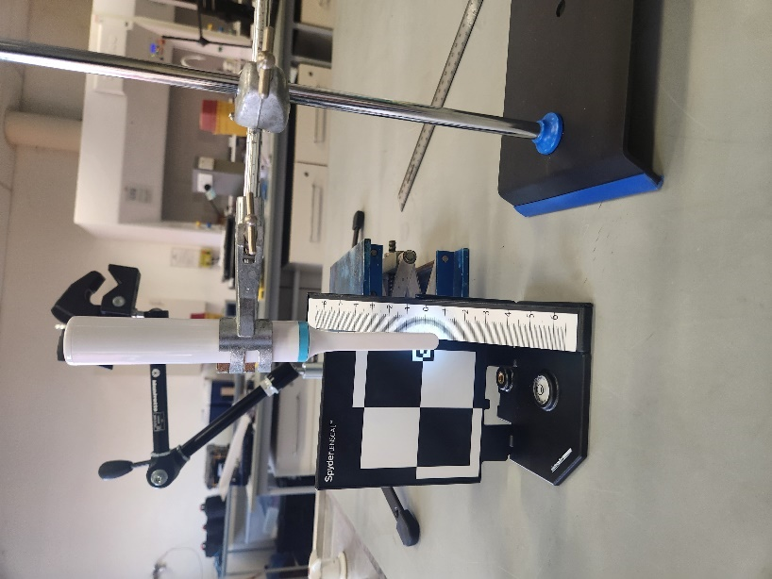
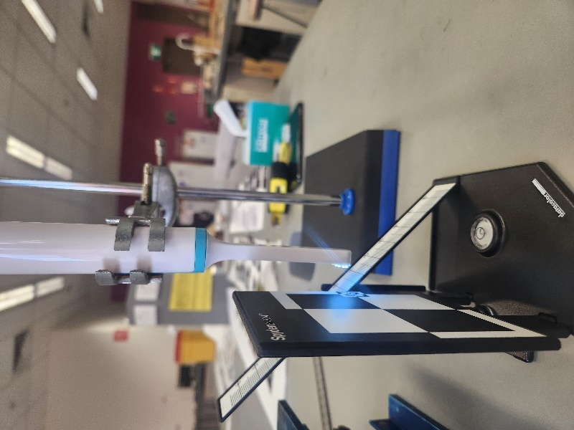
Figure 53: Setup of the Dental CAMERA for the photographic capture of the depth of field target.

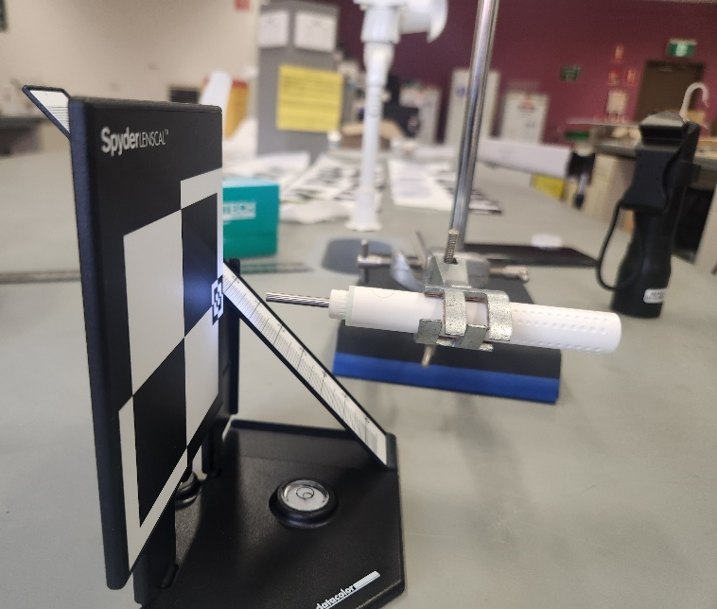
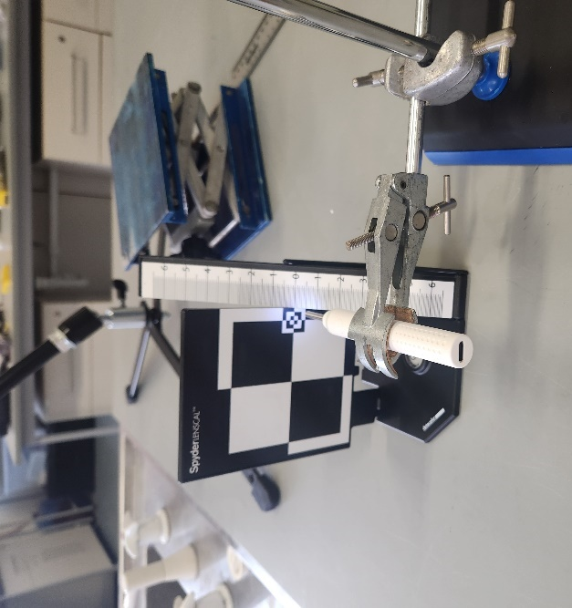
Figure 54: Setup of the Otoscope for the photographic capture of the depth of field target.
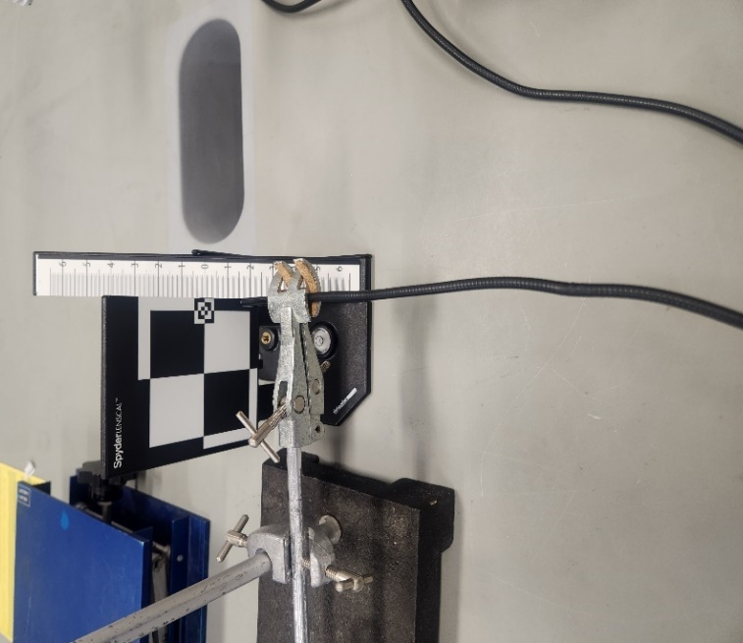
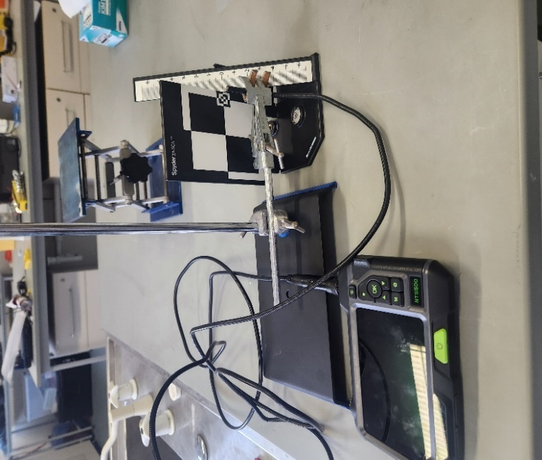
Figure 55: Setup of the Teslong Straight (Left) and Side (Right) CAMERAs for the photographic capture of the depth of field target.

2.2.9 Pixel Per Inch
PPI was measured in two different ways, the first was in accordance with the SWGDE guidelines and the second was through physically measuring the PPI within an image. According SWGDE (2017) the required PPI to capture level three detail of a fingermark with sufficient quality is 1000ppi which equates to 9.8 to 13 lp/mm. PPI was calculated using the images captured of the USAF target in the resolution and contrast section (2.2.1). Group 3, element 3 was the limit that equated to the minimum number of lp/mm a camera needed to resolve to be capable of reaching 1000ppi. After the visual limits were determined for each image captured and the corresponding lp/mm was calculated as explained in section 2.2.1. Figures 70, 71 and 72 are the graphically representations of each camera’s resolution per lighting type with the 1000ppi limit highlighted.
The second method for PPI involved each camera to capture the one-inch measurement on a ruler (Figure 56). The inch ruler had to be placed within the centre of the frame and fill the frame, to the camera’s best ability. The cameras tested were all setups as shown in Figures 38 to 42 to capture the inch ruler. The images were captured using ambient and ambient with torch lighting conditions. The images were measured using FCS to measure the number of pixels along the inch of the ruler which was recorded in Table 13 this formed the secondary result for a camera’s PPI.

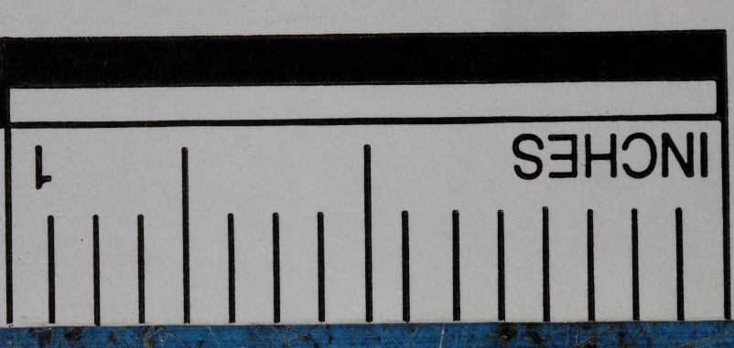

Figure 56: Inch ruler used as the test target for PPI experiment.

2.2.10 CAST Grading for fingermarks in sections 2.2.4 to 2.2.7
To analyse the fingermarks captured during the experimentation for part 1, the best images were chosen from each camera for each fingermark series that were photographed, ensuring that there were examples from each lighting condition. A representation of a high, mid, and low contrast prints from each series in the coloured, white, and black fingermark targets were chosen for CAST grade analysis. The chosen fingermarks for the latent series included a representation of high, mid, and low contrast from the 1 to 5 depletion numbers as this was the range where the alternate cameras were able to capture the target, the lower-level targets could not be captured via the alternate cameras. To ensure there was latent fingermark data these targets were chosen to demonstrate their ability to capture a high ranged latent fingermark. The chosen fluorescent targets were a representation of a highest and lowest contrast fingermarks from each series that were selected based on the optimal power level. The optimal power level was recorded for each target selected.
The selected images were graded by three separate graders who were blinded to which camera was used to take each image. This was to minimise bias that may occur to favour particular types of cameras. The median was taken from the three grades given to each image to produce the final grade for that image. Median was chosen as the CAST grade data was limited by three graders a median would allow for middle most whole number to be selected for this dataset.
The CAST grade system is a method used by forensic fingerprint examiners to determine the amount of fingermark detail present when an enhancement technique has been used on a print (Group 2014). The DSLR images were used as the ground truth and to ensure the quality of the fingermarks used. The CAST grade system has been adapted to help determine the amount of detail that each camera was able to capture for each target. Table 3 demonstrates the different levels used in CAST grading with an example image of each grading level.
Table 4: CAST Grade levels with example fingermark images (Group 2014)
Grade | Amount of detail | Example
0 | No fingermark detected | No image needed since there is not fingermark to capture.
1 | Some evidence of a fingermark | 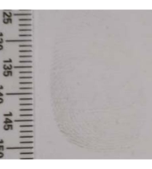
2 | Less than 1/3 of the fingermark has clear ridge detail | 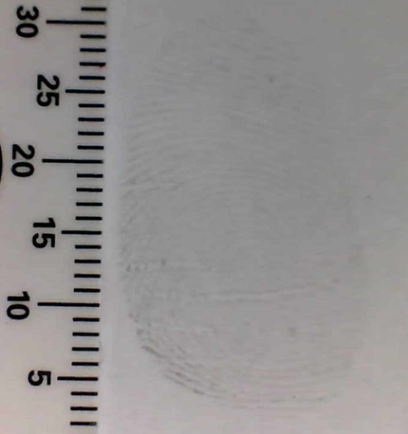
3 | Between 1/3 and 2/3 of the fingermark has clear ridge detail | 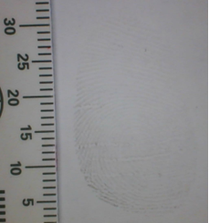
4 | Over 2/3 of the fingermark has clear ridge detail | 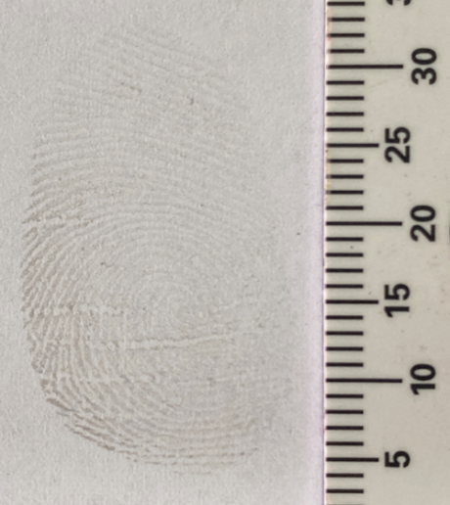

2.3 Part 2 of Method Development: Fingermark Image Quality
This part of the method development was aimed to determine what is the best approach in determining how well a camera captures fingermark detail and what is sufficient detail needed for identification. The series of fingermarks created in part 1 were used again through part 2, and from each series three fingermarks were chosen. One that best represented a high contrast fingermark, one that best represented a medium contrast fingermark, and one that best represented a low contrast fingermark. Each camera was setup within optimal focal distance of the mark of capture the best possible image. Each camera captured the same fingermark from the ones chosen for this experiment. This was done to eliminate the variability, if there was a difference in how the fingermark appeared in the image it was due to the camera’s image quality not due to fingermark quality. Ambient with a torch was the lighting condition used throughout this experiment as the previous tests in part 1 determined that torch increased the image quality of the fingermarks captured. Figure 56 demonstrates the difference between images captured by an alternative camera in both ambient and ambient with torch lighting conditions. The camera setups from figures 38 to 42 were used to capture the fingermarks through this experiment.
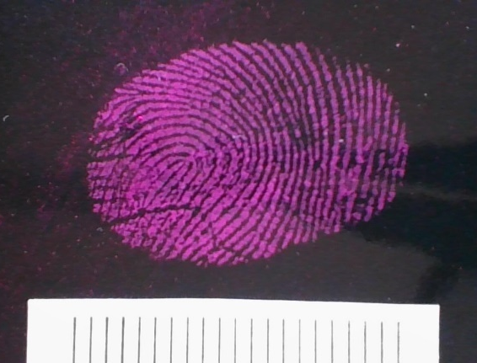
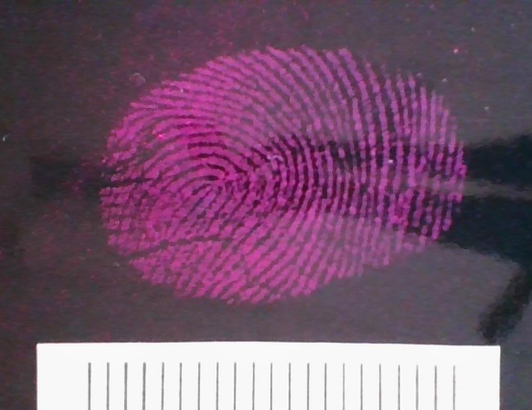

Figure 57: A high contrast pink coloured powdered fingermark captured via the Teslong straight camera. Left captured using ambient light. Right captured using ambient light with torch.

2.3.1 Fingerprint mark-up
The images captured via the DSLR formed the ground truths for fingermark image quality, the alternate camera’s images were compared to the ground truths. The ground truths were marked-up using FCS, the researcher identified all fingermark detail that was present to their knowledge for each selection of ground truths. There were three series chosen for this experiment, black and white dusted fingermarks and latent fingermarks. The high, mid, and low contrast fingermarks were marked up and formed that ground truths for each type of fingermark used.
Once the ground truths were marked-up the alternate’s camera images were marked-up using the ground truth as a guide. The fingermarks in each image are the same across all cameras, the ground truth is used as a guide as all the detail should have appeared the same across any alternate camera a variation is due to the camera’s fingermark image quality. The details on the alternate images were marked-up in four different colours. Green, detail is appearing the same as ground truth. Orange, the detail is there but is appearing different to the ground truth. Yellow, detail is missing. Red, detail has appeared that is not in the ground truth.
The mark-ups results were put into a graph to demonstrate how much of each type of colour was within a fingermark mark-up. This aids in determining how each camera’s fingermark image quality compares to the DSLR and if the variation affects the images being used for identification.

2.4 Part 3 of Method Development: Practicability in a controlled environment
The image quality along with fingermark image quality were both tested in the first two parts of this project, to determine the main components that a camera needed to be capable of to successfully capture a fingermark. The previous experiments were all conducted in optimal conditions and used a stand to limit camera shake while photographing the varying test targets and fingermarks.
This section will demonstrate the practical application of an alternative camera by simulating a variety of scenarios within a controlled laboratory environment. This experiment aimed to highlight the practical differences between the standard method used to capture fingermarks in hard-to-reach places with both the DSLR and lifting the print compared the alternative cameras. There was five key hard to reach scenarios selected for laboratory replication using the simulation apparatus (Figure 58) which were:
- Behind a door handle
- On top of a fence
- Outside of windowsill of a tall building
- Under a handrail
- Inside evidence items; a small safe
To create these simulations, measurements of these areas were conducted at the Joint NSW Police Force and WSU Crime Scene Research and Training Facility on WSU’s Hawkesbury Campus to gain accurate parameters to replicate.

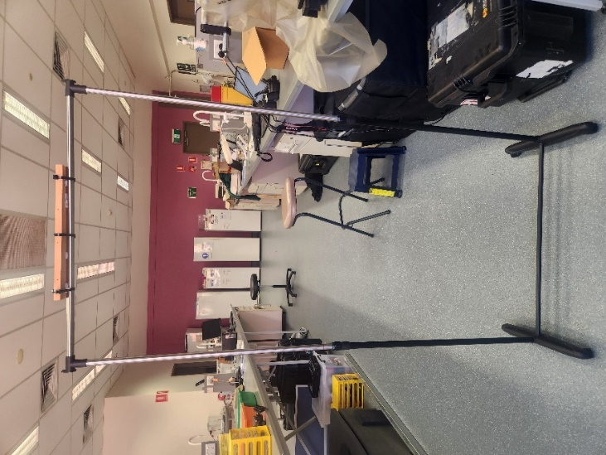

Figure 58: Simulation Apparatus used throughout experimentation to replicate the selected situations. (Brilliant Basics Portable Single Garment Rack).
In each situation, the following form (Table 5) was completed for the standard methods (DSLR and lifts) and for the alternate cameras. This form aimed to highlight the main differences between the standard methods and the alternate cameras. This form was completed for each camera for each individual situation. Each situation contained a set of six fingermark targets to be photographed by all cameras involved within the experiment. There were two fingermark series: black dusted fingermarks on a white shiny substrate, and white dusted fingermarks on a black shiny substrate.

2.4.1 Creation of fingermark targets
A doner deposited a charged depletion series consisting of ten fingermarks in total from the same finger to create a depletion series on a black shiny substrate and on a series of white shiny substrates. The chosen finger was charged with a fingermark deposited on each card labelled 1 – 10 without recharging in-between to form a depletion series of ten marks. This was repeated five times for each substrate to form a total of ten depletion series. The fingermarks were aged 24hrs. The series deposited on the shiny black substrates was dusted with white powder and the series deposited on shiny white substrates were dusted with black powder. A representation of a high, mid, and low contrast fingermark was chosen from each series. These fingermarks formed the targets used for the scenarios throughout the experiment.

Table 5: Results form for Part 3 Practicability
Factors of practicability | Results | Observations
Time Taken | Black High:  Black Mid:  Black Low:  White High:  White Mid:  White Low:
One or two hands needed
Use of additional equipment e.g. mirror
Lighting needed e.g. flash or torch
Ease of viewing (e.g. attached viewing screen or additional viewing screen)
Storage of images (SD card or device storage)
Successful capture of fingermark (Image includes full fingermark, linear scale and space for a label)
Security of images
Camera Settings

For the situations listed previously the following was performed for each fingermark within each situation. The fingermark was photographed by the DSLR first, then captured by all alternate cameras used then lifted and captured last. Before capture of a fingermark a timer was started and stopped once the researcher concluded that the fingermark was successfully captured or captured to the best a camera’s ability. The time was recorded in the corresponding form (Table 5) and relevant details and observations were recorded after each capture. Once all images were captured the fingermark was lifted in-situ using an adhesive hinge lift with the appropriate coloured backing card, then photographed via a DSLR on a copy stand. This formed the lifted image that the alternative camera’s images would be compared to.

2.4.2 Behind door handle
This situation was set to replicate a fingermark located on the inside of a doorhandle that cannot be easily accessed for photographic capture by the DSLR. The apparatus setup (Figure 59) involved the apparatus to be set as a height of 103cm and set against a wall with a gap of 5cm between the wall and the fingermark. The fingermark was placed on the inside of the apparatus to replicate a fingermark deposited behind a door handle.
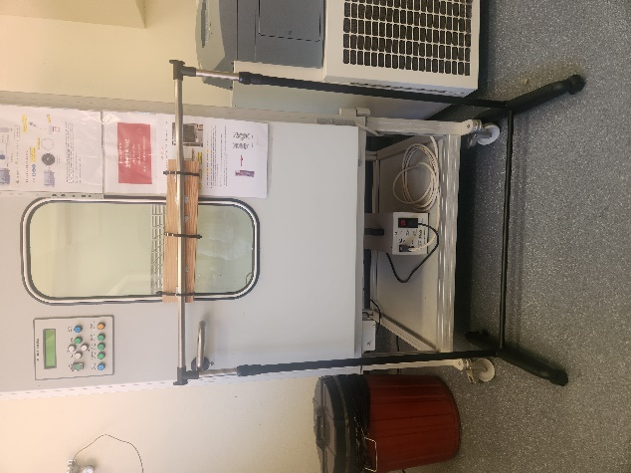
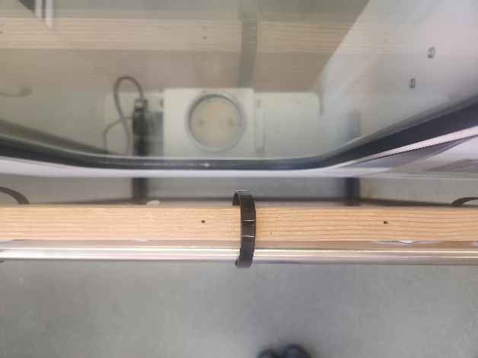

Figure 59: Simulation Apparatus setup for behind a door handle scenario. The red arrow indicates where the fingermark target was placed for the experiment.

2.4.3 On top of fence
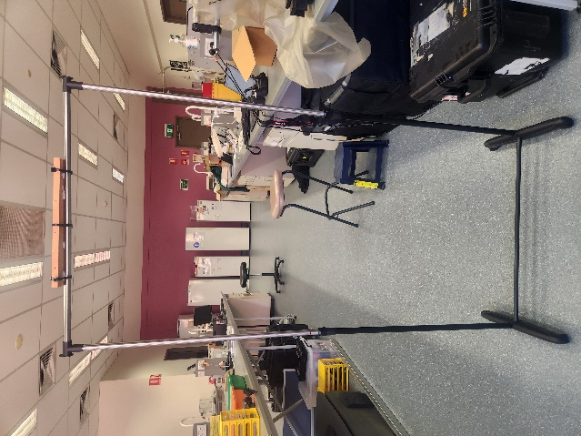
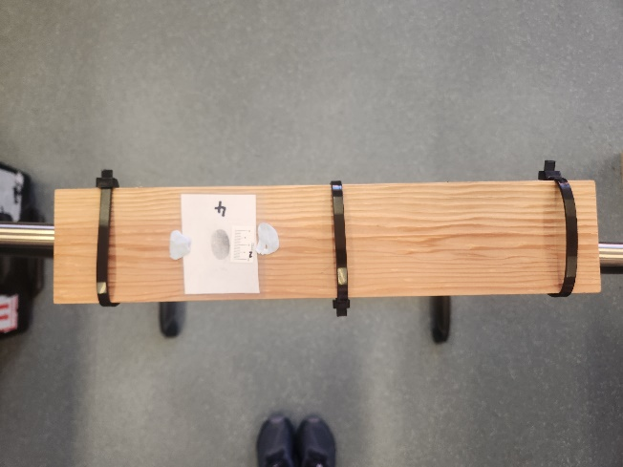
This situation was set to replicate a fingermark located on top of a fence that cannot be easily accessed for photographic capture by the DSLR. The apparatus setup (Figure 60) involved the apparatus being set to a height of 170cm as this was the maximum height the simulation apparatus could be set, with the fingermark being placed at the top of apparatus. The height was chosen due to NSW fencing regulations stating that majority of behind the building line fences have a maximum height of 1.8m (DPE 2022). The apparatus was set within the limits of the NSW fencing regulations and high enough to be deemed a difficult to reach situations.

Figure 60: Simulation Apparatus setup for on top of a fence scenario. The red arrow indicates where the fingermark target was placed for the experiment.

2.4.4 Outside of windowsill
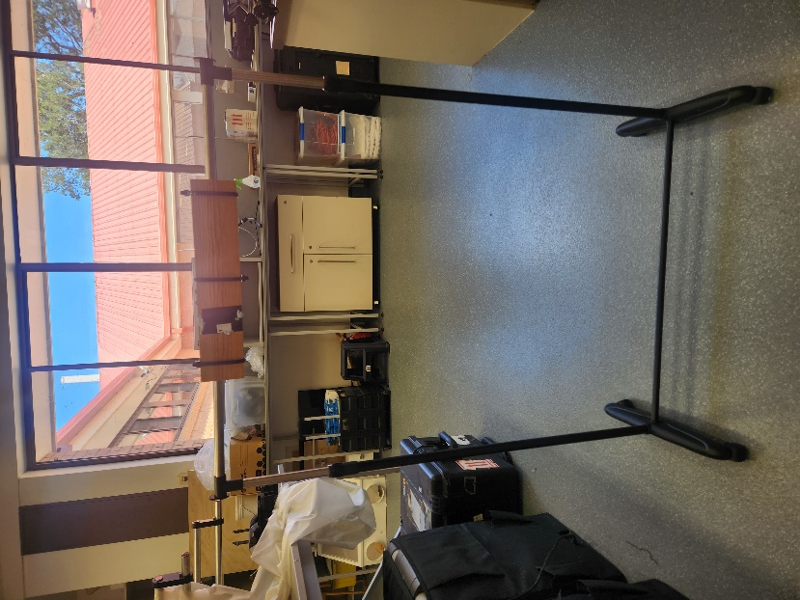
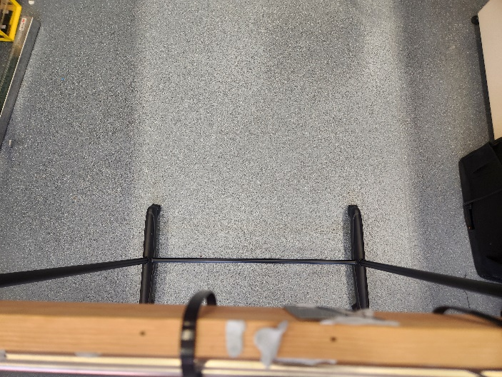
This situation was set to replicate a fingermark located on the outside of a windowsill of a tall building that cannot be easily accessed for photographic capture by the DSLR. The apparatus setup (Figure 61) involved the apparatus to be set as a height of 112cm. The fingermark was placed on the opposite side of which the researcher chose to photograph from. The researcher was limited to photographing the print from the opposite side and over the top of the apparatus to simulate holding a camera out of a window to capture the fingermark.

Figure 61: Simulation Apparatus setup for outside of a windowsill scenario. The red arrow indicates where the fingermark target was placed for the experiment.

2.4.5 Under a handrail
This situation was set to replicate a fingermark located under a handrail that is blocked on one side to prevent easy access for photographic capture by the DSLR. The apparatus setup (Figure 62) involved the apparatus to be set as a height of 90cm and 17cm away from a wall, the apparatus was weighted to this position to prevent movement during experiment. The fingermark was placed on the underside of the apparatus.
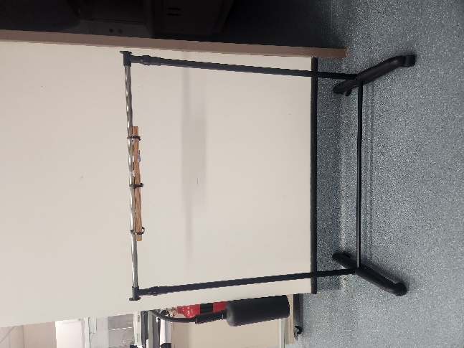
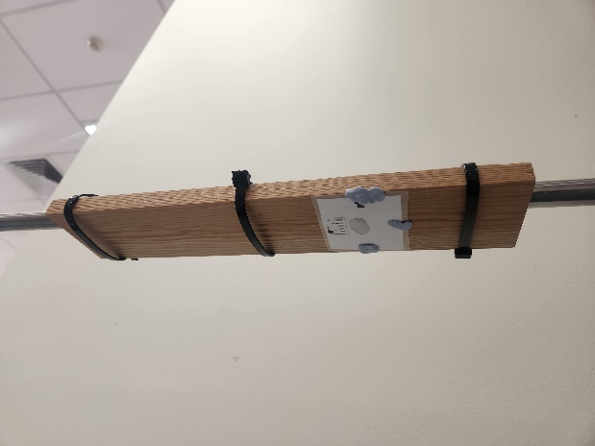

Figure 62: Simulation Apparatus setup for under a handrail scenario. The red arrow indicates where the fingermark target was placed for the experiment.

2.4.6 Small safe (Inside evidence items)
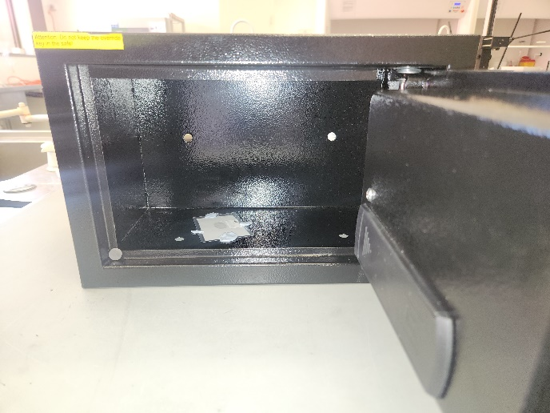
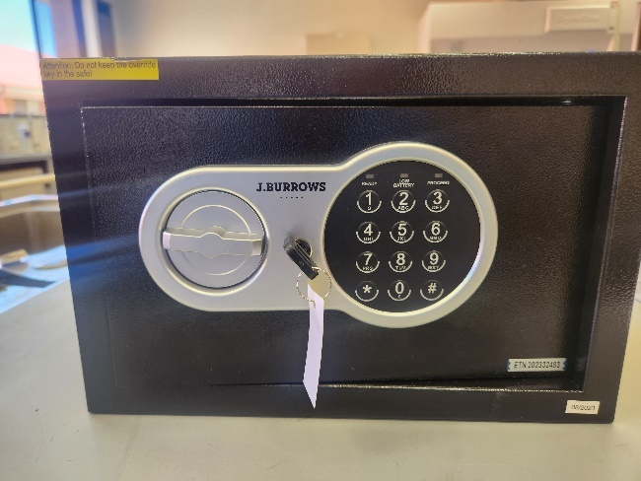
The aim of this experiment was to replicate fingermarks located within evidence items that are not easily accessible through the standard methods. A safe was chosen as an example as it represents a confided and restricted evidence item, that is commonly found within crime scenes. The safe used was SuresafeTM Fremont (J.Burrows) which is shown in Figure 63 the safe was placed on top of a laboratory bench with the fingermark targets placed on the bottom of the safe (Figure 63).

Figure 63: SuresafeTM Fremont (J.Burrows) (left) and the simulation with the fingermark location indicated via the red arrow (right).

2.4.7 CAST Grade Analysis for Fingermarks in Part 3
To analyse the fingermarks captured during the experimentation for part 3, the best images were chosen from each camera for each type of fingermark within all the different situations tested. The selected images were graded by three separate graders who were blinded to which camera was used to take each image. This was to minimise bias that may occur to favour a particular type of camera. The median was taken from the three grades given to each image to produce the final grade for that image. Median was chosen as the CAST grade data was limited by three graders a median would allow for middle most whole number to be selected for this dataset.
The CAST grade system is a method used by forensic fingerprint examiners to determine the amount of fingermark detail present when an enhancement technique has been used on a print (Group 2014). The DSLR images were used as the ground truth and to ensure the quality of the fingermarks used. The CAST grade system has been adapted to help determine the amount of detail that each camera was able to capture for each target. Table 3 demonstrates the different levels used in CAST grading with an example image of each grading level.

2.4.8 Charging time and battery life experiment
The charging time and battery life for the alternate cameras were conducted in a separate test. The cameras were all drained until the battery was dead. The dead cameras were plugged into a charging outlet and timed to see how long it took the device to charge to 100%. Once the device was fully charged, over the course of a week the device would take 30 photos each day for that week without charging between days. If the device had remaining charge at the end of the week it would be deemed to have a sustainable battery life for crime scene work. If the camera lasted less than the week it would be deemed to not have a sustainable battery life for crime scene work. The type of battery was also recorded if the device had to be recharged or if it contained a battery that could be switched out when necessary. The charging times were recorded in Table 50 and the remaining charge after a week was recorded in Table 51.

2.5 Part 4 of Method Development: Pseudo-operational application
The aim of this experiment was to put all previous experiments into context and assess the performances of the alternative cameras within pseudo-operational situations. The development of this experiment was to determine what is the best way to structure a pseudo-operational environment that allowed the tester to evaluate the performance of the alternate camera and to determine if the device was suitable for in-field work.

2.5.1 Set-up of Experimentation
The Joint NSW Police Force and WSU Crime Scene Research and Training Facility on WSU’s Hawkesbury Campus was used to conduct this experiment. There was a total of nine locations chosen throughout the facility that represented real world examples of situations replicated in the previous section also with several other locations that varied in difficult to photograph areas and substates. The following locations in Table 6 were chosen and tested to ensure fingermarks could be left on the surface and be seen as a latent or through powdering before donation. Doners were instructed to place natural prints all the locations listed within Table 6. The fingermarks were aged for five days before photographic capture commenced. The week age was chosen to also determine the alternate camera’s ability to capture an older fingermark.

Table 6: Locations of fingermarks used in pseudo-operational experiments
Location | Reason | Substrate | Photograph of location
Handrails located on both sides of a staircase. | Real world example of under a handrail. | Non-porous, white, shiny metal, curved surface. | 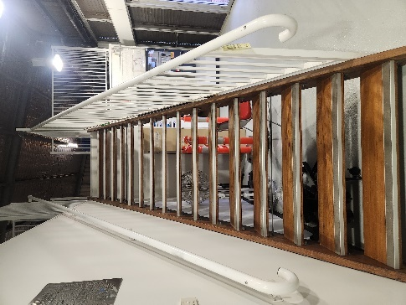
Doorhandle leading into the kitchen. | Real world example for behind a doorhandle. | Non-porous, reflective metal. | 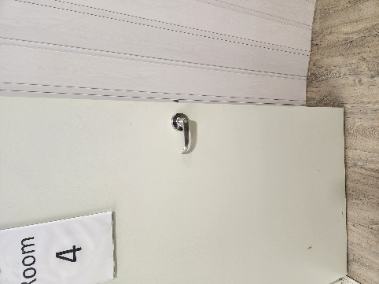
Top shelf in kitchen cupboards. | Difficult to reach due to height of fingermark. Closest real-world example of on top of a fence due to height restrictions. | Non-porous, white, shiny coated chip board. | 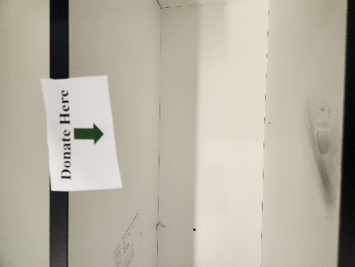  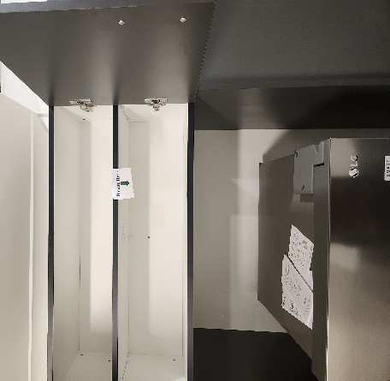
Inside kitchen drawer. | Confined space example of a difficult to reach place | Non-porous, white, shiny coated chip board. | 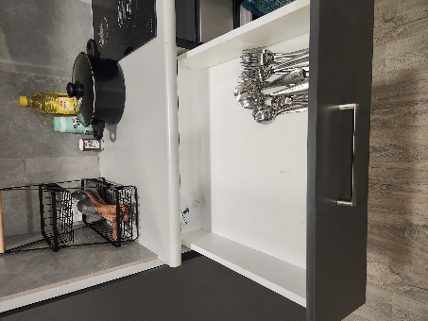
Underneath kitchen sink handle. | Confined space another example of a difficult to reach place. | Non-porous, reflective metal. | 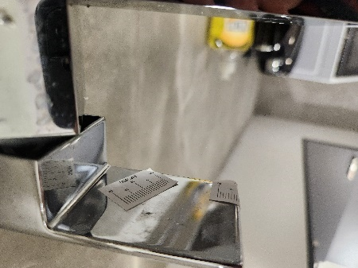
Outside of a window, a fingermark located on the top glass and the other on the bottom windowsill. | Must photograph mark from inside the room and stretch out window to capture marks to replicate capturing marks outside of window on a tall building. | Windowsill = wood with white shiny paint coat.  Window = non-porous clear glass. | 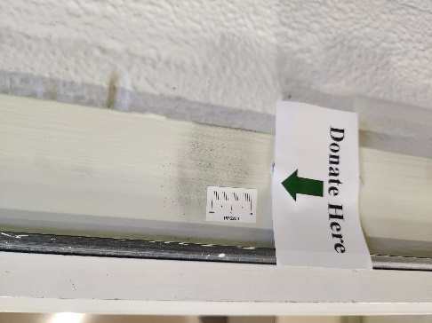  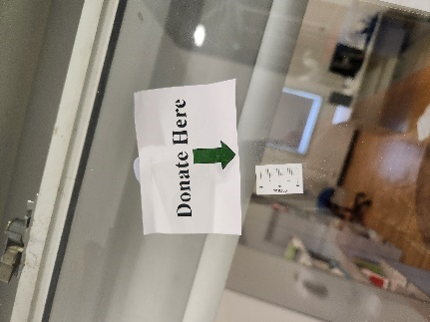
Car, the rear-view mirror, the mirror. | Difficult in situations where investigator cannot physically get into the car and is limited to leaning into the car to capture mark. | Mirror = non-porous reflective glass surface | 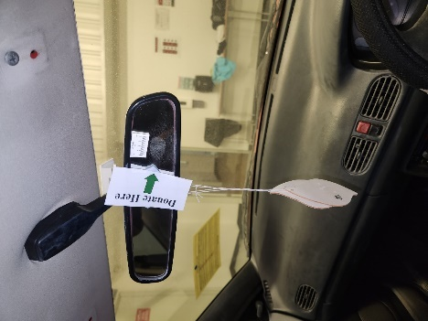

2.5.2 Photographic capture of fingermarks
Once photographic capture began, all locations were checked to identify the location of any latent fingermarks using a torch. Once these locations were identified the DSLR was used to capture the visible latent fingermarks. Then the alternate cameras identified in previous sections that could capture latent fingermarks captured those fingermarks. The time each camera took to capture all latent fingermarks was recorded. Due to there only being one mark in some locations, latent fingermarks had to be captured first by all appropriate cameras before powdering could be applied. Powdering of all fingermarks using the appropriate powder type determined by the researcher was conducted on all donated fingermarks. Once all the fingermarks were powdered each camera was taken through to capture all fingermarks, with the total run-through time being recorded and any observations noted. The DSLR was first, with the iphone, dental camera, teslong straight and teslong side following in that order. The otoscope was not taken through as it was excluded from further testing in the previous section. Due to there being limited fingermarks in some locations the alternate camera tests had pre-powdered prints but the time it took to powder all prints was recorded and can be added to the alternate camera’s run-through time to replicate a more realistic crime scene run-through time if powdering had to be done before each photo was captured.

Once all the required photographs were captured by all cameras, each fingermark was lifted and then collected. The collected lifts were photographed in a laboratory using an alternate camera. This was to replicate situations where a successful photograph of a fingermark could not be captured, and a lift was required to capture the fingermark evidence. The time and observations from collecting and photographing lifts were recorded.

Due to time restrictions only the week aged fingermarks were able to be completed and with whatever locations had successful fingermark donations were able to be captured. Opposed to both 24hr aged fingermarks and week aged fingermarks being tested. Unfortunately, the doorhandle fingermarks had to be removed from testing as there was no fingermarks present when testing occurred even after powder enhancement. The fingerprint doner was able to donate a fresh set of prints for the doorhandle within the time frame that were aged a day, but those fingermarks did not show up either even after powdering therefore it was removed from testing, as there were time constraints on the facility.

2.5.3 CAST Grade Analysis for Fingermarks in Part 4
To analyse the fingermarks captured during the experimentation for part 4, the best images were chosen from each camera for each fingermark in all the location selected. The selected images were graded by three separate graders who were blinded to which camera was used to take each image and where the fingermark was located. This was to minimise bias that may occur to favour a particular type of camera. The median was taken from the three grades given to each image to produce the final grade for that image. Median was chosen as the CAST grade data was limited by three graders a median would allow for middle most whole number to be selected for this dataset.
The CAST grade system is a method used by forensic fingerprint examiners to determine the amount of fingermark detail present when an enhancement technique has been used on a print (Group 2014). The DSLR images were used as the ground truth and to ensure the quality of the fingermarks used. The CAST grade system has been adapted to help determine the amount of detail that each camera was able to capture for each target. Table 3 demonstrates the different levels used in CAST grading with an example image of each grading level.

Chapter 3: Results

3.1 Results for Part 1 of Method Development: Image Quality

3.1.1 Resolution and Contrast
The visual limits and calculated lp/mm to two decimal points, based on the different lighting conditions tested are displayed in the following tables 7, 8, 9, 10, 11, and 12. Below each table for each individual camera is a graphical representation of the data presented within the tables. The graphs visually represent how each camera preforms in each tested lighting condition. Targets 1 to 13 were selected for these graphs. Targets 14 and 15 were excluded to reduce the error of the human eye, as the camera may be able to reach a greater resolution limit but is not clear to the human eye.
Table 7: The visual limits and calculated lp/mm for the dental camera in all lighting conditions.
Lighting Conditions |  |  | Ambient |  |  | Ambient with Torch |  |  | Low
Target No. | Group No. | Element No. |  | Lp/mm | Group No. | Element No. | Lp/mm | Group No. |  | Element No. | Lp/mm
1 | 2 | 1 |  | 4 | 2 | 1 | 4 | 1 |  | 6 | 3.56
2 | 2 | 3 |  | 5.04 | 2 | 3 | 5.04 | 1 |  | 6 | 3.56
3 | 2 | 2 |  | 4.49 | 2 | 3 | 5.04 | 2 |  | 2 | 4.49
4 | 2 | 2 |  | 4.49 | 2 | 3 | 5.04 | 2 |  | 1 | 4
5 | 2 | 3 |  | 5.04 | 2 | 3 | 5.04 | 2 |  | 1 | 4
6 | 2 | 6 |  | 7.13 | 2 | 4 | 5.66 | 2 |  | 3 | 5.04
7 | 2 | 3 |  | 5.04 | 2 | 3 | 5.04 | 2 |  | 3 | 5.04
8 | 2 | 4 |  | 5.66 | 2 | 4 | 5.66 | 2 |  | 2 | 4.49
9 | 2 | 4 |  | 5.66 | 2 | 3 | 5.04 | 2 |  | 1 | 4
10 | 2 | 2 |  | 4.49 | 2 | 2 | 4.49 | 2 |  | 1 | 4
11 | 2 | 1 |  | 4 | 2 | 2 | 4.49 | 2 |  | 2 | 4.49
12 | 1 | 6 |  | 3.56 | 2 | 1 | 4 | 1 |  | 6 | 3.56
13 | 1 | 6 |  | 3.56 | 1 | 6 | 3.56 | 1 |  | 6 | 3.56
14 | 1 | 5 |  | 3.17 | 1 | 4 | 2.83 | 1 |  | 4 | 2.83
15 | N/A | N/A |  | 0 | N/A | N/A | 0 | N/A |  | N/A | 0

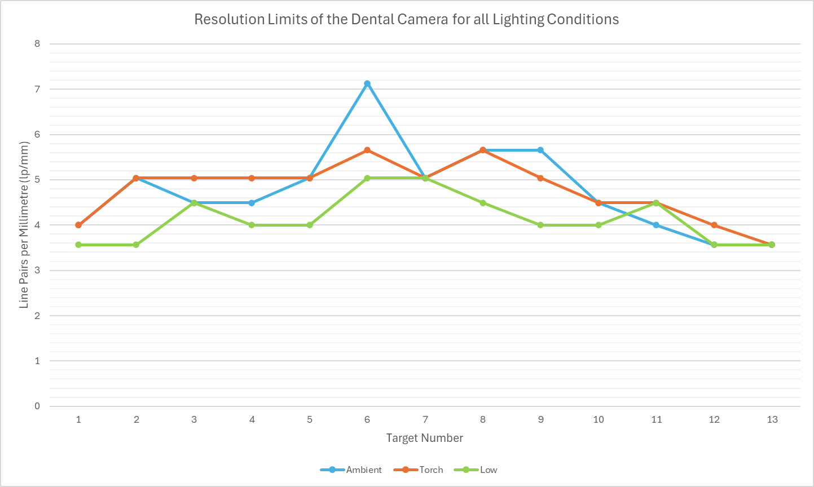

Figure 64: Graphical Representation of Table 7

Table 8: The visual limits and calculated lp/mm for the DSLR Camera in all lighting conditions.
Lighting Conditions |  |  | Ambient |  |  | Ambient with Torch |  |  | Low
Target No. | Group No. | Element No. |  | Lp/mm | Group No. | Element No. | Lp/mm | Group No. |  | Element No. | Lp/mm
1 | 4 | 1 |  | 16 | 4 | 3 | 20.1587368 | 4 |  | 2 | 18
2 | 4 | 1 |  | 16 | 4 | 3 | 20.1587368 | 4 |  | 3 | 20.2
3 | 4 | 1 |  | 16 | 4 | 3 | 20.1587368 | 4 |  | 3 | 20.2
4 | 4 | 3 |  | 20.2 | 4 | 3 | 20.1587368 | 4 |  | 3 | 20.2
5 | 4 | 3 |  | 20.2 | 4 | 3 | 20.1587368 | 4 |  | 3 | 20.2
6 | 4 | 3 |  | 20.2 | 4 | 3 | 20.1587368 | 4 |  | 3 | 20.2
7 | 4 | 3 |  | 20.2 | 4 | 3 | 20.1587368 | 4 |  | 3 | 20.2
8 | 4 | 3 |  | 20.2 | 4 | 3 | 20.1587368 | 4 |  | 3 | 20.2
9 | 4 | 2 |  | 18 | 4 | 3 | 20.1587368 | 4 |  | 2 | 18
10 | 4 | 2 |  | 18 | 4 | 2 | 17.95939277 | 4 |  | 1 | 16
11 | 3 | 5 |  | 12.7 | 3 | 4 | 11.3137085 | 3 |  | 3 | 10.1
12 | 3 | 2 |  | 8.98 | 3 | 1 | 8 | 2 |  | 5 | 6.35
13 | 2 | 6 |  | 7.13 | 2 | 3 | 5.0396842 | 2 |  | 2 | 4.49
14 | 2 | 1 |  | 4 | 1 | 6 | 3.563594873 | 1 |  | 6 | 3.56
15 | 1 | 5 |  | 3.17 | 1 | 1 | 2 | 1 |  | 1 | 2

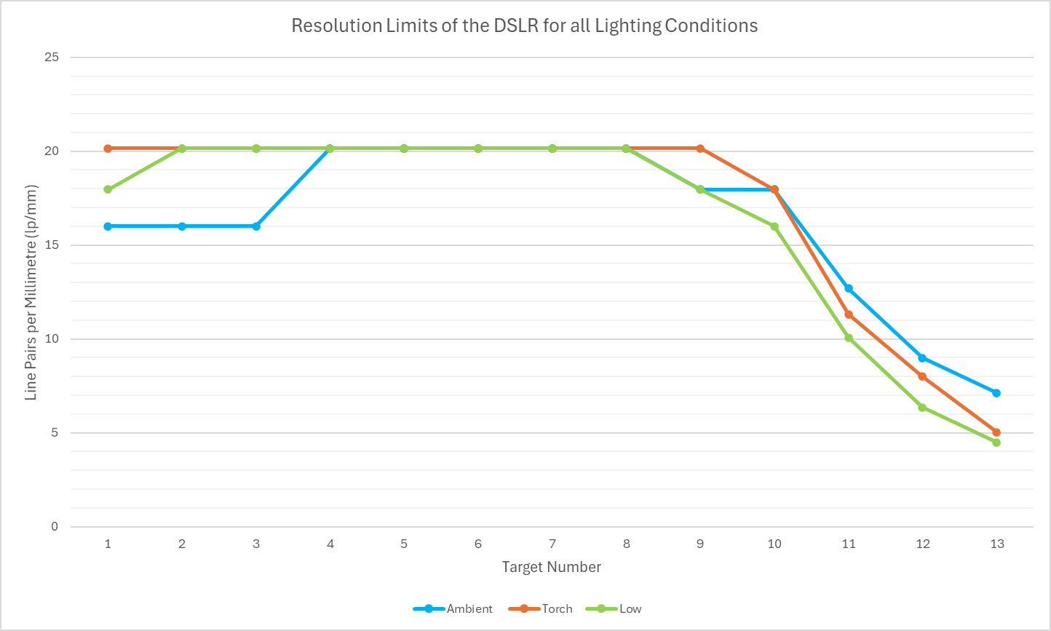

Figure 65: Graphical Representation of Table 8

Table 9: The visual limits and calculated lp/mm for the Otoscope in all lighting conditions.
Lighting Conditions |  |  | Ambient |  |  | Ambient with Torch |  |  | Low
Target No. | Group No. | Element No. |  | Lp/mm | Group No. | Element No. | Lp/mm | Group No. |  | Element No. | Lp/mm
1 | 1 | 4 |  | 2.83 | 1 | 5 | 3.17 | 1 |  | 3 | 2.52
2 | 1 | 5 |  | 3.17 | 2 | 1 | 4 | 1 |  | 4 | 2.83
3 | 2 | 1 |  | 4 | 2 | 1 | 4 | 1 |  | 5 | 3.17
4 | 2 | 1 |  | 4 | 2 | 2 | 4.49 | 2 |  | 1 | 4
5 | 2 | 1 |  | 4 | 2 | 2 | 4.49 | 2 |  | 1 | 4
6 | 2 | 3 |  | 5.04 | 2 | 3 | 5.04 | 2 |  | 3 | 5.04
7 | 2 | 3 |  | 5.04 | 2 | 3 | 5.04 | 2 |  | 2 | 4.49
8 | 2 | 1 |  | 4 | 2 | 3 | 5.04 | 2 |  | 1 | 4
9 | 2 | 1 |  | 4 | 2 | 1 | 4 | 2 |  | 1 | 4
10 | 2 | 1 |  | 4 | 2 | 1 | 4 | 2 |  | 1 | 4
11 | 1 | 6 |  | 3.56 | 2 | 2 | 4.49 | 1 |  | 6 | 3.56
12 | 1 | 5 |  | 3.17 | 2 | 2 | 4.49 | 1 |  | 6 | 3.56
13 | 1 | 4 |  | 2.83 | 1 | 4 | 2.83 | 1 |  | 5 | 3.17
14 | 1 | 2 |  | 2.24 | 1 | 2 | 2.24 | 1 |  | 2 | 2.24
15 | 0 | 1 |  | 1 | 0 | 1 | 1 | 0 |  | 1 | 1

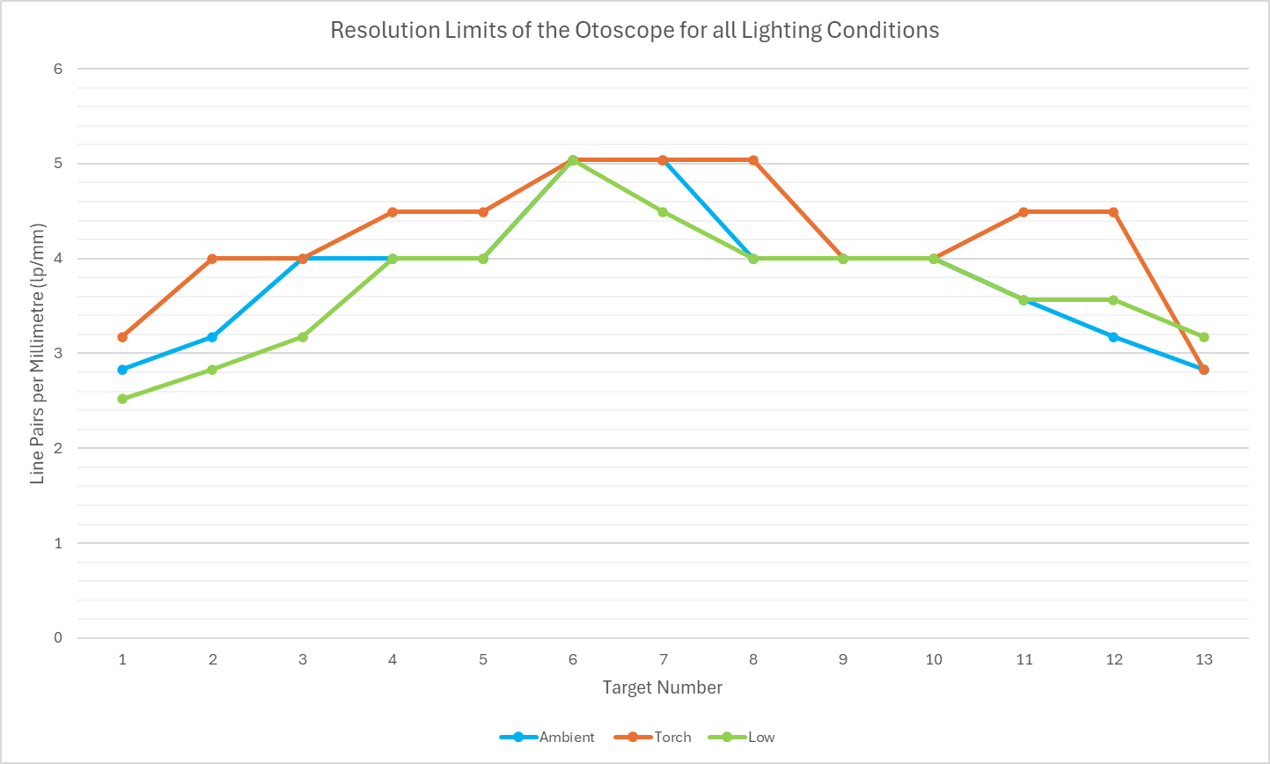
Figure 66: Graphical Representation of Table 9

Table 10: The visual limits and calculated lp/mm for the Iphone in all lighting conditions.
Lighting Conditions |  |  | Ambient |  |  | Ambient with Torch |  |  | Low
Target No. | Group No. | Element No. |  | Lp/mm | Group No. | Element No. | Lp/mm | Group No. |  | Element No. | Lp/mm
1 | Group | Element |  | lp/mm | 3 | 1 | 8 | 2 |  | 6 | 7.13
2 | 3 | 1 |  | 8 | 3 | 1 | 8 | 2 |  | 6 | 7.13
3 | 3 | 2 |  | 8.98 | 3 | 2 | 8.98 | 2 |  | 6 | 7.13
4 | 3 | 2 |  | 8.98 | 3 | 2 | 8.98 | 3 |  | 1 | 8
5 | 3 | 3 |  | 10.1 | 3 | 2 | 8.98 | 3 |  | 2 | 8.98
6 | 3 | 2 |  | 8.98 | 3 | 2 | 8.98 | 3 |  | 2 | 8.98
7 | 3 | 2 |  | 8.98 | 3 | 2 | 8.98 | 3 |  | 3 | 10.1
8 | 3 | 2 |  | 8.98 | 3 | 2 | 8.98 | 3 |  | 2 | 8.98
9 | 3 | 2 |  | 8.98 | 3 | 2 | 8.98 | 3 |  | 2 | 8.98
10 | 3 | 2 |  | 8.98 | 3 | 2 | 8.98 | 3 |  | 2 | 8.98
11 | 3 | 2 |  | 8.98 | 3 | 1 | 8 | 3 |  | 1 | 8
12 | 3 | 3 |  | 10.1 | 2 | 5 | 6.35 | 2 |  | 6 | 7.13
13 | 3 | 2 |  | 8.98 | 2 | 4 | 5.66 | 2 |  | 3 | 5.04
14 | 2 | 4 |  | 5.66 | 1 | 5 | 3.17 | 1 |  | 6 | 3.56
15 | 2 | 1 |  | 4 | 1 | 2 | 2.24 | 1 |  | 1 | 2

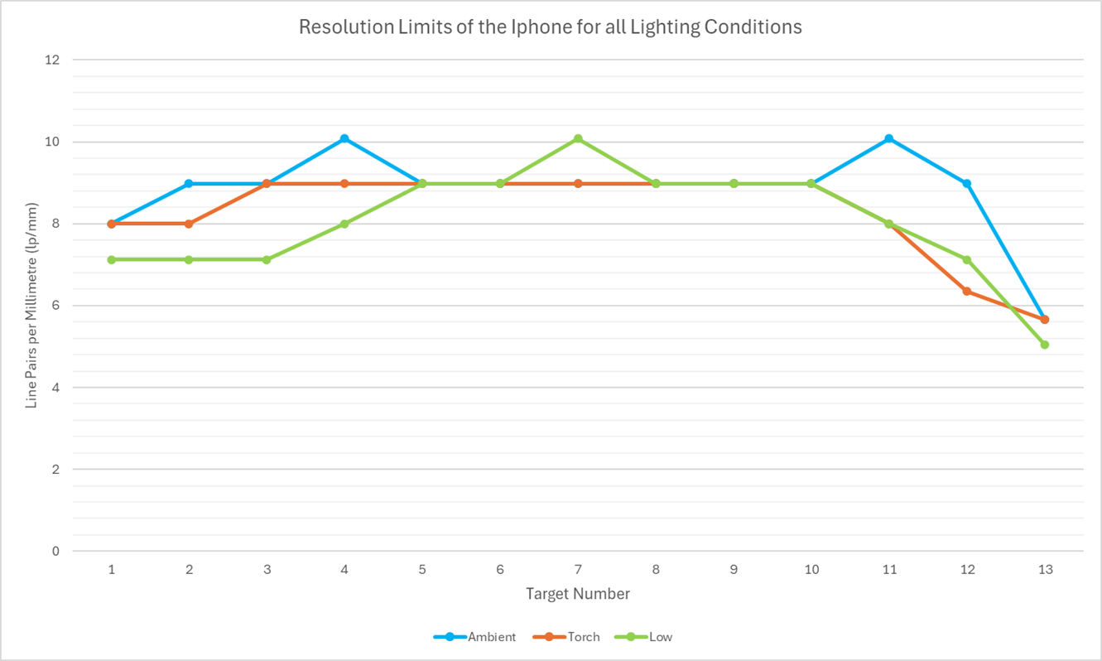

Figure 67: Graphical Representation of Table 10
Table 11: The visual limits and calculated lp/mm for the Teslong Straight in all lighting conditions.
Lighting Conditions |  |  | Ambient |  |  | Ambient with Torch |  |  | Low
Target No. | Group No. | Element No. |  | Lp/mm | Group No. | Element No. | Lp/mm | Group No. |  | Element No. | Lp/mm
1 | 2 | 1 |  | 4 | 2 | 3 | 5.04 | 2 |  | 1 | 4
2 | 2 | 2 |  | 4.49 | 2 | 3 | 5.04 | 2 |  | 2 | 4.49
3 | 2 | 3 |  | 5.04 | 2 | 3 | 5.04 | 2 |  | 2 | 4.49
4 | 2 | 3 |  | 5.04 | 2 | 3 | 5.04 | 2 |  | 2 | 4.49
5 | 2 | 3 |  | 5.04 | 2 | 3 | 5.04 | 2 |  | 3 | 5.04
6 | 2 | 3 |  | 5.04 | 2 | 3 | 5.04 | 2 |  | 3 | 5.04
7 | 2 | 2 |  | 4.49 | 2 | 3 | 5.04 | 2 |  | 3 | 5.04
8 | 2 | 3 |  | 5.04 | 2 | 3 | 5.04 | 2 |  | 3 | 5.04
9 | 2 | 2 |  | 4.49 | 2 | 3 | 5.04 | 2 |  | 3 | 5.04
10 | 2 | 2 |  | 4.49 | 2 | 3 | 5.04 | 2 |  | 3 | 5.04
11 | 2 | 2 |  | 4.49 | 2 | 2 | 4.49 | 2 |  | 2 | 4.49
12 | 1 | 6 |  | 3.56 | 1 | 6 | 3.56 | 2 |  | 1 | 4
13 | 1 | 3 |  | 2.52 | 1 | 5 | 3.17 | 1 |  | 4 | 2.83
14 | 1 | 1 |  | 2 | 1 | 2 | 2.24 | 1 |  | 2 | 2.24
15 | 0 | 2 |  | 1.12 | 0 | 2 | 1.12 | 0 |  | 3 | 1.26

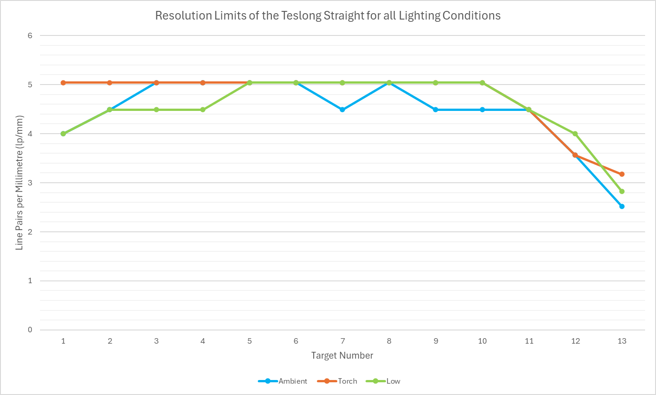

Figure 68: Graphical Representation of Table 11

Table 12: The visual limits and calculated lp/mm for the Teslong Side in all lighting conditions.

Lighting Conditions |  |  | Ambient |  |  | Ambient with Torch |  |  | Low
Target No. | Group No. | Element No. |  | Lp/mm | Group No. | Element No. | Lp/mm | Group No. |  | Element No. | Lp/mm
1 | 2 | 2 |  | 4.49 | 2 | 2 | 4.49 | 2 |  | 2 | 4.49
2 | 2 | 3 |  | 5.04 | 2 | 3 | 5.04 | 2 |  | 3 | 5.04
3 | 2 | 3 |  | 5.04 | 2 | 3 | 5.04 | 2 |  | 3 | 5.04
4 | 2 | 3 |  | 5.04 | 2 | 3 | 5.04 | 2 |  | 3 | 5.04
5 | 2 | 3 |  | 5.04 | 2 | 4 | 5.66 | 2 |  | 4 | 5.66
6 | 2 | 3 |  | 5.04 | 2 | 3 | 5.04 | 2 |  | 4 | 5.66
7 | 2 | 3 |  | 5.04 | 2 | 3 | 5.04 | 2 |  | 4 | 5.66
8 | 2 | 3 |  | 5.04 | 2 | 2 | 4.49 | 2 |  | 3 | 5.04
9 | 2 | 2 |  | 4.49 | 2 | 1 | 4 | 2 |  | 3 | 5.04
10 | 2 | 2 |  | 4.49 | 2 | 1 | 4 | 2 |  | 3 | 5.04
11 | 2 | 2 |  | 4.49 | 2 | 2 | 4.49 | 2 |  | 2 | 4.49
12 | 2 | 1 |  | 4 | 2 | 1 | 4 | 2 |  | 1 | 4
13 | 1 | 5 |  | 3.17 | 1 | 3 | 2.52 | 1 |  | 5 | 3.17
14 | 1 | 1 |  | 2 | 1 | 1 | 2 | 1 |  | 1 | 2
15 | 0 | 2 |  | 1.12 | 0 | 1 | 1 | 0 |  | 2 | 1.12

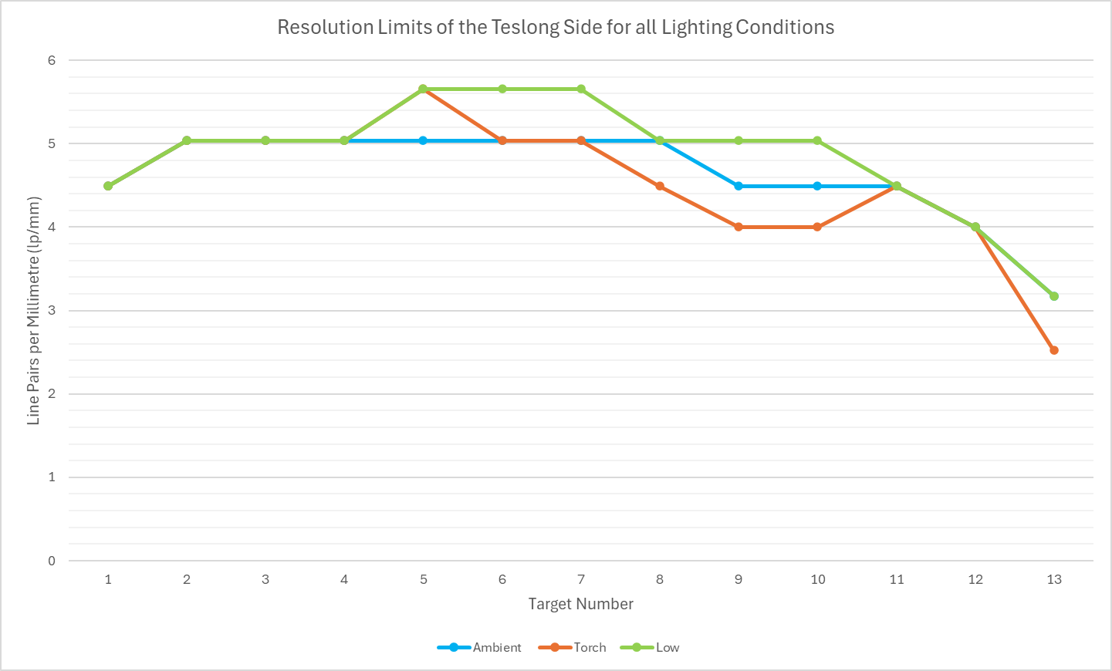

Figure 69: Graphical Representation of Table 12

3.1.2 Pixel Per Inch Results

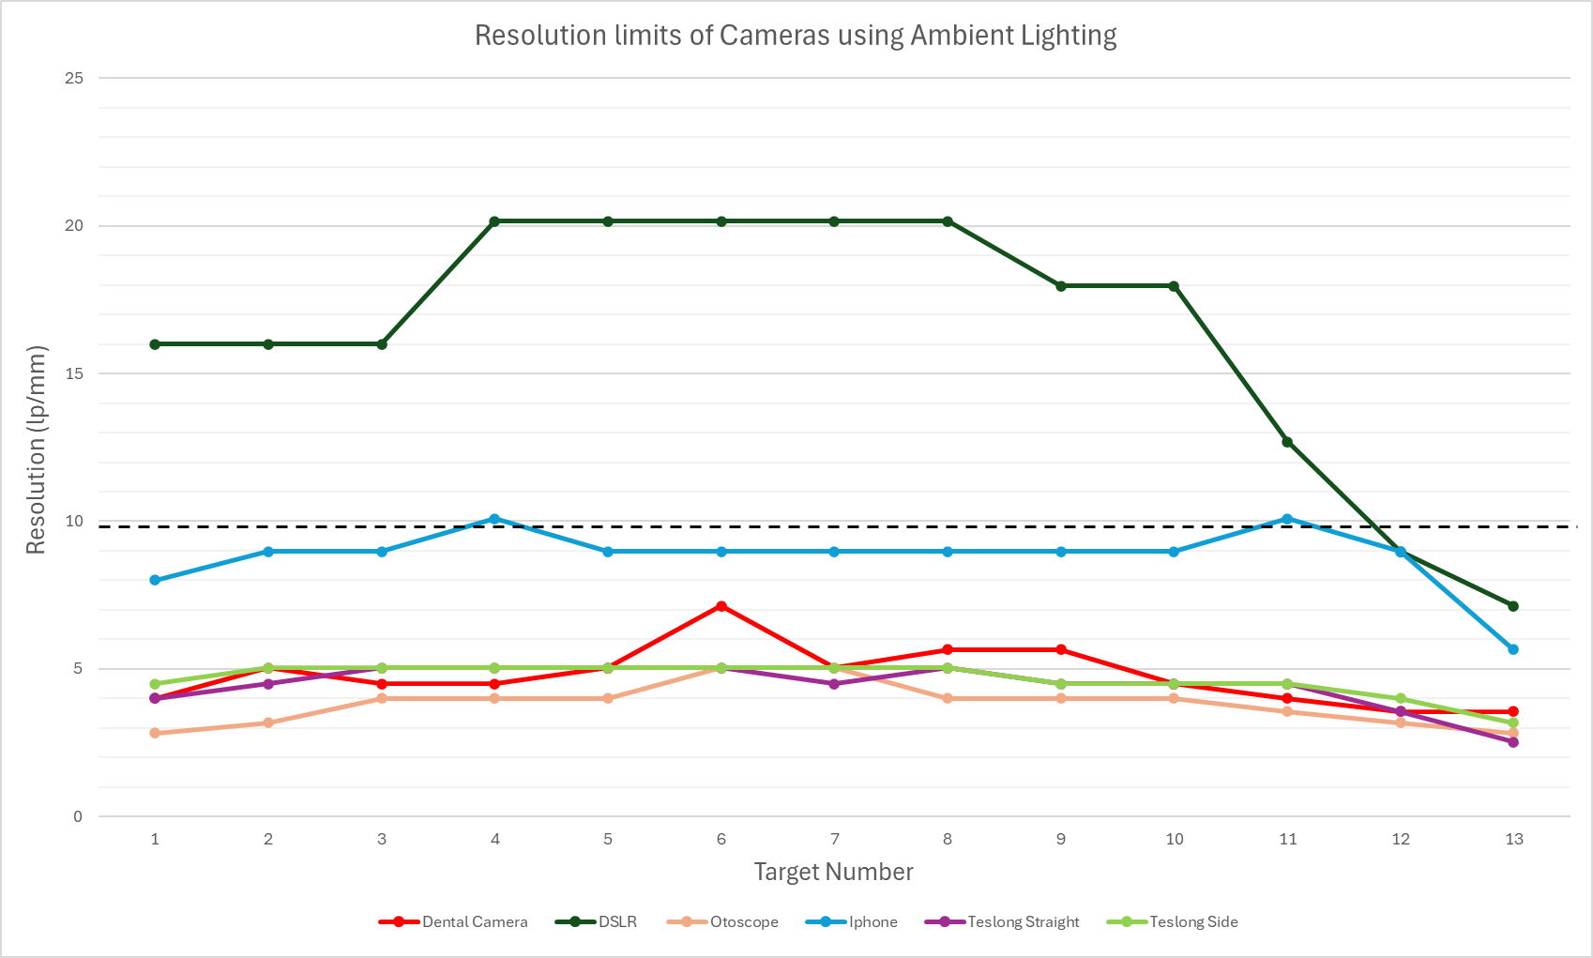
3.1.2.1 Results for SWGDE guidelines
Figure 70: The graph demonstrates the resolution limit of each camera within the different number targets on the USAF resolution and contrast target Captured in Ambient Lighting.

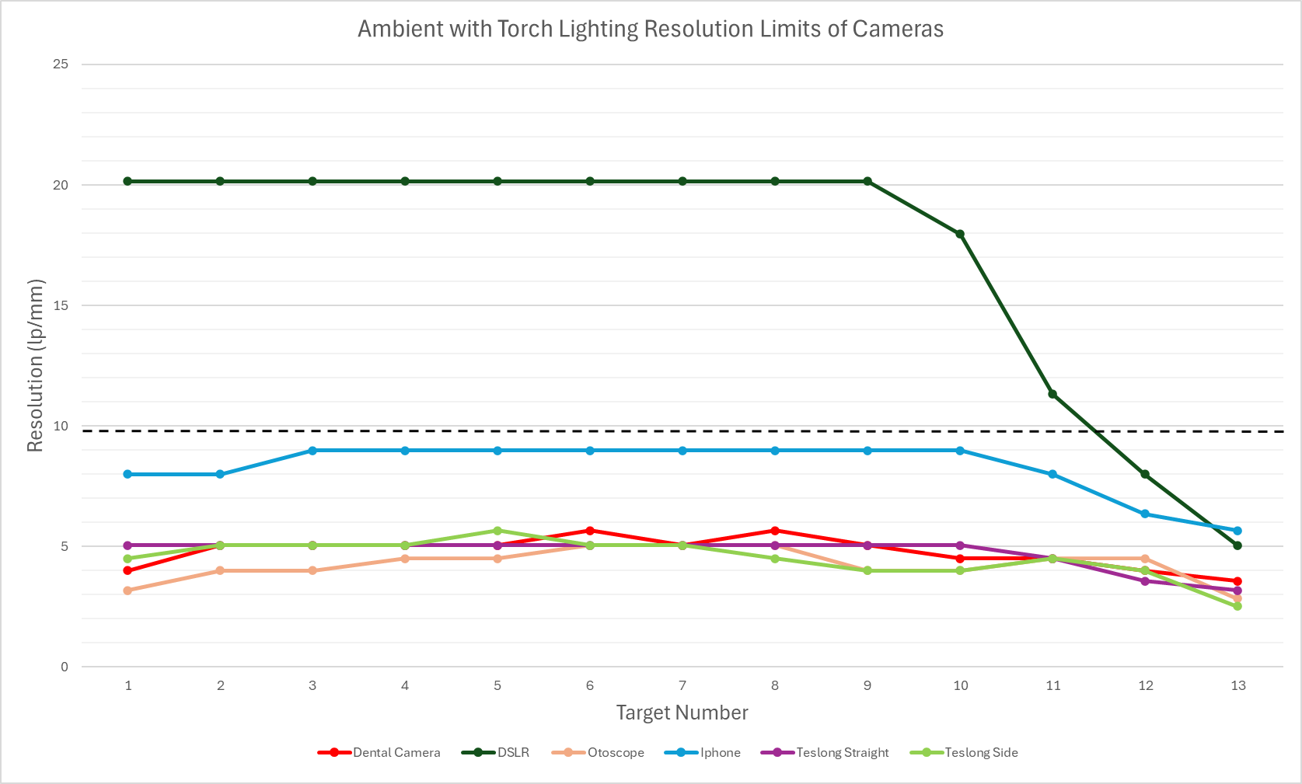
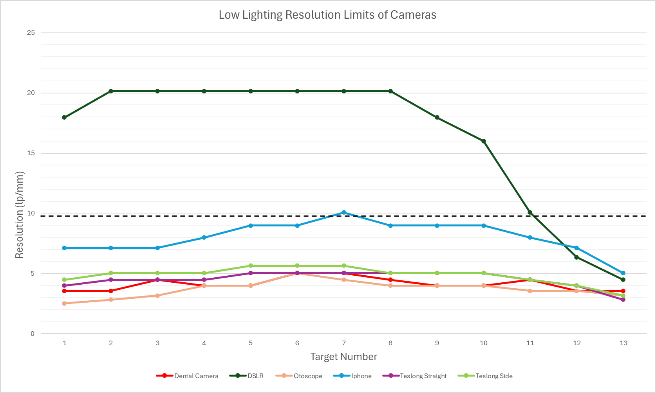
Figure 71: The graph demonstrates the resolution limit of each camera within the different number targets on the USAF resolution and contrast target captured in ambient with torch lighting.
Figure 72: The graph demonstrates the resolution limit of each camera within the different number targets on the USAF resolution and contrast target captured in low lighting.

3.1.2.2 PPI Results from FCS measurements
Table 13: Recorded PPi measurements from FCS for each lighting conditions
Camera Type | Lighting Type | PPI
Dental Camera | Ambient | 2404
 | Ambient with Torch | 2418
DSLR | Ambient | 8575
 | Ambient with Torch | 8559
Iphone | Ambient | 2652
 | Ambient with Torch | 2615
Otoscope | Ambient | 2621
 | Ambient with Torch | 2633
Teslong Straight | Ambient | 1146
 | Ambient with Torch | 1147
Teslong Side | Ambient | 1236
 | Ambient with Torch | 1238

3.1.3 Depth of Field Results
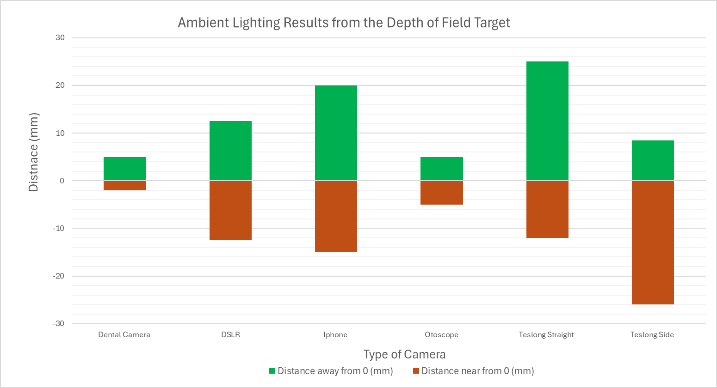
Table 14: Recorded Depth of Field Results for each lighting condition
A.
Camera Type | Lighting Type | Distance away from 0 (mm) | Distance near 0 (mm)
Dental Camera | Ambient | 5 | 2
Dental Camera | Ambient with Torch | 5 | 2
DSLR | Ambient | 12.5 | -12.5
DSLR | Ambient with Torch | 12.5 | -12
Iphone | Ambient | 20 | -15
Iphone | Ambient with Torch | 12 | -14
Otoscope | Ambient | 5 | -5
Otoscope | Ambient with Torch | 5 | -5
Teslong Straight | Ambient | 25 | -12
Teslong Straight | Ambient with Torch | 30 | -11.5
Teslong Side | Ambient | 8.5 | -26
Teslong Side | Ambient with Torch | 8.5 | -26

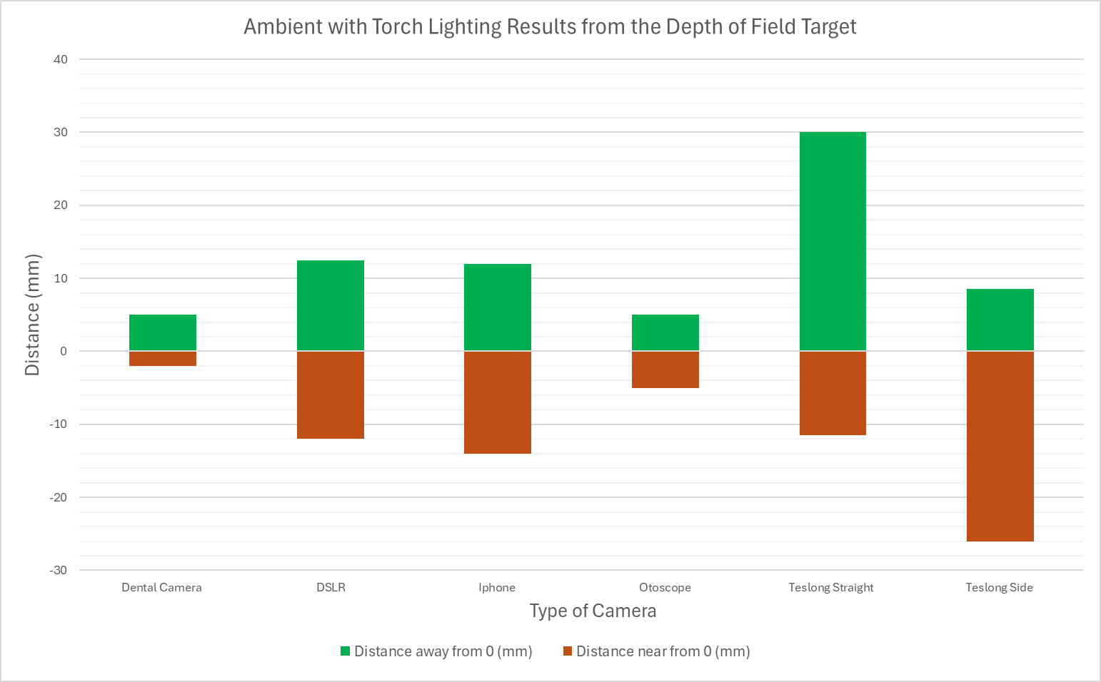
B.

Figure 73: Graph depicting the results from the depth of field targets for the cameras tested. A. ambient lighting. B. ambient with torch lighting.

3.1.4 Distortion Results
Table 15: Amount and type of distortion between the alternate cameras
Camera Types | Lighting condition | AD (mm) | PD (mm) | Distortion (%) | Type of distortion
Dental Camera | Ambient | 23.25 | 10 | 1.33 | Pincushion
Otoscope | Ambient | 14.21 | 4.47 | 2.18 | Pincushion
Iphone | Ambient | 12.81 | 12.81 | 0 | No distortion
Teslong Straight | Ambient | 10.27 | 12.81 | -0.20 | Barrel
Teslong Side | Ambient | 13.88 | 12.81 | 0.08 | Pincushion

3.1.5 Colour Accuracy Results
Table 16: Colour difference for each alternate camera compared to the ground truth
Camera Type | Lighting Conditions | Level of difference
Dental Camera | Ambient | 3
Dental Camera | Ambient with Torch | 3
Dental Camera | Low | 3
Dental Camera | Lightbox (Home) | 3
Dental Camera | Lightbox (Office) | 3
Dental Camera | Lightbox (Outside) | 3
Otoscope | Ambient | 3
Otoscope | Ambient with Torch | 3
Otoscope | Low | 3
Otoscope | Lightbox (Home) | 3
Otoscope | Lightbox (Office) | 3
Otoscope | Lightbox (Outside) | 3
Iphone | Ambient | 1
Iphone | Ambient with Torch | 1
Iphone | Low | 1
Iphone | Lightbox (Home) | 1
Iphone | Lightbox (Office) | No Difference
Iphone | Lightbox (Outside) | 1
Teslong Straight | Ambient | 1
Teslong Straight | Ambient with Torch | 2
Teslong Straight | Low | 2
Teslong Straight | Lightbox (Home) | 2
Teslong Straight | Lightbox (Office) | 1
Teslong Straight | Lightbox (Outside) | 1
Teslong Side | Ambient | 2
Teslong Side | Ambient with Torch | 2
Teslong Side | Low | 2
Teslong Side | Lightbox (Home) | 2
Teslong Side | Lightbox (Office) | 1
Teslong Side | Lightbox (Outside) | 1

3.1.6 CAST Grading Results
CAST grading was performed on the images specified in part 1 to investigate an alternate’s camera’s ability to capture different type of fingermarks from latent to different coloured powders. Any images that contained a hot spot from the led lighting contained in some alternate cameras in which the light could not be turned off or covered was removed from CAST grading. These cameras include the dental camera and otoscope, their images were removed from as a fingermark image containing a hotspot is not used operationally, this would be a determining factor in eliminating cameras for fingermark capture. The median was taken from the three graders scores, median was chosen as this gave whole numbers as results instead of point numbers. Any camera image’s that consistently scored under a 2 meaning there is no clear ridge detail present was consider incapable of capturing that type of fingermark.
The DSLR grades for all types of fingermarks were either 3 or 4, ensuring that the fingermarks were of high quality and had sufficient detail for the cameras to capture. If a camera scored lower was due to the camera’s image quality not the quality of the fingermark. The results within the following sections graphically represent the median grade for each type of fingermark target within each lighting condition tested.

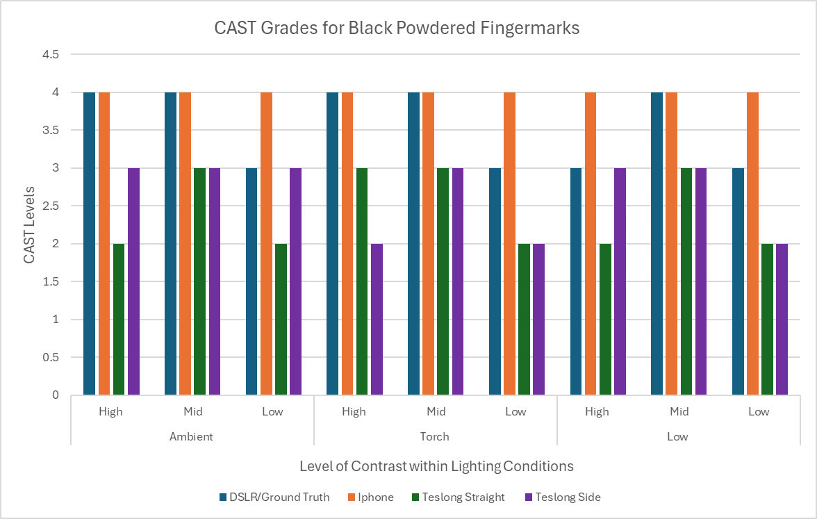
3.1.6.2 CAST Grading Results for Black powdered Fingermark Target
Figure 74: The graphically represent of the median grade for each type of black powdered fingermark target within each lighting condition tested.

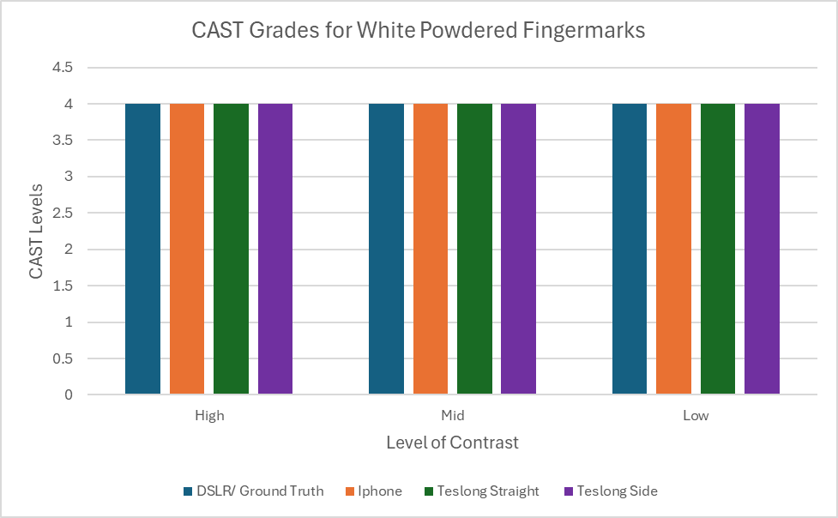
3.1.6.2 CAST Grading Results for White Fingermark Targets
Figure 75: The graphically represent of the median grade for each type of white powdered fingermark target using diffused reflection as its lighting conditions.

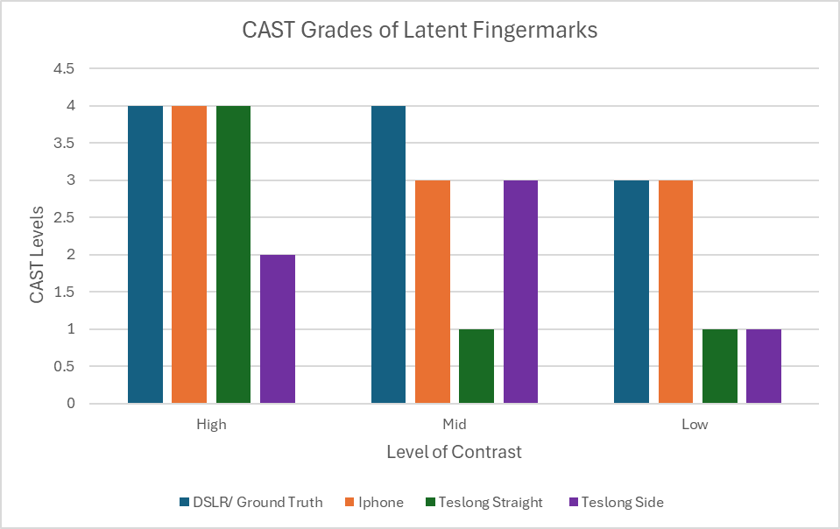
3.1.6.3 CAST Grading Results for Latent Fingermark Targets

Figure 76: The graphically represent of the median grade for each type of latent fingermark target using diffused reflection as its lighting conditions.

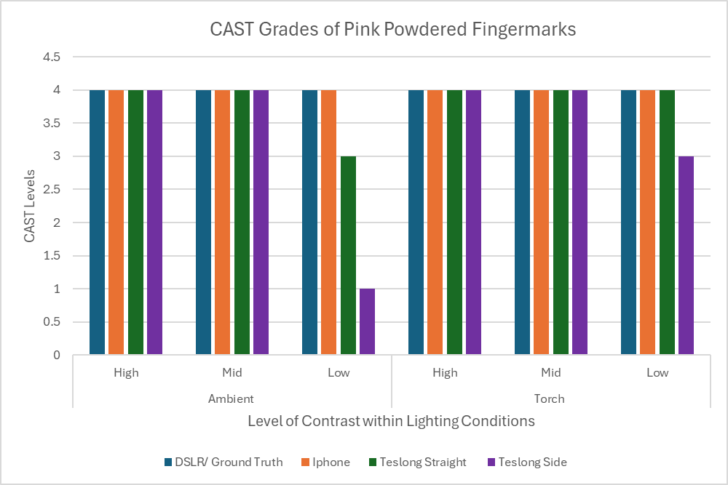
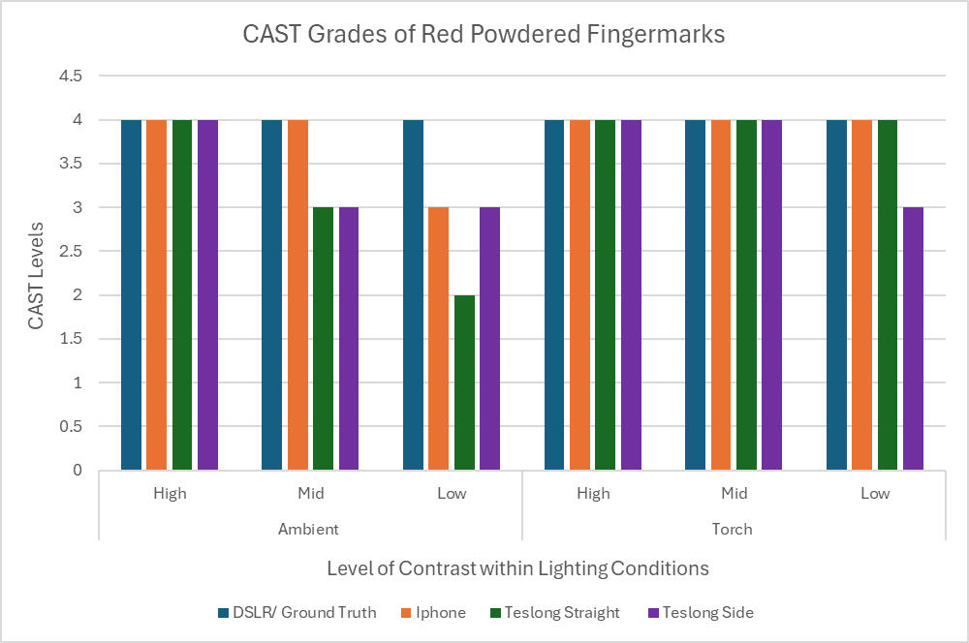
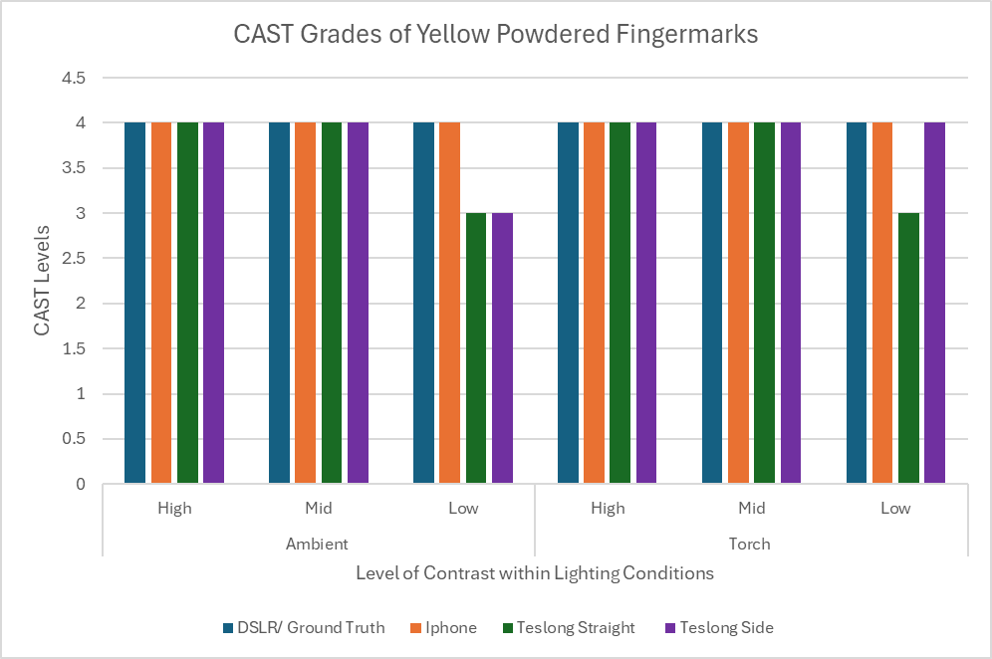
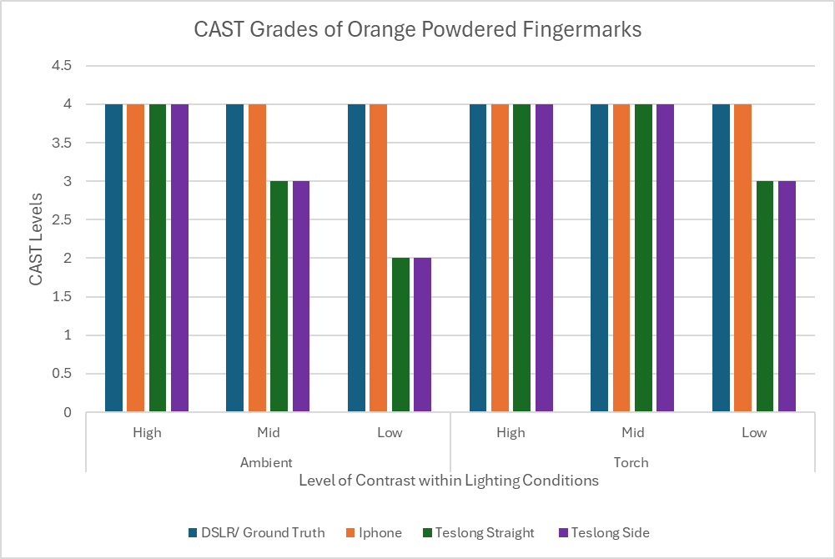
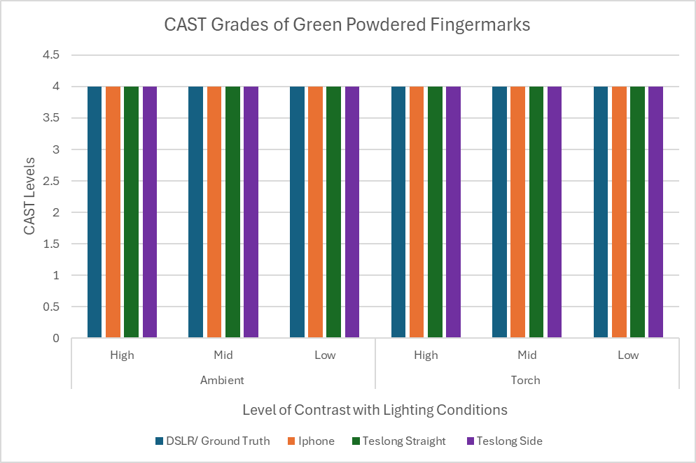
3.1.6.4 CAST Grading Results for Coloured powdered Fingermark Targets
A.
B.
C.
D.
E.

Figure 77: The graphically represent of the median grade for each type of coloured fingermark targets within each lighting condition tested. a. Orange Powder. B. Pink Powder. C. Red powder. D. Yellow powder. E. Green powder.

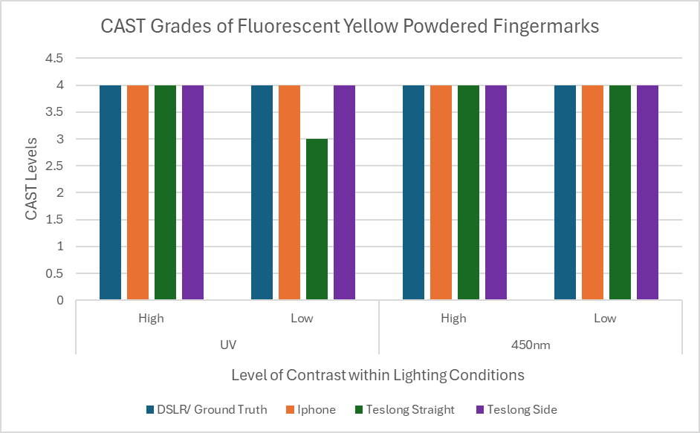
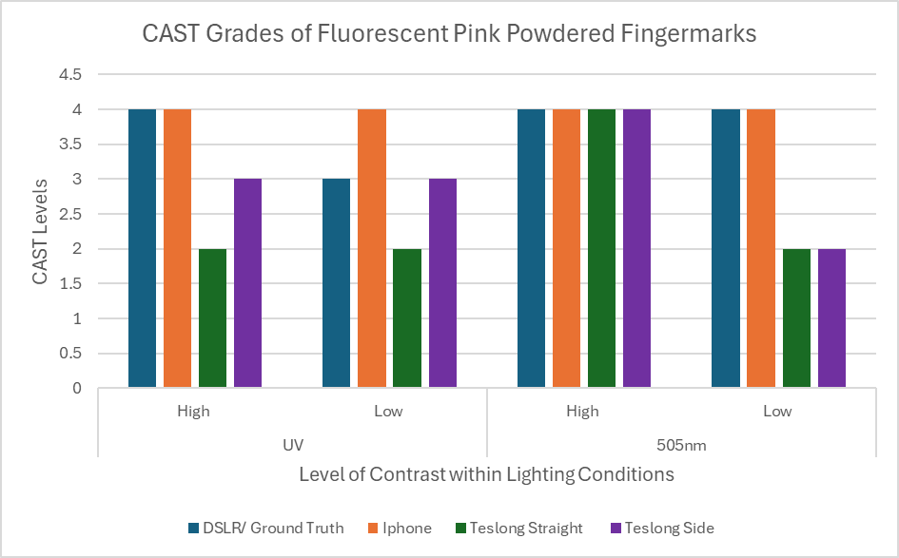
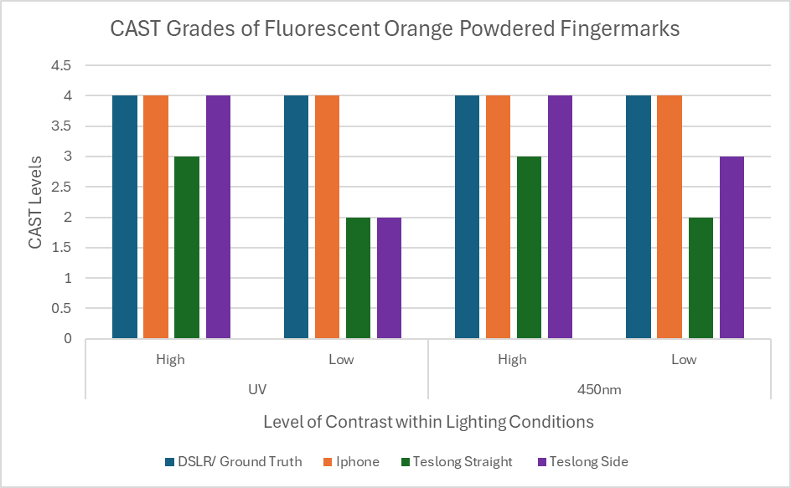
3.1.6.5 CAST Grading Results for Fluorescent powdered Fingermark Targets
D.
C.
B.
A.
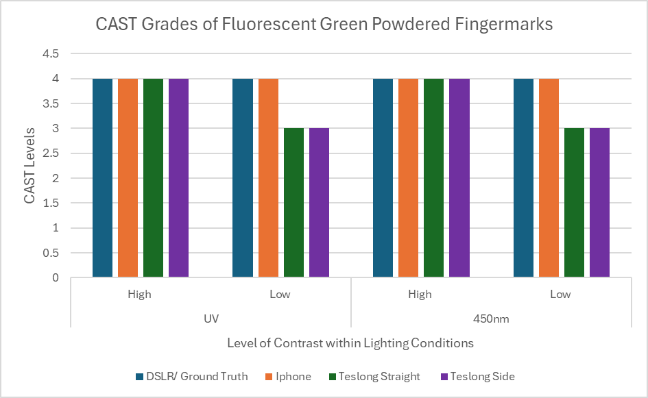
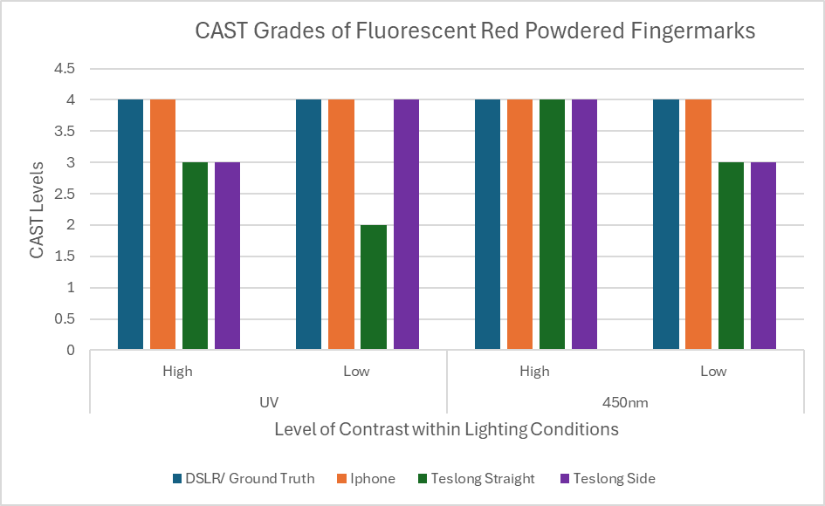

E.

Figure 78: The graphically represent of the median grade for each type of fluorescent fingermark targets within each lighting condition tested. a. Orange Powder. B. Pink Powder. C. Red powder. D. Yellow powder. E. Green powder.
Table 17: Optimal power level of polilight for each type of alternate Camera to best capture each type fluorescent powder
Name of Camera | Colour of Powder | Optimal Power Level
Dental Camera | Pink | UV = 2 - 3
Dental Camera | Pink | 505nm = 4
Dental Camera | Green | UV = 3
Dental Camera | Green | 450nm = 2 - 3
Dental Camera | Orange | UV = 2 - 3
Dental Camera | Orange | 450nm = 2
Dental Camera | Red | UV = 2 - 4
Dental Camera | Red | 450nm = 2 - 3
Dental Camera | Yellow | UV = 2 - 4
Dental Camera | Yellow | 450nm = 3 - 4
Otoscope | Pink | UV = 2 – 4
Otoscope | Pink | 505nm = 4
Otoscope | Green | UV = 1 – 3
Otoscope | Green | 450nm = 3 – 4
Otoscope | Orange | UV = 2 – 3
Otoscope | Orange | 450nm = 3
Otoscope | Red | UV = 3 – 6
Otoscope | Red | 450nm = 3
Otoscope | Yellow | UV = 3 – 4
Otoscope | Yellow | 450nm = 2 – 3
Iphone | Pink | UV = 3
Iphone | Pink | 505nm = 1 – 2
Iphone | Green | UV = 3
Iphone | Green | 450nm = 1
Iphone | Orange | UV = 2 – 3
Iphone | Orange | 450nm = 1 – 2
Iphone | Red | UV = 3 – 4
Iphone | Red | 450nm = 1
Iphone | Yellow | UV = 2 – 3
Iphone | Yellow | 450nm = 1
Teslong Straight | Pink | UV = 2 – 5
Teslong Straight | Pink | 505nm = 2
Teslong Straight | Green | UV = 3 – 4
Teslong Straight | Green | 450nm = 2
Teslong Straight | Orange | UV = 2 – 4
Teslong Straight | Orange | 450nm = 1 – 2
Teslong Straight | Red | UV = 3 – 4
Teslong Straight | Red | 450nm = 2
Teslong Straight | Yellow | UV = 3 – 5
Teslong Straight | Yellow | 450nm = 2 – 3
Teslong Side | Pink | UV = 2 – 5
Teslong Side | Pink | 505nm = 2
Teslong Side | Green | UV = 1 – 5
Teslong Side | Green | 450nm = 2 – 3
Teslong Side | Orange | UV = 2 – 5
Teslong Side | Orange | 450nm = 1 – 2
Teslong Side | Red | UV = 2 – 5
Teslong Side | Red | 450nm = 2
Teslong Side | Yellow | UV = 2 – 5
Teslong Side | Yellow | 450nm = 2 – 3

- Dynamic range, how many shades of grey can the camera capture.
- Mode for CAST grading.
- Average for UC

3.2 Part 2 Fingermark Image Quality Results

3.2.1 Black Powdered Fingermarks

3.2.2 White Powdered Fingermarks

3.2.3 Latent Fingermarks

3.3 Part 3 Practicality Results
The following sections contained the filled-out forms from Table 5 for each camera for each situation. The forms were filled out while conducting these experiments and all observations were recorded to detail how each camera handled in the given situations. The lifts for all situations were photographed using the DSLR camera on a copy stand.

3.3.1 Situation 1: Behind a doorhandle

Table 18: DSLR/ Standard Methods results for situation 1.
Factors of practicability | Results | Observations
Time Taken | Black High: 10mins 28 secs  Black Mid: 3mins 46 secs  Black Low: 2mins 59secs  White High: 3mins 58secs  White Mid: 2mins 15secs  White Low: 4mins 50secs | 1st print took extra time to work out how to successful capture the print. The tripod and holding the mirror were unsuccessful. The mirror had to be taped to the door to capture the print, while using the flash.  Diffused reflection causes the light from the flash to be reflected in the mirror.
One or two hands needed | Two hands | Handheld camera and flash
Use of additional equipment e.g. mirror | Small handheld mirror and tape | The mirror was taped to door to gain a reflection of the fingermark for photographic capture. If unable to tape the mirror the fingermark could not be captured via the DSLR.
Lighting needed e.g. flash or torch | Flash needed with sync cord | Flash angled towards the actual print not the mirror and was held as far back as possible. This was difficult to achieve due to limited working space (5cm). The flash was angled to skim across lift for diffused reflection to capture the white powdered fingermarks.  The 2 second timer was used to allow the flash to be positioned correctly before capture.
Ease of viewing (e.g. attached viewing screen or additional viewing screen) | Attached viewing screen to camera | The viewfinder was the better option compared to live view while capturing these fingermarks.
Storage of images (SD card or device storage) | SD Card
Successful capture of fingermark (Image includes full fingermark, linear scale and space for a label) | Yes | Fingermark was captured clearly. Linear scale and label can be included in image. But there is distortion to the print as its reflection on the mirror was captured not the actual print.
Security of images | SD card manual transfer of files into secure locations | Ensure SD card is always kept in a secure location and images are transferred to appropriate locations as soon as possible.
Camera Settings | Mode: Manual  Metering: Evaluative  Aperture: f/22  Shutter speed: 1/125th  Exposure: 0 (black powdered fingermarks) and -0.3 (white powdered fingermarks)  ISO: 100

Table 19: Iphone results for situation 1.
Factors of practicability | Results | Observations
Time Taken | Black High: 6mins 58secs  Black Mid: 2mins 46secs  Black Low: 2mins 36secs  White High: 2mins 8secs  White Mid: 2mins 35secs  White Low: 2mins 17secs | 1st print took extra time to work out how to successful capture the print.  The focal distance is greater than the distance between the fingermark and the door, so a mirror is needed.  To capture the mark the angle of the Iphone and the reflection of the mark both cause distortion.  The lighting used for diffused reflection causes the light to be reflected in the mirror.
One or two hands needed | Two hands | One hand to control the Iphone and the other to operate the torch.
Use of additional equipment e.g. mirror | Small mirror and tape | The mirror had to be taped to door to allow for the torch to be used.  Able to capture the mark holding the mirror but without the torch. Lighting is needed to properly capture the mark.
Lighting needed e.g. flash or torch | Torch | The torch was held at a 45-degree angle and held back to gain even lighting. The torch was angled to skim across the mark for diffused reflection.
Ease of viewing (e.g. attached viewing screen or additional viewing screen) | Iphone screen is attached to lens. | The screen is in a fixed position and must be viewed in order to successfully capture subject.
Storage of images (SD card or device storage) | Images stored to Iphone’s storage. | The images need to be moved to a secure location from the phone’s storage.
Successful capture of fingermark (Image includes full fingermark, linear scale and space for a label) | Yes | Images clear. Linear scale and label can be included in image.  Distortion caused by mirror.
Security of images | Low security as the Iphone used was not password protected. | Need to ensure there are security measures such as a password to protect the images on the Iphone and moved to a secure location as soon as possible to maintain image integrity.
Camera Settings | Flash disabled  2x magnification camera  Auto focus  Photo mode

Table 20: Dental Camera results for situation 1.
Factors of practicability | Results | Observations
Time Taken | Black High: 2mins 20sec  Black Mid: 4mins 6secs  Black Low: 3mins 38 secs  White High: 2mins 16 secs  White Mid: 1min 40secs  White Low: 4mins 34secs | Capturing a print was quicker in this situation using the dental camera.
One or two hands needed | Two hands | One to operate the camera the other to operate the torch. The dental camera had a capture button on the device itself to allow for one handed operation of the camera.
Use of additional equipment e.g. mirror | To allow for torch use a universal mobile phone stand was used. The stand held the phone while capturing marks. | Able to capture print without the use of a mirror.  The phone stand allowed the Iphone to be hooked around the researcher’s neck to allow for use of both hands one to hold the device the other for holding a torch.
Lighting needed e.g. flash or torch | Device has in built flash that cannot be turned off. | A torch can only be used when the phone can be placed down or placed into the phone stand. Torch held at a 45-degree angle and held back to gain even lighting. The torch was angled to skim across lift for diffused reflection.
Ease of viewing (e.g. attached viewing screen or additional viewing screen) | Separate viewing screen needed that is capable of Wi-Fi connection. An app is required on phone to use the camera. | The Iphone was used as the viewing screen, through the DT-WIFI app.
Storage of images (SD card or device storage) | Viewing screen’s storage | The images will be stored onto whatever device is used at the viewing screen for the dental camera
Successful capture of fingermark (Image includes full fingermark, linear scale and space for a label) | No, only partial print captured | Part of the print and linear scale were captured clearly. At times only part of the print was captured, and it was not always clear due to the cameras small focal range. Camera could not capture a full print along with a linear scale and label.
Security of images | Depends on viewing screen used. | Need to ensure there are security measures such as a password to protect the images on the Iphone and moved to a secure location as soon as possible to maintain image integrity.
Camera settings | 1920 x 1080 resolution

Table 21: Teslong Straight for situation 1.
Factors of practicability | Results | Observations
Time Taken | Black High: 4mins 55secs  Black Mid: 3mins 36secs  Black Low: 2mins 25secs  White High: 2mins 45secs  White Mid: 2 mins 7secs  White Low: 1min 55secs | Camera appears on reflection within the mirror and covers the fingermark if it gets close enough to focus.  The marks are out of focus in the mirror and the camera struggles to capture the reflection.  The flash causes the light to reflect in the mirror.
One or two hands needed | Two Hands | One to hold viewing screen and the other to focus camera lens.
Use of additional equipment e.g. mirror | Mirror | Able to handhold the mirror along with the device.
Lighting needed e.g. flash or torch | No torch could be used.  Flash was used for white powdered prints. | A torch could not be used as both hands were needed for holding the screen and device.  The flash was used for white powdered prints to be able to see the dusted mark. There was a hotspot from the flash.
Ease of viewing (e.g. attached viewing screen or additional viewing screen) | Screen attached to the fibre optic camera | The screen and camera are one device. The screen can be held while the lens is moved into position allowing for easy viewing.
Storage of images (SD card or device storage) | Mirco SD card | Difficult to insert and remove SD card.
Successful capture of fingermark (Image includes full fingermark, linear scale and space for a label) | No  Low white couldn’t be captured at all. | The print is captured but it is out of focus due to not being able to get close enough to the mark.
Security of images | Mirco SD card with manual transfer of files into secure locations | Ensure SD card is always kept in a secure location and images are transferred to appropriate locations as soon as possible.
Camera Settings | Default camera settings.

Table 22: Teslong Side results for situation 1.
Factors of practicability | Results | Observations
Time Taken | Black High: 2mins 52 secs  Black Mid: 2mins 58secs  Black Low: 4mins 10secs  White High: 2mins 30secs  White Mid: 2mins 4secs  White Low: 2mins 26secs | Able to capture print without additional equipment.  Unable to capture horizontal photos due to situation.
One or two hands needed | Two Hands | One to hold viewing screen and the other to focus camera lens
Use of additional equipment e.g. mirror | No
Lighting needed e.g. flash or torch | No torch could be used.  Flash was used for white powdered prints. | A torch could not be used as both hands were needed for holding the screen and device.  The flash was used for white powdered prints to be able to see the dusted mark. There was a hotspot from the flash.
Ease of viewing (e.g. attached viewing screen or additional viewing screen) | Screen attached to the fibre optic camera | The screen and camera are one device. The screen can be held while the lens is moved into position allowing for easy viewing.
Storage of images (SD card or device storage) | Mirco SD card | Difficult to insert and remove SD card.
Successful capture of fingermark (Image includes full fingermark, linear scale and space for a label) | Yes | Print captured clearly, linear scale and label can be captured in image.
Security of images | Mirco SD card with manual transfer of files into secure locations | Ensure SD card is always kept in a secure location and images are transferred to appropriate locations as soon as possible.
Camera Settings | Default camera settings

Table 23: Otoscope results for situation 1.
Factors of practicability | Results | Observations
Time Taken | Black High: 2min 54secs  Black Mid: 4mins 42secs  Black Low: 1min 29 secs  White High: 1 min 10secs  White Mid: 1min 7secs  White Low: 1min 23secs | The flash on the camera reflects off the mirror which affects the captured image.  Device cannot get close enough to mirror or print to focus.  Due to the small focal range it is extremely difficult to focus camera when operating handheld.
One or two hands needed | Two hands | One hand to operate the device and the other to hold the viewing screen.
Use of additional equipment e.g. mirror | Mirror | Able to hold mirror and camera with one hand.  Even with the mirror taped to door the images captured are of the same quality taping and hand holding the mirror.
Lighting needed e.g. flash or torch | Device has in built flash that cannot be turned off. Without a torch diffused reflection cannot be achieved. Which is needed for the white prints | A torch couldn’t be used due to both hands needed for holding the screen and device.
Ease of viewing (e.g. attached viewing screen or additional viewing screen) | Separate viewing screen needed that is capable of Wi-Fi connection. App required on phone to used device | Samsung Galaxy S22 used as the viewing screen with Smart Endoscope app.
Storage of images (SD card or device storage) | Viewing screen’s memory | The images will be stored onto whatever device is used at the viewing screen for the dental camera
Successful capture of fingermark | No, print is not in focus after multiple attempts. | The reflection causes distortion which the camera has trouble capturing.  The flash on the camera reflects off the mirror which affects the captured image.
Security of images | Depends on viewing screen used. | In this case with the Samsung there needs to be security measures such as a password to protect the images on the Samsung, to ensure image integrity.
Camera Settings | Default camera settings as it cannot be changed.

Table 24: Lift results for situation 1.
Factors of practicability | Results | Observations
Time Taken | Black High:1min 40secs  Black Mid: 2mins  Black Low: 2mins  White High: 2mins  White Mid: 2mins 29 secs  White Low: 50secs `  Ensure that print is next to the lift’s linear scale before lifting and cautious has to be taken so print is not cut off. | When the print is lifted the linear scale sticker comes with it sometimes. In some cases, not all the print collected in the lift. Time, equipment and hands is the results of how the lift is taken not the photographing of the lift.  The remaining results are how the lift was photographed.  The reflective surface of the lift causes issues when photographing, the air bubbles and cover surface both reflect light affecting the image of the actual mark.
One or two hands needed | Two hands | One to lift the other for the mirror
Use of additional equipment e.g. mirror | Mirror | A mirror was needed to see the print before lifting, would not lift print blind.
Lighting needed e.g. flash or torch | Flash needed with sync cord | Flash angled 45 degrees towards the print and was held to gain even illumination. The flash was angled to skim across lift for diffused reflection to capture the white powdered fingermarks.  The 2 second timer was used to allow the flash to be positioned correctly before capture.
Ease of viewing (e.g. attached viewing screen or additional viewing screen) | Attached viewing screen to camera | The screen could be flipped out to view the mark while capturing the photo.
Storage of images (SD card or device storage) | SD Card
Successful capture of fingermark (Image includes full fingermark, linear scale and space for a label) | Yes | Fingermark was captured clearly. Linear scale and label can be included in image. But there is distortion to the print as its reflection on the mirror was captured not the actual print.
Security of images | SD card manual transfer of files into secure locations | Ensure SD card is always kept in a secure location and images are transferred to appropriate locations as soon as possible.
Camera Settings | Mode: Manual and AV  Metering: Evaluative  Aperture: f/16 and f/22  Shutter speed: 1/125th  Exposure: -0.3  ISO: 100  2 second timer

3.3.1.1 Situation 1 CAST grading results

3.3.2 Situation 2: On top of a fence
Table 25: DSLR/ Standard Methods results for situation 2.
Factors of practicability | Results | Observations
Time Taken | Black High: 7 mins 17 secs  Black Mid: 5mins 15secs  Black Low: 7 mins 56secs  White High: 7 mins 3 secs  White Mid: 4min 17 secs  White Low: 6mins 22secs | Difficult to focus camera while hand holding device. Hand cramps occur due to holding the heavy equipment in awkward positions for extended amount of time.
One or two hands needed | Two hands | Difficult to manage flash and camera without touching apparatus. Difficult to hold equipment in position for successful capture.
Use of additional equipment e.g. mirror | Stepladder if available | Due to the limitations of the researcher’s height, a stepladder was needed to capture the print. Capturing the print without the stepladder was conducted beforehand and was unsuccessful.
Lighting needed e.g. flash or torch | Flash needed with sync cord | Flash angled 45 degrees towards the print and was held to gain even illumination. The flash was angled to skim across lift for diffused reflection to capture the white powdered fingermarks.  The 2 second timer was used to allow the flash to be positioned correctly before capture.
Ease of viewing (e.g. attached viewing screen or additional viewing screen) | Attached viewing screen to camera | The screen could be flipped out to view the mark while capturing the photo.
Storage of images (SD card or device storage) | SD Card
Successful capture of fingermark (Image includes full fingermark, linear scale and space for a label) | Yes | Fingermark was captured clearly. Linear scale and label can be included in image. But there is distortion to the print as its reflection on the mirror was captured not the actual print.
Security of images | SD card manual transfer of files into secure locations | Ensure SD card is always kept in a secure location and images are transferred to appropriate locations as soon as possible.
Camera Settings | Mode: Manual and AV  Metering: Evaluative  Aperture: f/16 and f/22  Shutter speed: 1/125th or 1/250th  Exposure: 0  ISO: 100  2 second timer

Table 26: Iphone results for situation 2.
Factors of practicability | Results | Observations
Time Taken | Black High: 2 mins 4 secs  Black Mid: 1min 18 secs  Black Low: 1min 56 secs  White High: 2mins 15 secs  White Mid: 3mins 52 secs  White Low: 2mins 10secs | Moving the shutter button or using the side button to capture photos allows for easier one-handed operation of the device.
One or two hands needed | Two hands | One hand is needed to operate the device. The other is to operate the torch.
Use of additional equipment e.g. mirror | Stepladder | Due to the limitations of the researcher’s height, a stepladder was needed to capture the print. Capturing the print without the stepladder was conducted beforehand and was unsuccessful.
Lighting needed e.g. flash or torch | Torch | The torch was held at a 45-degree angle and held back to gain even lighting. The torch was angled to skim across the mark for diffused reflection.
Ease of viewing (e.g. attached viewing screen or additional viewing screen) | Iphone screen is attached to lens. | The screen is in a fixed position and must be viewed to successfully capture subject.
Storage of images (SD card or device storage) | Images stored to Iphone’s storage. | The images need to be moved to a secure location from the phone’s storage.
Successful capture of fingermark (Image includes full fingermark, linear scale and space for a label) | Yes | Images clear. Linear scale and label can be included in image.
Security of images | Low security as the Iphone used was not password protected. | Need to ensure there are security measures such as a password to protect the images on the Iphone and moved to a secure location as soon as possible to maintain image integrity.
Camera Setting | Flash disabled  2x magnification camera  Auto focus  Photo mode

Table 27: Dental Camera results for situation 2.
Factors of practicability | Results | Observations
Time Taken | Black High: 3 mins 23 secs  Black Mid: 1 min 20 secs  Black Low: 4mins 41 secs  White High: 2mins 2 secs  White Mid: 4mins 5secs  White Low: 4mins 35 secs | Difficult to focus camera. Since the focal length is so short, focusing and staying still is very difficult since the smallest moment affects the image quality.  White powder marks were captured better than black powder marks.
One or two hands needed | Two hands | One to operate the camera the other to operate the torch. The dental camera had a capture button on the device itself to allow for one handed operation of the camera.
Use of additional equipment e.g. mirror | To allow for torch use a universal mobile phone stand was used. The stand held the phone while capturing marks. | The phone stand allowed the Iphone to be hooked around the researcher’s neck to allow for use of both hands one to hold the device the other for holding a torch.
Lighting needed e.g. flash or torch | Device has in built flash that cannot be turned off. | A torch can only be used when the phone can be placed down or placed into the phone stand. Torch held at a 45-degree angle and held back to gain even lighting. The torch was angled to skim across lift for diffused reflection.
Ease of viewing (e.g. attached viewing screen or additional viewing screen) | Separate viewing screen needed that is capable of Wi-Fi connection. An app is required on phone to use the camera. | The Iphone was used as the viewing screen, through the DT-WIFI app.
Storage of images (SD card or device storage) | Viewing screen’s storage | The images will be stored onto whatever device is used at the viewing screen for the dental camera
Successful capture of fingermark (Image includes full fingermark, linear scale and space for a label) | No, only partial print captured | Part of the print and linear scale were captured clearly. At times only part of the print was captured, and it was not always clear due to the cameras small focal range. Camera could not capture a full print along with a linear scale and label.
Security of images | Depends on viewing screen used. | Need to ensure there are security measures such as a password to protect the images on the Iphone and moved to a secure location as soon as possible to maintain image integrity.
Camera Settings | 1920 x 1080 resolution

Table 28: Teslong Straight for situation 2.
Factors of practicability | Results | Observations
Time Taken | Black High: 4mins 30secs  Black Mid: 2mins  Black Low: 4mins 54 secs  White High: 6mins 36secs  White Mid: 8mins and 38 secs  White Low: 6min 5secs | Difficult to focus camera with long fibre optic cable.
One or two hands needed | Two Hands | One to hold viewing screen the other to focus camera lens.
Use of additional equipment e.g. mirror | No | Was able to capture print from the ground.
Lighting needed e.g. flash or torch | No torch could be used.  Flash was used for white powdered prints. | A torch could not be used as both hands were needed for holding the screen and device.  The flash was used for white powdered prints to be able to see the dusted mark. There was a hotspot from the flash.
Ease of viewing (e.g. attached viewing screen or additional viewing screen) | Screen attached to the fibre optic camera | The screen and camera are one device. The screen can be held while the lens is moved into position allowing for easy viewing.
Lighting needed e.g. flash or torch | No torch could be used.  Flash was used for white powdered prints. | A torch could not be used as both hands were needed for holding the screen and device.  The flash was used for white powdered prints to be able to see the dusted mark. There was a hotspot from the flash.
Successful capture of fingermark (Image includes full fingermark, linear scale and space for a label) | Yes | Print captured clearly, linear scale and label can be captured in image.
Security of images | Mirco SD card with manual transfer of files into secure locations | Ensure SD card is always kept in a secure location and images are transferred to appropriate locations as soon as possible.
Camera Settings | Default camera settings

Table 29: Teslong Side results for situation 2.
Factors of practicability | Results | Observations
Time Taken | Black High: 2 mins 21secs  Black Mid: 4mins 55 secs  Black Low: 3mins 16secs  White High: 3mins 48 secs  White Mid: 6mins 2 secs  White Low: 2mins 50secs | The side camera is easier to focus than the straight in this situation. Linear scale in focus but fingermark looks out of focus. Difficult to focus handheld.
One or two hands needed | Two Hands | One to hold viewing screen the other to focus camera lens
Use of additional equipment e.g. mirror | No | Able to capture print from the ground.
Lighting needed e.g. flash or torch | No torch could be used.  Flash was used for white powdered prints. | A torch could not be used as both hands were needed for holding the screen and device.  The flash was used for white powdered prints to be able to see the dusted mark. There was a hotspot from the flash.
Ease of viewing (e.g. attached viewing screen or additional viewing screen) | Screen attached to the fibre optic camera | The screen and camera are one device. The screen can be held while the lens is moved into position allowing for easy viewing.
Storage of images (SD card or device storage) | Mirco SD card | Difficult to insert and remove SD card.
Successful capture of fingermark (Image includes full fingermark, linear scale and space for a label) | Yes | Print captured clearly, linear scale and label can be captured in image.
Security of images | Mirco SD card with manual transfer of files into secure locations | Ensure SD card is always kept in a secure location and images are transferred to appropriate locations as soon as possible.
Camera Settings | Default camera settings

Table 30: Otoscope results for situation 2.
Factors of practicability | Results | Observations
Time Taken | Black High: 3mins 30secs  Black Mid: 2 mins 40 secs  Black Low: 4mins 30secs  White High: 2min 56secs  White Mid: 2mins 50secs  White Low: 2mins 10secs | Difficult to focus camera. Since the focal length is so short, focusing and staying still is very difficult since the smallest moments affect the image quality.  Impossible to focus as image keeps changing orientation on the app to account for camera movement. Cannot focus device while using it handheld.
One or two hands needed | Two hands | One hand to operate the device and the other to hold the viewing screen.
Use of additional equipment e.g. mirror | No | Was able to capture print from the ground
Lighting needed e.g. flash or torch | Device has in built flash that cannot be turned off. Without a torch diffused reflection cannot be achieved. Which is needed for the white prints | A torch couldn’t be used due to both hands needed for holding the screen and device.
Ease of viewing (e.g. attached viewing screen or additional viewing screen) | Separate viewing screen needed that is capable of wifi connection. App required on phone to used device | Samsung Galaxy S22 used as the viewing screen.
Storage of images (SD card or device storage) | Viewing screen’s memory | The images will be stored onto whatever device is used at the viewing screen for the dental camera
Successful capture of fingermark | No, only partial print captured. 2nd time round couldn’t capture print. Print is not in focus after multiple attempts. | Part of the print and linear scale were captured but couldn’t get the camera to focus with a limited focal length. Also, couldn’t capture a full print along with a linear scale and label.
Security of images | Depends on viewing screen used. | In this case with the Samsung need to ensure there are security measures such as a password to protect the images on the Samsung, to reduce the risk of images being exposed.
Camera Settings | Default camera settings as it cannot be changed

Table 31: Lift results for situation 2.
Factors of practicability | Results | Observations
Time Taken | Black High: 1min 14 secs  Black Mid: 2 min 11 secs  Black Low: 1 min 6secs  White High: 1min 27secs  White Mid: 2 mins 36 secs  White Low: 1min 58secs | When the print is lifted the linear scale sticker comes with it sometimes. In some cases, not all the print collected in the lift. Time, equipment and hands is the results of how the lift is taken not the photographing of the lift.  The remaining results are how the lift was photographed.  The reflective surface of the lift causes issues when photographing, the air bubbles and cover surface both reflect light affecting the image of the actual mark.
One or two hands needed | Two hands
Use of additional equipment e.g. mirror | Stepladder needed to view print to lift it correctly. | If there is no ladder couldn’t lift the prints, would not lift the print blind.
Lighting needed e.g. flash or torch | Flash needed with sync cord | Flash angled 45 degrees towards the print not and was held to gain even illumination. The flash was angled to skim across lift for diffused reflection to capture the white powdered fingermarks.  The 2 second timer was used to allow the flash to be positioned correctly before capture.
Ease of viewing (e.g. attached viewing screen or additional viewing screen) | Attached viewing screen to camera | The screen could be flipped out to view the mark while capturing the photo.
Storage of images (SD card or device storage) | SD Card
Successful capture of fingermark (Image includes full fingermark, linear scale and space for a label) | Yes | Fingermark was captured clearly. Linear scale and label can be included in image. But there is distortion to the print as its reflection on the mirror was captured not the actual print.
Security of images | SD card manual transfer of files into secure locations | Ensure SD card is always kept in a secure location and images are transferred to appropriate locations as soon as possible.
Camera Setting | Mode: Manual and AV  Metering: Evaluative  Aperture: f/16 and f/22  Shutter speed: 1/125th  Exposure: 0  ISO: 100  2 second timer

3.3.2.1 Situation 2 CAST grading results

3.3.3 Situation 3: Outside of windowsill of a tall building
Table 32: DSLR/ Standard Methods results for situation 3.
Factors of practicability | Results | Observations
Time Taken | Black High: 10mins 01 secs  Black Mid: 2mins 47secs  Black Low: 3mins 56secs  White High: 1min 30secs  White Mid: 1min 32secs  White Low: 1min 39secs | Hand cramping due to holding camera out with one hand and for an extended time.  First print took extra time to work out how to successfully capture the print.
One or two hands needed | Two Hands | Difficult to hold camera with one hand due to its weight.
Use of additional equipment e.g. mirror | No
Lighting needed e.g. flash or torch | Flash needed with sync cord | Flash angled 45 degrees towards the print not and was held to gain even illumination. The flash was angled to skim across lift for diffused reflection to capture the white powdered fingermarks.  The 2 second timer was used to allow the flash to be positioned correctly before capture.
Ease of viewing (e.g. attached viewing screen or additional viewing screen) | Attached viewing screen to camera | The screen could be flipped out to view the mark while capturing the photo.
Storage of images (SD card or device storage) | SD Card
Successful capture of fingermark (Image includes full fingermark, linear scale and space for a label) | Yes | Fingermark was captured clearly. Linear scale and label can be included in image. But there is distortion to the print as its reflection on the mirror was captured not the actual print.
Security of images | SD card manual transfer of files into secure locations | Ensure SD card is always kept in a secure location and images are transferred to appropriate locations as soon as possible.
Camera Settings | Mode: Manual  Metering: Evaluative  Aperture: f/16  Shutter speed: 1/125th  Exposure: -0.3  ISO: 100
Table 33: Iphone results for situation 3.
Factors of practicability | Results | Observations
Time Taken | Black High: 2mins 13secs  Black Mid: 2mins 27secs  Black Low: 4mins 28secs  White High: 4mins 22secs  White Mid: 1min 35secs  White Low: 1min 40secs | Awkward hand holding of device to gain access to capture print, highly likely to drop phone when capturing the fingermark in this situation. Due to the position of hands the settings can be changed accidently due to the device’s touchscreen while photographing.
One or two hands needed | Two hands | One hand is needed to operate the device. The other is to operate the torch.
Use of additional equipment e.g. mirror | No
Lighting needed e.g. flash or torch | Torch  Flash on Iphone causes hotspot on the print. | Torch held at a 45-degree angle and farther back from the subject to gain even illumination.  Difficult to handle Iphone while trying to achieve diffused reflection. (light skimmed)
Ease of viewing (e.g. attached viewing screen or additional viewing screen) | Iphone screen is attached to lens. | The screen is in a fixed position and must be viewed to successfully capture subject.
Storage of images (SD card or device storage) | Images stored to Iphone’s storage. | The images need to be moved to a secure location from the phone’s storage.
Successful capture of fingermark (Image includes full fingermark, linear scale and space for a label) | Yes | Images clear. Linear scale and label can be included in image.
Security of images | Low security as the Iphone used was not password protected. | Need to ensure there are security measures such as a password to protect the images on the Iphone and moved to a secure location as soon as possible to maintain image integrity.
Camera Settings | Flash disabled  2x magnification camera  Auto focus  Photo mode

Table 34: Dental Camera results for situation 3.
Factors of practicability | Results | Observations
Time Taken | Black High: 3 mins 8secs  Black Mid: 2mins 11secs  Black Low: 2mins 11secs  White High: 2mins 37secs  White Mid: 1min 30secs  White Low: 1min 37secs | Separate screens allowed for device to held out over the window instead of leaning out.
One or two hands needed | Two hands | One to operate the camera the other to operate the torch. The dental camera had a capture button on the device itself to allow for one handed operation of the camera.
Use of additional equipment e.g. mirror | To allow for torch use a universal mobile phone stand was used. The stand held the phone while capturing marks. | The phone stand allowed the Iphone to be hooked around the researcher’s neck to allow for use of both hands one to hold the device the other for holding a torch.
Lighting needed e.g. flash or torch | Device has in built flash that cannot be turned off. | A torch can only be used when the phone can be placed down or placed into the phone stand. Torch held at a 45-degree angle and held back to gain even lighting. The torch was angled to skim across lift for diffused reflection.
Ease of viewing (e.g. attached viewing screen or additional viewing screen) | Separate viewing screen needed that is capable of Wi-Fi connection. An app is required on phone to use the camera. | The Iphone was used as the viewing screen, through the DT-WIFI app.
Storage of images (SD card or device storage) | Viewing screen’s storage | The images will be stored onto whatever device is used at the viewing screen for the dental camera
Successful capture of fingermark (Image includes full fingermark, linear scale and space for a label) | No, only partial print captured | Part of the print and linear scale were captured clearly. At times only part of the print was captured, and it was not always clear due to the cameras small focal range. Camera could not capture a full print along with a linear scale and label.
Security of images | Depends on viewing screen used. | Need to ensure there are security measures such as a password to protect the images on the Iphone and moved to a secure location as soon as possible to maintain image integrity.
Camera Settings | 1920 x 1080 resolution

Table 35: Teslong Straight for situation 3.
Factors of practicability | Results | Observations
Time Taken | Black High: 4mins 50secs  Black Mid: 1min 38secs  Black Low: 1min 25s  White High: 1min 19secs  White Mid: 1min 15secs  White Low: 1min 15secs | First print took extra time to work out how to successfully capture the print.
One or two hands needed | Two Hands | One to hold viewing screen the other to focus camera lens
Use of additional equipment e.g. mirror | No
Lighting needed e.g. flash or torch | Torch needed  Flash used for black prints to gain better lighting.  Flash used for white prints to attempt to achieve diffused reflection which is needed for white prints | A torch couldn’t be used due to both hands needed for holding the screen and device.  Hotspot from flash.
Ease of viewing (e.g. attached viewing screen or additional viewing screen) | Screen attached to the fibre optic camera | The screen and camera are one device
Storage of images (SD card or device storage) | Mirco SD card | Difficult to insert and remove SD card
Successful capture of fingermark | Yes | Print captured clearly, linear scale and label can be captured in image.
Security of images | Mirco SD card manual transfer of files into secure locations | Ensure SD card is kept in a secure location at all times and images are transferred to appropriate locations as soon as possible.
Camera Settings | Default camera settings

Table 36: Teslong Side results for situation 3.
Factors of practicability | Results | Observations
Time Taken | Black High: 2mins 15 secs  Black Mid: 3mins 57secs  Black Low: 1min 25secs  White High: 59secs  White Mid: 1min 35secs  White Low: 1min 47secs | Difficult to angle camera perpendicular to print.
One or two hands needed | Two Hands | One to hold viewing screen the other to focus camera lens
Use of additional equipment e.g. mirror | No
Lighting needed e.g. flash or torch | No torch could be used.  Flash was used for white powdered prints. | A torch could not be used as both hands were needed for holding the screen and device.  The flash was used for white powdered prints to be able to see the dusted mark. There was a hotspot from the flash.
Ease of viewing (e.g. attached viewing screen or additional viewing screen) | Screen attached to the fibre optic camera | The screen and camera are one device. The screen can be held while the lens is moved into position allowing for easy viewing.
Storage of images (SD card or device storage) | Mirco SD card | Difficult to insert and remove SD card.
Successful capture of fingermark (Image includes full fingermark, linear scale and space for a label) | Yes | Print captured clearly, linear scale and label can be captured in image.
Security of images | Mirco SD card with manual transfer of files into secure locations | Ensure SD card is always kept in a secure location and images are transferred to appropriate locations as soon as possible.
Camera Settings | Default camera settings.

Table 37: Lift results for situation 3.
Factors of practicability | Results | Observations
Time Taken | Black High: 44secs  Black Mid: 1min 5secs  Black Low: 40secs  White High: 57secs  White Mid: 38secs  White Low: 57secs | When the print is lifted the linear scale sticker comes with it. In some cases, not all the print collected in the lift. Time, equipment and hands is the results of how the lift is taken not the photographing of the lift.  The remaining results are how the lift was photographed.  The reflective surface of the lift causes issues when photographing, the air bubbles and cover surface both reflect light affecting the image of the actual mark.
One or two hands needed | Two hands
Use of additional equipment e.g. mirror | No
Lighting needed e.g. flash or torch | Flash needed with sync cord | Flash angled 45 degrees towards the print not and was held to gain even illumination. The flash was angled to skim across lift for diffused reflection to capture the white powdered fingermarks.  The 2 second timer was used to allow the flash to be positioned correctly before capture.
Ease of viewing (e.g. attached viewing screen or additional viewing screen) | Attached viewing screen to camera | The screen could be flipped out to view the mark while capturing the photo.
Storage of images (SD card or device storage) | SD Card
Successful capture of fingermark (Image includes full fingermark, linear scale and space for a label) | Yes | Fingermark was captured clearly. Linear scale and label can be included in image. But there is distortion to the print as its reflection on the mirror was captured not the actual print.
Security of images | SD card manual transfer of files into secure locations | Ensure SD card is always kept in a secure location and images are transferred to appropriate locations as soon as possible.
Camera Settings | Mode: Manual  Metering: Evaluative  Aperture: f/22  Shutter speed: 1/125th  Exposure: 0  ISO: 100  2 second timer.

The otoscope was removed from further testing after situation 2 onwards, as it was considered not suitable for practical use. The images captured during part three where out of focus and could not capture the fingermark even after multiple attempts. It was not reasonable to continue to test that camera as no usable images were being produced in either situation. Due to the camera’s focal range being too short made it impossible to focus properly while using it handheld to gain useable images of fingermarks.

3.3.3.1 Situation 3 CAST grading results

3.3.4 Situation 4: Under a handrail
Table 38: DSLR/ Standard Methods results for situation 4.
Factors of practicability | Results | Observations
Time Taken | Black High: 11mins 16 secs  Black Mid: 4mins 49secs  Black Low: 7mins 10secs  White High: 3mins 48secs  White Mid: 2mins 33secs  White Low: 2mins 39secs | First attempt is longest due to working out how to properly capture the print.  Second attempt the camera was handheld to compare the difference between handheld and use of a tripod. Hand gets sore holding camera in position
One or two hands needed | One hand when using tripod  Two hands needed without tripod | When tripod is used one hand is needed to hold the flash.  One hand to hold camera and other to hold flash.
Use of additional equipment e.g. mirror | Tripod | Tripod used to gain access to the print. On first and third attempt.  Handholding the device was the most appropriate approach to capturing marks in this situation.
Lighting needed e.g. flash or torch | Flash needed with sync cord | Flash angled 45 degrees towards the print and was held to gain even illumination. The flash was angled to skim across lift for diffused reflection to capture the white powdered fingermarks.  The 2 second timer was used to allow the flash to be positioned correctly before capture.
Ease of viewing (e.g. attached viewing screen or additional viewing screen) | Attached viewing screen to camera | The screen could be flipped out to view the mark while capturing the photo.
Storage of images (SD card or device storage) | SD Card
Successful capture of fingermark (Image includes full fingermark, linear scale and space for a label) | Yes | Fingermark was captured clearly. Linear scale and label can be included in image. But there is distortion to the print as its reflection on the mirror was captured not the actual print.
Security of images | SD card manual transfer of files into secure locations | Ensure SD card is always kept in a secure location and images are transferred to appropriate locations as soon as possible.
Camera Settings | Mode: Manual  Metering: Evaluative  Aperture: f/22  Shutter speed: 1/125th  Exposure: -0.3  ISO: 100

Table 39: Iphone results for situation 4.
Factors of practicability | Results | Observations
Time Taken | Black High: 1min 48secs  Black Mid: 2mins 18secs  Black Low: 1min 1sec  White High: 4mins 33secs  White Mid: 2mins 25secs  White Low: 2mins 50secs | Researcher had to get under the apparatus to capture the print. Difficult to see screen as it faces downwards. The iphone was easier to use compared to the DSLR in this situation.
One or two hands needed | Two hands | One hand is needed to operate the device. The other is to operate the torch.
Use of additional equipment e.g. mirror | No
Lighting needed e.g. flash or torch | Torch | The torch was held at a 45-degree angle and held back to gain even lighting. The torch was angled to skim across the mark for diffused reflection.
Ease of viewing (e.g. attached viewing screen or additional viewing screen) | Iphone screen is attached to lens. | The screen is in a fixed position and must be viewed in order to successfully capture subject.
Storage of images (SD card or device storage) | Images stored to Iphone’s storage. | The images need to be moved to a secure location from the phone’s storage.
Successful capture of fingermark (Image includes full fingermark, linear scale and space for a label) | Yes | Images clear. Linear scale and label can be included in image.
Security of images | Low security as the Iphone used was not password protected. | Need to ensure there are security measures such as a password to protect the images on the Iphone and moved to a secure location as soon as possible to maintain image integrity.
Camera Settings | Flash disabled  2x magnification camera  Auto focus  Photo mode

Table 40: Dental Camera results for situation 4.
Factors of practicability | Results | Observations
Time Taken | Black High: 3mins 46secs  Black Mid: 1min 45secs  Black Low: 1min 21secs  White High: 1min 30secs  White Mid: 2mins 55secs  White Low: 2mins 52secs | Hard to keep steady and in focus when capturing print.
One or two hands needed | Two hands | One to operate the camera the other to operate the torch. The dental camera had a capture button on the device itself to allow for one handed operation of the camera.
Use of additional equipment e.g. mirror | To allow for torch use a universal mobile phone stand was used. The stand held the phone while capturing marks. | The phone stand allowed the Iphone to be hooked around the researcher’s neck to allow for use of both hands one to hold the device the other for holding a torch.
Lighting needed e.g. flash or torch | Device has in built flash that cannot be turned off. | A torch can only be used when the phone can be placed down or placed into the phone stand. Torch held at a 45-degree angle and held back to gain even lighting. The torch was angled to skim across lift for diffused reflection.
Ease of viewing (e.g. attached viewing screen or additional viewing screen) | Separate viewing screen needed that is capable of Wi-Fi connection. An app is required on phone to use the camera. | The Iphone was used as the viewing screen, through the DT-WIFI app.
Storage of images (SD card or device storage) | Viewing screen’s storage | The images will be stored onto whatever device is used at the viewing screen for the dental camera
Successful capture of fingermark (Image includes full fingermark, linear scale and space for a label) | No, only partial print captured | Part of the print and linear scale were captured clearly. At times only part of the print was captured, and it was not always clear due to the cameras small focal range. Camera could not capture a full print along with a linear scale and label.
Security of images | Depends on viewing screen used. | Need to ensure there are security measures such as a password to protect the images on the Iphone and moved to a secure location as soon as possible to maintain image integrity.
Camera Settings | 1920 x 1080 resolution

Table 41: Teslong Straight for situation 4.
Factors of practicability | Results | Observations
Time Taken | Black High: 3mins 55secs  Black Mid: 1mins 9secs  Black Low: 1min 11secs  White High: 3mins 25secs  White Mid: 2mins  White Low: 1min 1sec | Holding the camera steady is difficult in this situation.
One or two hands needed | Two Hands | One to hold viewing screen the other to focus camera lens
Use of additional equipment e.g. mirror | No
Lighting needed e.g. flash or torch | Torch needed  Flash used for black prints to gain better lighting.  Flash used for white prints to attempt to achieve diffused reflection which is needed for white prints | A torch couldn’t be used due to both hands needed for holding the screen and device.  Hotspot from flash.
Ease of viewing (e.g. attached viewing screen or additional viewing screen) | Screen attached to the fibre optic camera | The screen and camera are one device
Storage of images (SD card or device storage) | Mirco SD card | Difficult to insert and remove SD card
Successful capture of fingermark | Yes | Print captured clearly, linear scale and label can be captured in image.
Security of images | Mirco SD card manual transfer of files into secure locations | Ensure SD card is kept in a secure location at all times and images are transferred to appropriate locations as soon as possible.
Camera Settings | Default camera settings

Table 42: Teslong Side results for situation 4.
Factors of practicability | Results | Observations
Time Taken | Black High: 4mins 51secs  Black Mid: 1min 9secs  Black Low: 1min 54secs  White High: 1min 57secs  White Mid: 2mins 1sec  White Low: 43secs | Difficult to operate and focus camera in this situation.
One or two hands needed | Two Hands | One to hold viewing screen the other to focus camera lens
Use of additional equipment e.g. mirror | No
Lighting needed e.g. flash or torch | No torch could be used.  Flash was used for white powdered prints. | A torch could not be used as both hands were needed for holding the screen and device.  The flash was used for white powdered prints to be able to see the dusted mark. There was a hotspot from the flash.
Ease of viewing (e.g. attached viewing screen or additional viewing screen) | Screen attached to the fibre optic camera | The screen and camera are one device. The screen can be held while the lens is moved into position allowing for easy viewing.
Storage of images (SD card or device storage) | Mirco SD card | Difficult to insert and remove SD card.
Successful capture of fingermark (Image includes full fingermark, linear scale and space for a label) | Yes | Print captured clearly, linear scale and label can be captured in image.
Security of images | Mirco SD card with manual transfer of files into secure locations | Ensure SD card is always kept in a secure location and images are transferred to appropriate locations as soon as possible.
Camera Settings | Default camera settings

Table 43: Lift results for situation 4.
Factors of practicability | Results | Observations
Time Taken | Black High: 58secs  Black Mid: 1min  Black Low: 1min  White High: 45secs  White Mid: 59secs  White Low: 35secs | Caution to place lift back on backing card straight.  When the print is lifted the linear scale sticker and bluetack sometimes comes with it. In some cases, not all the print collected in the lift. Time, equipment and hands is the results of how the lift is taken not the photographing of the lift.  The remaining results are how the lift was photographed.  The reflective surface of the lift causes issues when photographing, the air bubbles and cover surface both reflect light affecting the image of the actual mark.
One or two hands needed | Two hands
Use of additional equipment e.g. mirror | No
Lighting needed e.g. flash or torch | Flash needed with sync cord | Flash angled 45 degrees towards the print and was held to gain even illumination. The flash was angled to skim across lift for diffused reflection to capture the white powdered fingermarks.  The 2 second timer was used to allow the flash to be positioned correctly before capture.
Ease of viewing (e.g. attached viewing screen or additional viewing screen) | Attached viewing screen to camera | The screen could be flipped out to view the mark while capturing the photo.
Storage of images (SD card or device storage) | SD Card
Successful capture of fingermark (Image includes full fingermark, linear scale and space for a label) | Yes | Fingermark was captured clearly. Linear scale and label can be included in image. But there is distortion to the print as its reflection on the mirror was captured not the actual print.
Security of images | SD card manual transfer of files into secure locations | Ensure SD card is always kept in a secure location and images are transferred to appropriate locations as soon as possible.
Camera Settings | Mode: Manual  Metering: Evaluative  Aperture: f/22  Shutter speed: 1/125th  Exposure: 0  ISO: 100  2 second timer.

3.3.4.1 Situation 4 CAST grading results

3.3.5 Situation 5: Inside evidence items; a small safe
Table 44: DSLR/ Standard Methods results for situation 5.
Factors of practicability | Results | Observations
Time Taken | Black High: 2mins  Black Mid: 2mins 23secs  Black Low: 1min 07secs  White High: 2min 6secs  White Mid: 2mins 33secs  White Low: 1min 3secs | Unable to fit camera in safe, had to capture fingermark from the outside. The angle for capture causes keystone distortion.
One or two hands needed | Two hands | One to hold the camera and one to hole the flash.
Use of additional equipment e.g. mirror | No
Lighting needed e.g. flash or torch | Flash needed with sync cord | Flash angled 45 degrees towards the print and was held to gain even illumination. The flash was angled to skim across lift for diffused reflection to capture the white powdered fingermarks.  The 2 second timer was used to allow the flash to be positioned correctly before capture.
Ease of viewing (e.g. attached viewing screen or additional viewing screen) | Attached viewing screen to camera | The viewfinder was the better option in this situation to view the mark.
Storage of images (SD card or device storage) | SD Card
Successful capture of fingermark (Image includes full fingermark, linear scale and space for a label) | Yes | Fingermark was captured clearly. Linear scale and label can be included in image. But there is distortion to the print as its reflection on the mirror was captured not the actual print.
Security of images | SD card manual transfer of files into secure locations | Ensure SD card is always kept in a secure location and images are transferred to appropriate locations as soon as possible.
Camera Settings | Mode: Manual  Metering: Evaluative  Aperture: f/22  Shutter speed: 1/125th  Exposure: 0  ISO: 100  2 second timer.

Table 45: Iphone results for situation 5.
Factors of practicability | Results | Observations
Time Taken | Black High: 2mins 2secs  Black Mid: 44secs  Black Low: 1min 8secs  White High: 1min 40secs  White Mid: 56secs  White Low: 1min 19secs | Able to fit camera into safe and gain a perpendicular angle for capture.
One or two hands needed | Two hands | One hand is needed to operate the device. The other is to operate the torch.
Use of additional equipment e.g. mirror | No
Lighting needed e.g. flash or torch | Torch | The torch was held at a 45-degree angle and held back to gain even lighting. The torch was angled to skim across the mark for diffused reflection.
Ease of viewing (e.g. attached viewing screen or additional viewing screen) | Iphone screen is attached to lens. | The screen is in a fixed position and must be viewed in order to successfully capture subject.
Storage of images (SD card or device storage) | Images stored to Iphone’s storage. | The images need to be moved to a secure location from the phone’s storage.
Successful capture of fingermark (Image includes full fingermark, linear scale and space for a label) | Yes | Images clear. Linear scale and label can be included in image.
Security of images | Low security as the Iphone used was not password protected. | Need to ensure there are security measures such as a password to protect the images on the Iphone and moved to a secure location as soon as possible to maintain image integrity.
Camera Setting | Flash disabled  2 x magnification camera  Auto focus  Photo mode

Table 46: Dental Camera results for situation 5.
Factors of practicability | Results | Observations
Time Taken | Black High: 1min 55secs  Black Mid: 1min 3secs  Black Low: 1min 15secs  White High: 1min 7secs  White Mid: 1min 15secs  White Low: 1min 26secs | Able to fit camera into safe. But due to handle and camera head being different sizes getting into focal range was difficult without angling the camera which caused distortion.  At certain angles the camera can’t fit in the safe and can’t capture the whole fingermark even via sections.
One or two hands needed | Two hands | One to operate the camera the other to operate the torch. The dental camera had a capture button on the device itself to allow for one handed operation of the camera.
Use of additional equipment e.g. mirror | To allow for torch use a universal mobile phone stand was used. The stand held the phone while capturing marks. | The phone stand allowed the Iphone to be hooked around the researcher’s neck to allow for use of both hands one to hold the device the other for holding a torch.
Lighting needed e.g. flash or torch | Device has in built flash that cannot be turned off. | A torch can only be used when the phone can be placed down or placed into the phone stand. Torch held at a 45-degree angle and held back to gain even lighting. The torch was angled to skim across lift for diffused reflection.
Ease of viewing (e.g. attached viewing screen or additional viewing screen) | Separate viewing screen needed that is capable of Wi-Fi connection. An app is required on phone to use the camera. | The Iphone was used as the viewing screen, through the DT-WIFI app.
Storage of images (SD card or device storage) | Viewing screen’s storage | The images will be stored onto whatever device is used at the viewing screen for the dental camera
Successful capture of fingermark (Image includes full fingermark, linear scale and space for a label) | No, only partial print captured | Part of the print and linear scale were captured clearly. At times only part of the print was captured, and it was not always clear due to the cameras small focal range. Camera could not capture a full print along with a linear scale and label.
Security of images | Depends on viewing screen used. | Need to ensure there are security measures such as a password to protect the images on the Iphone and moved to a secure location as soon as possible to maintain image integrity.
Camera Settings | 1920 x 1080 resolution

Table 47: Teslong Straight for situation 5.
Factors of practicability | Results | Observations
Time Taken | Black High: 2mins 1secs  Black Mid: 1min 15secs  Black Low: 1min 29secs  White High: 2mins 38secs  White Mid: 2mins 38secs  White Low: 1min 8secs | Camera can fit into safe and gain a perpendicular angle to the mark, but fibre optic cable gets in the way and becomes tangled when operating in the small space.
One or two hands needed | Two Hands | One to hold viewing screen the other to focus camera lens
Use of additional equipment e.g. mirror | No
Lighting needed e.g. flash or torch | Torch needed  Flash used for black prints to gain better lighting.  Flash used for white prints to attempt to achieve diffused reflection which is needed for white prints | A torch couldn’t be used due to both hands needed for holding the screen and device.  Hotspot from flash.
Ease of viewing (e.g. attached viewing screen or additional viewing screen) | Screen attached to the fibre optic camera | The screen and camera are one device
Storage of images (SD card or device storage) | Mirco SD card | Difficult to insert and remove SD card
Successful capture of fingermark | Yes | Print captured clearly, linear scale and label can be captured in image.
Security of images | Mirco SD card manual transfer of files into secure locations | Ensure SD card is always kept in a secure location and images are transferred to appropriate locations as soon as possible.
Camera Settings | Default camera settings.

Table 48: Teslong Side results for situation 5.
Factors of practicability | Results | Observations
Time Taken | Black High: 3mins 09secs  Black Mid: 1min 43secs  Black Low: 56secs  White High: 2min 1sec  White Mid: 1min 46secs  White Low: 1min 10secs | Camera can fit into safe and gain a perpendicular angle to the mark, but fibre optic cable gets in the way and becomes tangled when operating in the small space.
One or two hands needed | Two Hands | One to hold viewing screen the other to focus camera lens
Use of additional equipment e.g. mirror | No
Lighting needed e.g. flash or torch | No torch could be used.  Flash was used for white powdered prints. | A torch could not be used as both hands were needed for holding the screen and device.  The flash was used for white powdered prints to be able to see the dusted mark. There was a hotspot from the flash.
Ease of viewing (e.g. attached viewing screen or additional viewing screen) | Screen attached to the fibre optic camera | The screen and camera are one device. The screen can be held while the lens is moved into position allowing for easy viewing.
Storage of images (SD card or device storage) | Mirco SD card | Difficult to insert and remove SD card.
Successful capture of fingermark (Image includes full fingermark, linear scale and space for a label) | Yes | Print captured clearly, linear scale and label can be captured in image.
Security of images | Mirco SD card with manual transfer of files into secure locations | Ensure SD card is always kept in a secure location and images are transferred to appropriate locations as soon as possible.
Camera Settings | Default camera settings

Table 49: Lift results for situation 5.
Factors of practicability | Results | Observations
Time Taken | Black High: 1min  Black Mid: 50 secs  Black Low: 52secs  White High: 56secs  White Mid: 55secs  White Low: 45secs | When the print is lifted the linear scale sticker comes with it and well as the bluetack in some cases. In some cases, not all the print collected in the lift. Time, equipment and hands is the results of how the lift is taken not the photographing of the lift.  The remaining results are how the lift was photographed.  The reflective surface of the lift causes issues when photographing, the air bubbles and cover surface both reflect light affecting the image of the actual mark.
One or two hands needed | Two hands
Use of additional equipment e.g. mirror | Torch needed for white fingermarks | Torch to located and see fingermarks in order to lift.
Lighting needed e.g. flash or torch | Flash needed with sync cord | Flash angled 45 degrees towards the print and was held to gain even illumination. The flash was angled to skim across lift for diffused reflection to capture the white powdered fingermarks.  The 2 second timer was used to allow the flash to be positioned correctly before capture.
Ease of viewing (e.g. attached viewing screen or additional viewing screen) | Attached viewing screen to camera | The screen could be flipped out to view the mark while capturing the photo.
Storage of images (SD card or device storage) | SD Card
Successful capture of fingermark (Image includes full fingermark, linear scale and space for a label) | Yes | Fingermark was captured clearly. Linear scale and label can be included in image. But there is distortion to the print as its reflection on the mirror was captured not the actual print.
Security of images | SD card manual transfer of files into secure locations | Ensure SD card is always kept in a secure location and images are transferred to appropriate locations as soon as possible.
Camera Settings | Mode: Manual  Metering: Evaluative  Aperture: f/22  Shutter speed: 1/125th  Exposure: 0  ISO: 100  2 second timer

3.3.5.1 Situation 5 CAST grading results

3.3.6 Battery Life Results
Table 50: Charging times for alternate cameras
Camera Name | Charging Time
Dental Camera | 1 hour
Iphone | 2 hours
Teslong (Side and Straight) | 5 hours
Otoscope | 2 hours

Table 51: Remaining Charge of each alternate camera after the week of battery testing
Camera Name | Remaining Charge (%)
Dental Camera | 100
Iphone | 38
Teslong (Side and Straight) | 67
Otoscope | 100

All cameras are remaining charge after the week of battery testing, concluding that all cameras have sufficient battery life that is suitable for in field use.

3.4 Pseudo- operational Results

Chapter 4: Discussion

4.1 Discussion of Part 1 results
Contrast and Resolution
The contrast and resolution targets aimed to test how an alternate camera’s resolution was affected by the changes in contrast and if lighting conditions affected a camera’s performance. This test is to mimic the changes in fingermark contrast and aid in revealing the limitations of a camera if it struggles to capture the target at certain contrast levels and is reflected in fingermark capture, this can be linked back to this test. This test also indicates how an alternate camera compares the standard camera along with comparing the alternate cameras to one another. This test allows for resolution limits to be set by organisations to ensure that these alternate cameras reach their resolution thresholds.
The resolution of the DLRS remained consistent within all lighting conditions with the highest resolution level of all the cameras tested. The DSLR’s resolution dropped towards the low contrast targets seeing an obvious change from target 10 onwards. In ambient lighting there was a lower resolution level at the highest contrast targets with the resolution increasing from target 4 onwards. This demonstrated that the DSLR had lower resolution when capturing high contrast targets and low contrast targets. The DSLR was the ground truth for all experiments this indicates that if alternate cameras had a similar trend in these areas, it was consistent with the ground truth and would be expected in the alternate camera’s results.

The dental camera showed a consistent low resolution across all the contrast target levels. Ambient and ambient with torch lighting conditions displayed similar results with low lighting having a slight impact on resolution across all targets. The dental camera dropped resolution across all lighting conditions with the low contrast targets from 11 onwards. There was not a steady trend resolution level for any lighting conditions as resolution mostly changed from target to target. The shows indicate that the dental camera was of low resolution and was not able to capture targets at a similar resolution within each lighting condition.

The otoscope overall showed to have a low resolution across all lighting conditions and contrast levels. The data indicates that the otoscope performance improved with external lighting, with most targets being captured at a higher resolution. The mid contrast target had the highest resolution levels throughout all lighting conditions with the otoscope struggling with high and low contrast targets. Therefore, the otoscope’s resolution was low across the board but remained consistent with its resolution.

The iphone overall showed to have a mid-range resolution across all lighting conditions and contrast levels. The iphone showed to have similar trends to the DSLR with lower resolution with both the higher and lower contrast targets. The iphone performed better within ambient light for the higher and lower contrast levels compared to the other lighting conditions. Therefore, the iphone’s resolution was mid-ranged across the board but remained consistent with its resolution.

The Teslong straight overall showed to have a low resolution across all lighting conditions and contrast levels. The Teslong straight showed similar trends to the DSLR with its resolution dropping when capturing the lower contrast targets from level 11 onwards. The Teslong straight’s resolution was improved with external lighting and well as low lighting conditions. The Teslong’s original purpose is to look inside darken areas hence the possible reason why its resolution is increased in low light. The use of external lighting improved the resolution of the camera with the higher contrast targets opposed to the other lighting conditions which show similar trends to the DSLR with the higher contrast targets. Therefore, the Teslong straight’s resolution was low across the board but remained consistent with its resolution.

The Teslong side overall showed to have a low resolution across all lighting conditions and contrast levels. In low lighting the Testlong side had the best performance with a significant difference in resolution for the same target captured with the other lighting conditions. The Teslong’s original purpose is to look inside darken areas hence the possible reason why its resolution is increased in low light. The resolution of the images from the mid to low contrast levels dropped from level 7 onwards for both the ambient and torch lighting but only dropped at the low contrast targets level 10 onwards for the low lighting. Therefore, the Teslong side’s resolution was low across the board but remained consistent with its resolution.

The overall performance for the alternate cameras compared to the DSLR were similar in all lighting conditions. Figures 70, 71 and 72 all display that all the alternate camera except for the iphone performed at a significantly lower that the DSLR but at similar resolution levels as each other. The iphone was the only outlier as its performance was in the middle of the DSLR and the alternate cameras. The iphone was performance significantly higher than the other alternate cameras throughout the contrast and resolution experiments.

PPI
According to SWGDE (2017), a camera should be capable of capturing 1000ppi in order to record level three quality of a fingermark at an acceptable quality. SWGDE (2017) also mentions even though a camera cannot resolve an image at 1000ppi, that does not mean it is excluded from use. SWGDE (2017) details that is no minimum numerical resolution standard for fingerprint comparisons so lower images can still be used, if fingerprint experts are still able to determine sufficient detail for analysis. To begin development of an acceptable resolution standard for alternate cameras, the 1000ppi limit was used to demonstrate if any of the example alternate cameras could meet the SWGDE guidelines. This threshold may change upon further testing in part 2 of this project when fingermark image quality is explored in detail. This will aid in determining if lower resolution cameras are still capable of capturing fingermarks at sufficient detail even though it may not reach the 1000ppi threshold. Figure 57, 58, and 59 are graphical representations of the resolution limits of the cameras tested for each individual target used in the USAF resolution and contrast target. In each graph the SWGDE guidelines for the minimum resolution that a camera should capture to reach 1000ppi is dotted at 9.8 lp/mm in black. Targets 1 to 13 were selected for these graphs. Targets 14 and 15 were excluded to reduce the error of the human eye, as the camera may be able to reach a greater resolution limit but is not clear to the human eye.

The second part of PPI testing revealed that all the tested cameras met the 1000ppi threshold. The test involved simply measuring the pixels within an image when an inch ruler was photographed. This test should be performed first to gauge if a camera reaches the threshold. The resolution target used for the SWGDE guidelines is to be used to verify these results to determine if a camera’s resolution differs due to the contrast of the target does the camera still consistently meet the 1000ppi threshold. In this case all the alternate cameras fell below the 1000ppi threshold according to SWGDE (2017), with the DSLR being the only camera to consistently perform above this threshold. Although as mentioned in the previously that the 1000ppi threshold does not exclude a camera from capturing fingermarks in sufficient detail, this is one part to a series of tests to ensure a camera is capable to effectively capture fingermarks.

Depth of field
The depth of field test aimed to determine the limits of an alternate camera and to determine if it’s depth of field was sufficient to capture fingermark detail. The depth of field target contained two squares which either could be used as the focus point the smaller square was chosen for this experiment as it was a similar size to a fingermark. This allowed the determination of the depth of field for each camera in relation the fingermark capture. The far and near distance was both measured for this experiment. Two lighting conditions were tested during to determine if lighting had an effect on a camera’s performance the results from both lightings were similar hence lighting did not affect a camera’s depth of field.
The DSLR was the ground truth for this experiment as it is known that a DSLR can capture fingermarks in sufficient detail, the depth of field recorded for DSLR was values the alternate camera are compared too. The dental camera and the otoscope have significantly lower depth of fields this can be linked to their limited focal length. The iphone, teslong straight’s near and teslong side’s far all had similar depth of field results to the DSLR. Where the Teslong straight’s far and Teslong side’s near depth of field was significantly greater than the DSLR. From this experiment the iphone, teslong straight and side meet the depth of field limit for fingermark capture, but this is one section of fingermark capture.

Distortion
The distortion test was used to determine the amount of distortion within the alternate camera’s images. Table 15 details the amount of distortion caused by each alternate camera along with detailing the type of distortion the camera causes. The Iphone was the only camera that did not cause distortion within the image. The remaining camera’s distortion are under +/- 3%, which is not significant to be noticeable (Hollows & James 2011). If a camera was above the noticeable limit this test would reveal its percentage and discount it from further testing as distortion can affect the accuracy of fingermark captured.

Colour Targets
The colour accuracy test aimed to determine an alternate camera’s ability to capture colour. This test is to supplement the coloured and fluorescent fingermark tests as they both involve a camera capturing coloured target. If a camera struggled to capture the colour target and also struggled to capture a coloured fingermark the tests can be linked back to the colour target where a camera is limited by colour capture. The dental camera and otoscope both could not capture colour accurately and had the most extreme colour difference from the ground truth in all lighting conditions. The iphone either had no difference or slight colour difference to the ground truth concluding it can capture colour accurately in all lighting conditions. The teslong straight and side could capture colour accurately in some lighting environments but could not in others, lighting affected its colour accuracy.

CAST Grade
The CAST grading was used to determine how effectively an alternate camera could capture fingermark detail for different types of fingermarks within different lighting conditions. The alternate cameras were compared to the ground truth as each camera captured the same set of fingermarks therefore a drop in CAST grade was a result of an image quality drop in the camera not a fingermark quality drop. The DSLR images were used as the ground truth to determine the maximum grade of that fingermark target. The different lighting conditions were used to determine if different lighting affected the amount of detail an alternate camera could capture. Any cameras that were lower than a CAST grade of two meant it could not capture sufficient fingermark detail (refer to table …. For CAST grade definitions). The dental camera and the otoscope images were removed from CAST grading as they both contained hotspots from camera lighting that could not be turned off, these images would not be used practically due to the hotspots covering majority of the fingermark.

White powdered fingermarks
The results for the CAST grades for white powdered fingermarks, showed from the ground truth all targets were a CAST grade level four. The iphone and teslong cameras CAST grades were the same as the DSLR for all targets for all lighting conditions. All the cameras can capture sufficient detail and there is no loss in image quality. The white powdered fingermarks were placed on a black substrate which would not over saturate the camera’s sensors as the white substrate did hence there is not a drop in quality.
Black powdered fingermarks
The results for the CAST grades for black powdered fingermarks, showed from the ground truth all targets were a CAST grade level four. The iphone CAST grades were the same as the DSLR for all targets, hence the camera can capture sufficient detail and there is no loss in image quality. The teslong straight sat between a cast grade of two and three for all fingermarks varying from targets and lighting, constantly scoring a three for all mid contrast targets for all lighting conditions. The teslong side sat between a cast grade of two and three for all fingermarks varying from targets and lighting. The camera constantly scored a three for all mid contrast targets for all lighting conditions and a three for targets in ambient lighting. The teslong cameras both had a drop in image quality but remained to capture sufficient fingermark detail. The drop in quality can also be attributed to the white background the black fingermarks were placed on as the white substrate can over saturate the camera’s sensors causing the quality drop.
Coloured powdered fingermarks
The results for the CAST grades for coloured powdered fingermarks, showed from the ground truth all targets were a CAST grade level four. The iphone and teslong cameras CAST grades were the same as the DSLR for all the green targets for all lighting conditions. The iphone CAST grades were the same as the DSLR for all the orange, pink and yellow targets for all lighting conditions, hence the camera can capture sufficient detail and there is no loss in image quality. The iphone cast grades for the red fingermarks were the same as the DSLR except for the low ambient target which dropped a grade but still contained sufficient detail. This was the only target that was different to the DSLR and could be linked to the iphone dropping in resolution when contrast is deceased. The teslong straight trend remained the same across all the coloured fingermarks with majority of fingermarks having the same CAST grade as the DSLR. When there was a drop in quality it was within the mid or low contrast fingermarks. The teslong straight has shown in the contrast test that its resolution drops when contrast is decreased along with the colour accuracy test demonstrating this camera struggles with colour capture. These results are expected in conjunction with the results from previous tests there is a drop in quality, but the camera is still able to capture sufficient fingermark detail.
The teslong side trend remained the same across all the coloured fingermarks with majority of fingermarks having the same CAST grade as the DSLR. When there was a drop in quality it was within the mid or low contrast fingermarks. Adding external lighting increased the amount of detail captured by the camera. An example of the different the torch made to image quality is with the pink low fingermark in ambient light the cast grade was one with a torch it was three. A torch should always be used to produce the best images for this camera. The teslong side has shown in the contrast test that its resolution drops when contrast is decreased along with the colour accuracy test demonstrating this camera struggles with colour capture. These results are expected in conjunction with the results from previous tests there is a drop in quality, but the camera is still able to capture sufficient fingermark detail.
Latent fingermarks
The latent fingermarks chosen for this experiment were all in the high contrast range as the alternate cameras could not capture anything below a high ranged contrast latent. This test aimed to see if an alternate camera had the ability to capture a latent fingermark. The DSLR had a CAST grade of four for the high and mid contrast target but dropped in a three for the low contrast target. The iphone was able to capture the highest contrast latent with a grade of four but dropped to a three for the mid and low contrast, which is sufficient detail captured. The teslong straight could only capture the highest contrast latent and could not capture the mid or low with sufficient detail therefore overall, this camera cannot capture latent fingermarks. The teslong side could capture the high and mid contrast fingermark but at a lower quality than the DSLR and could not capture the low contrast fingermark. Therefore overall, the teslong side cannot capture latent fingermarks.

Fluorescent powdered fingermarks
The results for the CAST grades for fluorescent powdered fingermarks, showed from the ground truth all targets were a CAST grade level four. The iphone CAST grades were the same as the DSLR for all the orange, pink, red, green and yellow targets for all lighting conditions, hence the camera can capture sufficient detail and there is no loss in image quality. The teslong straight trend remained the same across all the coloured fingermarks with majority of fingermarks having the same CAST grade as the DSLR. When there was a drop in quality it was within the low contrast fingermarks and UV lighting. The teslong straight has shown in the contrast test that its resolution drops when contrast is decreased along with the colour accuracy test demonstrating this camera struggles with colour capture. UV lighting may not always fluorescent the fingermark as brightly as coloured light which could also contribute to the image quality drop. These results are expected in conjunction with the results from previous tests there is a drop in quality, but the camera is still able to capture sufficient fingermark detail.

The teslong side trend remained the same across all the coloured fingermarks with majority of fingermarks having the same CAST grade as the DSLR. When there was a drop in quality it was within the low contrast fingermarks or UV lighting. The teslong side has shown in the contrast test that its resolution drops when contrast is decreased along with the colour accuracy test demonstrating this camera struggles with colour capture. UV lighting may not always fluorescent the fingermark as brightly as coloured light which could also contribute to the image quality drop. These results are expected in conjunction with the results from previous tests there is a drop in quality, but the camera is still able to capture sufficient fingermark detail.

4.2 Discussion of Part 2 results

4.3 Discussion of Part 3 results

4.4 Discussion of Part 4 results

Chapter 5: Conclusion

5.1 Conclusion

Chapter 6 – Future Research

Chapter 7 – Method for Evaluating Alternate Cameras for Fingermark Capture

References

Bibliography

Glossary
Fingerprint: A reference print collected under controlled conditions (Hawthorne, Plotkin & Douglas 2021).
Fingermark: A print that is collected under uncontrolled conditions example are prints found at crime scenes (Hawthorne, Plotkin & Douglas 2021).
Non-porous: Surfaces in which liquids, water and/or air cannot pass through (Laboratory 2022). Examples include glass, several soft and hard plastics, ceramics, metals, and painted metals (Laboratory 2022).
Porous: Surfaces that contain components that absorb water and liquids (Laboratory 2022). Examples include carboard, paper and wood that is untreated (Laboratory 2022).
Semi-Porous: Surfaces that contain properties of both porous and non-porous surfaces (Laboratory 2022). Examples include leather, many painted surfaces and heavily printed cardboard or paper (Laboratory 2022).
Barrel distortion: A type of distortion caused by a camera lens (Barnbaum 2017). The image appears to bubble outwards in the centre with the centre edges pushing in an onward direction (Barnbaum 2017). While the edges of the image appear to curve around back together (Barnbaum 2017).
Pincushion distortion: A type of distortion caused by a camera lens (Barnbaum 2017). The image appears squished in the centre with the corners of the images are stretched outwards (Barnbaum 2017).

Appendices

Index

References
Baechler, S, Gélinas, A, Tremblay, R, Lu, K & Crispino, F 2017, 'Iphone and Tablet Applications for Crime Scene Investigation: State of the Art, Typology, and Assessment Criteria', Journal of forensic sciences, vol. 62, no. 4, pp. 1043-53, DOI 10.1111/1556-4029.13383.

Barbaro, A & Mishra, A 2022, Manual of crime scene investigation, CRC Press, Taylor & Francis Group, Boca Raton, FL.

Barnbaum, B 2017, The Art of Photography, 2nd Edition, 2nd edition edn, Rocky Nook.

Bleay, SM, Croxton, RS & De Puit, M 2018, Fingerprint Development Techniques : Theory and Application, John Wiley & Sons, Incorporated, Newark.

Cardinal, D 2020, 'Iphones vs Cameras: Closing the gap on image quality', vol. 12, 2020, p. 2021, viewed 28/06/2024, <https://www.dxomark.com/iphones-vs-cameras-closing-the-gap-on-image-quality/>.

Champod, C 2016, Fingerprints and Other Ridge Skin Impressions, 2 edn, vol. 27, CRC Press, United States.

Davenport, A 1999, The history of photography : an overview, University of New Mexico Press, Albuquqerque.

DPE 2022, Fences: Rules for exempt and complying development, New South Wales Government, NSW Planning Portal<https://www.google.com/url?sa=t&source=web&rct=j&opi=89978449&url=https://www.planning.nsw.gov.au/sites/default/files/2023-02/fences-rules-for-exempt-and-complying-development.pdf&ved=2ahUKEwidl-ThsLKIAxUrsFYBHVdpOWsQFnoECBgQAQ&usg=AOvVaw0fiHDI4yhkaR9dZdox3pfo>.

Duncan, CD 2023, Advanced crime scene photography, 3rd edn, CRC Press, Taylor & Francis Group, Boca Raton, FL.

Gardner, RM 2012, Practical crime scene processing and investigation, 2nd edn, CRC Press, Boca Raton, FL.

Gorse, CA, Johnston, D & Pritchard, M 2020, A dictionary of construction, surveying, and civil engineering, Second edition. edn, Oxford University Press, Oxford, England.

Group, IFR 2014, 'Guidelines for the Assessment of Fingermark Detection Techniques', Journal of forensic identification, vol. 64, no. 2, pp. 174 - 200, viewed 10 June 2023.

Gupta, S, Sukhad, A & Rai, A 2017, 'Fingerprint Extraction Using Iphone Camera', arXiv.org, DOI 10.48550/arxiv.1708.00884.

Haertel, MEM, Linhares, EJ & Melo, AL 2021, 'Iphones for latent fingerprint processing and photography: A revolution in forensic science', WIREs. Forensic science, vol. 3, no. 6, pp. e1410-n/a, DOI 10.1002/wfs2.1410.

Hawthorne, MR, Plotkin, S & Douglas, B-A 2021, Fingerprints analysis and understanding the science, Second edition / Mark R. Hawthorne, Sharon L. Plotkin, Bracey-Ann Douglas. edn, CRC Press, Taylor & Francis Group, Boca Raton.

Hollows, G & James, N 2011, Distortion, Edmund Optics, viewed 01/08 2024, <https://www.edmundoptics.com/knowledge-center/application-notes/imaging/distortion/>.

Houck, MM 2016, Forensic fingerprints, Elsevier Science, San Diego.

Houck, MM & Siegel, JA 2015, Fundamentals of forensic science, Third edition. edn, Academic Press, Amsterdam.

Kathiravan, A, Gowri, A, Srinivasan, V, Smith, TA, Ashokkumar, M & Asha Jhonsi, M 2020, 'A simple and ubiquitous device for picric acid detection in latent fingerprints using carbon dots', Analyst (London), vol. 145, no. 13, pp. 4532-9, DOI 10.1039/d0an00750a.

Laboratory, DSaT 2022, 'Fingermark visualisation manual: second edition', 12 March 2024, p. 985, viewed 5 June 2024, <https://www.gov.uk/government/publications/fingermark-visualisation-manual-second-edition>.

Mancini, K 2017, Fundamentals of Forensic Photography: Practical Techniques for Evidence Documentation on Location and in the Laboratory, 1 edn, Routledge, United Kingdom.

Miller, MT & Massey, P 2018, The Forensic Crime Scene : A Visual Guide, 2nd edn, Elsevier Science & Technology, San Diego.

Pentapati, KC, Mishra, P, Damania, M, Narayanan, S, Sachdeva, G & Bhalla, G 2017, 'Reliability of intra-oral camera using teledentistry in screening of oral diseases – Pilot study', The Saudi dental journal, vol. 29, no. 2, pp. 74-7, DOI 10.1016/j.sdentj.2017.03.002, <https://www.ncbi.nlm.nih.gov/pmc/articles/PMC5411894/pdf/main.pdf>.

Pitts, R, Wei, M, Yu, J & Rairden, A 2021, 'Empirical comparison of DSLRs and iphone cameras for latent prints photography', WIREs. Forensic science, vol. 3, no. 1, pp. e1391-n/a, DOI 10.1002/wfs2.1391.

Robinson, EM 2016, Crime scene photography, Third edition. edn, Elsevier Inc., Cambridge, MA.

Robinson, EM & Richards, GB 2012, Introduction to Crime Scene Photography, Elsevier Science, San Diego.

Saferstein, R 2015, Criminalistics : an introduction to forensic science, Eleventh, global edition. edn, Pearson, Boston.

Shrivastava, P 2023, Textbook of Forensic Science, 1st 2023. edn, Springer Nature Singapore, Singapore.

Suresh, R, Thiyagarajan, SK & Ramamurthy, P 2018, 'An AIE based fluorescent probe for digital lifting of latent fingerprint marks down to minutiae level', Sensors and actuators. B, Chemical, vol. 258, pp. 184-92, DOI 10.1016/j.snb.2017.11.051.

SWGDE, SWGoDE 2017, SWGDE Guidelines for the Testing and Capture of Latent Impressions Using a Camera or Scanner, viewed 27/10/2023 2023, <https://www.swgde.org/documents/published-by-committee/photography>.

SWGDE, SWGoDE 2018, SWGDE Guidelines for Capturing Latent Impressions Using a Digital Camera in the Field, viewed 08/06/2024 2024, <https://www.swgde.org/documents/published-by-committee/photography/>.

SWGDE, SWGoDE 2019, SWGDE General Photography Guidelines for the Documentation of Evidence Items in the Laboratory, viewed 08/06/2024 2024, <https://www.swgde.org/documents/published-by-committee/photography/>.

Thanakiatkrai, P, Yaodam, A & Kitpipit, T 2013, 'Age estimation of bloodstains using iphones and digital image analysis', Forensic science international, vol. 233, no. 1, pp. 288-97, DOI 10.1016/j.forsciint.2013.09.027.

Worldwide, EO 2023, 1951 USAF Resolution Calculator, viewed 5/05 2023, <https://www.edmundoptics.com.au/knowledge-center/tech-tools/1951-usaf-resolution>.

