ABSTRACT
Single metal deposition (SMD II) is a fingermark detection technique based on the use of colloidal gold. The technique has been simplified and optimised over the years to become more reliable, sensitive and user-friendly. Physical developer (PD) is a well-established detection method based on silver deposition from a redox solution. This study presents an extensive comparison of SMD II against PD for fingermark detection on porous substrates. The two techniques were compared as (i) standalone methods, (ii) in sequence after the application of routine amino acids reagents (1,2-indanedione/zinc followed by ninhydrin), and (iii) after the substrates have been wet. More than 1000 fingermark specimens were processed.
Overall, the performance of SMD II was judged to be inferior to that of PD; therefore, SMD II cannot be recommended as a valid replacement for fingermark detection on porous substrates. Indanedione/zinc and ninhydrin application negatively impacts on SMD II performance and the technique gave inconsistent results across the selected range of porous substrates. Moreover, the detected fingermarks lacked contrast making their visualisation difficult. However, even if PD remains the technique of choice, SMD II showed significant potential. It proved to be less affected by donor variability and it can be applied on both porous and non-porous substrates. It did not lead to uncontrolled background staining that commonly occurs with PD. If contrast and consistency issues can be addressed in future research, SMD II may become a viable alternative to PD.

KEYWORDS
Gold nanoparticles, MMD, SMD, amino acid reagents, detection sequences, contrast, water immersion

HIGHLIGHTS
- Single metal deposition (SMD II) is a detection technique based on the use of colloidal gold
- Physical developer (PD) is a detection method based on silver deposition from a redox solution.
- SMD II was compared to PD as standalone and after amino acid reagents on more than 1000 fingermarks
- The performance of SMD II was judged to be inferior to that of PD
- SMD II is less affected by donor variability and can be applied on both porous and non-porous substrates
- PD is less affected by substrate variability and wetting of the substrate
- Introduction
The past decade has witnessed a significant improvement in the effectiveness of several routine fingermark detection techniques. For instance, 1,2-indandione/zinc (IND-Zn) is now commonly used worldwide on porous substrates and it has progressively replaced 1,8-diazafluoren-9-one (DFO) [1-4] due to superior sensitivity and luminescence intensity. Cyanoacrylate fuming is another example where both fuming and luminescence staining can now occur in a one-step process [5, 6]. In parallel, more advanced techniques have been extensively studied; physical developer (PD) [7, 8] and vacuum metal deposition (VMD) [9-11] are renowned for their effectiveness, and are routinely used in forensic laboratories worldwide despite being relatively expensive and time-consuming. However, despite the numerous detection techniques available, more sensitive and selective techniques are desirable.
Multimetal deposition (MMD) and single metal deposition (SMD) are other techniques that have evolved over the years and have been optimised several times to give the current formulations [12-18]. While being disregarded in the past, the recently optimised and simplified version of SMD II has the potential to be used routinely as an alternative to PD. Moreover, the application of SMD II is not limited to porous substrates as is the case with PD; it can also be successfully applied on various non-porous and semi-porous substrates. The technique relies on a two-step immersion process that first involves gold nanoparticles (colloidal gold), followed by a reinforcement bath that increases the contrast of the mark to improve its visibility (Figure 1). The technique has progressed from an unreliable process, published in 1989 [12], to a fully optimised technique in 2015 [18]. Over the course of those 26 years, gold nanoparticles synthesis, deposition and reinforcement baths have been improved to provide a sensitive, reliable, cost-efficient and user-friendly technique. A summary of the various improvements can be found elsewhere [17].

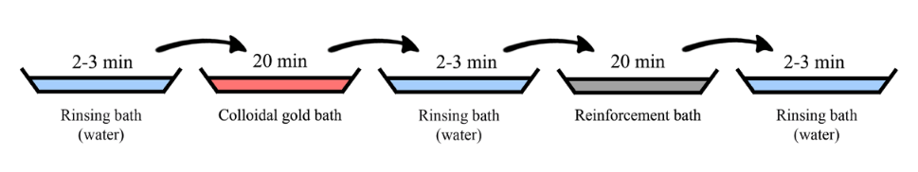
Figure 1: Illustration of the SMD II detection procedure, from [18]

The most recently published optimised protocol was designed to improve robustness and ease of implementation [18]. As opposed to previous formulations, the performance of SMD II is less dependent on pH. In addition, the gold synthesis is straightforward and does not need temperature monitoring. With the technique being more robust, pH does not need to be precisely adjusted to 2.5-2.8 as recommended by Schnetz and Margot [13]. These improvements help promote adoption of the technique for routine use. The efficiency of SMD II and its application parameters were confirmed in a recently published study [19]. However, implementation of the technique remains more complex than with amino acid reagents. It is a multiple-bath process that, in this regard, is comparable to that of PD. Marks developed with SMD II are also similar in appearance to those of PD, with dark-grey ridges against a light background.
Fairley et al. [20] and Charlton et al. [21] performed a comparison of MMD against various benchmark techniques (cyanoacrylate fuming, VMD, etc.) and concluded that MMD was the most effective technique on low-yield substrates such as cling film. Up to this point, SMD II has never been assessed against other benchmark techniques on porous substrates, and has only been compared to its previous formulation (SMD I) [18]. Therefore, the aim of this study was to compare SMD II to PD in order to get a realistic assessment of the technique’s selectivity and sensitivity.

- Materials and methods
2.1 General methodology
Three different comparison experiments were performed to assess the performance of SMD II against that of PD. The two techniques were firstly applied as standalone detection methods, then applied in sequence after two amino acids reagents: 1,2-indandione/zinc (IND-Zn) followed by ninhydrin (NIN). Finally, the techniques were compared on substrates that had been immersed in water after fingermark deposition ‒ a situation where amino acid reagents are ineffective. The study was conducted following the Phase 2 recommendations of the guidelines published by the International Fingerprint Research Group (IFRG) [22].

2.2 Fingermark specimens
In order to provide a realistic assessment of the two techniques, all the fingermarks collected during the study were natural, with no deliberate enrichment with skin secretions. Donors were asked to conduct their normal daily activities but to avoid washing their hands or applying cosmetics an hour before fingermark deposition. To homogenise the secretions naturally present on their hands, they were asked to rub their hands together just before touching the substrates. Pressure used to deposit fingermark was not controlled.
For the standalone and in-sequence comparisons of SMD II with PD, fingermarks from five donors (four males, one female) were collected on 12 substrates (nine conventional paper substrates, one thermal paper, one cardboard paper and one glossy magazine paper) (Table 1). Two fingermark ages were considered in this study ‒ one week and four months old ‒ and two sequential depositions of two fingers were collected for each condition (i.e., a 2x2 array), leading to a total of 480 fingermark specimens for the standalone comparison and the same number of marks for the in-sequence comparison. The choice was made to focus the study on the effect of substrate types, therefore to keep the number of fingermarks specimen to a reasonable amount, only two fingermark appositions were collected per depletion series. Additionally, fingermarks on one non-porous substrate (#13 – transparent polypropylene) were also collected in order to assess SMD II on a different substrate type. Results obtained on that substrate were not taken into account for the comparisons since PD is not effective for the detection of fingermarks on non-porous substrates. However, this substrate acted as a control for SMD II performance. Assessments on wetted substrates were performed on a smaller set of fingermarks. In this case, three donors and five substrates were chosen (substrates #1, #3, #7, #10 and #11), and again two sequencial depositions of two fingers were collected. Two sets of fingermarks were respectively aged for one day and one week before being immersed in deionised water for one hour. Specimens were then dried at room temperature for two days before processing. A total of 120 fingermarks were thus collected for this last experiment.
All fingermark specimens were stored in the dark (office drawer) under ambient conditions (mean temperature 19.5 ±1 °C, mean relative humidity 54.3 ±15%) before being processed.

Table 1: Substrates used to compare the effectiveness of SMD II with PD
Substrate |  | Brand | Porosity
1 | White copy paper | Reflex | Porous
2 | White copy paper | Fuji Xerox | Porous
3 | Exercise book paper | Quill | Porous
4 | Orange paper | Australian Paper | Porous
5 | Green paper | Australian Paper | Porous
6 | Grey paper | Australian Paper | Porous
7 | Recycled paper | Evolve | Porous
8 | Thermal paper | Non-branded | Porous
9 | Newspaper | Sydney Moring Herald | Porous
10 | Magazine paper | Woolworths | Semi-porous
11 | Brown paper envelope | Non-branded | Porous
12 | Cardboard | Officeworks | Porous
13 | Transparent polypropylene | J.Burrows | Non-porous

2.3 Processing and recording
For the standalone comparison and the wetted substrate experiment, the fingermarks were cut in half. Two left and two right half-fingermarks were processed with PD and their respective halves were processed with SMD II. The procedures described by de la Hunty et al. [8, 23] and Moret and Bécue [18] were followed, respectively, for PD and SMD II without modification. For the in-sequence experiment, full fingermarks were first processed with IND-Zn then NIN following the protocols described by Champod et al. [24], before being cut in half and the halves processed either with PD or SMD II as described above.

Maleic acid, citric acid monohydrate, iron (III) nitrate nonahydrate (ferric nitrate), ammonium iron (II) sulfate hexahydrate (ammonium ferrous sulphate), silver nitrate, hydrogen tetrachloroaurate (III) trihydrate, L-aspartic acid, hydroxylamine hydrochloride, citric acid monohydrate, sodium hydroxide, Tween 20, zinc chloride, ethyl acetate and absolute ethanol were supplied by Chem-Supply Pty Ltd. (Australia) with high purity and were used without further purification. N-dodecylamine acetate was supplied by Optimum Technologies (Australia). Trisodium citrate dihydrate and ninhydrin were provided by Sigma-Aldrich (Australia). 1,2-indanedione was supplied by RedyChemtech, acetic acid was provided by RCL Labscan Limited, and HFE-7100 was provided by 3M (Australia).

Fingermarks detected with IND-Zn and NIN were imaged using a Poliview IV imaging system and a Polilight PL550XL forensic light source (Rofin Australia Pty. Ltd.). IND-Zn results were recorded under 530 nm excitation in conjunction with a 590 nm band-pass barrier filter, and NIN results were recorded under white light. For PD and SMD II, results were scanned using a Canon 9000F Mark II scanner at a resolution of 1000 dpi without any digital adjustments. All recorded images in this study were exported as Tagged Image File (TIF) format.

2.4 Comparison and evaluation
Each result was evaluated by three independent assessors not otherwise involved in the study. Images presented in a random order were scored from 0 to 4 using the Centre for Applied Science and Technology (CAST) grading scheme [25]. To compare the techniques, the median score for each fingermark was calculated. To avoid skewing the results in favour of SMD II, fingermarks detected on substrate #13 (non-porous transparent polypropylene) were assessed but were not included in the general comparison of the techniques.

- Results and discussion
A total of 1080 fingermark specimens were collected and processed for this study. PD and SMD II were compared in three sets of experiments: as standalone techniques (direct comparison – 480 fingermarks), in sequence after the application of routine amino acids reagents (IND-Zn followed by NIN – 480 fingermarks) and after the substrates had been wet (120 fingermarks). Results are presented and discussed in two sections; standalone and in-sequence comparisons are presented conjointly for simplicity reasons, and the wetted substrate comparisons are presented separately.

3.1 Standalone and in-sequence comparisons
3.1.1 Overall results
On average, scores were quite low for both PD and SMD II. Such a result was expected since natural fingermarks of variable quality were collected from various donors on substrates of different colours. As shown in Figure 2, average values were slightly higher for SMD II when the technique was applied on its own. However, PD performed better when applied in sequence after IND-Zn and NIN. Moreover, PD efficiency does not seem to be affected by previous techniques; scores obtained after the amino acid detection techniques were even slightly better, but this improvement could simply be due to natural variations in fingermark quality between the two sample sets. SMD II results after amino acid treatments (average score 0.66) were lower than for the standalone application (average score 0.89). This tends to indicate that previous techniques are either targeting compounds also targeted by SMD II, or that the IND-Zn and NIN carrier solvent (HFE7100) is partially removing compounds targeted by SMD II. As mentioned above, a comparison of the two data sets is not ideal since differences between the sample sets can arise. However, with each set containing 480 fingermarks, such differences cannot only be attributed to natural variations. The indication is that IND-Zn and NIN treatments have a detrimental effect on SMD II performance.
In order to further explore these results, the data was separated into the number of marks in each score category, along with individual IND-Zn and NIN scores. For the standalone applications, both PD and SMD II gave similar results for scores of 3 and 4, with 9% and 10% of the treated marks in these two categories (Figure 3). However, 14% more marks remained undetected with PD; this showed that SMD II was more sentitive than PD when applied as a standalone technique. When looking at the in-sequence application, IND-Zn clearly outperformed the other three techniques, with only 24% of marks undetected and 24% of mark of identifiable quality (scores 3 and 4). Such a difference in performances can be explained by the fact that IND-Zn produces luminescent results, thus lowering the detection threshold (i.e., increased sensitivity). Interestingly, NIN had a similar percentage of undetected marks compared to PD and SMD II, and offered a similar performance overall. Even if a comparison between the standalone and in-sequence results has limitations, the large number of marks in each set allows for the reasonable conclusion that PD performed similarly as a standalone technique and after amino acid reagents. This was not the case with SMD II for which more marks were undetected and there was an overall decrease in quality after the application of IND-Zn and NIN.

Figure 2: Comparison of average scores obtained by PD and SMD II when used on their own (standalone application) and after amino acid reagents (in-sequence).

Figure 3: Detailed scores obtained by PD and SMD II when used on their own (standalone application) and after amino acid reagents (in-sequence).

Results from Figure 3 showed that IND-Zn alone could detect more marks than subsequent techniques (NIN and PD or SMD II). However, the dual-goal of sequencing detection techniques is (i) to detect additional marks, and (ii) to improve the quality of the marks already detected. Figure 4 presents the score distribution for PD and SMD II results according to their initial IND-Zn scores. A trend can be observed: the higher the initial score, the better the quality of marks detected with both PD and SMD II. However, even when no mark was initially detected with amino acid reagents (IND-Zn score 0), scores as high as 3 and 4 were obtained for SMD II and PD, respectively. This indicates that both techniques are targeting compounds not targeted by IND-Zn, and this further emphasises the importance of applying complementary techniques in sequence. This is further illustrated in Figure 5.

Figure 4: Collated scores obtained for PD and SMD II sorted according to their initial scores obtained for IND-Zn.

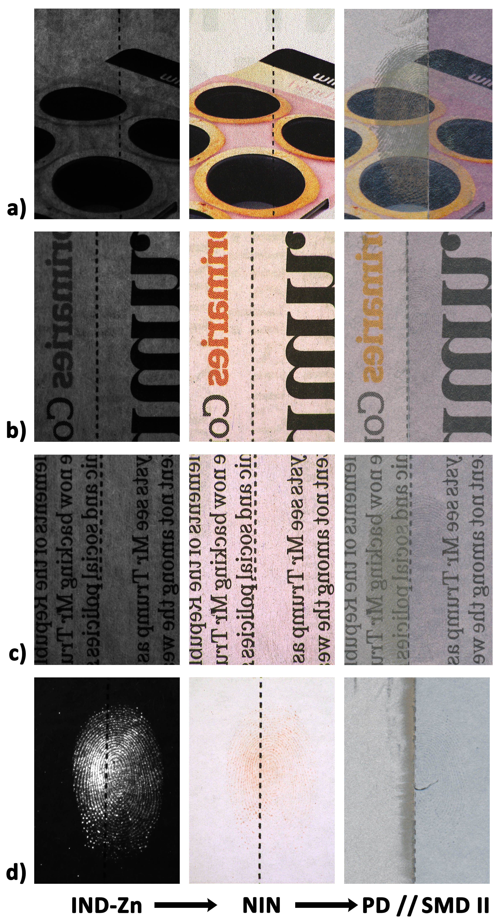
Figure 5: Various fingermarks detected following the sequence of IND-Zn, NIN and PD (left halves) or SMD II (right halves). Images (a), (b) and (c) show a lack of detection with IND-Zn and NIN, while good subsequent detection is obtained either with PD (a), SMD II (b) or both (c). Image (d) illustrates the most common results when IND-Zn, NIN and PD/SMD II when these are applied in sequence. Note that images (b) and (c) are mirror images to place PD and SMD II on the left and right, respectively, to avoid confusion.

Comparing PD and SMD II solely as standalone techniques is not a realistic way to assess their efficiency since, in casework, amino acid reagents would be systematically applied beforehand unless the substrate had been wet (discussed in the next section). Therefore, in order to provide a more valid comparison, only PD and SMD II results obtained after the application of amino acid reagents are presented and discussed hereafter.

3.1.2 Fingermark age
Fingermarks aged for one week and four months were used in this study. The two ages chosen provided a more realistic assessment of the techniques. On average, better results were obtained on the fresher marks for both techniques (Figure 6), and PD gave superior results for both age intervals. Increased fingermark age appeared to have a similar effect on both techniques. Therefore, results from the two age categories are grouped and discussed together from this point.

Figure 6: Comparison of average scores obtained by PD and SMD II (applied after amino acid reagents) on fingermarks of two different ages.

3.1.3 Fingermark depletion
A drop in quality was noticed between the first and second sequential fingermark depositions for both techniques (Figure 7). This effect was expected since a depletion series produces marks with a decreasing amount of secretions [26]. However, PD was less affected by this depletion effect; the score difference between the two depositions was smaller than was the case for SMD II (average score is 34% smaller for PD, against 43.5% for SMD II). This indicates a better sensitivity for PD.

Figure 7: Comparison of average scores obtained by PD and SMD II (applied after amino acid reagents) on fingermarks in a depletion series.

3.1.4 Donor variability
When the results are sorted by fingermark donor, SMD II produced similar results if not better than PD for four out of five donors (Figure 8). A significant average score difference was obtained for donor 2 that skewed the results in favour of PD. Even if PD gave superior results with one particular donor, SMD II showed less donor-dependency. The standard deviation for the SMD II results was 0.33 against 0.84 for PD. As previously observed by Moret et al. [27], fingermark detection with nanoparticles such as silicon oxide or gold are less affected by donor variations than with non-nanoparticle-based methods. This offers a major advantage over standard techniques since donor variability cannot be controlled in operational casework.

Figure 8: Comparison of average scores obtained by PD and SMD II (applied after amino acid reagents) on fingermarks from different donors.

3.1.5 Substrate effects
When results are separated by substrate, seven out of twelve (excluding the non-porous surface) gave superior results with PD (Figure 9). On average, PD produced better results across the majority of substrates, with a smaller standard deviation (0.32 against 0.63 for SMD II). This shows that PD was generally less affected by substrate type and further studies are required to minimise the influence of paper type on SMD II results. Such variations in quality are illustrated on Figure 10. SMD II performed better than PD on some substrates, with better contrast and ridge clarity (Figure 10a – substrate #1). However, SMD II did not perform as well on other paper types (Figure 10b – substrate #3), where PD resulted in better ridge development and a stronger contrast. SMD II gave the poorest results of the study on glossy magazine paper (Figure 10c – substrate #10) with only one mark out of 80 being scored above 0 (score 1). On coloured papers (Figure 10d and 10e – substrates #4 and #5), SMD II was able to detect marks with good resolution but with a significant lack of contrast, preventing adequate visualisation of the results. This is illustrated in Figure 11 where the same digital enhancement was performed on both sides of the mark. At first, a similar result for both PD and SMD II was obtained (Figure 11a) but, after some basic digital enhancements, the half mark detected with SMD II showed superior ridge detail (Figure 11b and 11c). This illustrates that SMD II is able to detect fingermarks with high resolution on such substrates, but with poor contrast. This issue has previously been raised by several authors [18, 20] and future improvements should be focused on improving visibility of the final results. It should also be noted that SMD II gave high quality results on the non-porous substrate where PD was ineffective (Figure 10f – substrate #13). This result was expected and, as mentioned previously, the scores obtained on this substrate were not included in the overall method evaluation. However, the versatility of SMD II is highlighted by this observation.

Figure 9: Comparison of average scores obtained by PD and SMD II (applied after amino acid reagents) on fingermarks on various substrates. Substrate 13 (non-porous transparent polypropylene) was not considered in the score analysis.
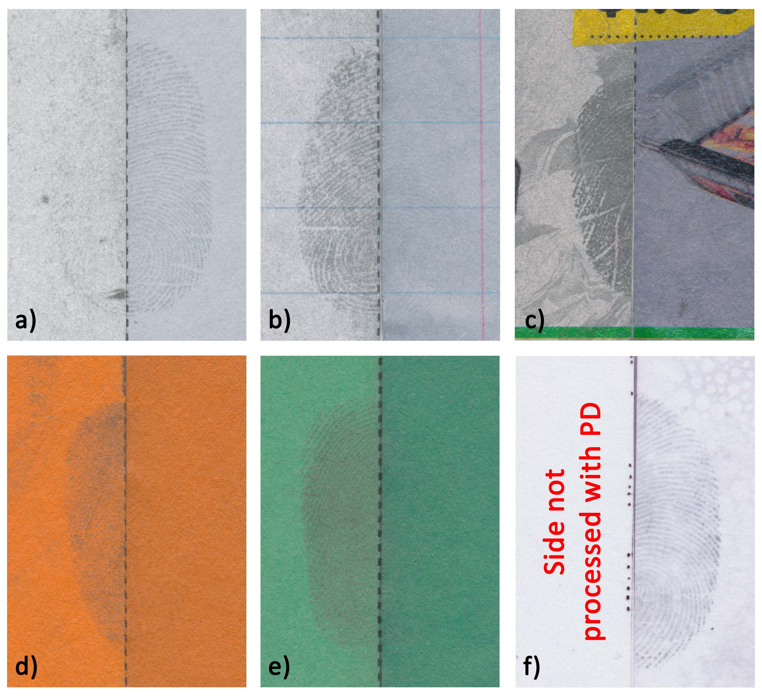
Figure 10: Illustration of results obtained with PD (left halves) and SMD II (right halves) on various substrates: (a) #1 – White copy paper (Reflex), (b) #3 – Exercise book paper (Quill), (c) #10 – Magazine paper (Woolworths), (d) #4 – Orange paper (Australian Paper), (e) #5 – Green paper (Australian Paper) and (f) #13 – Transparent polypropylene (J.Burrows).

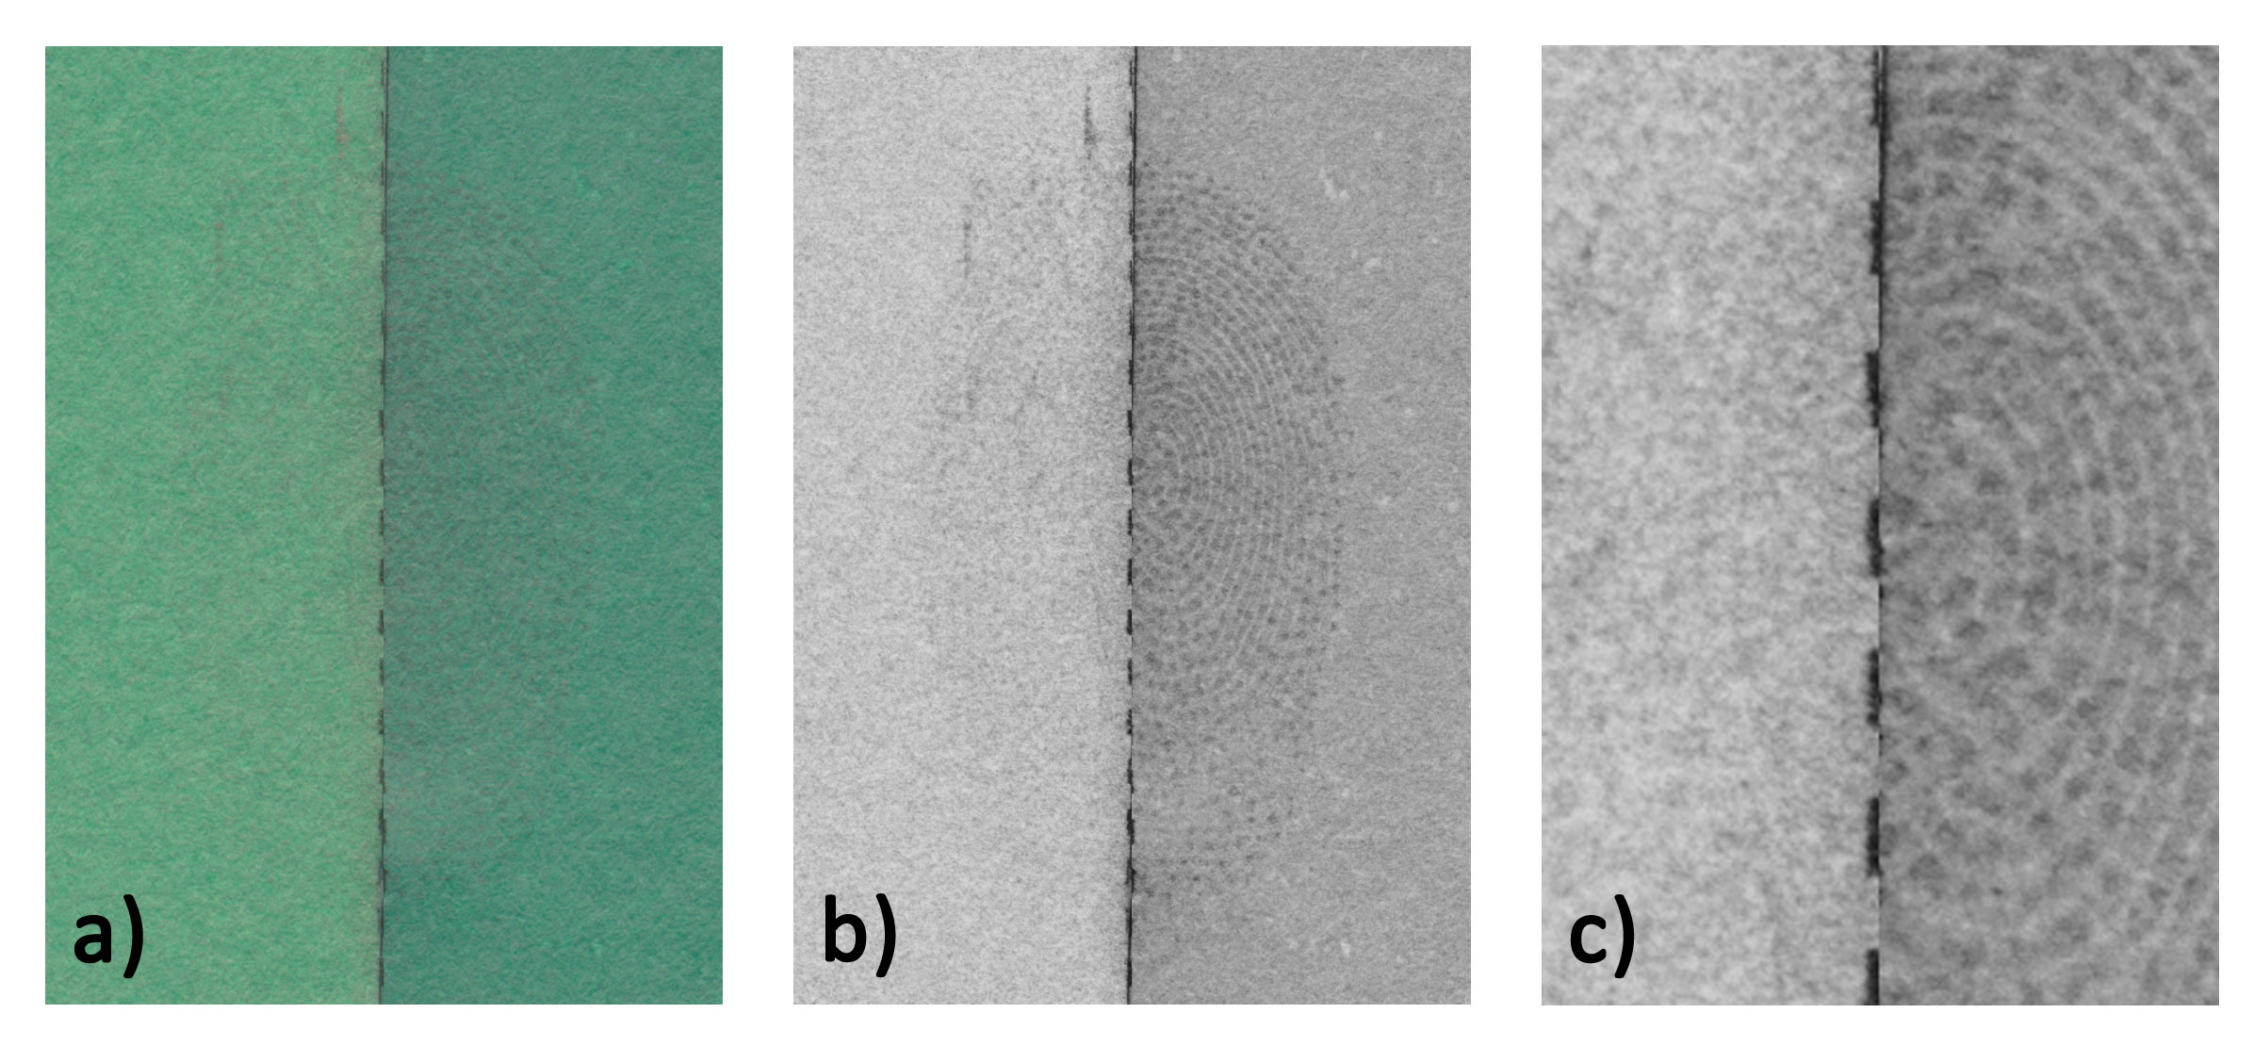
Figure 11: Fingermark on green paper detected with PD (left half) and SMD II (right half), (a) scanned results without any digital enhancements, (b) digital enhancement performed on both sides, (c) close-up of (b).

3.2 Wetted fingermark specimens
3.2.1 Overall results
To further assess the two techniques, PD and SMD II were compared on substrates that had been wet respectively one day and one week after fingermark deposition (a condition that precludes the use of amino acid reagents). Overall, similar trends were observed in that PD performed better than SMD II (Figure 12). Direct comparison with the previous results is not possible since the two data sets are different in terms of number of donors, substrates and age of the marks; however, it can be noted that water immersion has a more pronounced negative effect on the performance of SMD II compared to that of PD.

Figure 12: Comparison of average scores obtained by PD and SMD II on substrates that had been wet after fingermark deposition.

3.2.2 Donor and substrate effects
Superior results were obtained with PD for two of the three donors (Figure 13). Donor 4 gave the lowest quality results and there was no significant difference between the two techniques. As noticed previously, the standard deviation was smaller for SMD II (0.47 against 1.45 for PD).

Figure 13: Comparison of average scores obtained by PD and SMD II (substrates that have been wet) on fingermarks from different donors.

PD performed consistently better across all substrates compared to SMD II (Figure 14). As observed previously, PD has a small standard deviation (0.11) on substrates compared to that of SMD II (0.60). This highlights the need for further research on the application of SMD II on porous substrates to increase its consistency across different paper types.

Figure 14: Comparison of average scores obtained by PD and SMD II (substrates that have been wet) on fingermarks across various substrates.

3.2.3 Fingermark age
The last parameter that was studied was the age of the mark prior to immersion in water. The time elapsed between the fingermark deposition and its contact with water (one-hour immersion time) was expected to have an effect on its subsequent detection. Therefore, two fingermark ages were employed (one-day and one-week old marks). PD performed better for both age categories, while SMD II gave consistent results with a similar score for both ages (Figure 15).

Figure 15: Comparison of average scores obtained by PD and SMD II (substrates that have been wet) on fingermarks of various ages.

3.3 General discussion
3.3.1 Methodology
In this research, SMD II was assessed against PD. The two techniques can be validly compared since they are both considered end-of-sequence techniques and developed marks appear similar under white light (i.e., dark ridges on a light background). They are also both water based and require multiple baths for method application.
The performance of SMD II was evaluated across three experiments; the techniques were compared as standalone methods, after amino acid reagent application (namely IND-Zn followed by NIN), and on substrates that had been wet post fingermark deposition. The first experiment provides an evaluation of absolute performance under ideal conditions; however, experiments 2 and 3 provided the most realistic conditions and relevant results. It is crucial to assess the performance of detection techniques when applied in sequence, as well as the effect of environmental conditions (water immersion in this instance).
Result assessment was conducted on split fingermarks where one-half was processed with PD and the other half with SMD II. IFRG recommendations for Phase 2 research studies were followed [22]. Five donors, twelve substrates, two ages, two fingers and two depositions per finger were selected, leading to 480 fingermarks each for experiments 1 and 2, and another 120 marks for experiment 3. Three independent assessors with a background in fingermark detection and comparison performed the quality assessments. To avoid any confirmatory bias, the assessors were not otherwise involved in the project. To grade the results, the CAST scale was chosen to permit the comparison of full marks (IND-Zn and NIN results) with the SMD II and PD results (half marks). A relative scale, such as the UC scale, would not have been suitable for this purpose. While the CAST scale was the most suitable one for this study, it still suffers from several limitations [26]. For example, a low score can reflect the technique efficiency at detecting fingermarks, but also the donors’ ability to deposit fingermark.

3.3.2 Overall performance of SMD II
In experiments 2 and 3, SMD II performance was judged inferior to that of PD and, therefore, SMD II cannot be recommended as a valid alternative for fingermark detection on porous substrates. Amino acid reagents negatively affect SMD II performance, and the technique gave inconsistent results across the selected range of porous substrates. Moreover, mark visualisation is impeded by a general lack of contrast. However, SMD II was considered equivalent if not superior to PD on some substrates, showing some complementarity of the two techniques. Therefore, sequencing PD and SMD II was considered; however, application of SMD II after PD did not result in any improvements, and the application of PD after SMD II damaged the specimens, with the entire strip of paper being covered in silver (results not shown). Such a result was expected since, originally, the second step of MMD involved the use of a modified PD solution.

3.3.3 Benefits and further improvements
Even if PD remains the technique of choice to be applied in sequence after amino acid reagents, the results illustrated the potential of SMD II as a detection method. The main advantages of SMD II are that the technique can be applied on various substrate types – ranging from porous to non-porous – and, interestingly, the results show less donor-dependency.
The application of SMD II is straightforward and, while PD is renowned to be a difficult technique (i.e., it requires an experienced operator or multiple trials before satisfactory results can be obtained), this is not the case for SMD II. Moreover, SMD II is less detrimental to the substrate, with minimal background staining in most cases. In that sense, SMD II can be considered as being more robust and user-friendly than PD. The technique also requires less chemicals and thus a lower cost.
Contrast improvement is required and further research work should focus on optimising or even re-thinking the reinforcement bath that currently relies on the selective reduction of gold chloride to increase ridge contrast. The effect of amino acid reagents (and their carrier solvents) should also be investigated to improve detection rates when the techniques are applied in sequence.

- Conclusion
This study involved a comparison between two advanced fingermark detection techniques, namely physical developer (PD) and single metal deposition (SMD II). An extensive comparison was performed on more than 2000 split fingermarks from a number of donors. This study demonstrated that PD remains the technique of choice as it was shown to detect fingermarks of a better quality overall ; however, SMD II displayed significant potential as a detection method. One of the main advantages is that the technique is less affected by donor variability. If contrast and consistency issues can be addressed in future research, SMD II may become a viable alternative to PD.

References
[1] Stoilovic M., Lennard C., Wallace-Kunkel C., Roux C. (2007), Evaluation of a 1,2-indanedione formulation containing zinc chloride for improved fingermark detection on paper, Journal of Forensic Identification, 57, 4-18.
[2] Lam R., Wilkinson D. (2011), Forensic light source and environmental effects on the performance of 1,2-indanedione-zinc chloride and 1,8-diazafluoren-9-one for the recovery of latent prints on porous substrates, Journal of Forensic Identification, 61, 607-620.
[3] Nicolasora N., Downham R., Hussey L., Luscombe A., Mayse K., Sears V. (2018), A validation study of the 1,2-indandione reagent for operational use in the uk: Part 1 – formulation optimization, Forensic Science International, DOI: 10.1016/j.forsciint.2018.04.046.
[4] Nicolasora N., Downham R., Dyer R. M., Hussey L., Luscombe A., Sears V. (2018), A validation study of the 1,2-indandione reagent for operational use in the uk: Part 2 - optimization of processing conditions, Forensic Science International, 288, 266-277.
[5] Stewart V., Deacon P., Farrugia K. (2016), A review of one-step fluorescent cyanoacrylate techniques, Fingerprint Whorld, 41, 162.
[6] Khuu A., Chadwick S., Spindler X., Lam R., Moret S., Roux C. (2016), Evaluation of one-step luminescent cyanoacrylate fuming, Forensic Science International, 263, 126-131.
[7] Cantú A. A. (2001), Silver physical developers for the visualization of latent prints on paper, Forensic Science Review, 13, 29-64.
[8] de la Hunty M., Moret S., Chadwick S., Lennard C., Spindler X., Roux C. (2018), An effective physical developer (PD) method for use in australian laboratories, Australian Journal of Forensic Sciences, DOI: 10.1080/00450618.2018.1424243.
[9] Stoilovic M., Speers N., Lennard C. (2012), Vacuum metal deposition, In: Lee and Gaensslen’s advances in fingerprint technology, 3rd ed., Ramotowski, R. S., Ed., CRC Press LLC; pp 241-261.
[10] Fraser J., Deacon P., Bleay S., Bremner D. H. (2014), A comparison of the use of vacuum metal deposition versus cyanoacrylate fuming for visualisation of fingermarks and grab impressions on fabrics, Science & Justice, 54, 133-140.
[11] Davis L. W. L., Kelly P. F., King R. S. P., Bleay S. M. (2016), Visualisation of latent fingermarks on polymer banknotes using copper vacuum metal deposition: A preliminary study, Forensic Science International, 266, e86-e92.
[12] Saunders G. (1989), Multimetal deposition technique for latent fingerprint development, in 74th IAI Educational Conference, International Association for Identification, Pensacola, FL, USA.
[13] Schnetz B., Margot P. (2001), Technical note: Latent fingermarks, colloidal gold and multimetal deposition (MMD) optimisation of the method, Forensic Science International, 118, 21-28.
[14] Stauffer E., Bécue A., Singh K. V., Thampi K. R., Champod C., Margot P. (2007), Single-metal deposition (SMD) as a latent fingermark enhancement technique: An alternative to multimetal deposition (MMD), Forensic Science International, 168, e5-e9.
[15] Bécue A., Scoundrianos A., Champod C., Margot P. (2008), Fingermark detection based on the in situ growth of luminescent nanoparticles - towards a new generation of multimetal deposition, Forensic Science International, 179, 39-43.
[16] Durussel P., Stauffer E., Bécue A., Champod C., Margot P. (2009), Single-metal deposition: Optimization of this fingermark enhancement technique, Journal of Forensic Identification, 59, 80-96.
[17] Bécue A., Scoundrianos A., Moret S. (2012), Detection of fingermarks by colloidal gold (MMD/SMD) - beyond the pH 3 limit, Forensic Science International, 219, 39-49.
[18] Moret S., Bécue A. (2015), Single-metal deposition for fingermark detection—a simpler and more efficient protocol, Journal of Forensic Identification, 65, 118-137.
[19] Newland T. G., Moret S., Bécue A., Lewis S. W. (2016), Further investigations into the single metal deposition (SMD II) technique for the detection of latent fingermarks, Forensic Science International, 268, 62-72.
[20] Fairley C., Bleay S. M., Sears V. G., NicDaeid N. (2012), A comparison of multi-metal deposition processes utilising gold nanoparticles and an evaluation of their application to ‘low yield’ surfaces for finger mark development, Forensic Science International, 217, 5-18.
[21] Charlton D. T., Bleay S. M., Sears V. G. (2013), Evaluation of the multimetal deposition process for fingermark enhancement in simulated operational environments, Analytical Methods, 5, 5411-5417.
[22] International Fingerprint Research Group (IFRG) (2014), Guidelines for the assessment of fingermark detection techniques, Journal of Forensic Identification, 64, 174-200.
[23] de la Hunty M., Moret S., Chadwick S., Lennard C., Spindler X., Roux C. (2015), Understanding physical developer (PD): Part I – is PD targeting lipids?, Forensic Science International, 257, 481-487.
[24] Champod C., Lennard C., Margot P., Stoilovic M. (2016), Fingerprints and other ridge skin impressions, second edition, CRC Press: Boca Raton, FL.
[25] Sears V. G., Bleay S. M., Bandey H. L., Bowman V. J. (2012), A methodology for finger mark research, Science & Justice, 52, 145-160.
[26] Chadwick S., Moret S., Jayashanka N., Lennard C., Spindler X., Roux C. (2018), Investigation of some of the factors influencing fingermark detection, Forensic Science International, 289, 381-389.
[27] Moret S., Bécue A., Champod C. (2016), Functionalised silicon oxide nanoparticles for fingermark detection, Forensic Science International, 259, 10-18.

