Abstract

The application of nanoparticles for latent fingermark detection has been reported in the literature over the past two decades. One of the nanoparticles that shows promise to become a routine technique is functionalised silicon oxide nanoparticles (SiO₂ NPs). In a recent optimisation of the technique, the use of a carboxyl-functionalised SiO₂ NPs doped with luminescent ruthenium complex was proposed as a breakthrough for latent fingermark detection.

In this study, the aforementioned functionalised SiO₂ NPs were extensively evaluated. Modification and optimisation of the original detection parameters were performed to enhance detection quality and improved applicability. Various detection parameters were evaluated and assessed. A lower concentration of the functionalised nanoparticles used in the colloidal dispersion was determined to offer improved detection effectiveness. A combination of increased bath temperature and reduced immersion time was found to produce good overall results. A set of modified detection parameters was suggested for the use of the functionalised SiO₂ NPs to detect latent fingermarks. Performance of the modified detection parameters was compared against that of the published detection method. Comparison experiments were carried out on fingermark specimens deposited on aluminium foil, transparent polypropylene plastic and green polyethylene plastic. Three donors (weak, average and strong) and two age intervals (ten days and three months) were considered in the comparison study. Evaluation of the results suggested that the overall performance of the modified method for latent fingermark detection was superior to that obtained using the previously published detection parameters.

Keywords

Surface functionalisation, luminescence technique, colloidal, bath temperature, detection effectiveness, method modification

Highlights

- The use of a carboxyl-functionalised silicon oxide nanoparticles doped with luminescent ruthenium complex was previously proposed as a breakthrough for latent fingermark detection
- The method was further evaluated. Modification and optimisation of the original detection parameters were performed
- A combination of lower NP concentration, increased bath temperature and reduced immersion time was found to produce good overall results
- Performance of the modified and published detection parameters were compared
- The overall performance of the modified method was deemed to be superior

1. Introduction

Latent fingermark detection remains of major research interest in the forensic science community because of the substantial value of fingermarks in criminal investigations. Diverse methods, ranging from conventional techniques such as powder dusting and cyanoacrylate fuming to advanced techniques including metal deposition methods and quantum dots [1-12], continue to be studied around the world. Despite the reliability of routine detection techniques employed by law enforcement agencies, a recent study indicated that conventional development methods struggle to detect some fingermarks that are present [13]. This is a major drawback with current techniques and recent research has focussed on a better understanding of latent fingermark detection mechanisms [14-16]. There remains a need for new and advanced latent fingermark detection and enhancement techniques to assist law enforcement agencies in improving crime clearance rates.

Nanoparticles (NPs) have attracted great attention in the field of latent fingermark development over the last few decades. A number of latent fingermark detection techniques that involve the use of NPs have been studied and applied [4,11,17]. Three main advantages are offered by NPs for latent fingermark development. First, the small size of NPs permits the high-resolution enhancement of fingermarks without the risk of over-development. Second, the surface of most NPs can be functionalised. Various molecules or functional groups can be grafted onto the surface of NPs to selectively enhance interactions with fingermark residues. Finally, certain groups of NPs possess luminescence properties that can be beneficial for substrates where background interference is problematic. This unique combination of features (size, surface functionalisation and optical properties) provided by NPs have driven many researchers to further investigate their application in this field [11,18,19]. A substantial number of NPs have been used by forensic scientists to detect latent fingermarks, with various levels of success [1,3,4,20-24].
Silicon oxide nanoparticles (SiO₂ NPs) are one of a few NPs that possess all of the aforementioned characteristics for latent fingermark detection and enhancement. SiO₂ NPs can be produced with a homogeneous size distribution via the reversed micro-emulsion process. The silanol and siloxane groups on the surface of SiO₂ NPs permit the use of a wide range of molecules for surface functionalisation. Also, highly luminescent dye molecules can be encapsulated in the core of SiO₂ NPs during the synthesis process [11]. The application of SiO₂-based NPs to detect latent fingermarks has been demonstrated in the literature [16,19,25-27].

Theaker et al. synthesised hydrophobic SiO₂-based particles for developing latent fingermarks [27]. Both nano-size (used as an aqueous suspension) and micro-size (used as powders) SiO₂-based particles were investigated regarding their ability to develop latent fingermarks on glass surface. The authors incorporated a variety of fluorescent dyes (fluorescein, thiazole orange, oxazine perchlorate, methylene blue, basic yellow 40, basic red 28, and rhodamine B and 6G) with the SiO₂-based particles. The researchers demonstrated the use of the reagent mainly as micro-size dusting powders and developed fingermarks were obtained with good ridge detail. Despite that Theaker et al. did not perform in-depth comparisons of the reagents to conventional techniques, the study provided an indication of the versatility of SiO₂-based particles for latent fingermark development from an optical point of view.

In comparison to the study from Theaker et al., Liu et al. investigated the use of a highly fluorescent material – Europium metal ion (Eu³⁺)/sensitizer complex in SiO₂-based nanocomposites – to detect latent fingermarks [26]. The authors tested different sensitizers/SiO₂-based gel template combinations; a 1,10-phenanthroline (OP) sensitizer in tetraethoxysilane (TEOS) template was concluded to be the best composite. The Eu³⁺/OP/TEOS SiO₂-based nanocomposites were applied as a powder on various non-porous surfaces resulting in luminescent fingermarks. However, the proposed nanocomposites in the study were not compared to conventional techniques in terms of performance and questionable parameters were applied (e.g., donors cleaned their hands prior to depositing fingermarks and detection was performed within 10 minutes). Despite these shortcomings, the study incorporated a range of different materials with SiO₂-based nanocomposites, suggesting that SiO₂-based NPs show promise for this application.

Research in recent years attempted to apply SiO₂-based NPs to detect latent fingermarks by utilising their advantages of small size, surface functionalisation and optical properties. Different synthetic routes and surface functionalisation groups were explored [25,28,29]. However, no exhaustive application and comparison experiments were presented to evaluate the techniques’ performance in these studies. A much deeper and comprehensive understanding of using SiO₂-based NPs to detect latent fingermarks was still required.

Recently, Moret et al. delivered an insight into the use of SiO₂ NPs for latent fingermark detection [19]. This publication indicated that the application of surface functionalised SiO₂ NPs with a luminescent core showed comparable performance to one-step cyanoacrylate fuming on non-porous substrates. Based on this study, the SiO₂ NP-based technique has the potential to become a real breakthrough for latent fingermark detection. The authors also observed that one-step CA fuming was more donor-dependent while the SiO₂ NP-based technique showed more variations between substrate types. Results suggest that the SiO₂ NP-based technique requires further optimisation.

The study reported here presents further application and optimisation of the above-mentioned SiO₂ NP-based latent fingermark detection reagent as suggested by Moret et al. Various modified detection parameters and conditions are proposed and have been evaluated. Comparisons of reagent performance with modified detection parameters were undertaken.

2. Materials and methods

Triton X-100 (TX-100), 1-hexanol, ammonium hydroxide (30%), tetraethyl orthosilicate (TEOS), tris(2,2’-bipyridyl)dichlororuthenium (II) hexahydrate (RuBpy) and sodium chloride (NaCl) were purchased from Sigma-Aldrich. Cyclohexane was purchased from Chem-Supply and carboxyethylsilanetriol disodium salt (CES) was supplied by abcr GmbH. All chemicals were used as received.

Experimental design for this research followed the guidelines published by the International Fingerprint Research Group (IFRG) [30] with a view to meeting current standards for fingermark-related research. This study was conducted as a Phase 2 (Optimisation & Comparison) activity.

2.1 Synthesis of functionalised silicon oxide nanoparticles

SiO₂ NPs were synthesised via the reversed micro-emulsion technique as described by Moret et al. [19] with only a modification to the precipitation of the NPs. A summary of the synthetic procedure is presented here. 3.54 mL of TX-100, 15 mL of cyclohexane and 3.6 mL of 1-hexanol were added to a round bottom flask, 960 μL of RuBpy (16.6 mM), 200 μL of TEOS and 120 μL of ammonium hydroxide (30%) were then added. After 24 hours of constant magnetic stirring, 100 μL of TEOS and 100 μL of CES were added to the reaction mixture for surface functionalisation. The mixture was stirred for an additional 24 hours. The micro-emulsion mixture was transferred to a falcon centrifuge tube and 20 mL of acetone was added to it to initiate precipitation of the NPs. The NPs were isolated via centrifugation at 2500 RPM for 3 minutes, after which the acetone was decanted. Subsequently, 15 mL of acetone was added to the isolated NPs. The falcon centrifuge tube containing the NPs was shaken using a vortex mixer and then centrifuged at 2500 RPM for 3 minutes before the acetone was decanted. Finally, the RuBpy-doped, CES-SiO₂ NPs (0.1 g) were collected and redispersed in 20 mL of RO/DI water.

2.2 Characterisations of the functionalised silicon oxide nanoparticles

A Zeiss Supra 55VP high resolution Field Emission Scanning Electron Microscope (FESEM) with a Schottky source was used for scanning electron microscopy (SEM). To analyse a sample by SEM, 2 to 3 drops of the RuBpy-doped CES-SiO₂ NPs were dispersed in 2 mL of RO/DI water and sonicated for 15 minutes. 1 to 2 drops of this dispersion were deposited onto a silicon chip wafer (5 x 5 mm) that had been glued to an aluminium SEM stub with conductive double-sided adhesive carbon tape. After drying overnight, the sample was coated with 7 nm of carbon using a Leica EM ACE600 high vacuum coater. These stubs were then mounted onto the sample stage of the SEM, allowing the sample to be viewed and imaged. These images were analysed using ImageJ software. A Malvern Zetasizer Nano ZS was also used to determine the average size and size distribution profile of the CES-SiO₂ NPs in solution.

A Bruker D8 Discover diffractometer was used for powder X-ray diffraction (PXRD) measurements on the functionalised SiO₂ NPs. Data was collected by running a continuous scan at 2θ with a range from 10° to 75° and step size of 0.040°. The data was analysed using the ICDD-JCPDS CD-ROM database. The PXRD samples were prepared by repeatedly drying drops of the NP dispersions in RO/DI water cast on circular glass slides.

A Shimadzu RF-6000 spectrofluorophotometer was used to measure the photoluminescence spectra in the range 200 – 900 nm. All samples were prepared by mixing 0.1 mL of the CES-SiO₂ NPs with 5 mL of RO/DI water and then analysed by placing in quartz cuvettes (1 cm path length).

2.3 Fingermark specimens

Three individuals – representing weak, average and strong fingermark donors – provided latent fingermarks for this study. Natural (ungroomed) fingermarks were used to mimic typical casework scenarios. Charged (groomed) fingermarks were avoided as this would substantially increase the sebaceous content in fingermark residues, deviating from the chemical composition of natural impressions (i.e., using the secretions that are naturally present on the donor’s fingers). Prior to depositing fingermarks on substrates, donors were instructed to rub their hands together to achieve a homogeneous distribution of fingermark secretions across the fingertips. Donors were asked to avoid hand washing 30 minutes before fingermark depositions. Three substrates were used in the study: aluminium foil, transparent polypropylene (PP) sheets and green polyethylene (PE) sheets. All fingermark specimens were stored in laboratory drawers under normal office conditions with a mean temperature of 18.1 ± 1.30°C and a mean relative humidity of 52.8 ± 4.23%.

A set of modified parameters for the use of RuBpy-doped CES-SiO₂ NPs was optimised and applied to latent fingermark detection in this study. Comparison experiments were set up between the published and modified detection parameters to test out their performances for latent fingermark detection. Split fingermarks were used for direct comparison between the two sets of parameters. For each donor on each substrate, 16 fingermarks were collected representing four depletions for each of four fingers. Two age intervals – ten days and three months – were employed to condition the fingermark specimens prior to treatment. A total of 288 fingermark deposits were processed and analysed in the comparison phase (see 2.5 below).

2.4 Modification and optimisation of the published detection parameters

Moret et al. proposed the use of RuBpy-doped CES-SiO₂ NPs to detect latent fingermarks with a set of recommended detection parameters [19]. Briefly, the functionalised NPs were diluted by half to make up a colloidal dispersion with the presence of 0.5 M NaCl. It included a 60-min fingermark immersion at room temperature. These published detection parameters were further modified and assessed in this research (Table 1). Fingermark specimens of different ages from the three donors were used across the three substrates to evaluate modifications of the published parameters. Once a modified detection parameter was deemed to offer improvements in fingermark detection quality, it was then subjected to further adjustment and evaluation.

Table 1: Summary of the detection parameters that were modified and evaluated for latent fingermark detection using the RuBby-doped CES-SiO₂ NPs.
Detection parameter | Published value [19] | Evaluated in this study
NP dilution | 2x | 2x, 4x, 10x, 20x, 40x, 80x and 200x
Ionic strength | 0.5 M of NaCl | 0.05 M, 0.25 M, 0.5 M, 1 M and 3 M of NaCl
pH | 7 | 3, 5, 7, 9 and 11
Immersion time | 60 minutes | 2, 3, 5, 15, 30 and 60 minutes
Bath temperature | Room temperature | Room temperature, 3°C, 30°C, 35°C, 40°C, 45°C and 50°C

2.5 Fingermark processing, visualisation and evaluation

Direct comparisons between the published and modified detection parameters were performed on the collected fingermark specimens. To achieve this, all fingermark specimens were cut in half, with two sets of detection parameters employed to process the two halves of each bisected impression. The number of left- and right-half fingermark specimens from each donor on each substrate were balanced to minimise intra-donor deposition variability. The processing of fingermarks during the modification and optimisation stages was completed using one batch of the functionalised SiO₂ NPs to avoid the effect of any batch-to-batch variability. Comparison experiments were completed using two batches of RuBpy-doped CES-SiO₂ NPs, with one batch utilised for the ten-day-old fingermark specimens and another batch employed for the three-month-old fingermark specimens.

All processed fingermark specimens in this study underwent a visual “screening” procedure, using a Rofin Polilight® PL500 forensic light source at 450 nm with the examiner wearing orange goggles, to mimic operational procedures for processing fingermark evidence. Specimens with positive development observed during the “screening” procedure (i.e., detectable fingermarks under the conditions indicated) were recorded using a Rofin Poliview® imaging system. Fingermarks were recorded using excitation at 450 nm with observation at 590 nm (610 nm band-pass filter tilted by 30 degrees).

Three assessors with fingerprint research experience participated in the evaluation of recorded impressions. A comparative fingermark assessment (Table 2) based on the University of Canberra (UC) comparative scale was used to evaluate the relative performance of the two sets of detection parameters [30]. A “00” value (ND – no detection) was incorporated into the scoring system to reflect processed fingermark specimens where no detection was observed with either set of detection parameters. Fingermark images captured with the Rofin Poliview® system were saved using the Tagged Image File (TIF) format without any digital adjustments. A total of 288 fingermark specimens were processed in the comparison experiments and included in the assessments independently undertaken by three assessors. Each assessor scored the fingermark images in a random order from a computer screen. All scores were then collated and the frequencies of scores were used. This gave 864 scores that were analysed. Assessed data were collected and analysed using Microsoft® Excel spreadsheet software.

Table 2: The comparative scale for fingermark assessment employed in the study.
Score | Definition
+2 | Significant increase in enhancement of the assessed technique when compared to the other technique
+1 | Slight increase in enhancement of the assessed technique when compared to the other technique
0 | No enhancement of the assessed technique when compared to the other technique
−1 | Slight decrease in enhancement of the assessed technique when compared to the other technique
−2 | Significant decrease in enhancement of the assessed technique when compared to the other technique
00 | No detection on either side

3. Results and discussion

3.1 Synthesis and characterisations of the functionalised silicon oxide nanoparticles

In order to characterise the size of the NPs produced by the synthesis, three analytical methods were employed. SEM was used to visualise the functionalised SiO₂ NPs. Figure 1 is an SEM image of the NPs and an illustration of their corresponding size distribution. The presence of monodispersed spherical SiO₂ NPs with an average size of 90.2 nm (standard deviation of 4.7 nm) was clearly reflected in these analyses. Figure 2 shows the size distribution of the NPs measured by dynamic light scattering (DLS) with an average size of 93.0 nm (standard deviation of 4.7 nm). This analysis was consisitent with the SEM results, as well as previous studies [16,19]. Figure 3 shows the PXRD spectrum of the SiO₂ NPs. This spectrum corresponds to the characteristic amorphous nature of the SiO₂.

Figure 4 depicts the excitation and emission spectra of the RuBpy-doped CES-SiO₂ NPs in solution. The functionalised SiO₂ NPs displayed maximum excitation at 459 nm, with a maximum emission at 612 nm. Although observation at 610 nm would appear to be the most suitable imaging parameter, a 590 nm band-pass filter was used for fingermark visualisation in this study because it was judged to provide better results compared to a 610 nm band-pass filter.
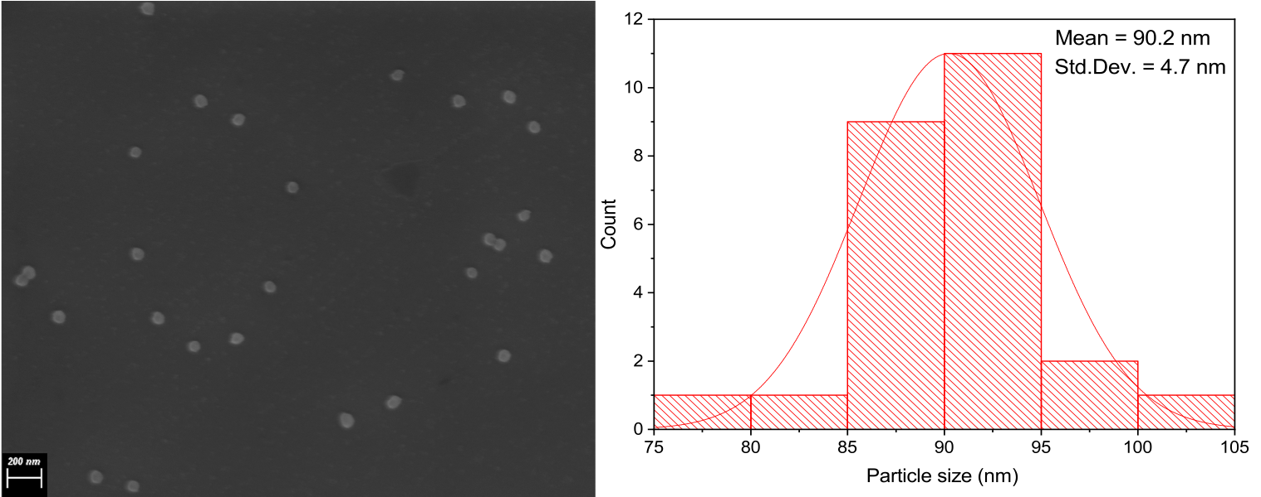
Figure 1: SEM image of the RuBpy-doped CES-SiO2 NPs showing the presence of monodispersed spherical NPs (L) captured using a Zeiss Supra 55VP high resolution FESEM with a Schottky source. Size distribution analysis of the RuBpy-doped CES-SiO2 NPs from the SEM analysis achieved using ImageJ software (R). The functionalized SiO2 NPs possessed an average size of 90.2 nm.

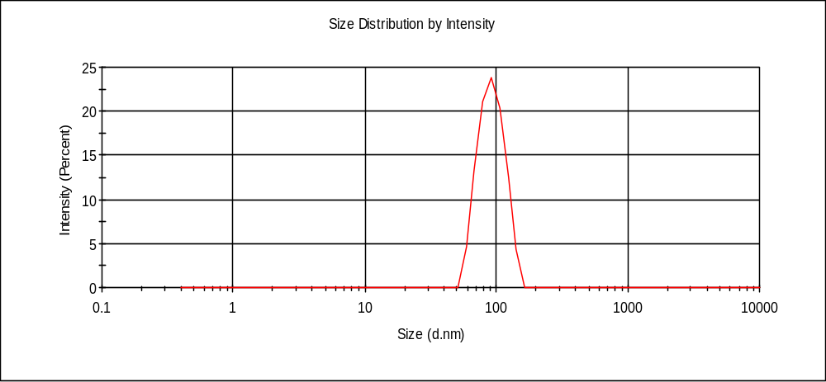
Figure 2: DLS measurement of the RuBpy-doped, CES-SiO₂ NPs using a Malvern Zetasizer Nano ZS instrument. The average hydrodynamic diameter of the NPs was 93.0 nm.
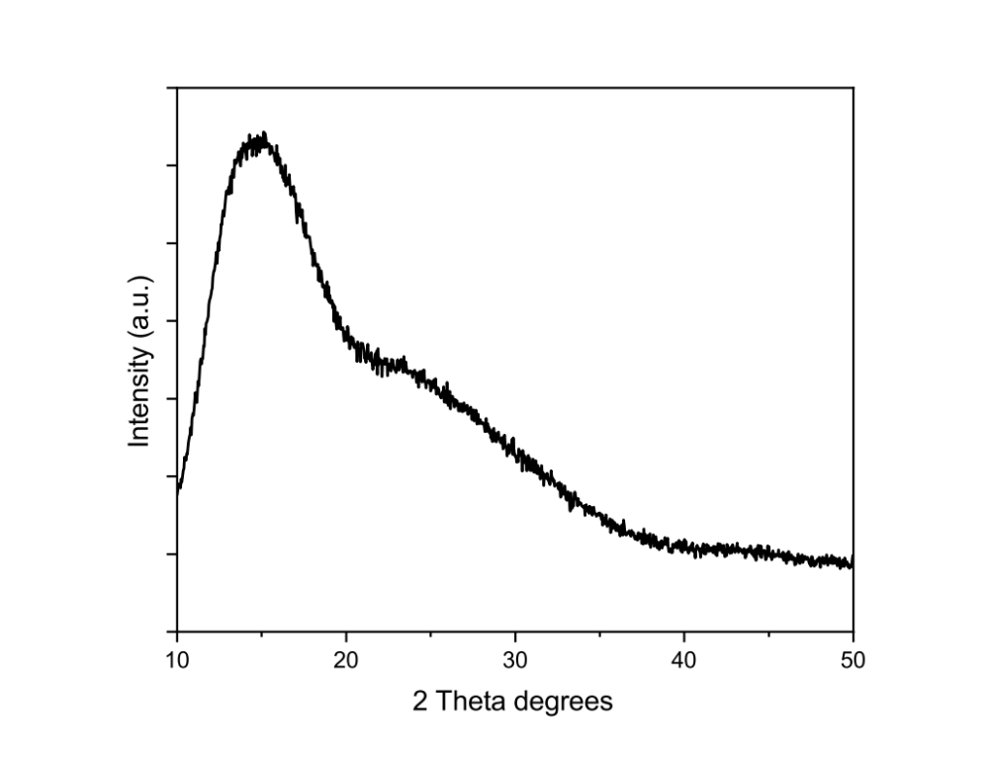
Figure 3: The PXRD spectrum of the RuBpy-doped CES-SiO₂ NPs recorded using a Bruker D8 Discover diffractometer.
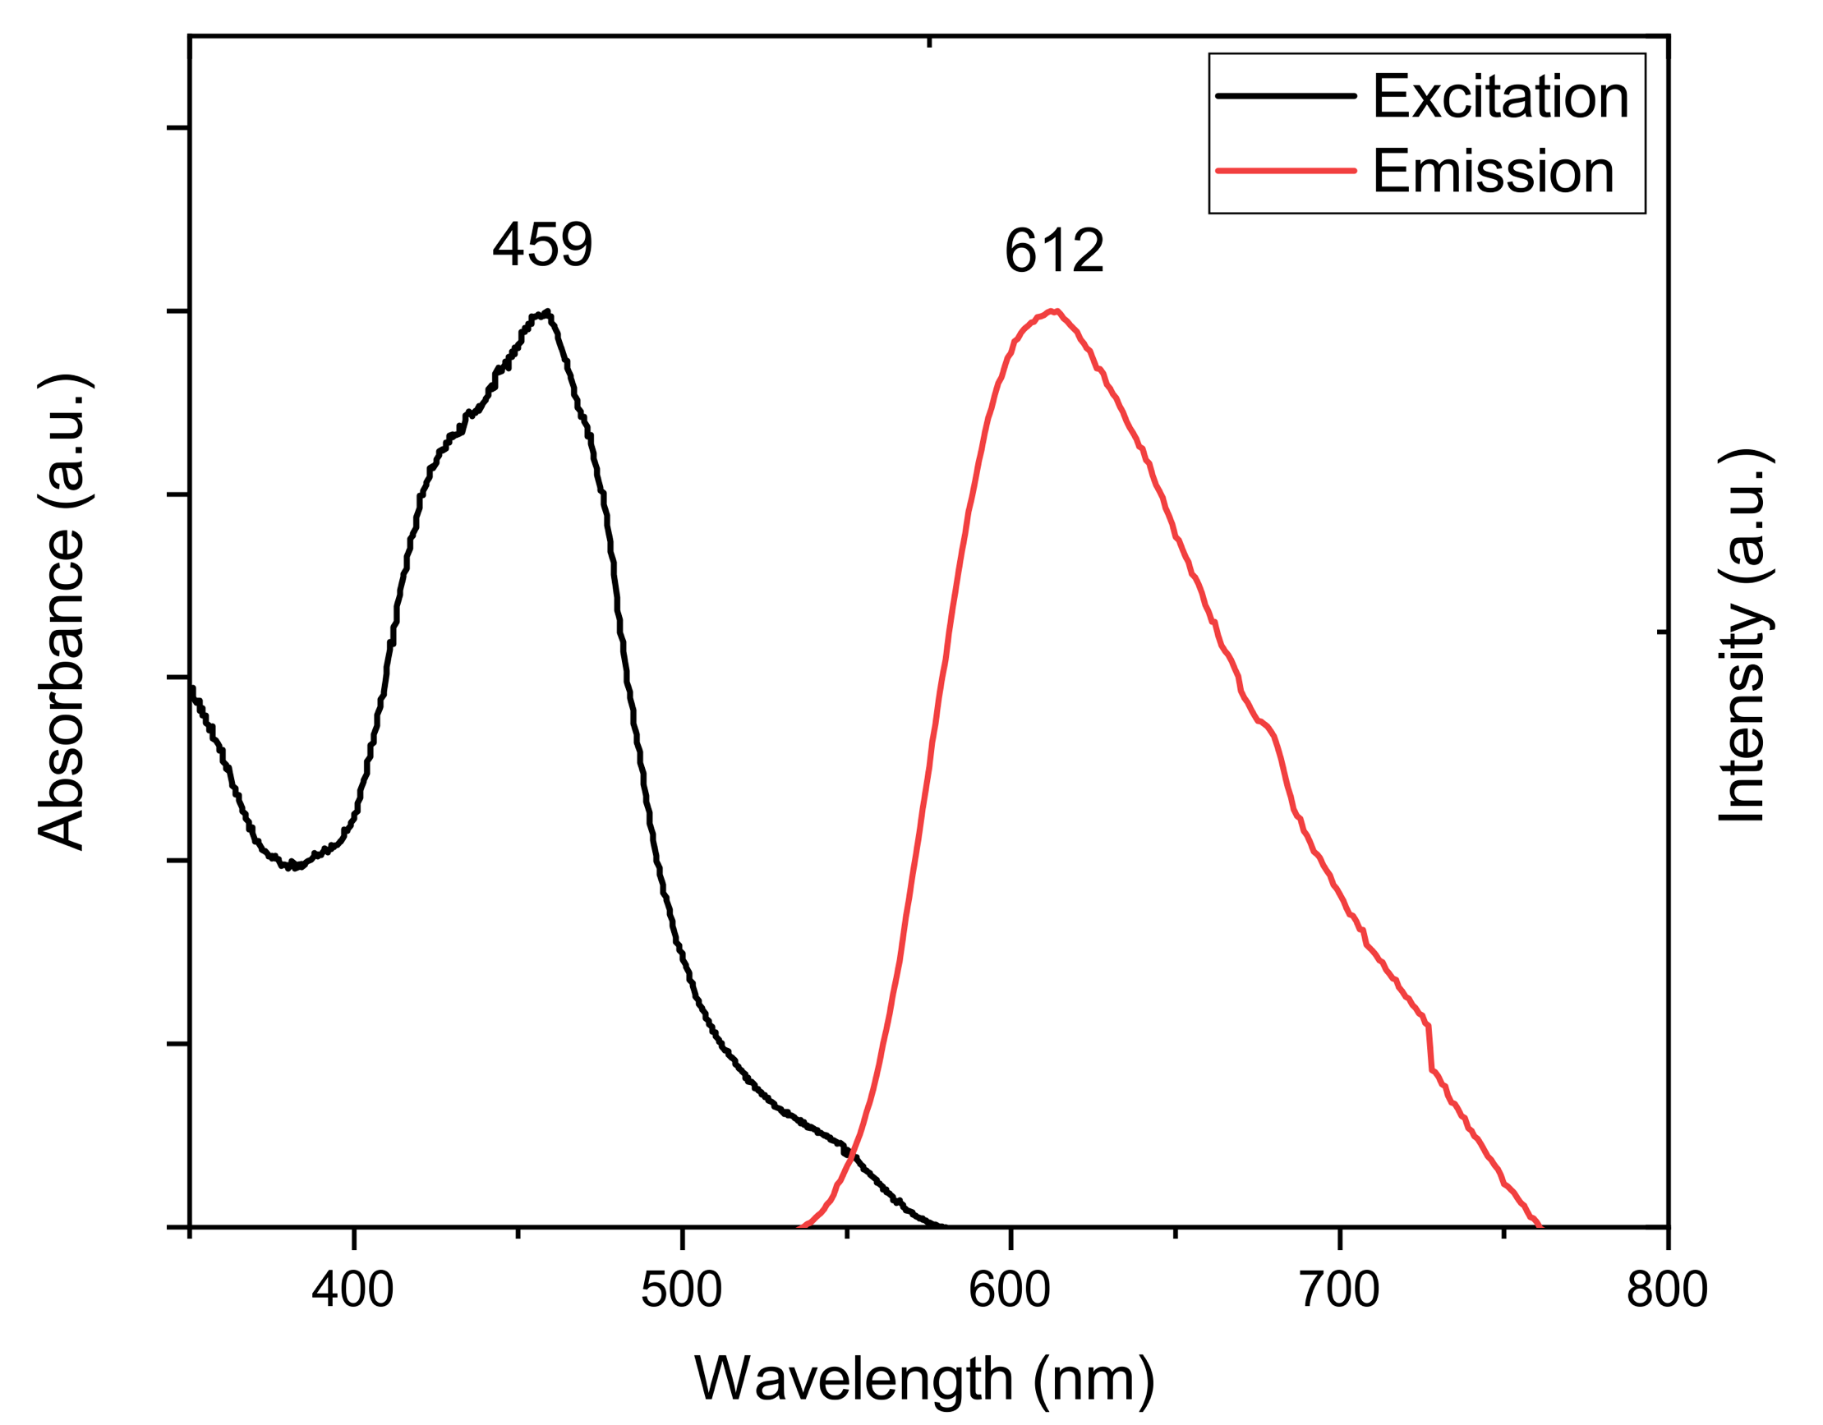
Figure 4: Excitation and emission spectra of the RuBpy-doped CES-SiO₂ NPs in solution. The NPs exhibited maximum excitation and emission at 459 nm and 612 nm, respectively. The spectra were collected using a Shimadzu RF-6000 spectrofluorophotometer.

3.2 Detection parameter modification and optimisation

3.2.1 Nanoparticle concentration in the colloidal dispersion

The synthesis procedure for the RuBpy-doped CES-SiO₂ NPs requires three days to complete, and the previous research did not assess whether or not the proposed 2x NP dilution was optimal [19]. In order to maximise both time and cost efficiency, an optimum concentration of the colloidal dispersion (the minimum amount of the functionalised NP solution needed in the working formulation to deliver adequate development, full ridge detail and identifiable fingermarks) was determined. 0.1 g of the functionalised NPs was synthesised and dispersed in 20 mL of RO/DI water to prepare a stock dispersion (i.e. NP concentration = 5 mg/mL). As summarised in Table 1, seven dilution factors were evaluated in comparison with the published method, with all other parameters kept in accordance with the published detection method [19]. Figure 5 demonstrates fingermark development with the different dilutions of NPs in the colloidal dispersions. It was determined that a 40x dilution (0.125 mg/mL) of the NPs was optimum to deliver comparable results to the original dilution (2x – 2.5 mg/mL). It was observed that lowering the NP concentration increases detection quality, which might seem peculiar at first. However, it is suggested that, at higher concentrations, the CES-functionalised SiO₂ NPs encounter inter-nanoparticle attractions and that these attractions hinder effective interactions with fingermark residues on the test substrates. As a result, a 40x dilution of the RuBby-doped CES-SiO₂ NPs was subsequently employed as the optimised dilution parameter for all subsequent experiments. Figure 6 presents direct comparisons of fingermark detection between the application of a 2x NP dilution and a 40x NP dilution in the colloidal dispersion. Throughout the study, background staining on aluminium foil was observed (as reflected in Figure 6 – right half-mark on aluminium foil). Although this did not substantially decrease the fingermark detection effectiveness on the test substrate, background staining issues on metallic substrates is being further evaluated as part of our research group’s ongoing study.
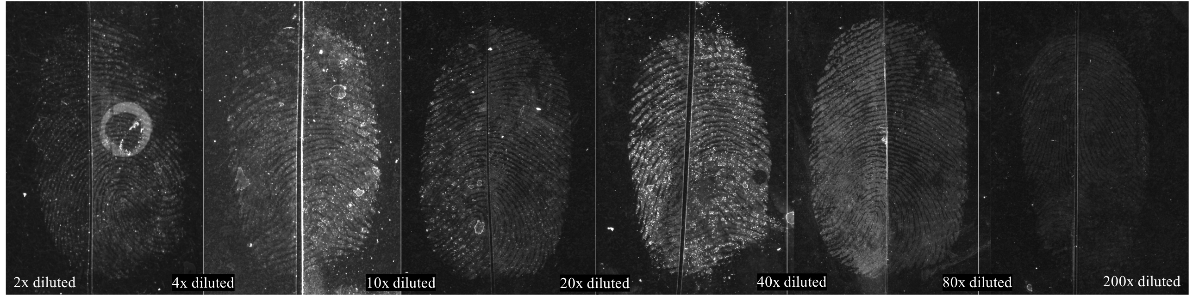
Figure 5: Fingermark specimens on transparent PP (2 – 3 weeks old) detected using the functionalised SiO₂ NPs. Various concentrations (indicated on each image) of the NPs in the colloidal dispersions were evaluated. A 40x dilution was determined to be optimum.
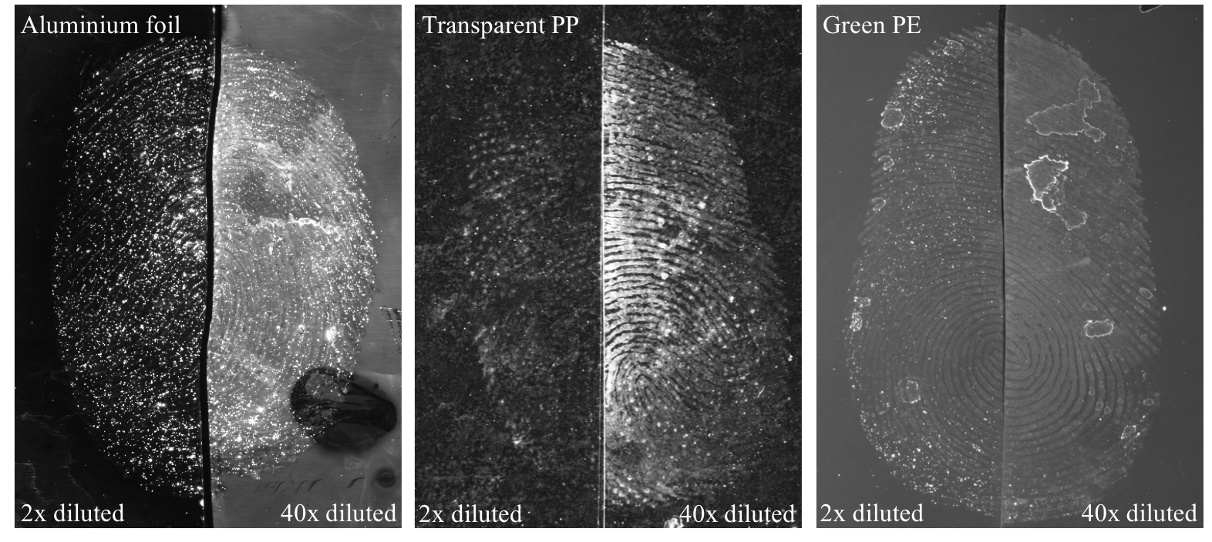
Figure 6: Direct comparisons of fingermark detection quality using the functionalised SiO₂ NPs with a 2x dilution (left halves) and a 40x dilution (right halves) of the NPs in the colloidal dispersions. Fingermark specimens were 10 weeks old.

3.2.2 Ionic strength and pH of the colloidal dispersion

The application of the functionalised NPs for fingermark detection is via an aqueous (RO/DI water) medium. The functionalised NPs are presented as a dispersion in the water-based working medium. Similar to other NPs, a working dispersion with the RuBpy-doped CES-SiO₂ NPs is indeed a colloidal system. The stability of such a system needs to be maintained at a certain level for the detection of fingermarks. In the interest of this, the stability of a colloidal system can be reflected by its zeta potential. The zeta potential is the potential difference that exists between the surface of a solid particle immersed in a conducting liquid (e.g., water) and the bulk of the liquid. In a colloidal system, the zeta potential can be affected by factors including ionic strength and pH [31,32]. These effects of these factors on fingermark detection effectiveness were evaluated in this study.

The current published formulation for the RuBpy-doped CES-SiO₂ NPs applied for latent fingermark detection involves the use of 0.5 M NaCl in the colloidal dispersion. The addition of NaCl was suggested and evaluated in previous studies, and it was introduced to adjust the zeta potential of the colloidal dispersion [16,19]. Since the NP concentration in the colloidal dispersion was modified in this study, the suitability of utilising 0.5 M NaCl for ionic strength adjustment needed to be reassessed. As such, various concentrations of NaCl were tested in the colloidal dispersions (Table 1). Through a series of comparisons, the presence of 0.5 M NaCl in the colloidal dispersion with a 40x dilution of the functionalised NPs was determined to be optimum for fingermark detection. Figure 7 demonstrates examples of fingermark development with the use of various concentrations of NaCl in the colloidal dispersions.

The pH of the colloidal dispersion was also adjusted (with values of 3, 5, 7, 9 and 11) and these solutions evaluated for fingermark detection. Comparison results indicated that detection quality was optimum at pH 7 with the use of a 40x dilution of NPs and the presence of 0.5 M NaCl in the colloidal dispersion (Figure 8). It is suggested that the dispersion and stability of the functionalised NPs, as a colloidal system, at pH 7 are maintained at an adequate level for fingermark detection by the presence of 0.5 M NaCl. These two parameters used in the colloidal dispersion both agreed with the published formulation [19].
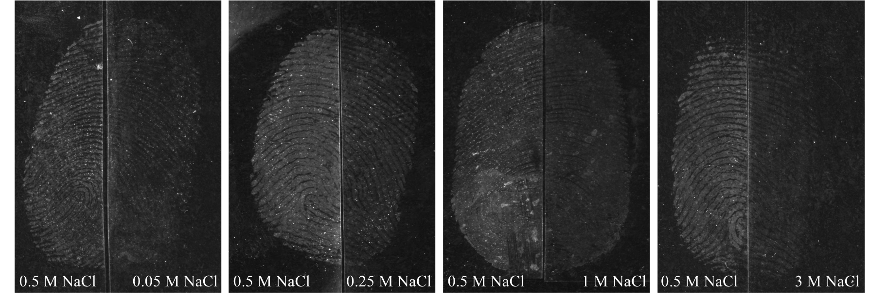
Figure 7: Comparisons of fingermark detection quality using the RuBpy-doped CES-SiO₂ NPs with the presence of different NaCl concentrations (indicated on each image) in the colloidal dispersions. Fingermark specimens were collected on transparent PP (4 – 5 weeks old).
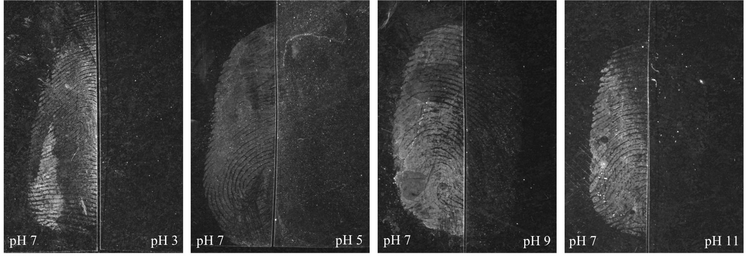
Figure 8: Comparisons of fingermark detection quality using the RuBpy-doped CES-SiO₂ NPs in the colloidal dispersions at various pH (indicated on each image). Fingermark specimens were collected on transparent PP (6 weeks old).

3.2.3 Optimised bath temperature and immersion time

Moret et al. suggested that chemical bonding (peptide bonding) is the major interaction between the functionalised NPs and the fingermark secretions [16]. Given this proposed interaction and from a thermodynamic viewpoint, the following hypothesis was proposed: increasing the temperature of the colloidal dispersion during detection will increase the reaction rate and hence allows for shorter immersion times.

To test this hypothesis, comparison experiments were initially performed at 3°C, 23°C (room temperature) and 45°C for 60 minutes, using the newly modified NP concentration (40x dilution) in a colloidal dispersion with 0.5 M NaCl. Results indicated that fingermark specimens detected at higher temperature experienced better enhancement of fingermark ridges than at lower temperature (Figure 9).
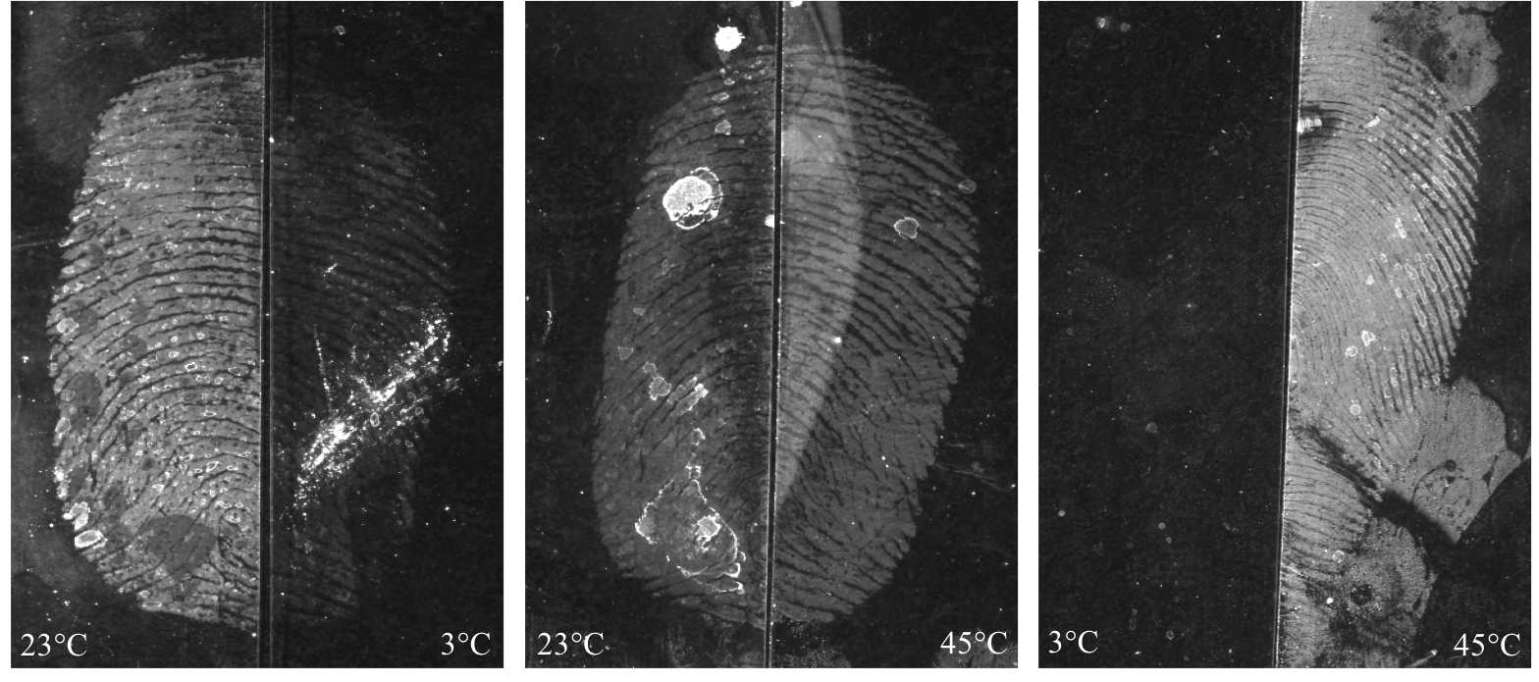
Figure 9: Comparisons of fingermark detection on transparent PP (12-week-old specimens) at different temperature points with RuBpy-doped CES-SiO₂ NPs.

As fingermark detection quality increased at 45°C compared to detection at room temperature, reduction of the 60-min immersion time was attempted at 45°C. Fingermark specimens were treated at 45°C for 30, 15 and 5 minutes in comparison to detection at room temperature for 60 minutes. It was observed that a 5-min immersion time at 45°C was able to enhance fingermark specimens with at least comparable quality to that achieved with 60-min treatment at room temperature. Comparison of fingermark detection quality at different temperature points with shorter immersion times are shown in Figure 10. Some pronounced background interference was encountered during the temperature modification experiments when the temperature of the colloidal dispersion was adjusted to around 50°C. No background interference was observed when the bath temperature was reduced to 40°C (while still delivering comparable detection quality to 60-min treatment at room temperature as illustrated in Figure 11). Hence, treatment at 45°C was reduced to 40°C from this point onwards.
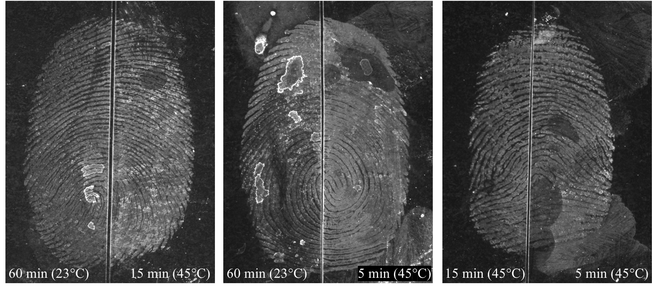
Figure 10: Comparisons of fingermark detection at different temperature points and immersion times with RuBpy-doped CES-SiO₂ NPs. Fingermark specimens were collected on transparent PP (3 weeks old).
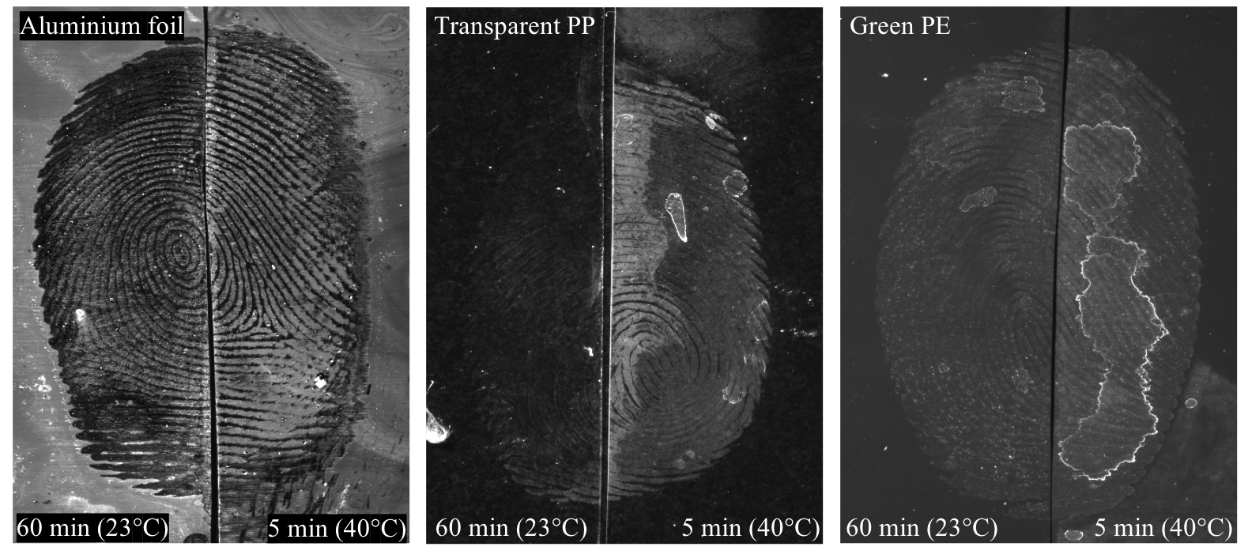
Figure 11: Direct comparisons of fingermark detection at 40°C for 5 minutes and room temperature for 60 minutes with RuBpy-doped, CES-SiO₂ NPs. Fingermark specimens were 5 weeks old.
From the above, improved fingermark detection quality was achieved at a higher temperature (40°C) with a shorter immersion time (5 min) compared to detection at room temperature for 60 minutes. Further optimisation of both bath temperature and immersion time was therefore undertaken. Firstly, the lowest bath temperature that could develop fingermark specimens with comparable quality to development at 40°C was determined with immersion time fixed at 5 min. Comparison experiments were undertaken at 30°C, 35°C and 40°C. Results revealed that detection quality declined at 30°C compared to detection at 35°C and 40°C, while detection quality at 35°C and 40°C was similar (Figure 12). With optimum bath temperature subsequently set at 40°C, the minimum immersion time was determined. Fingermark detection comparisons were completed at 40°C for 2, 3 and 5 minutes. As illustrated in Figure 13, inferior fingermark development was observed with a 2-min immersion time. Immersion times of 3 and 5 minutes gave similar results.
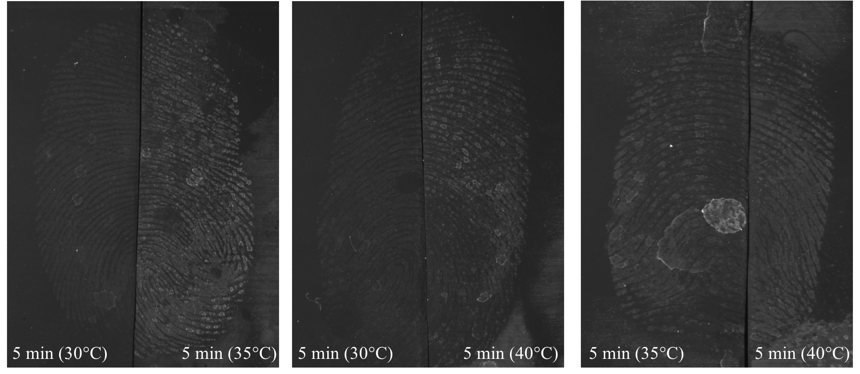
Figure 12: Comparison of fingermark treatments at 30°C, 35°C and 40°C for 5 min with RuBpy-doped CES-SiO₂ NPs. Fingermark specimens were collected on green PE (5 weeks old).
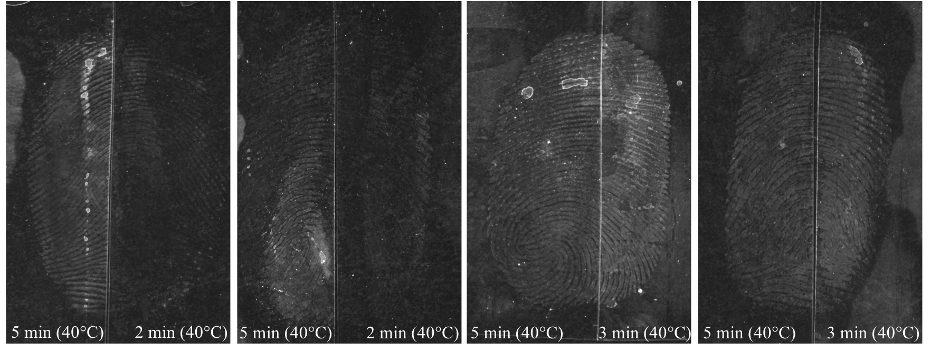
Figure 13: Comparison of fingermark treatments at 40°C for 2, 3 and 5 min with RuBpy-doped CES-SiO₂ NPs. Fingermark specimens were collected on transparent PP (7 weeks old).

3.2.4 Modified detection parameters

From the results achieved, the recommended detection parameters are as follows. A lower NP concentration in the colloidal dispersion (40x dilution) is proposed in contrast to the previous concentration (2x dilution). While ionic strength and pH of the colloidal dispersion are kept the same (0.5 M NaCl; pH 7), the immersion time is shortened to 3 – 5 min with a bath temperature set between 35 and 40°C. Figure 14 illustrates the comparison of fingermark detections using the published and modified detection parameters on the three test substrates.
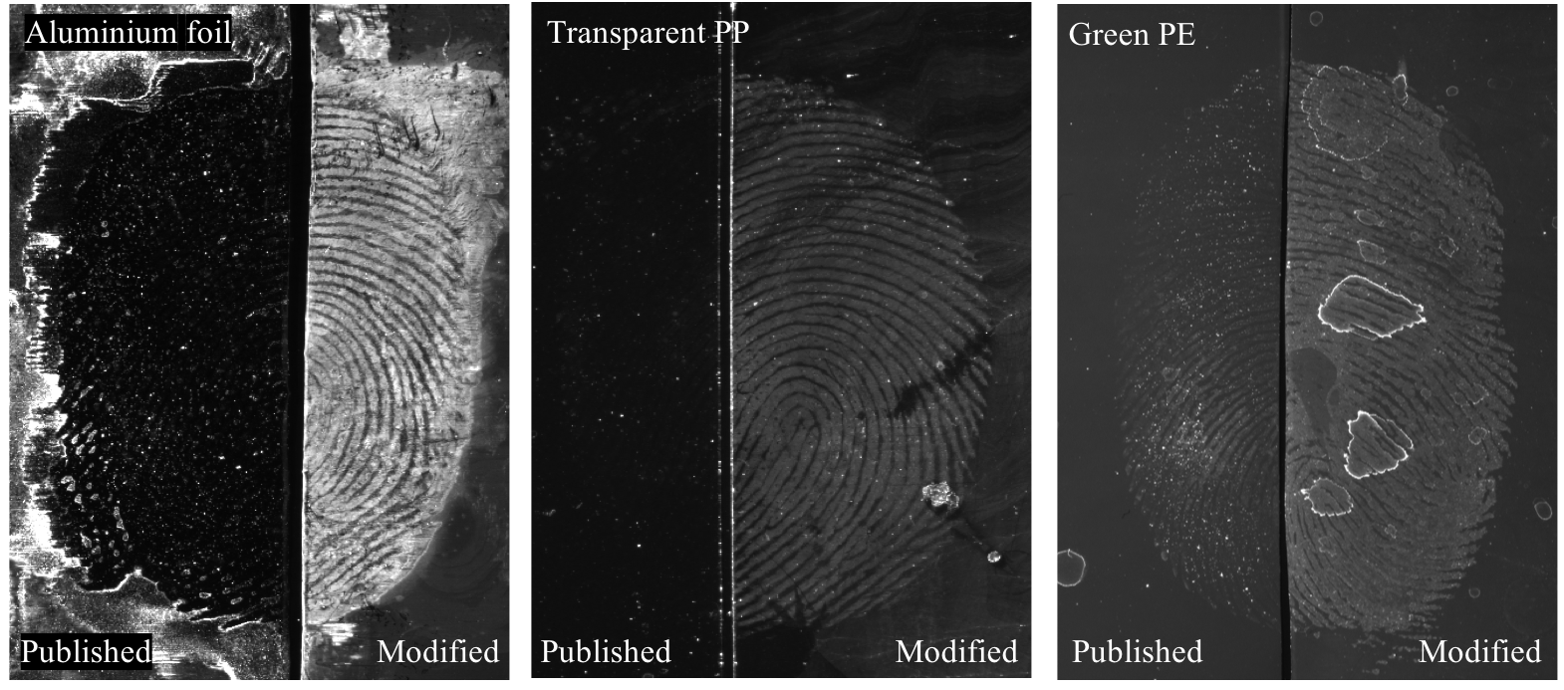
Figure 14: Comparison of fingermark detections using the published and modified detection parameters. Fingermark specimens were 10 days old.

3.3 Comparison of the published and modified detection parameters

3.3.1 Overall performance of the modified detection parameters

The overall performance of the modified detection parameters is depicted in Figure 15. About 70% of the assessed fingermarks were graded above 0. This indicated that substantial improvement in fingermark detection quality was offered by the modified detection parameters compared to the published detection parameters. A 10% “no detection” (00) rate was recorded using the functionalised NPs on latent fingermarks in this study. This is quite low given that a recent study indicated a “no detection” rate of available fingermarks on non-porous substrate of about 20%. [13]. The comparison chart in Figure 15 shows a consistent and increased ability of the modified detection parameters to detect latent fingermarks across four fingermark depletions. Fingermark specimens were collected in successive appositions to reflect a decline in deposition quality. This result indicated that the modified detection parameters permit the detection of latent fingermarks with improved visibility even with low deposition quality. This is important for casework where deposition quality is highly variable.
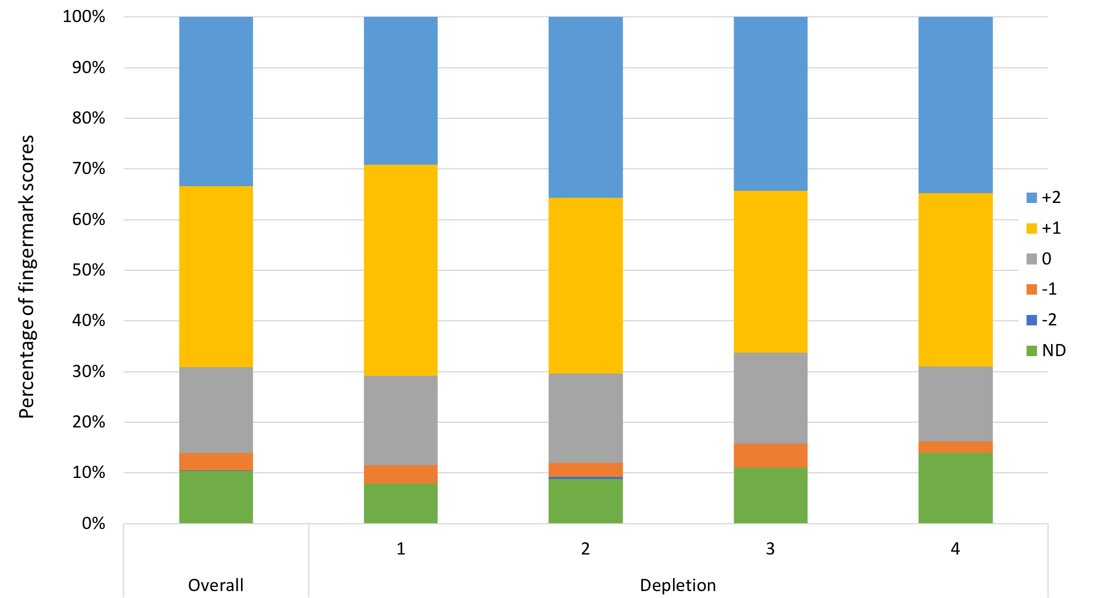
Figure 15: Overall distribution of comparison scores of the assessed fingermark specimens and distribution of comparison scores based on fingermark depletions. Scores were graded based on the modified detection parameters compared to the published detection parameters.

3.3.2 Effects of fingermark age

Two fingermark age intervals – ten days and three months – were employed in the study. These were implemented to mimic real case scenarios and to test the technique’s ability to detect older fingermarks. Figure 16 shows the performance of the modified detection parameters over the two age intervals. In general, the detection quality for ten-day-old fingermark specimens was superior compared to three-month-old specimens (with the total number of +2 and +1 scores being less for the latter age period). The three-month-old specimens also resulted in a higher number of “no detection” results. This suggests that the SiO₂ NPs are more effective for the detection of fresher fingermarks.
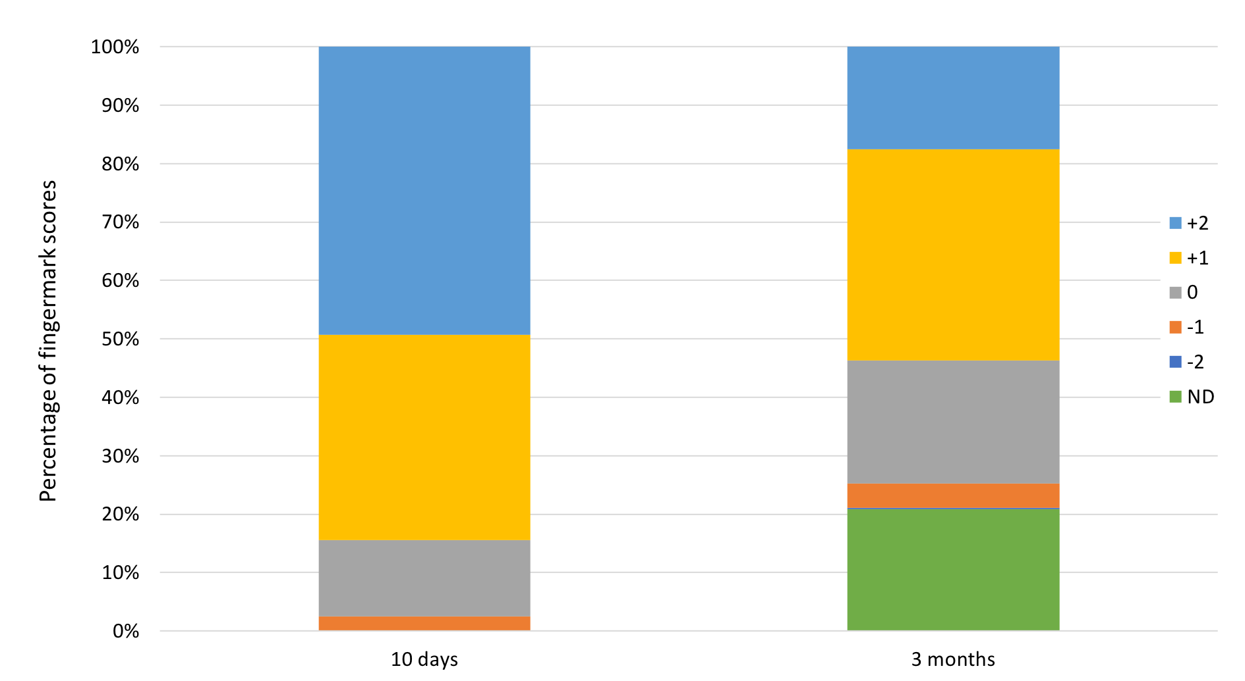
Figure 16: Distribution of comparison scores for the assessed fingermark specimens across the two age intervals.

3.3.3 Substrate effects and donor variability

The distribution of fingermark scores across the three substrates over the two age intervals is reflected in Figure 17. Substantial decreases in the number of +2 scores from ten-day to three-month-old specimens were observed on aluminium foil and green PE. This indicated that the two sets of detection parameters were closer in performance when applied to the older fingermarks. However, the optimised set of detection parameters still performed better overall. Fingermark specimens with no detection with either set of detection parameters were only observed with the three-month-old sample set across the three substrates, with a more pronounced rate of no detection (29%) being obtained on the transparent PP.

The variability of fingermark detection results was also assessed based on the donors themselves. Figure 18 shows the distribution of fingermark scores based on donors and the two fingermark age intervals. The score distribution from donor 1 (an average donor) was relatively consistent across the two age periods, with a slight increase in +2 and +1 scores being noted. A higher variability was observed with donor 2 (a strong donor); the respective score distributions showed a substantial decline in +2 scores. For donor 3 (a weak donor), a dramatic change in score distributions was observed across the two age intervals. Almost all of the ten-day-old fingermark specimens showed an increase in detection quality using the modified detection parameters compared to the use of the published parameters, while more than half of the three-month-old fingermark specimens were graded as “no detection”. In fact, these fingermark specimens contributed to about 85% of the “no detection” scores across the entire comparison study. As indicated in the effects of fingermark age, the SiO₂ NPs are suggested to be more effective for the detection of fresher fingermarks. However, this could not be the only reason to account for the high “no detection” scores for the three-month-old fingermark specimens from donor 3. During the comparison study, two different batches of the functionalised SiO₂ NPs were applied for the detection of the ten-day-old and three-month-old fingermarks. Since inter-batch variations were observed in terms of fingermark detection effectiveness, it is suggested that the detection of fingermark specimens from donor 3 was substantially impacted by this. The differences in average detection effectiveness of fingermarks across the two age intervals were therefore more pronounced.

To account for this effect of batch-to-batch variations on fingermark detection effectiveness, additional direct comparison experiments between the two batches used in the comparison study were performed. It was noted that the difference in fingermark detection quality from different donors were impacted to various extents. Fingermark detection effectiveness was superior using the ten-day-old specimens’ batch than that using the three-month-old specimens’ batch. Strong donors were impacted to a lesser extent than weak donor. This result agreed to the difference in variability of fingermark detection results between donor 2 and donor 3.
Although batch-to-batch variation was observed from the comparison study, assessment of fingermark detection effectiveness with the modified detection parameters would not be affected as all fingermarks were processed and assessed directly on the respective half fingermarks (i.e., two corresponding half fingermarks were always processed using the same batch of functionalised NPs). From the results obtained, donor variations were noticed between the three donors. However, the modified detection parameters showed improvement in detection effectiveness across the three donors. This indicates that improved fingermark detection quality is offered by the modified detection parameters compared to the previously published detection parameters, regardless of donor variability.
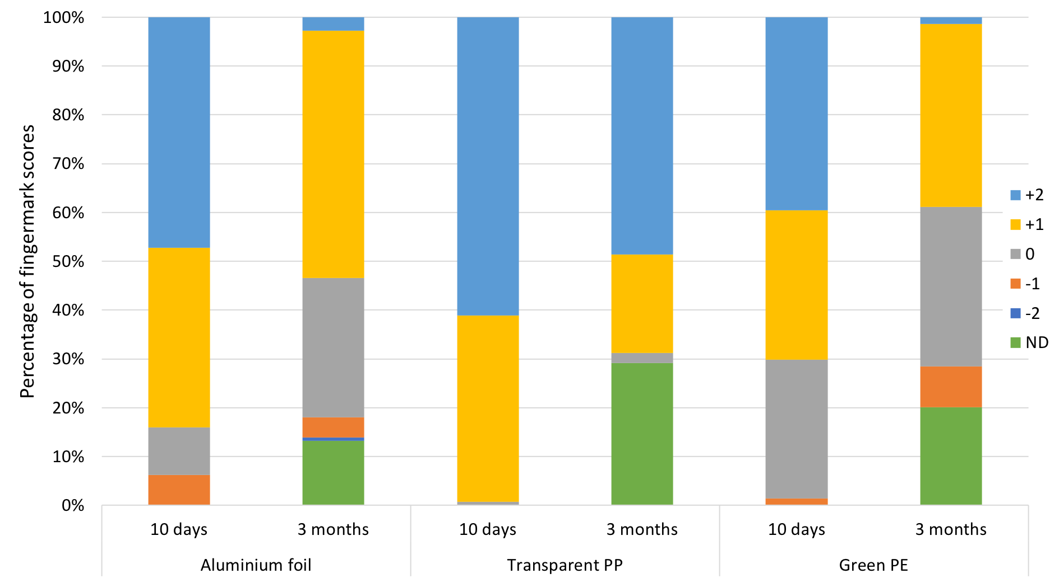
Figure 17: Distribution of comparison scores for the assessed fingermark specimens from the three substrates across the two age intervals.
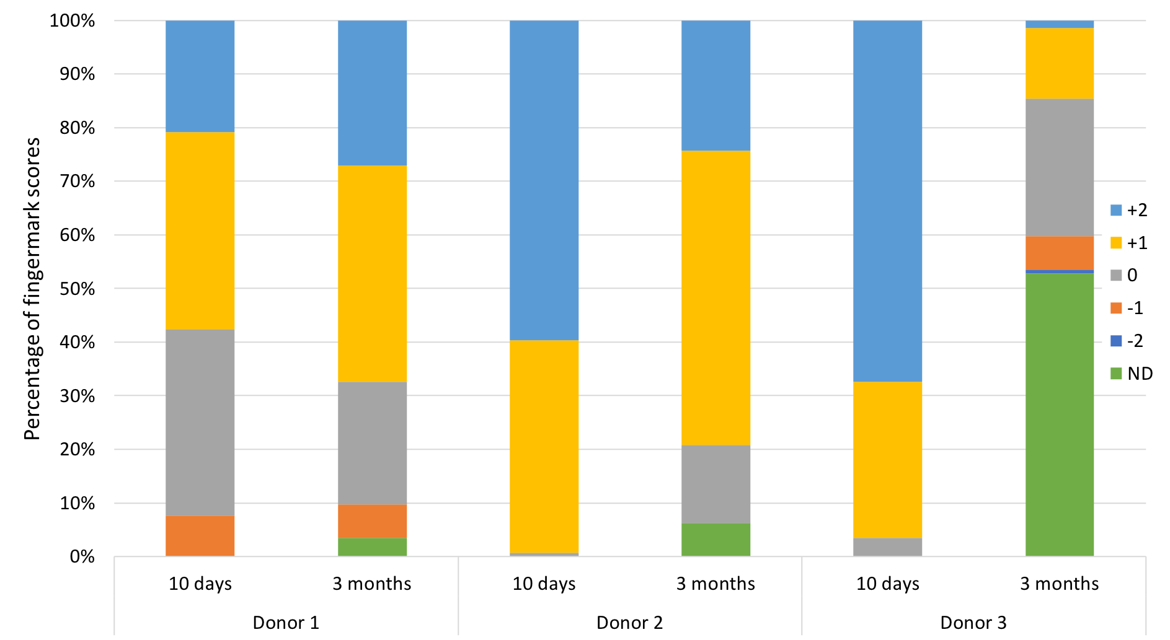
Figure 18: Distribution of comparison scores for the assessed fingermark specimens from the three donors across the two age intervals.

3.4 Practical considerations and discussion

During the entire study, various batches of RuBpy-doped CES-SiO₂ NPs were synthesised and applied for fingermark detection. It was noted that fingermark detection quality was substantially higher using stock reagents (functionalised NPs dispersed in RO/DI water after synthesis) that were at least two weeks old compared to any reagents that were under ten days old. It is suggested that the functionalised NPs are homogeneously dispersed in the aqueous medium after a certain period of time; NP reagents that have not reached this homogeneous state of dispersion would experience inter-nanoparticle interactions that lead to inferior detection quality. In addition, batch-to-batch variations in terms of fingermark detection effectiveness were also recorded during the research. This indicates a lack of robustness in the synthesis process to produce the functionalised NPs. Further optimisation of the NP synthesis is underway within our research group to improve batch-to-batch consistency.

4. Conclusions

This study investigated the use of RuBpy-doped CES-functionalised SiO₂ NPs for latent fingermark detection. Evaluation of the technique was performed and a new set of detection parameters was proposed. The dilution of the functionalised NPs has been modified from 2x to 40x for improved detection effectiveness and cost efficiency. The results indicate that a shorter immersion time (5 min) at a higher temperature (40°C) during fingermark treatment can substantially improve detection quality in comparison to the published detection parameters. The modified detection parameters were also applied in a comparison study to investigate fingermark detection performance in contrast to the previously published parameters. The overall performance was evaluated from 288 fingermark specimens at two age intervals on aluminium foil, transparent polypropylene plastic and green polyethylene plastic. It was concluded that the modified detection parameters can detect latent fingermarks with superior enhancement quality compared to the published method. Additional studies using the modified SiO₂ NP technique for latent fingermark detection in comparison with conventional methods is underway and will be reported in due course. Our research group is also investigating other functionalised SiO₂-based NPs and their application for latent fingermark detection.

References

[1] J. Dilag, H. Kobus, A.V. Ellis, Cadmium sulfide quantum dot/chitosan nanocomposites for latent fingermark detection, Forensic Science International 187(1–3) (2009) 97-102.
[2] S. Moret, A. Bécue, C. Champod, Cadmium-free quantum dots in aqueous solution: Potential for fingermark detection, synthesis and an application to the detection of fingermarks in blood on non-porous surfaces, Forensic Science International 224(1–3) (2013) 101-110.
[3] J. Dilag, H. Kobus, A.V. Ellis, CdS/polymer nanocomposites synthesized via surface initiated RAFT polymerization for the fluorescent detection of latent fingermarks, Forensic Science International 228(1–3) (2013) 105-114.
[4] A. Bécue, A. Scoundrianos, S. Moret, Detection of fingermarks by colloidal gold (MMD/SMD) – beyond the pH 3 limit, Forensic Science International 219(1–3) (2012) 39-49.
[5] C. Prete, L. Galmiche, F.-G. Quenum-Possy-Berry, C. Allain, N. Thiburce, T. Colard, Lumicyano™: A new fluorescent cyanoacrylate for a one-step luminescent latent fingermark development, Forensic Science International 233(1–3) (2013) 104-112.
[6] E.R. Menzel, M. Takatsu, R.H. Murdock, K. Bouldin, K.H. Cheng, Photoluminescent CdS/Dendrimer Nanocomposites for Fingerprint Detection, Journal of Forensic Sciences 45(4) (2000) 770-3.
[7] E.R. Menzel, S.M. Savoy, S.J. Ulvick, K.H. Cheng, R.H. Murdock, M.R. Sudduth, Photoluminescent Semiconductor Nanocrystals for Fingerprint Detection, Journal of Forensic Sciences 45(3) (2000) 545-51.
[8] C. Huynh, J. Halámek, Trends in fingerprint analysis, TrAC Trends in Analytical Chemistry 82 (2016) 328-336.
[9] A. Bécue, S. Moret, C. Champod, P. Margot, Use of quantum dots in aqueous solution to detect blood fingermarks on non-porous surfaces, Forensic Science International 191(1–3) (2009) 36-41.
[10] S. Chadwick, P. Maynard, P. Kirkbride, C. Lennard, X. Spindler, C. Roux, Use of Styryl 11 and STaR 11 for the Luminescence Enhancement of Cyanoacrylate-Developed Fingermarks in the Visible and Near-Infrared Regions, Journal of Forensic Sciences 56(6) (2011) 1505-1513.
[11] A. Bécue, A. Cantú, Fingermark Detection Using Nanoparticles, in: R.S. Ramotowski (Ed.), Lee and Gaensslen's Advances in Fingerprint Technology, 3rd ed., CRC Press2012, pp. 307-380.
[12] R.S. Ramotowski, Metal Deposition Methods, in: R.S. Ramotowski (Ed.), Lee and Gaensslen's Advances in Fingerprint Technology, 3rd ed., CRC Press2012, pp. 55-82.
[13] S. Chadwick, S. Moret, N. Jayashanka, C. Lennard, X. Spindler, C. Roux, Investigation of some of the factors influencing fingermark detection, Forensic Science International 289 (2018) 381-389.
[14] M. de la Hunty, S. Moret, S. Chadwick, C. Lennard, X. Spindler, C. Roux, Understanding physical developer (PD): Part I – Is PD targeting lipids?, Forensic Science International 257 (2015) 481-487.
[15] M. de la Hunty, S. Moret, S. Chadwick, C. Lennard, X. Spindler, C. Roux, Understanding Physical Developer (PD): Part II – Is PD targeting eccrine constituents?, Forensic Science International 257 (2015) 488-495.
[16] S. Moret, A. Bécue, C. Champod, Nanoparticles for fingermark detection: an insight into the reaction mechanism, Nanotechnology 25(42) (2014) 425502.
[17] P. Durussel, E. Stauffer, A. Bécue, C. Champod, P. Margot, Single-metal deposition: Optimization of this fingermark enhancement technique, Journal of Forensic Identification 59(1) (2009) 80-96.
[18] A. Bécue, S. Moret, C. Champod, P. Margot, Use of stains to detect fingermarks, Biotechnic & Histochemistry 86(3) (2011) 140-160.
[19] S. Moret, A. Bécue, C. Champod, Functionalised silicon oxide nanoparticles for fingermark detection, Forensic Science International 259 (2016) 10-18.
[20] M.J. Choi, A.M. McDonagh, P. Maynard, C. Roux, Metal-containing nanoparticles and nano-structured particles in fingermark detection, Forensic Science International 179(2–3) (2008) 87-97.
[21] S. Moret, A. Bécue, Single-Metal Deposition for Fingermark Detection-A Simpler and More Efficient Protocol, Journal of Forensic Identification 65(2) (2015) 118-137.
[22] G. Saunders, Multimetal deposition method for latent fingerprint development, 74th Conference of the International Association for Identification, Pensacola, FL, 1989.
[23] B. Schnetz, P. Margot, Technical note: latent fingermarks, colloidal gold and multimetal deposition (MMD): Optimisation of the method, Forensic Science International 118(1) (2001) 21-28.
[24] E. Stauffer, A. Bécue, K.V. Singh, K.R. Thampi, C. Champod, P. Margot, Single-metal deposition (SMD) as a latent fingermark enhancement technique: An alternative to multimetal deposition (MMD), Forensic Science International 168(1) (2007) e5-e9.
[25] Y.-J. Kim, H.-S. Jung, J. Lim, S.-J. Ryu, J.-K. Lee, Rapid Imaging of Latent Fingerprints Using Biocompatible Fluorescent Silica Nanoparticles, Langmuir 32(32) (2016) 8077-8083.
[26] L. Liu, S.K. Gill, Y. Gao, L.J. Hope-Weeks, K.H. Cheng, Exploration of the use of novel SiO₂ nanocomposites doped with fluorescent Eu³⁺/sensitizer complex for latent fingerprint detection, Forensic Science International 176(2) (2008) 163-172.
[27] B.J. Theaker, K.E. Hudson, F.J. Rowell, Doped hydrophobic silica nano- and micro-particles as novel agents for developing latent fingerprints, Forensic Science International 174(1) (2008) 26-34.
[28] E. Alsolmy, W.M. Abdelwahab, G. Patonay, A Comparative Study of Fluorescein Isothiocyanate-Encapsulated Silica Nanoparticles Prepared in Seven Different Routes for Developing Fingerprints on Non-Porous Surfaces, Journal of Fluorescence 28(5) (2018) 1049-1058.
[29] A. Sandhyarani, M.K. Kokila, G.P. Darshan, R.B. Basavaraj, B. Daruka Prasad, S.C. Sharma, T.K.S. Lakshmi, H. Nagabhushana, Versatile core–shell SiO₂@SrTiO₃:Eu³⁺, Li⁺ nanopowders as fluorescent label for the visualization of latent fingerprints and anti-counterfeiting applications, Chemical Engineering Journal 327 (2017) 1135-1150.
[30] International Fingerprint Research Group, Guidelines for the Assessment of Fingermark Detection Techniques, Journal of Forensic Identification 64(2) (2014) 174-200.
[31] P. Leroy, N. Devau, A. Revil, M. Bizi, Influence of surface conductivity on the apparent zeta potential of amorphous silica nanoparticles, Journal of Colloid and Interface Science 410 (2013) 81-93.
[32] N. Wang, C. Hsu, L. Zhu, S. Tseng, J.-P. Hsu, Influence of metal oxide nanoparticles concentration on their zeta potential, Journal of Colloid and Interface Science 407 (2013) 22-28.

